Task 1: Create a New Pluggable Database (PDB) Each student is required to create a PDB named plsql_class2024db. ▪ Username Format: Your username should begin with the first two letters of your first name followed by _plsqlauca. Example: If your first name is Eric, your username will be er_plsqlauca. ▪ Password: Choose a personal password, preferably something simple for ease of use. ▪ Purpose: This username will be used for class activities where you will store all your work during the course.

Solution

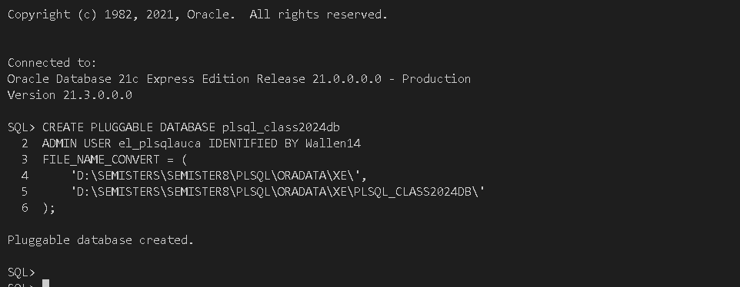

Task 2: Create and Delete a Pluggable Database Instructions: ▪ You are required to create another Pluggable Database (PDB) based on the first two letters of your first name followed by _to_delete_pdb. ▪ After creating the PDB, you must delete it. Example: If your first name is Eric, you will: ▪ Create a PDB named er_to_delete_pdb. ▪ Once the PDB is successfully created, proceed to delete it. Ensure you take screenshots of both the creation and deletion process, and include all SQL commands used.

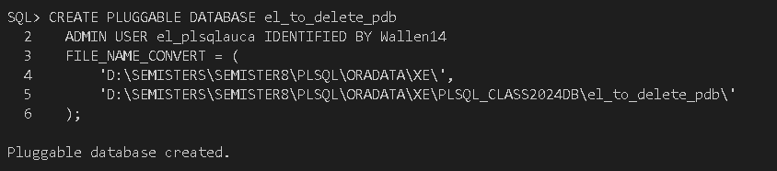

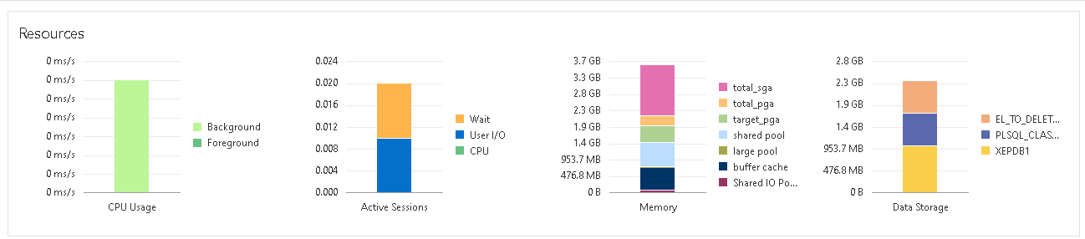

DELETING PLUGGABLE DATABASE

