FPGA Digital Down Conversion on the DE10 Lite
  - Technical design implementation and verification report
Mutikedzi Seremane
5 October 2026

Abstract
A register controlled digital down converter was implemented on the DE10-Lite using the board, its USB connection, and a PC. An internally generated 20 kHz signal was processed at 100 kHz, mixed with a selectable 18 kHz or 20 kHz local oscillator, filtered into I and Q channels, and decimated to 20 kHz. Sixteen I/Q pairs were stored in FPGA memory and transferred to the PC through JTAG for plotting and numerical analysis. The 18 kHz oscillator produced an estimated difference frequency of 2000.01 Hz. The 20 kHz oscillator produced a constant output of I = 5999 and Q = 0. RTL simulation reproduced all 32 recorded I/Q pairs exactly. The final implementation used 1571 logic elements, 721 dedicated logic registers, one M9K block, and four embedded multiplier 9-bit elements. Quartus reported positive setup and hold slack for the analysed board-clock paths. The project demonstrates frequency translation and PC control without external signal-generation equipment.
The report develops the design from the sampling and frequency translation requirements through its register interface, sequential filter implementation and measured results. The principal evidence is the retained FPGA sample data, the completed RTL comparisons and the final Quartus reports. Physical board photographs and selected internal probe observations support the initial integration checks. The conclusions apply to a controlled digital test signal and two oscillator settings.

Contents
1 Project purpose and requirements 3
2 System architecture and hardware integration 5
3 Sampling and digital signal generation 9
4 Quadrature mixing and fixed point arithmetic 13
5 FIR filtering and sequential implementation 16
6 Decimation capture and register control 21
7 JTAG transfer and PC processing 24
8 Hardware results and interpretation 27
9 RTL simulation and hardware comparison 32
10 Timing closure and resource analysis 37
11 Engineering assessment and conclusions 42
References 45
Frequency values are nominal unless explicitly described as estimates. Amplitudes are reported in digital counts. I and Q denote the in-phase and quadrature channels, LO denotes the local oscillator, and FIR denotes a finite impulse response filter.

1 Project purpose and requirements

1 1 Project context
Digital down conversion moves a sampled signal from a selected input frequency towards baseband. Multiplication by a local oscillator creates sum and difference components. A low-pass filter suppresses the unwanted high-frequency component, after which the sampling rate can be reduced. In this project, two mixer paths provide the in-phase and quadrature outputs needed to represent the translated signal as a complex sequence.
The available hardware was a DE10-Lite board. External signal generators, analogue front ends, and additional communication adapters were not available. An internal test signal therefore provided a repeatable input. This allowed the signal-processing chain to be checked while keeping the implementation achievable with the board alone. The USB-Blaster connection was used both to program the FPGA and to exchange control and sample data with the PC.
The objectives were to implement a simple DDC, control its operation through registers, transfer processed data to a PC, quantify FPGA resource usage, and obtain evidence that the design worked. The verification combined initial board checks, hardware captures, Python analysis, RTL simulation, and Quartus timing analysis.
A board-only implementation still needs a meaningful input, a means of changing operating conditions and a way of examining the result. The internally generated tone supplies the input without an external generator. A small PC-controlled register selects the oscillator setting and starts an acquisition. The captured I/Q record provides a numerical output that can be analysed independently of the LED display. Together these functions make the project a complete processing experiment rather than an isolated arithmetic block.

1 2 Functional requirements
Table 1. Project requirements and evidence
Requirement | Implemented behaviour | Evidence
Frequency translation | 20 kHz input mixed with 18 or 20 kHz LO | Measured periodic output or DC
Filtering and rate reduction | Nine tap FIR and decimation by five | Coefficient analysis and capture schedule
Register control | Reset run LO address and I/Q fields | JTAG writes and selected probe data
PC data processing | Sixteen I/Q pairs exported to CSV | Python graphs and numerical comparison
Implementation feasibility | Fit and operate on the existing MAX 10 | Quartus resource and timing reports
Verification | Repeat the measured cases in RTL | Exact comparison of 32 pairs

These requirements define the acceptance criteria for the completed demonstrator. Successful compilation alone would not establish frequency translation, and a convincing graph alone would not establish timing closure. Each requirement therefore has a separate form of evidence. The report relates the evidence to the claim it supports instead of treating one passing check as proof of the complete system.

1 3 Scope and practical constraints
The implemented system is a digital processing demonstrator. It generates its input inside the FPGA and does not sample an external analogue source. The board ADC and external SDRAM are not used. Captures are finite blocks of sixteen I/Q pairs rather than a continuous stream. These choices keep the implementation small and make each measured output directly reproducible in simulation.
The absence of an analogue input is a deliberate boundary of the experiment. A DDC operates on numbers, so its mixer, filter and decimator can be demonstrated with a digital source. This does not test an ADC or an RF front end. It does establish that the FPGA transforms a known sampled input into the expected baseband representation and returns the result to a PC using the resources already available.
The short record and the restricted oscillator settings also define the scope of the results. Two cases provide a useful contrast between a moving complex tone and a stationary baseband value. They do not provide a complete sweep of the filter or oscillator. The implementation was selected to remain understandable at module level and to make every retained integer reproducible in simulation.

1 4 Development and verification approach
The implementation was built in stages. The first stage established programming and physical I/O. The second established JTAG writes and reads, followed by clocked reset and enable behaviour. Signal generation, oscillator operation and mixing were then checked before filtering and capture were added. The final stages automated readout, compared the two oscillator settings and repeated the processing experiment in Questa.
Incremental development reduced ambiguity when a result was wrong. An incorrect probe value could be checked against a known simple signal before questioning the mixer. A fitted design with negative setup slack could be corrected structurally before final measurements were accepted. Saved hardware data was retained for the simulation comparison, so the board did not need to remain connected during RTL verification.
The numerical comparison preserves the implementation arithmetic. The testbench uses measured integer pairs as regression expectations. Separate ideal calculations explain why the two outputs should be a 2 kHz tone and DC. This combination gives both a physical interpretation and a precise check of the recorded digital result, while keeping the limitations of the comparison explicit.

2 System architecture and hardware integration

2 1 Hardware and development environment
Table 2. Hardware and software configuration
Item | Configuration
FPGA board | Terasic DE10-Lite
Target device | MAX 10 10M50DAF484C7G
Implementation software | Quartus Prime Lite 25.1std
Simulation software | Questa Altera FPGA Starter Edition 2025.2
Hardware language | Verilog
PC analysis | Python with NumPy and Matplotlib
Board clock | 50 MHz
Processing and output rates | 100 kHz and 20 kHz

The DE10-Lite uses a MAX 10 device and provides the clock, switches, LEDs and USB-Blaster programming interface required for this experiment [1]. No additional signal generator, communication adapter or external memory module was used. Quartus produced the FPGA configuration and analysed the fitted implementation. Questa executed the Verilog testbench on the PC, while Python processed the exported sample files.

2 2 Processing architecture
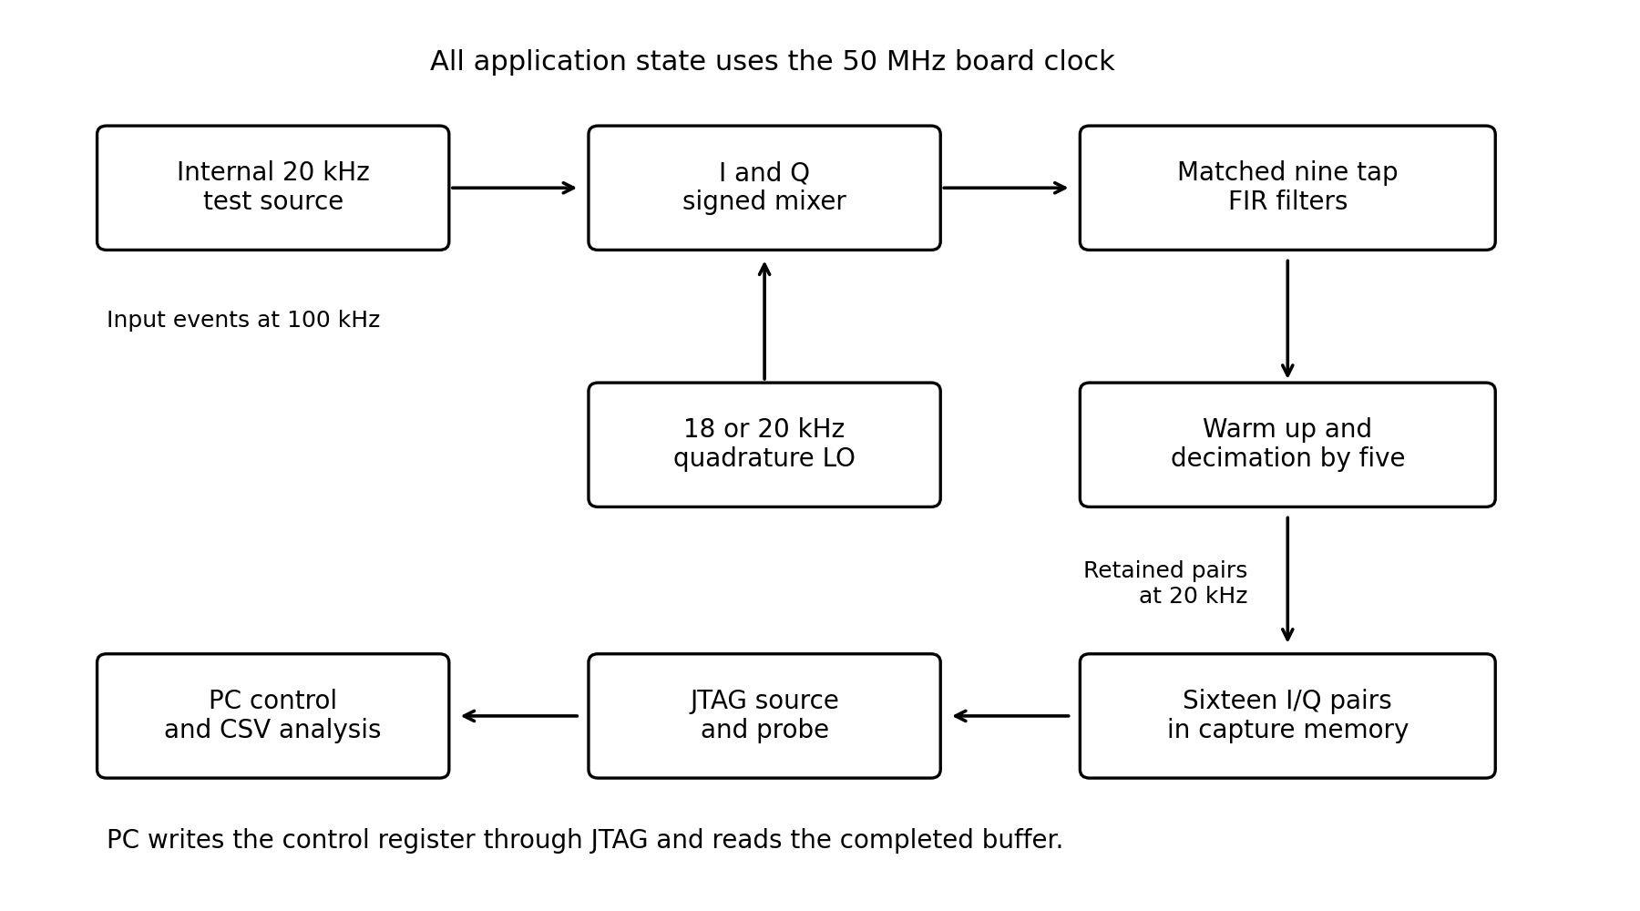
Figure 1. Implemented processing and stored data readout architecture.
Table 3. Processing stages and interfaces
Stage | Input and output | Purpose
Sample enable | 50 MHz clock to 100 kHz enable | Schedules the digital sample events
Internal source | Five signed samples repeated | Provides the 20 kHz test tone
Oscillator | Phase step to sine and cosine | Selects 18 kHz or 20 kHz translation
I/Q mixer | Real input to two signed products | Forms the complex translated signal
Two FIR filters | Mixer samples to valid filtered pair | Suppresses the sum component
Decimator and capture | 100 kHz pairs to sixteen at 20 kHz | Stores a finite output record
JTAG and host | Selected stored word to CSV | Allows control and PC analysis

The processing and transfer paths operate at different rates. The FPGA acquires the entire record first. The PC subsequently reads stored words through JTAG. Consequently the transfer does not need to maintain the 20 kHz output rate. This separation is essential because the source and probe interface is a debug and control path, while the sample clock enable determines the actual acquisition timing.
Both I and Q travel through matching filters and enter storage as a pair. A common oscillator phase and a common sample enable maintain their relationship. The complex interpretation would be lost if the two channels were captured at different sample indices. Output-valid signals therefore form part of the data path contract rather than merely indicating activity.

2 3 Quartus project and top level integration
The Quartus project was created in C:\FPGA\DDC_Board_Project with DDC_Board_Project as the top-level entity and 10M50DAF484C7G as the target device. The Verilog source files and generated JTAG IP configuration were included in the project. The generated synthesis QIP file was used for the IP integration. The instantiation template was used to connect the IP ports, rather than treated as another independent design module.
The top-level interface retained MAX10_CLK1_50, SW[9:0], and LEDR[9:0]. The clock was assigned to PIN_P11. Board I/O assignments used the appropriate DE10-Lite switch and LED locations with the 3.3 V LVTTL standard. The final resource report includes these top-level pins even though the DDC control is provided through JTAG.
A simple LED test was compiled, programmed, and checked before building the signal-processing chain. This established that the selected device, USB-Blaster programming connection, and basic board I/O operated correctly. A switch-to-probe check then confirmed that a board input could be observed from the PC. Both checks passed before the DDC was added.
The module boundaries isolate rate generation, lookup logic, arithmetic and capture. This makes it possible to observe one stage through the probe during development and to reuse the same processing modules in the testbench. The generated IP files belong to the project integration, while the application modules describe the DDC. Keeping the generated synthesis definition separate from the example instantiation avoids duplicate or incomplete module definitions.

2 4 Physical board verification
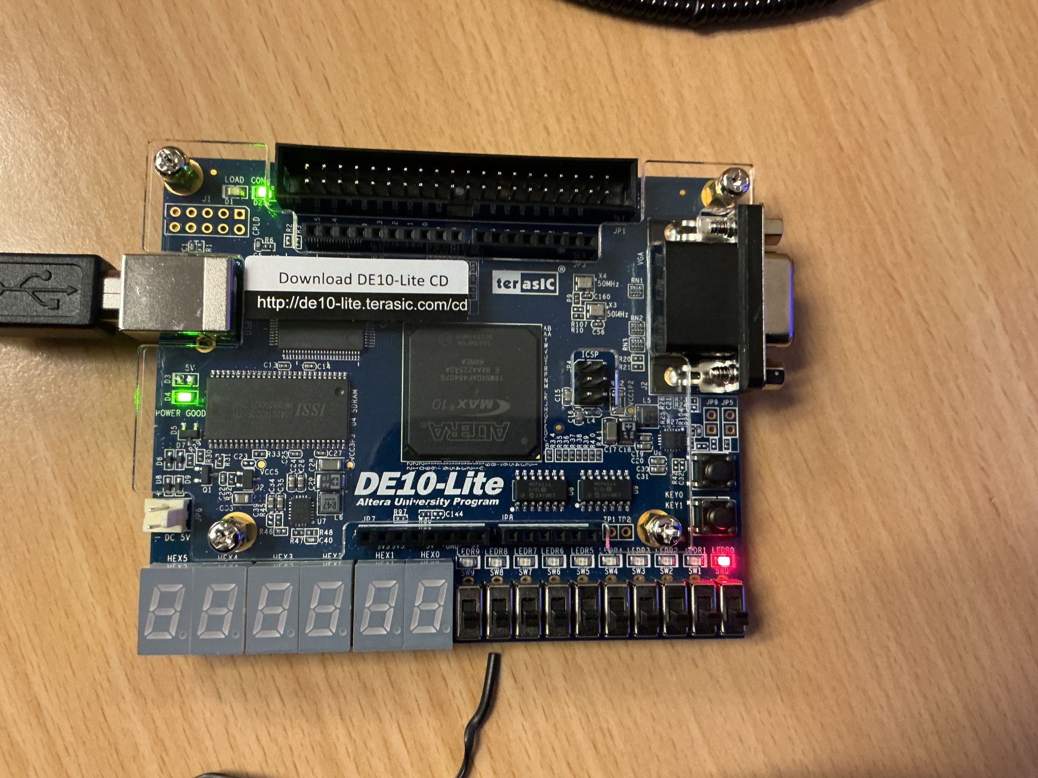
Figure 2. Physical one LED test on the DE10-Lite confirming a programmed board response.
The LED test was a preliminary integration check. Its significance is that the configuration reached the board and the intended output pin produced a visible response. It does not establish mixer arithmetic, filter gain or frequency translation. Those claims require the later captured data. A switch-to-probe test established the read direction of the same PC connection before the probe was connected to signed DDC data.
The initial tests were intentionally small. A working physical output, a working probe read and a clocked counter gave distinct checkpoints before a larger circuit was introduced. Their outcome justified moving to the signal-processing chain.

2 5 Synchronous clocking
A 20 ns clock period was specified in the project SDC file. All sample processing remains synchronous to this clock. The slower sample rate is implemented as a clock enable, so no additional sample clock or PLL is required.
The final timing summary is reported in Chapter 10. Its conclusions apply to the paths analysed under the project constraints. The summary alone does not demonstrate complete external I/O timing coverage.
create_clock -name board_clk -period 20.000 [get_ports {MAX10_CLK1_50}]
derive_clock_uncertainty
A clock enable allows state to advance at a lower sample rate without routing a counter output as a new clock. All application registers continue to use the physical 50 MHz clock. The enable only determines when a new input sample is consumed. The sequential FIR can therefore perform intermediate operations between sample events while remaining in the same clock domain.

3 Sampling and digital signal generation

3 1 Sample enable generation
The rates can be traced to the board clock rather than inferred only from a graph. The 50 MHz clock has a 20 ns period. A counter with 500 states produces one sample enable every 10 microseconds. The input generator advances once per enable and repeats after five samples. The resulting input frequency is therefore 20 kHz. This construction avoids a second clock domain in the processing chain.
Fₛ = 50 000 000 / 500 = 100 000 samples/s
fᵢₙ = Fₛ / 5 = 20 000 Hz
The oscillator uses 100 equally spaced phase positions. A phase step of 18 advances through 18 percent of a cycle per sample, while a phase step of 20 advances through 20 percent. Both frequencies are exact ratios of the same nominal sample clock. Their absolute accuracy depends on that clock, which was not independently calibrated.
fLO = Fₛ × phase_step / 100
After decimation by five, the retained output rate is 20 kHz. A 2 kHz output therefore has ten stored samples per cycle. The captured sequence repeats after ten pairs, which is consistent with the nominal frequency calculation. The sample rate is a property of the FPGA capture schedule. The speed of a later USB transfer does not change it.
The terminal count must be 499 because the interval contains the states 0 through 499. Counting through 500 instead would create 501 clock periods and a different sample rate. Reset establishes the same initial state for each acquisition. When disabled, the counter holds rather than introducing a partially completed sample event into another part of the circuit.
Table 4. Sampling rate calculations
Rate quantity | Calculation | Result
Clock period | 1 / 50 MHz | 20 ns
Cycles per input sample | 500 | 10 µs
Input processing rate | 50 MHz / 500 | 100 ksample/s
Stored output rate | 100 ksample/s / 5 | 20 kpair/s
Stored interval | 1 / 20 kHz | 50 µs

3 2 Internal input sequence
The sample-enable counter counts from 0 to 499 while enabled. One processing event therefore occurs every 500 cycles of the 50 MHz clock, giving a sample rate of 100000 samples per second. Reset clears the counter. Disabling it holds its state.
The input generator repeats the signed values 12000, 3708, -9708, -9708, and 3708. This is a quantised five-point cosine sequence with nominal amplitude 12000. Its five-sample period at 100 kHz corresponds to a 20 kHz tone. The sequence is deterministic and returns to its starting index after reset.
Table 5. Quantised internal input sequence
Sample index modulo five | Ideal cosine factor | Stored signed value
0 | 1 | 12000
1 | cos 72° | 3708
2 | cos 144° | −9708
3 | cos 216° | −9708
4 | cos 288° | 3708

The generator is a small table rather than a calculation of cosine on every sample. Its sequence is sufficiently short to inspect directly and its frequency follows from the repeat interval. The integer table approximates a sinusoid, so it should not be described as a mathematically perfect floating-point cosine. In particular, quantisation can introduce small additional spectral components. The exact table is part of the reference when comparing RTL and hardware.
Starting the input table from the same index after reset provides repeatable phase. Repeatability is necessary for an integer comparison because two otherwise correct acquisitions with different starting phases could produce different retained arrays. The testbench therefore reproduces the reset and sample schedule, not only the nominal frequencies.

3 3 Phase accumulator and frequency selection
The oscillator phase is represented by an integer from 0 to 99. It advances by the selected phase step on each input sample event and wraps at 100. A step of 18 implements 0.18 cycles per input sample. At 100 ksample/s this is 18 kHz. A step of 20 implements 0.20 cycles per sample and gives 20 kHz. The oscillator and input therefore use rational ratios of one common timebase.
Modulo wrapping is important because a lookup address must remain within the intended cycle. The phase accumulator is not a continuously increasing time counter. It represents periodic angle. Although the 18 kHz sequence does not visit the addresses in ascending order, it still follows the required phase advance. The relation between address order and oscillator frequency is set by the increment, not by a requirement to read every table element.
For the phase steps used here, the accumulator returns to its starting address after 50 input samples for step 18 and after five for step 20. The 18 kHz waveform completes nine cycles within that 50-sample sequence. This is consistent with its frequency and should not be confused with a 2 kHz oscillator. The 2 kHz component is created later by the difference between the input and LO frequencies.

3 4 Quadrature lookup representation
The oscillator lookup produces signed sine and cosine values with peak magnitude 32767. Quarter-wave symmetry reduces the table requirement. The appropriate address is reflected within a quadrant and the sign is changed according to the quadrant. Cosine is obtained with the corresponding phase offset. This provides the two oscillator components without evaluating trigonometric functions in hardware.
The scale factor is close to 2¹⁵. It allows the mixer to restore the input scale using a shift by 15 after multiplication. The positive peak is 32767 because a signed 16-bit word cannot represent positive 32768. This one-count difference is relevant when interpreting a result near the expected half-amplitude value. It is one of several small integer effects in the processing chain.
Sine and cosine must be evaluated from the same oscillator phase used for the input sample. A phase mismatch between these outputs would affect the direction and magnitude of the complex result. The paired lookup structure avoids that ambiguity. For the equal-frequency case, correct quadrature and phase alignment allow the high-frequency components to be rejected and leave a real DC output.

3 5 Intermediate oscillator verification
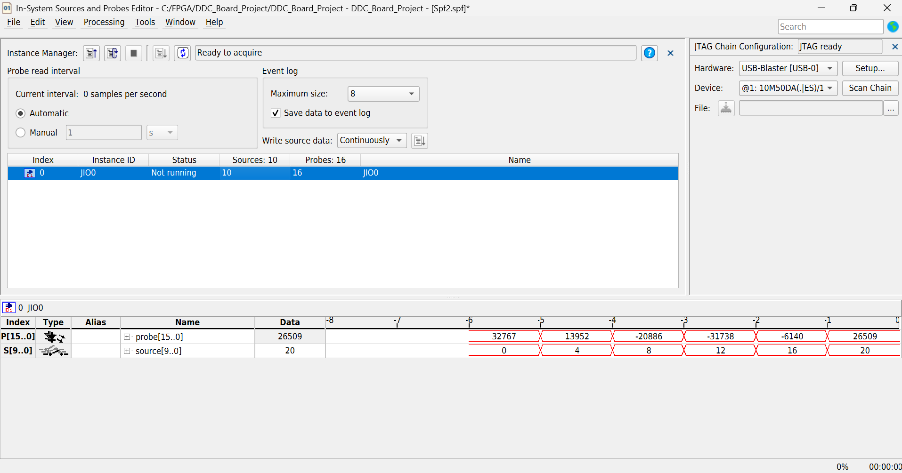
Figure 3. Intermediate probe observation for the 18 kHz oscillator setting.
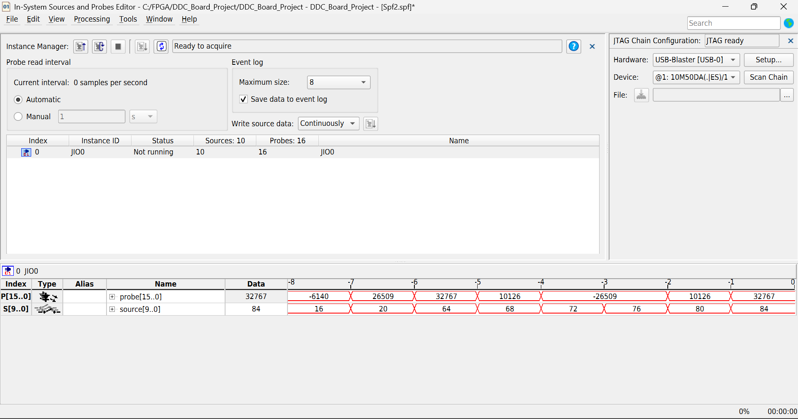
Figure 4. Intermediate probe observation for the 20 kHz oscillator setting.
The 18 kHz cosine probe sequence begins with 32767, 13952, −20886, −31738, −6140 and 26509. These values correspond to phase addresses 0, 18, 36, 54, 72 and 90. The 20 kHz sequence visits addresses 0, 20, 40, 60 and 80, giving the repeating cosine values 32767, 10126, −26509, −26509 and 10126. The observations are consistent with the selected phase increments and signed lookup scale. The filtered captures later establish the complete frequency translation result.

4 Quadrature mixing and fixed point arithmetic

4 1 Real input to complex baseband
For an ideal real input x[n] = A cos(ωᵢₙn), multiplication by cosine creates two cosine terms. The difference component is retained by the low-pass filter. Multiplication by negative sine provides the corresponding quadrature component. Together, the retained channels represent a complex tone rotating at the input frequency minus the oscillator frequency.
I[n] = ½A cos((ωᵢₙ − ωLO)n) + ½A cos((ωᵢₙ + ωLO)n)
Q[n] = ½A sin((ωᵢₙ − ωLO)n) − ½A sin((ωᵢₙ + ωLO)n)
The retained ideal term has amplitude A/2. With A = 12000, an equal-frequency test should approach I = 6000 and Q = 0 after the filter history has filled. The actual result is I = 5999. This difference is consistent with the finite input table, the oscillator peak of 32767 rather than 32768, and integer scaling. It is not a measured analogue gain error.
The input, oscillator values, mixer outputs, and filter outputs are signed 16-bit quantities. The multiplier products use 32 bits so that the multiplication is not first truncated to 16 bits. An arithmetic shift by 15 approximately removes the oscillator scale factor. Negative results are sign extended during this shift. A hexadecimal probe reading must then be interpreted as a two’s-complement value before plotting.
The FIR divider works on the magnitude and restores the sign at the end. Its division truncates towards zero. The mixer shift and filter division therefore have different rounding behaviour. The exact hardware-to-simulation comparison is useful because it preserves these integer effects rather than comparing the circuit with an ideal floating-point sinusoid.

4 2 Sum and difference components
The oscillator uses a phase accumulator with 100 phase positions per cycle. On each sample enable, the accumulator advances by 18 or 20 positions and wraps modulo 100. The corresponding oscillator frequencies are 18 kHz and 20 kHz. A quarter-wave lookup table, folded across the four quadrants, supplies signed 16-bit sine and cosine values with peak magnitude 32767.
The mixer computes I from the input multiplied by the cosine, and Q from the input multiplied by the negative sine. Each multiplication produces a signed 32-bit product. Arithmetic right shifting by 15 scales the product back to a signed 16-bit sample. The negative-sine convention means that a positive input-minus-LO difference appears as a positive rotation in I + jQ.
For the tested 20 kHz input, an 18 kHz oscillator produces components at 2 kHz and 38 kHz. A 20 kHz oscillator produces DC and 40 kHz. The low-pass filters retain the difference component and suppress the sum component. Signed shifts and integer division introduce small quantisation differences from ideal floating-point arithmetic.
Table 6. Mixer sum and difference frequencies
Input | LO | Wanted component | Unwanted component
20 kHz | 18 kHz | 2 kHz | 38 kHz
20 kHz | 20 kHz | DC | 40 kHz

The same mixer operation creates both components. It is the subsequent low-pass filter that distinguishes the wanted baseband term from the unwanted sum term. Looking only at the unfiltered product would therefore give an incomplete picture of a DDC. The output tests are performed after filtering and rate reduction so that they exercise the complete intended transformation.
The real input has equal positive and negative frequency components. Multiplication by the complex oscillator moves one component towards zero and the other farther away. This explains both the half-amplitude baseband term and the need for rejection of the translated high-frequency image. The system does not restore the factor of two with an additional gain stage, so a DC result near 6000 counts is expected from a 12000-count input.

4 3 Signed products and numerical scaling
A signed 16-bit input multiplied by a signed 16-bit oscillator requires a signed 32-bit product. Preserving that width until scaling prevents the multiplier result from being truncated before the oscillator scale is removed. The arithmetic right shift retains the sign of a negative result. An unsigned intermediate or a logical shift would produce a completely different interpretation for negative samples.
The mixer scale operation is product shifted right by 15. It approximates division by 32768. The operation is inexpensive in hardware because it selects the relevant product bits, but it is not unbiased rounding. Positive fractional results are reduced towards zero. Negative fractional results are rounded towards negative infinity by sign extension. The subsequent FIR division uses a different convention, so the two operations should not be merged into one ideal floating-point gain when checking exact values.
The available input amplitude gives comfortable headroom for the tested sinusoid. An approximate bound on each mixer product is 12000 × 32767 before scaling. After the shift, the magnitude remains near the input magnitude and fits in 16 signed bits. The filter accumulator must accommodate the weighted sum of nine samples before division. Its wider intermediate representation is necessary even though the final output returns to 16 bits.
This bound applies to the configured test source. The implementation has no general saturation function at the output. A future source with arbitrary full-scale values would require a new range analysis, including negative extreme values, accumulator width and narrowing after division. The reported tests establish correct arithmetic for the measured conditions rather than for every possible 16-bit input pattern.
assign product_i = signal_sample * lo_cosine;
assign product_q = signal_sample * lo_sine;
assign negative_product_q = -product_q;
assign mixed_i = product_i >>> 15;
assign mixed_q = negative_product_q >>> 15;
The excerpt above is from iq_mixer.v. Negation is applied to the wide Q product before the arithmetic shift. Keeping the sign operation at that width preserves the intended negative-sine convention without first narrowing the product to a sample word.

4 4 Probe words and signed interpretation
Table 7. Signed interpretation of probe words
Hexadecimal word | Unsigned integer | Signed sample
0000 | 0 | 0
176F | 5999 | 5999
FFFF | 65535 | −1
8000 | 32768 | −32768

A hexadecimal probe value describes bits, not a sign convention. The host first converts the word to an integer. If it is at least 32768, subtracting 65536 produces the signed two’s-complement sample. Values below 32768 are left unchanged. This conversion is applied to both channels before writing or analysing their signed values.
An unsigned plot would move all negative samples into a large positive range and could make a correct waveform appear discontinuous. Choosing a signed display radix helps during manual inspection, but the automated script still needs an explicit conversion. The CSV files contain ordinary signed integers so that later plotting does not depend on the source-and-probe editor display setting.

4 5 Mixer verification and interpretation
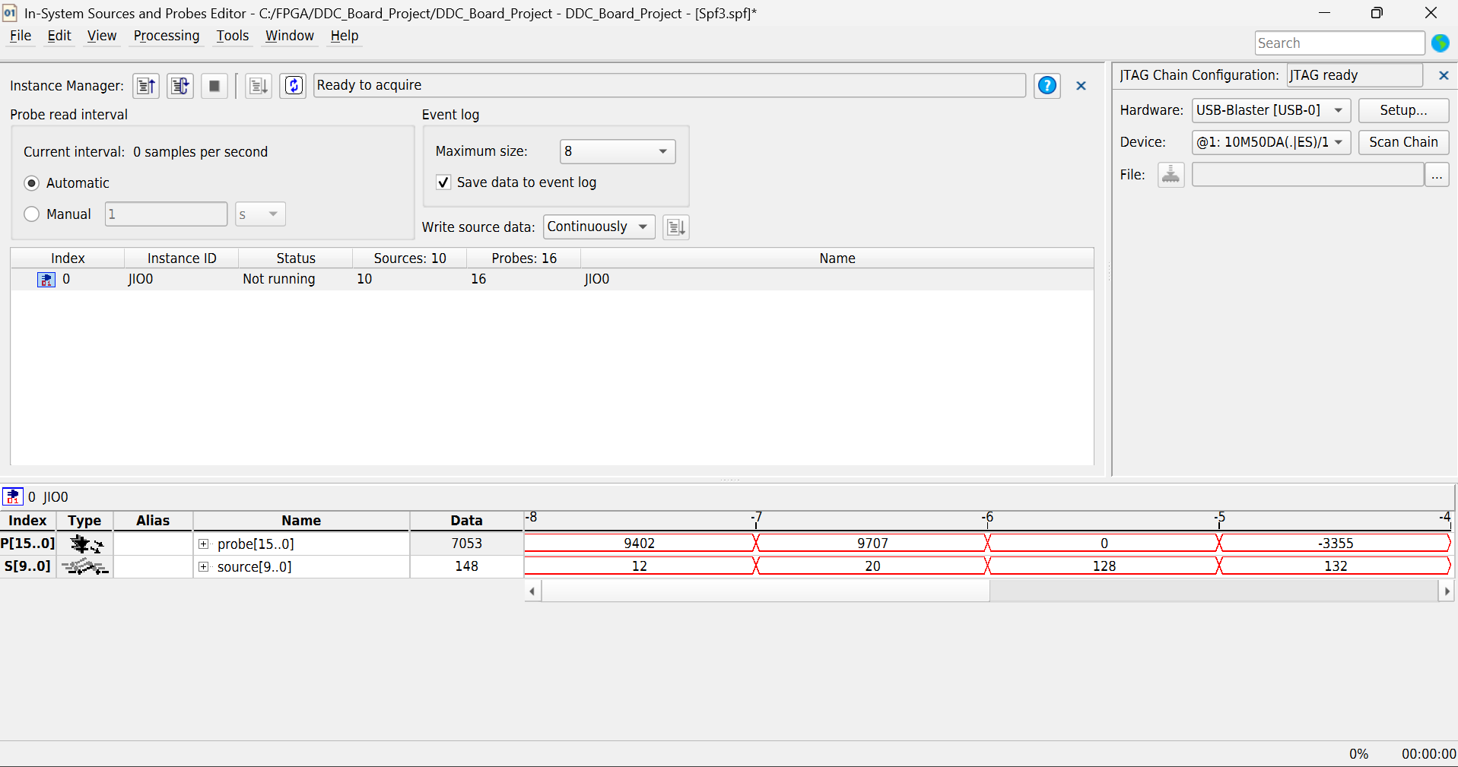
Figure 5. Intermediate I/Q mixer probe observation before filtering.
An intermediate mixer value verifies an arithmetic point in the chain and helps detect sign or scale mistakes. It cannot demonstrate rejection of the sum term because that term is still present at this stage. End-to-end verification therefore follows the mixer with the implemented filter, warm-up and capture schedule. This distinction prevents an internal debug observation from being overstated as a final baseband result.

5 FIR filtering and sequential implementation

5 1 FIR coefficients and normalisation
Both channels use the coefficient sequence 1, 2, 3, 4, 5, 4, 3, 2, 1. Its unnormalised sum is 25. The filtered sample is obtained by dividing the weighted history sum by 25. This gives unity DC gain in ideal arithmetic and uses the same coefficient set for I and Q. The symmetry also gives a linear phase response over frequencies where the response is nonzero.
y[n] = (x[n] + 2x[n−1] + 3x[n−2] + 4x[n−3]
+ 5x[n−4] + 4x[n−5] + 3x[n−6]
+ 2x[n−7] + x[n−8]) / 25
The history contains the current sample and eight preceding samples. Reset initialises this history, so the early output includes zero-filled positions. The capture does not treat these early values as settled data. After eight outputs have been discarded, the first retained value corresponds to a full nine-sample history. This warm-up decision follows directly from the filter length.
The small integer coefficients avoid general coefficient multipliers inside the FIR. Multiplication by two and four can use shifts. Multiplication by three and five can use a shifted value plus the original. However, low coefficient cost does not guarantee a short combinational path. Addition across the complete history and division can still exceed the board clock period if performed in one cycle.

5 2 Analytical frequency response
The coefficient sequence is the convolution of two five-sample rectangular sequences. This makes it possible to express the magnitude response directly. The denominator of 25 normalises the coefficient sum. At zero frequency the gain is one, while zeros occur at 20 kHz and 40 kHz for a 100 kHz input sample rate.
|H(f)| = |sin(5πf/Fₛ) / (5 sin(πf/Fₛ))|²
This response is an analytical property of the implemented coefficients. It is separate from the measured data. At 2 kHz, the predicted gain is approximately 0.9688, or −0.275 dB. An ideal half-amplitude mixer term of 6000 would therefore have a magnitude near 5813 counts. The measured mean magnitude was 5790.53 counts. The remaining sum-frequency component, quantised lookup values, and integer arithmetic mean that this ideal estimate is not an exact integer reference. After decimation, the residual sum component can fold into the same output band and combine with the wanted tone.
At 38 kHz, the analytical gain is approximately 0.00442, or −47.09 dB. At 40 kHz it is zero in ideal arithmetic. This is useful for the two test tones because the unwanted mixer terms lie close to a filter zero. It does not establish a complete anti-aliasing specification for arbitrary input signals.
The decimated stream has a 10 kHz Nyquist frequency. Signal content above that frequency can fold into the retained band. A practical receiver would need specified passband ripple, stopband attenuation, and transition width before selecting its coefficients. This project demonstrates the translation and capture mechanism with known tones. It does not claim general receiver performance.
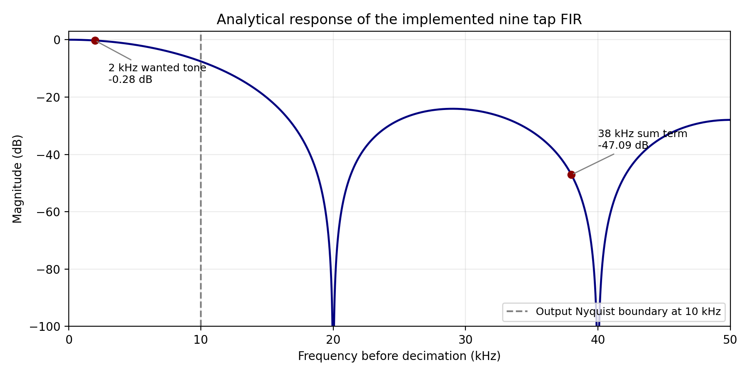
Figure 6. Calculated FIR magnitude response at the 100 kHz processing rate. This is a coefficient analysis rather than a measured frequency sweep.
Table 8. Analytical FIR gain at selected frequencies
Frequency | Analytical magnitude | Interpretation
0 Hz | 1.000000 | Unity DC gain
2 kHz | 0.968805 | Small loss at wanted tone
20 kHz | 0 in ideal arithmetic | Filter zero
38 kHz | 0.004418 | Strong attenuation of tested sum term
40 kHz | 0 in ideal arithmetic | Zero at equal-frequency sum term

The response values describe the coefficient sequence before integer effects. They explain the selection of a short triangular filter for this demonstration. The measured magnitude is considered against this response, but the response is not treated as an exact sample reference. Quantised input and oscillator values, arithmetic rounding and residual image components remain part of the actual implementation.

5 3 Why the first implementation failed timing
The first arithmetic structure placed too much work between registers. The timing analyser reported a worst board-clock setup slack of −78.960 ns for a 20 ns relationship. A circuit can fit in the available FPGA resources and still fail this check. Fitting establishes that the logic can be placed and routed. Setup analysis establishes whether the resulting path can meet the intended clock interval.
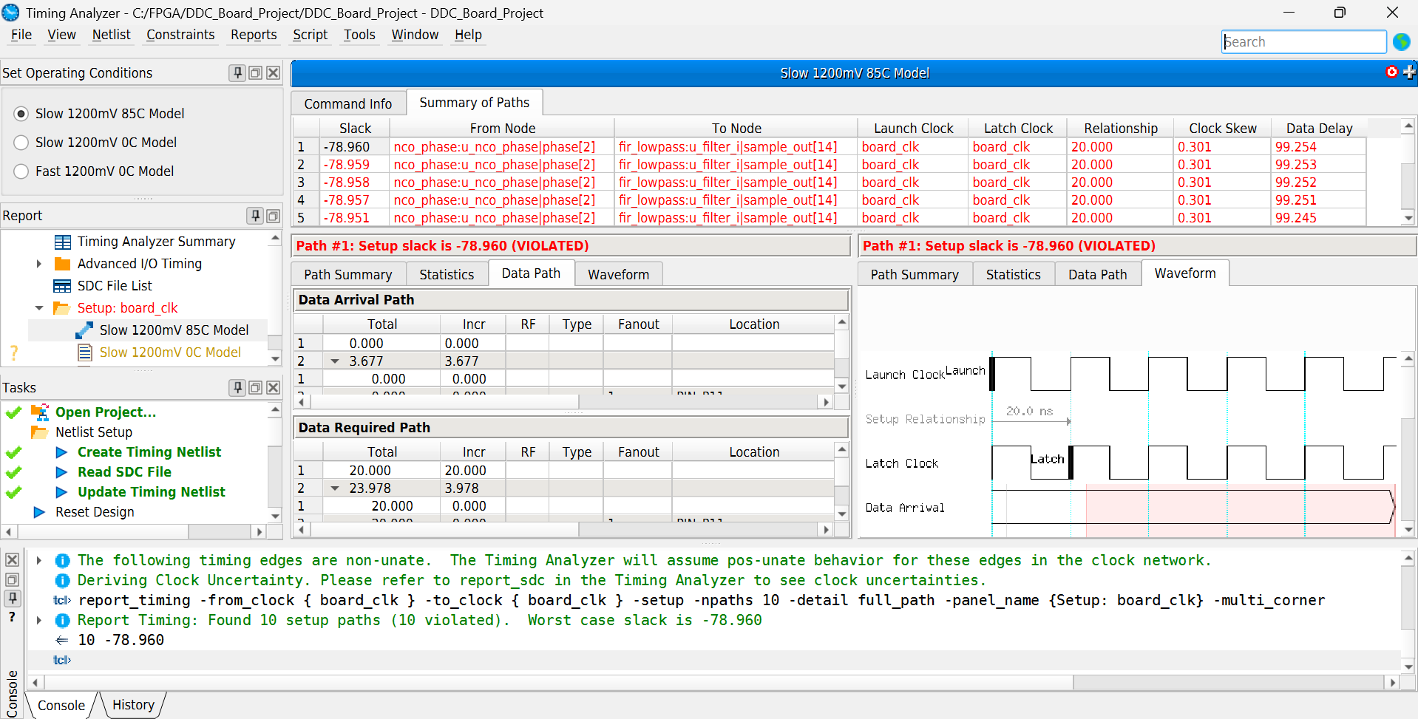
Figure 7. Detailed failing path from the earlier implementation with worst setup slack of −78.960 ns.
The detailed report showed a path from oscillator phase state towards a filter output, so the observed delay included more than an isolated coefficient operation. The engineering response was to introduce intermediate clocked work in the filter computation. The 50 MHz clock constraint was kept. The low sample rate already provided enough cycles to perform the arithmetic sequentially.

5 4 Sequential accumulation
The revised filter loads the new history and then visits the nine weighted samples across separate board-clock cycles. Each cycle contributes one weighted term to an accumulator. This replaces a large single-cycle arithmetic expression with a bounded operation and a registered partial result. A state counter identifies the tap being processed and determines when accumulation has finished.
Signed extension is required before the shifts and additions that form a weighted term. The accumulator must remain wide until all nine contributions have been included. Dividing each contribution separately would not be equivalent because truncation would occur nine times rather than once after the complete sum. The final structure preserves the intended weighted-sum definition by normalising after accumulation.
The last tap must be included before preparation of the division operands. In clocked Verilog, a nonblocking assignment updates a register after the procedural evaluation of that event. The state schedule therefore needs to account for when a newly calculated accumulator value becomes available. The output-valid comparison helps verify that the resulting filter sequence has the intended values rather than a missing final contribution or an old sum.

5 5 Division by twenty five
The normalising division was implemented as an iterative restoring divider. The signed sum is converted to a magnitude, the quotient is formed over 32 cycles, and the original sign is restored at completion. A fixed divisor of 25 makes the arithmetic repeatable. This implementation avoids requiring the entire division network to settle within one 20 ns cycle.
At each division step, the remainder is shifted and the next dividend bit is introduced. A comparison determines whether the divisor can be subtracted. The corresponding quotient bit records that decision. Repeating the operation for all dividend bits produces the integer magnitude quotient. Sign restoration yields division that truncates towards zero, matching the stated filter arithmetic.
For a negative sum whose magnitude is not divisible by 25, the fractional portion is discarded before the negative sign is restored. This is different from the mixer’s arithmetic shift convention. The distinction is small in amplitude but relevant to bit-exact output. It is retained in the testbench rather than hidden by an arbitrary floating-point tolerance.

5 6 Filter schedule and throughput
Table 9. Sequential FIR operation schedule
State operation | Work | Board clock cycles
Input loading | Accept sample and update history | Loading event
SUM | Accumulate nine coefficients | 9
PREP | Prepare sign and magnitude | 1
DIVIDE | Iterative quotient generation | 32
FINISH | Register result and assert valid | 1

The filter uses a signed 32-bit accumulator. For an input magnitude bounded by 12000, the sum of positive coefficient weights bounds the magnitude of the unnormalised result near 300000 counts. This is comfortably within the accumulator range. The divider remainder uses six bits. Before a division step its value is below 25, so shifting it and introducing one new bit gives a trial remainder no larger than 49. Subtracting 25 when needed restores the invariant that the remainder is below the divisor. These width choices support the implemented iterative arithmetic.
The 43-cycle arithmetic completion time is much shorter than the 500-cycle input interval. Approximately 457 cycles remain before the next sample loading opportunity. This is a throughput argument, not a claim that the filter has no delay. The arithmetic delay is 0.86 µs, while the coefficient sequence contributes a four-sample group delay of 40 µs. The two delays describe different features of the implementation.
I and Q use the same state schedule and common sample enable. The capture accepts only completed pairs. This makes a change in filter execution latency manageable because downstream logic follows the valid indication instead of assuming an immediate result at the input tick. The approach also provides a clear interface if a more selective filter is introduced later.

6 Decimation capture and register control

6 1 Decimation schedule
The FIR produces a completed I/Q pair at the input processing rate. The decimator retains one pair in every five after warm-up. This is a selection of filtered samples, not an averaging operation and not a change to the board clock. The retained rate is 100 ksample/s divided by five, giving 20 kpair/s.
The first eight completed filter outputs are discarded. The retained output indices are 8, 13, 18, 23 and so on. For stored address a, the selected input-rate filtered index is 8 + 5a. The final stored address is 15 and corresponds to filtered index 83. These indices are part of the experiment definition because selecting a different first index would change phase and could change the exact stored arrays.
Filtering precedes selection because high-frequency content must be suppressed before reducing the rate. The output Nyquist frequency becomes 10 kHz. Components above this boundary can alias after decimation. For the selected tones, the sum terms are at 38 and 40 kHz, where the filter has low gain or a zero. This suitability for two known components does not define a broadband anti-aliasing specification.

6 2 Capture memory and completion
The design stores sixteen signed 16-bit I samples and sixteen signed 16-bit Q samples. The useful storage requirement is 16 × 2 × 16 = 512 bits. Quartus implements this storage in one M9K block. Although only 512 bits hold sample data, the physical allocation occupies a complete 9216-bit block.
After the final pair is stored, capture_done is asserted and further sampling is disabled. The memory remains available for PC readout. Reset clears the processing and capture state, but does not clear the sample memory. A new readout must therefore follow a completed capture to avoid interpreting old memory contents as new data.
Each address represents one paired acquisition instant. Separate signed I and Q words are stored for that address. The write address advances only when a retained pair is accepted. Once sixteen pairs have been stored, the done condition prevents further sampling. This avoids overwriting the record while the PC reads it in a much slower sequence.
The finite buffer is adequate for a controlled demonstration. It also makes the transfer deterministic because every readout contains the same number of records. Continuous streaming would need a different architecture, such as a deeper FIFO and a transport that can maintain the required average throughput. The present design does not claim that capability.

6 3 Register bit allocation
The PC writes the 10-bit JTAG source bus to control the application. The register combines acquisition control with memory-read selection. The 16-bit probe returns one selected sample at a time. Intel documents the source and probe Tcl interface used for this exchange [2].
LEDR0 indicates capture completion. LEDR[4:1] display the four-bit write address, and the remaining LEDs are held low. Once acquisition has completed, changing the read address or channel selection changes the probe value without altering the stored samples.
Table 10. Control register bit allocation
Bits | Field | Meaning
0 | Run enable | 1 enables sampling until capture completes
1 | Reset | 1 clears processing and capture state
5 to 2 | Read address | Selects pair 0 through 15
6 | LO selection | 0 selects 18 kHz and 1 selects 20 kHz
7 | Channel selection | 0 selects I and 1 selects Q
9 to 8 | Unused | Written as zero

The interface is register based in the sense that the PC controls a defined collection of stored source bits and observes a selected data word. It is a single source register with bit fields rather than a processor-style memory-mapped peripheral with multiple addresses. Read-address selection is part of the source register. This distinction matters when describing what was implemented.
Reserved bits 9 and 8 are not assigned an application function. Keeping them zero avoids introducing undocumented control states. Bit 6 selects the LO and bit 7 selects Q instead of I. The read-address field occupies bits 5 through 2. Reset and run occupy the two least significant bits, so changing memory selection must preserve the other fields intentionally.

6 4 Acquisition protocol
For each test, the selected oscillator setting was applied with reset asserted. Reset was then released and run enable was asserted. After capture completion, the PC selected each address and read I followed by Q. A fresh acquisition used reset before restarting, including when changing the oscillator frequency.
Table 11. Acquisition and readout control words
Operation | 18 kHz LO | 20 kHz LO
Assert reset | 0x002 | 0x042
Release reset and run | 0x001 | 0x041
Read I at address a | a shifted left by 2 | 0x040 OR (a shifted left by 2)
Read Q at address a | 0x080 OR (a shifted left by 2) | 0x0C0 OR (a shifted left by 2)

Applying reset with the oscillator field already selected ensures that each case begins with the intended mode. Reset is then released before enabling acquisition. After completion, the same LO field is kept while the read address and channel are changed. The stored samples are stable because acquisition has stopped. A new case requires a new reset and completed capture.
Reading before completion can return old or incomplete memory data. Reset clears state but does not erase the array. This behaviour reduces unnecessary memory reset logic, but it places a clear condition on host readout. The saved record must come from a completed acquisition. The LED done indication and the control sequence provide a practical means of observing this condition in the demonstration.

6 5 Relative time axis
The first eight filtered outputs contain a partially filled history after reset and are discarded. The retained input-rate output indices are 8 + 5a, where a ranges from 0 to 15. The final retained output is index 83. Sixteen pairs span fifteen output intervals, so the first-to-last duration is 750 microseconds. The record contains 800 microseconds of sample slots, but the elapsed time between its first and last plotted point is 750 microseconds.
t[a] = a × 50 µs, a = 0, 1, …, 15
The time column is defined by the FPGA sampling schedule. Address zero is assigned relative time zero and address fifteen is assigned 750 µs. This convention removes the fixed warm-up and filter delays from the displayed origin. It is suitable for frequency estimation from the retained sequence, but it is not an absolute timestamp for the first input sample after a PC command.
A sixteen-pair record contains sixteen sample positions but only fifteen intervals between its first and last points. Using 800 µs in the endpoint phase formula would therefore give the wrong estimate. The elapsed time used for that estimate is 15 × 50 µs. This distinction is also necessary when reporting how many periods are visible in the graph.

7 JTAG transfer and PC processing

7 1 Source and probe integration
The In-System Sources and Probes IP was generated as jtag_control. The final configuration used a 10-bit source and a 16-bit probe with instance identifier JIO0. The source clock input was connected to MAX10_CLK1_50. This source bus became the application control register, while the probe bus returned the selected captured sample. The generated synthesis file jtag_control\synthesis\jtag_control.qip was included in Quartus.
Initial source writes and probe reads were checked in the In-System Sources and Probes Editor. Counter and sample-generation checks followed, allowing the clocked logic to be verified before the mixer and filters were integrated. Probe readings were interpreted using the appropriate signed or unsigned radix for the quantity being tested.
The source bus carries commands from the PC, while the probe returns the selected sample. Each write supplies the complete control word, including fields that are not being changed. For example, selecting Q for another address must retain the oscillator bit and leave reset cleared after capture. The single-register layout makes this operation simple, but the host still needs to compose the fields deliberately. The source clock connects the register output to the board clock used by the controlled application.
The IP synthesis QIP is part of the compiled design. The template only shows the required port connections. During development the configuration changed to include source_clk, so the generated port description was checked before integration. Using the final generated definition avoids relying on an earlier template with different ports or widths.

7 2 Hardware and instance discovery
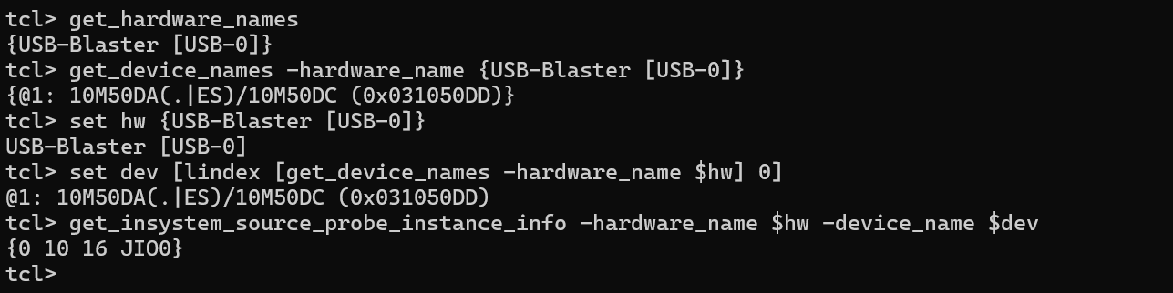
Figure 8. Successful Tcl instance discovery identifying JIO0 with a 10 bit source and a 16 bit probe.
The interactive quartus_stp session first queries the attached programming hardware and then the FPGA device. This avoids assuming that a USB port name will be identical on another PC. The detected instance at index zero had the widths expected by the application. Discovery therefore checked both the physical connection and the register interface in the programmed design.
The JTAG path provides sufficient access for a short stored record without extra hardware. It should not be interpreted as a general high-speed sample streaming interface. Its useful role here is to set operating conditions, initiate a capture and retrieve stable results. The acquisition rate remains defined by the FPGA even if the host reads the buffer slowly.

7 3 Automated sample readout
The interactive quartus_stp shell was launched from C:\altera_lite\25.1std\quartus\bin64. The connected USB-Blaster hardware and FPGA device were enumerated rather than assuming a fixed device name. Instance discovery returned index 0, a 10-bit source, a 16-bit probe, and identifier JIO0.
A source-and-probe session was opened, the acquisition control value was written, and sufficient time was allowed for capture. The readout loop visited all sixteen addresses. It used write_source_data and read_probe_data with hexadecimal values. Each probe result was converted to an integer. Values at or above 32768 were reduced by 65536 to recover their signed two’s-complement interpretation. The session was closed after readout.
The CSV columns were sample, time_us, I, and Q. Time was assigned from the FPGA output interval as sample × 50 microseconds. These timestamps describe the stored sequence, not host-side read delays. Automating the loop reduced repetitive manual probe reads and produced files that could be processed directly in Python.
For each stored address, the host writes a source word that selects I and reads the probe. It then sets the channel bit and reads Q for the same address. The loop advances after both words have been obtained. The pair is written as one CSV row. This ordering preserves the relationship between channels and makes an address-selection mistake easier to detect during comparison.
A host delay used to allow completion belongs to the command sequence, not to the waveform time axis. The total acquisition is short compared with manual operation or USB readout. Once the buffer is complete, additional read delays do not change the data. This separation explains why assigning time from the PC arrival time of each word would be incorrect.
Automated readout also removes repeated manual radix and address changes. Manual probe observations were useful during development, but they are a weaker record for a sixteen-pair comparison. CSV provides a complete sequence that can be reloaded, plotted and compared with simulation without repeating the hardware acquisition.

7 4 Register readout examples
Table 12. Read address and channel selection examples
Address | 18 kHz I | 18 kHz Q | 20 kHz I | 20 kHz Q
0 | 0x000 | 0x080 | 0x040 | 0x0C0
1 | 0x004 | 0x084 | 0x044 | 0x0C4
15 | 0x03C | 0x0BC | 0x07C | 0x0FC

These example words select stored data after acquisition, with run and reset cleared. The address is shifted left by two. Q selection adds bit 7, and the 20 kHz mode adds bit 6. Keeping the hexadecimal representation explicit helps check that a field has not been placed in the wrong bit position. The table describes the defined register map and is not a new set of hardware test cases.

7 5 CSV records and provenance
Table 13. Measured and simulated datasets
Dataset | Filename | Contents
Hardware 18 kHz LO | DDC_18kHz_1791116258309.csv | 16 measured I/Q pairs
Hardware 20 kHz LO | DDC_20kHz_1791117450737.csv | 16 measured I/Q pairs
RTL 18 kHz LO | SIM_DDC_18kHz.csv | 16 simulated I/Q pairs
RTL 20 kHz LO | SIM_DDC_20kHz.csv | 16 simulated I/Q pairs

All four files use the fields sample, time_us, I and Q. Sample is an integer index from zero through fifteen. Time increases by 50 µs. The channel fields are signed decimal integers. These conventions allow the comparison to check alignment before calculating numerical differences. Comparing two arrays without first checking their index and time fields could hide an offset or an incomplete file.
The hardware files originated from the programmed board. The simulation files originated from the testbench. Their agreement is meaningful because they share an explicitly defined input, reset and capture schedule. The comparison does not replace the need to state how each dataset was obtained. Saved hardware records remain valid evidence when the subsequent simulator runs without a connected FPGA.

7 6 Python processing method
Python loads the CSV columns and forms the complex sequence z = I + jQ. The magnitude is sqrt(I² + Q²), and phase is atan2(Q, I). Phase is unwrapped before estimating its change over the record. Matplotlib plots I and Q against relative sample time and overlays simulation with hardware when both datasets are available.
The channel values are converted to a numerical type suitable for calculation before squaring or subtraction. This avoids accidental narrow-integer overflow in host calculations. The mean complex magnitude is a count-based amplitude statistic. It is not a calibrated voltage because no analogue scale or ADC transfer function is used in the experiment.
A short record makes phase-based estimation more useful than a coarse FFT peak for this case. Sixteen samples at 20 kHz give nominal FFT bin spacing of 1250 Hz. A 2 kHz tone lies between those bins. The endpoint phase method uses the known complex rotation and the correct 750 µs first-to-last interval. It remains an estimate based on the nominal FPGA clock, not an independent frequency calibration.

8 Hardware results and interpretation

8 1 Hardware test conditions
Two captures were taken from the programmed DE10-Lite with the internal input fixed at 20 kHz. For the 18 kHz oscillator, I and Q varied periodically and the sequence repeated after ten stored samples, corresponding to a 500 microsecond period. For the 20 kHz oscillator, all sixteen I samples were 5999 and all sixteen Q samples were zero. The latter is the expected DC output when input and oscillator frequencies match.
The hardware captures were saved as DDC_18kHz_1791116258309.csv and DDC_20kHz_1791117450737.csv. Python loaded these files, plotted I and Q against their relative sample times, and compared the oscillator settings. The plotted interval ran from 0 to 750 microseconds, covering the sixteen stored pairs.
The input sequence was kept unchanged between cases. Only the oscillator setting was changed, with reset applied before each acquisition. This isolates frequency selection as the intended experimental variable. Both records used the same FIR, warm-up interval, decimation factor and sixteen-pair storage. Differences between the outputs can therefore be interpreted against the expected mixer difference frequency.

8 2 Eighteen kilohertz oscillator result
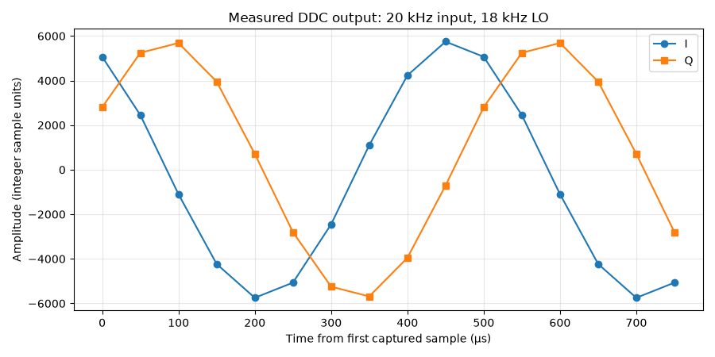
Figure 9. Measured DDC I and Q for the 20 kHz input and 18 kHz local oscillator.
The channels vary with a period of ten stored pairs. Ten intervals at 50 µs give a period of 500 µs and a frequency of 2 kHz. The two channels follow the expected quadrature progression. Their exact initial values depend on the oscillator phase, filter history and first retained output index, so a nonzero first Q value is consistent with the capture definition.
The plotted points are the stored measurements. Lines join them to make the progression easier to read. They are not extra observations between addresses. With ten samples per cycle, the visible shape is sufficiently resolved to demonstrate the expected periodic behaviour, but it is not a dense analogue waveform measurement.

8 3 Twenty kilohertz oscillator result
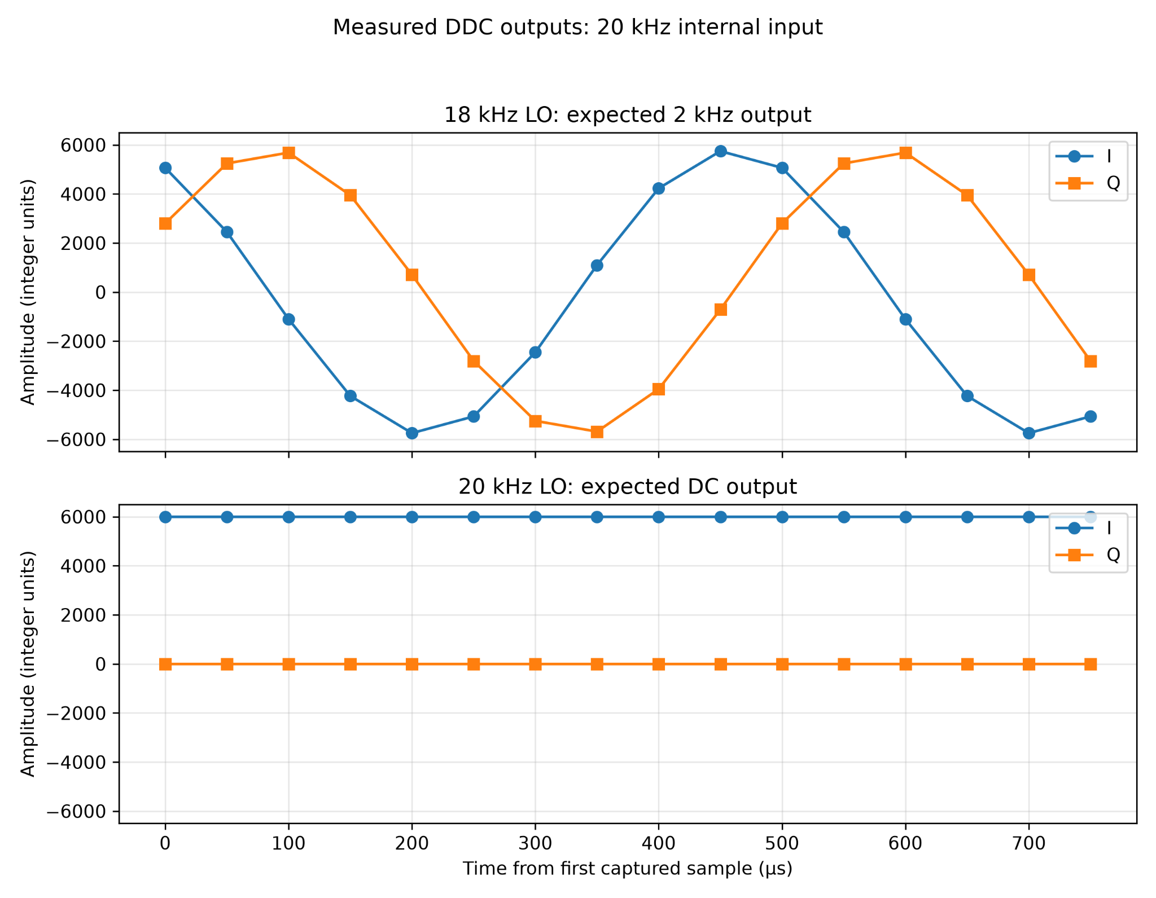
Figure 10. Measured output comparison for both local oscillator settings.
With equal input and oscillator frequency, the difference term is zero frequency. Every retained I sample is 5999 and every Q sample is zero. The approximately half-input amplitude follows from real cosine mixing. The filter has unity DC gain, so no attenuation is expected for the settled wanted component. The sum component at 40 kHz coincides with an ideal filter zero.
The result provides a useful check of settled-state behaviour as well as frequency translation. A changing output in this case could indicate a phase or frequency mismatch, an incomplete warm-up or a readout error. The constant recorded values agree with the intended equal-frequency operating condition. They do not by themselves quantify rejection of unrelated input frequencies.

8 4 Complete recorded sample values
Table 14. Complete measured output for the 18 kHz LO
Pair | Time µs | I at 18 kHz LO | Q at 18 kHz LO
0 | 0 | 5066 | 2803
1 | 50 | 2451 | 5246
2 | 100 | -1101 | 5685
3 | 150 | -4232 | 3952
4 | 200 | -5747 | 709
5 | 250 | -5067 | -2804
6 | 300 | -2452 | -5247
7 | 350 | 1100 | -5686
8 | 400 | 4231 | -3953
9 | 450 | 5746 | -710
10 | 500 | 5066 | 2803
11 | 550 | 2451 | 5246
12 | 600 | -1101 | 5685
13 | 650 | -4232 | 3952
14 | 700 | -5747 | 709
15 | 750 | -5067 | -2804

The table gives all sixteen retained pairs for the varying case. Pairs zero through five repeat at pairs ten through fifteen with the same integers. The full comparison found the same values in RTL. For the 20 kHz LO record, all sixteen rows contain I = 5999 and Q = 0 at the same sample times.

8 5 Frequency and magnitude analysis
The analysis formed the complex sequence z = I + jQ. NumPy calculated its magnitude and unwrapped phase. The output frequency was estimated from the phase change between the first and last pair divided by 2π times the elapsed sample interval. This method avoided trying to resolve a 2 kHz tone using a very short FFT record.
The nonzero means in the 18 kHz capture are consistent with the short observation window. The first-to-last interval contains 1.5 output cycles, so the sample means need not be zero. They are not sufficient evidence of a DC-offset fault. The frequency estimates assume the designed 20 kHz output rate. No independent clock-frequency calibration was performed.
Table 15. Hardware output statistics
LO | Frequency estimate | Mean magnitude | Mean I | Mean Q
18 kHz | 2000.01 Hz | 5790.53 | -539.69 | 974.12
20 kHz | 0.00 Hz | 5999.00 | 5999.00 | 0.00

For the varying output, the phase advances by approximately 0.2π radians per stored pair. Across fifteen intervals this gives approximately 3π radians. Dividing by 2π and 750 µs yields about 2000 Hz. The calculated value of 2000.01 Hz is consistent with the nominal translation. Its small difference from 2000 Hz reflects the finite integer record and should not be interpreted as a measured oscillator tolerance.
The mean magnitude of 5790.53 counts is below the unfiltered ideal baseband amplitude of 6000. The analytical filter gain at 2 kHz predicts about 5812.83 counts for an ideal sinusoidal difference term. The remaining discrepancy is not assigned to a single cause. Quantisation, integer rounding and the residual sum term all affect the implemented result.

8 6 Aliasing and the residual image
After decimation, frequency components separated by multiples of 20 kHz become indistinguishable in the retained sequence. The unwanted 38 kHz mixer term can therefore fold into the same output region as the wanted 2 kHz term. Its amplitude is small because the FIR gain at 38 kHz is approximately 0.004418. It can nevertheless combine with the wanted component and influence magnitude and phase.
This explains why an ideal wanted-tone gain calculation is useful but not a bit-exact prediction of the measured record. A stronger anti-alias filter would reduce that residual contribution. The equal-frequency case is especially favourable because the 40 kHz image falls exactly on a filter zero in ideal arithmetic. Both conditions should be considered when assessing the apparent quality of the two demonstrations.
A 10 kHz output Nyquist boundary does not mean that this filter rejects all frequencies above 10 kHz adequately. Its attenuation is frequency dependent. A receiver specification would need a defined wanted band and a required stopband level. The present experiment uses known tones near useful filter zeros and therefore demonstrates the mechanism within a restricted signal set.

8 7 Short record limitations
The sixteen-pair capture is sufficient to show periodicity and an exact regression comparison. It limits the conclusions that can be drawn about spectral purity, spurious-free dynamic range and long-term frequency stability. None of those quantities was measured. The observation window covers only 1.5 periods between the first and last points for the 2 kHz output.
A nonzero sample mean in that record is not evidence of a DC-offset fault. Averaging a non-integer number of cycles depends on starting phase and end point. The reported means of −539.69 in I and 974.12 in Q must be interpreted in that context. A longer integer-cycle record would be appropriate for a dedicated offset assessment, but it is not required to support the completed translation tests.

9 RTL simulation and hardware comparison

9 1 Simulation purpose and model boundary
Questa Altera FPGA Starter Edition 2025.2 was used for RTL simulation after the hardware captures had been recorded. The testbench instantiated the six processing modules with the same 50 MHz clock, reset behaviour, oscillator phase steps, and sample-enable interval. It reproduced the capture selection by discarding eight outputs and retaining every fifth result until sixteen I/Q pairs were obtained for each case.
The expected values in the testbench were the previously measured hardware pairs. Each simulated pair was checked against those integers using exact comparisons. This is a regression comparison with hardware measurements, rather than a new independent analogue measurement. It tests the processing chain and reproduced capture sequence. The JTAG IP, complete board top-level module, and physical USB transfer were not simulated.
The modules were compiled into a dedicated simulation library using vlog. The testbench was loaded with vsim, waveform signals were added, and run -all executed both cases. This follows the compile, elaborate, and run sequence described in the Questa quick-start guide [3]. Compilation reported zero errors and zero warnings. An optimisation warning during loading related to signal visibility with +acc and did not prevent the test from completing.
The Transcript reported that all sixteen pairs matched for each oscillator setting and that all thirty-two pairs matched overall. The final $stop was intentional, allowing the waveforms to remain visible. A timeout in the testbench would instead have stopped a capture that failed to complete.
The FPGA was disconnected while the testbench ran. This is valid because RTL simulation executes on the PC. The hardware comparison used saved data acquired earlier while the board was connected. The successful simulation does not imply that a new hardware capture took place during this run.

9 2 Testbench stimulus and capture schedule
The testbench drives a 50 MHz clock and applies reset before each oscillator case. It selects phase step 18 or 20 and enables the sample generator. The six processing modules are the sample tick, internal test source, phase accumulator, sine and cosine lookup, mixer and FIR implementation. The capture selection is reproduced in the testbench using the same warm-up and decimation rule.
Each completed filtered pair is checked for aligned valid signals. The first eight are ignored, and one in every five thereafter is retained until sixteen pairs have been obtained. Each retained pair is compared against the saved hardware expectations. This sequence checks numerical values and the sample-selection pattern, rather than merely waiting for a waveform to look plausible.
A global timeout of 2.5 ms catches a run that does not complete. It covers both oscillator acquisitions. The final stop is intentional after the comparisons have finished. This distinction is important when reading the transcript because a stop command does not necessarily mean the experiment failed. The PASS messages and the completed counts provide the result.

9 3 Simulation evidence
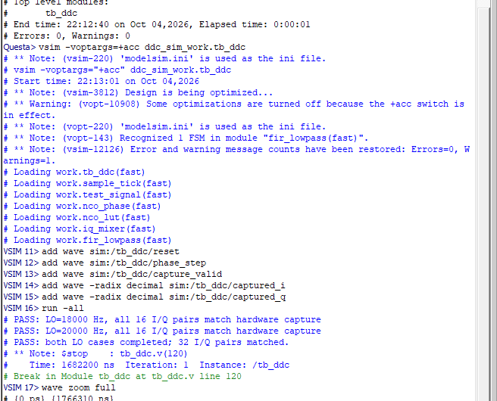
Figure 11. Enlarged original transcript showing the successful comparisons and intentional final stop.
The transcript is direct evidence of the executed testbench. Compilation reported zero errors and zero warnings. Loading with additional signal visibility produced an optimisation warning, but the test completed. The three result messages correspond to sixteen matching pairs for each setting and thirty-two matching pairs in total. The final stop time was 1682200 ns.

9 4 Waveform interpretation
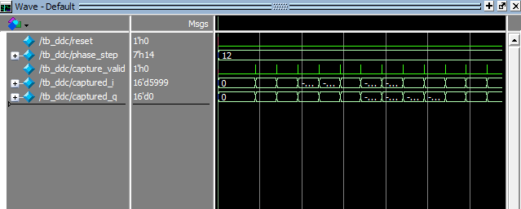
Figure 12. Enlarged original waveform detail from the completed run.
The final displayed state belongs to the 20 kHz oscillator case. The phase-step value is 20, the retained I result is 5999 and Q is zero. The earlier portion of the run contains the varying 18 kHz LO case. The waveform view should therefore be interpreted with the stimulus change and transcript rather than assuming that all visible values belong to one acquisition.
Waveform observation complements the integer checks. It can show reset sequencing and the valid pulses that precede capture. It is less precise than comparing every exported word when judging equality. The numerical comparisons establish the exact retained values, while the waveforms help explain how those values appear over the simulated execution.

9 5 Exported hardware and simulation comparison
The testbench exported SIM_DDC_18kHz.csv and SIM_DDC_20kHz.csv. The Python comparison checked the sample counts, indices, and timestamps before comparing I and Q values. Both files contained sixteen pairs, with times from 0 to 750 microseconds in 50 microsecond increments. The maximum absolute sample difference was zero for I and Q in both cases.
For the 18 kHz oscillator, the comparison shows the expected varying quadrature outputs. For the 20 kHz oscillator, both datasets show the same constant I value and zero Q. Straight lines connect discrete samples to aid readability. They do not represent extra measured samples between the stored points.
The comparison supports exact agreement for the tested reset conditions, input sequence, and oscillator settings. Chapter 8 gives the retained sample values so that this result can be checked without relying solely on the plot.
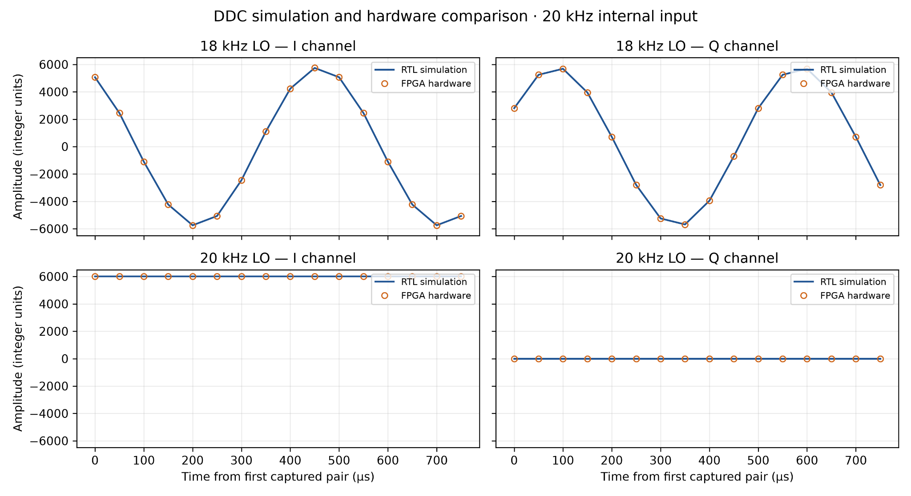
Figure 13. Simulation and hardware I/Q samples overlaid for both oscillator settings.
Table 16. Sample comparison error
LO setting | Pairs | Maximum I difference | Maximum Q difference
18 kHz | 16 | 0 | 0
20 kHz | 16 | 0 | 0

The four source records were aligned by sample number and time before subtraction. Every I difference and every Q difference was zero. This establishes equality of all sixty-four channel values across the thirty-two paired records. The plotted curves overlap because of that equality, not because a tolerance or visual fit was applied.

9 6 Meaning and limits of exact agreement
The hardware arrays in the testbench are measured expectations. They are not an independently derived exhaustive specification of the DDC. A passing regression shows that the processing RTL and reproduced capture schedule generate the recorded hardware values for the two conditions. It does not prove all input amplitudes, arbitrary phase steps or a complete register interface.
The ideal mixer identities provide a separate check of the expected physical behaviour. The nominal rate calculations predict a 2 kHz output for one case and DC for the other. Static timing provides another form of evidence about the fitted circuit. Together these checks support the completed demonstration more strongly than any one result alone, while remaining limited to the implemented scope.
The FPGA was disconnected during simulation because Questa executes the RTL model on the PC. No live JTAG transfer occurs in that run. The connection had already been established by hardware register access and saved CSV output. The report therefore separates communication evidence from processing simulation instead of implying that the simulator exercised the physical USB connection.

10 Timing closure and resource analysis

10 1 Timing acceptance criterion
The DDC was developed incrementally. Following the LED and JTAG checks, the sample counter, input generator, and oscillator were checked before the mixer and filters were combined. The capture memory and rate reduction were then added, followed by automated PC readout. This sequence helped separate communication problems from numerical or timing problems.
An earlier FIR implementation attempted to complete too much arithmetic in one board-clock cycle. Quartus reported a worst-case board-clock setup slack of -78.960 ns, so the circuit did not meet the specified 20 ns clock period. The filter was rewritten as the sequential implementation described in Chapter 5. This shortened the work required in each clock cycle while preserving the coefficient values and output arithmetic. The correction used the available interval between samples rather than relaxing the board-clock constraint.
The final design, including decimation and capture, was compiled and programmed. The resource report showed 1571 logic elements and 721 dedicated logic registers. The earlier combinational filter result was not treated as the final implementation. Final resource evidence is included in this chapter.
Setup slack is the difference between the available timing requirement and the data arrival condition after the analyser accounts for the relevant clock relationship and uncertainty. Negative slack indicates a violation. A successful fit with negative slack is not an acceptable final operating result at the stated clock frequency. The initial −78.960 ns result therefore required a design change.

10 2 Structural correction and recompilation
The correction used the 500 board-clock cycles available between input samples. Serial accumulation and iterative division introduced registered intermediate state without changing the nominal sample rate. This is an example of trading arithmetic parallelism for time within an existing sample interval. It addressed the actual critical-path problem while retaining the coefficient sequence and integer normalisation.
Table 17. Implementation stages before and after timing correction
Implementation stage | Logic elements | Dedicated registers | Worst board setup slack ns
Earlier combinational filter | 2237 | 499 | −78.960
Sequential intermediate build | 1554 | 718 | 1.610
Final capture implementation | 1571 | 721 | 2.453

The intermediate sequential result and final result are distinguished because further capture integration changes the fitted circuit. Resource and slack values are taken from the corresponding builds. They should not be combined into a fictional best-case design. The final figures used for acceptance are 1571 logic elements, 721 dedicated logic registers and 2.453 ns setup slack.
A structural arithmetic change can also change latency or rounding. The revised hardware therefore needed a targeted functional check before the final capture. Once the final arrays and RTL comparison agreed, repeating unchanged setup tests was unnecessary. The accepted evidence concerns the completed sequential implementation rather than the earlier failing circuit.

10 3 Final multicorner timing
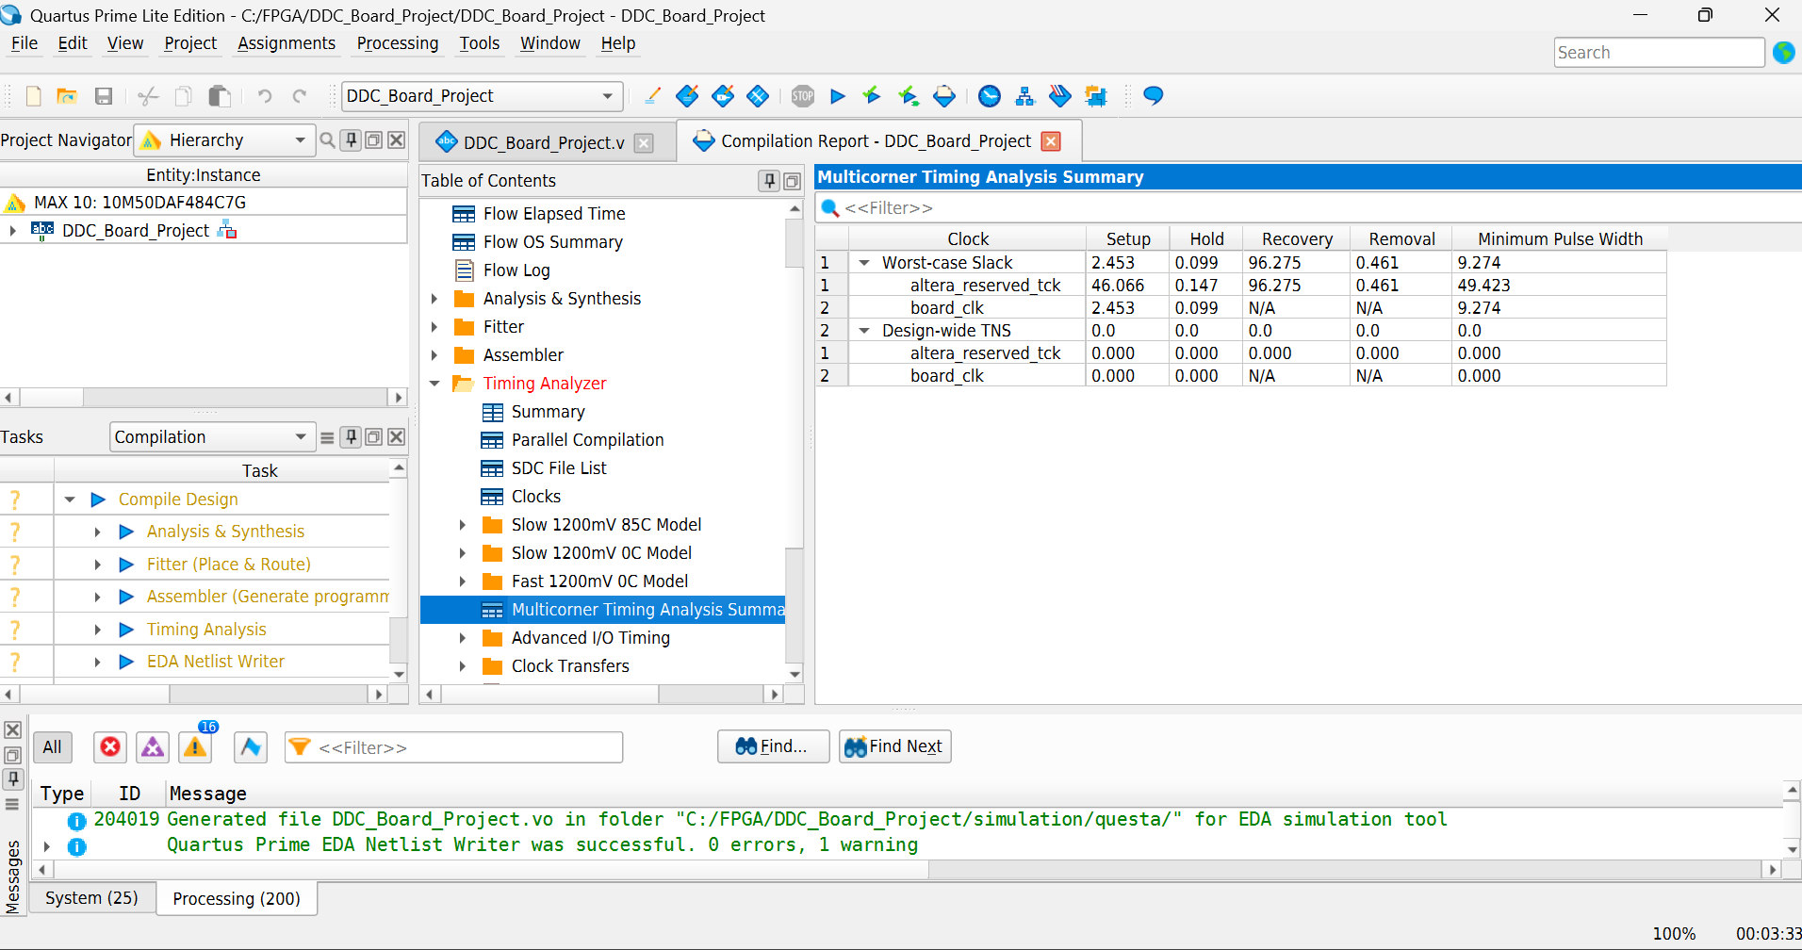
Figure 14. Final Quartus multicorner timing summary for the completed design.
Table 18. Final reported timing slack
Clock | Setup ns | Hold ns | Pulse width ns
board_clk | 2.453 | 0.099 | 9.274
altera_reserved_tck | 46.066 | 0.147 | 49.423

The multicorner summary reported zero total negative slack for all applicable checks shown. JTAG recovery and removal slack were 96.275 ns and 0.461 ns. Recovery and removal were listed as not applicable for board_clk. These results support operation of the analysed synchronous paths at the specified 50 MHz board-clock frequency. They do not replace a separate review of unconstrained paths or external interface timing.
The board-clock hold slack is positive but small at 0.099 ns. It is reported as passing under the analysed conditions. The setup and pulse-width results are also positive. The JTAG clock has separate reported checks because the debug interface is included in the fitted design. Recovery and removal checks are applicable there and were positive in the final summary.
These conclusions apply to the constraints and timing checks represented in the report. They do not prove that every external interface path is constrained. No independent review of complete I/O timing coverage is claimed. The important result for the processing demonstrator is that the reported final board-clock paths meet the specified 50 MHz relationship after the FIR correction.

10 4 Final resource evidence
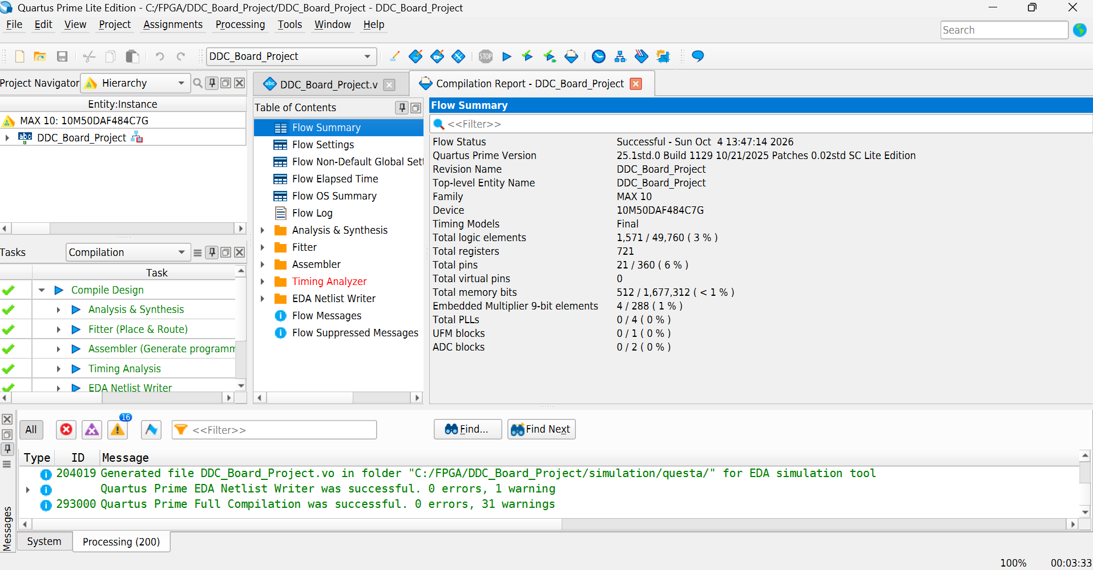
Figure 15. Final Quartus flow summary with the fitted logic, register, memory, multiplier and pin counts.
Table 19. Final FPGA resource utilisation
Resource | Used | Available | Utilisation
Logic elements | 1571 | 49760 | 3.16%
Dedicated logic registers | 721 | 49760 logic register capacity | 1.45%
M9K memory blocks | 1 | 182 | 0.55%
Embedded multiplier 9 bit elements | 4 | 288 | 1.39%
Pins | 21 | 360 | 5.83%
PLLs | 0 | Available but unused | 0
ADC blocks | 0 | Available but unused | 0
User flash memory | 0 | Available but unused | 0

The dedicated logic register count is 721 out of 49760, giving 1.45%. Quartus also reports a total-register capacity of 51509 because that category includes 1749 I/O registers. No I/O registers were used. The same count of 721 therefore appears under both categories, but their percentages use different denominators. The table reports the dedicated logic category consistently.

10 5 Memory and multiplier interpretation
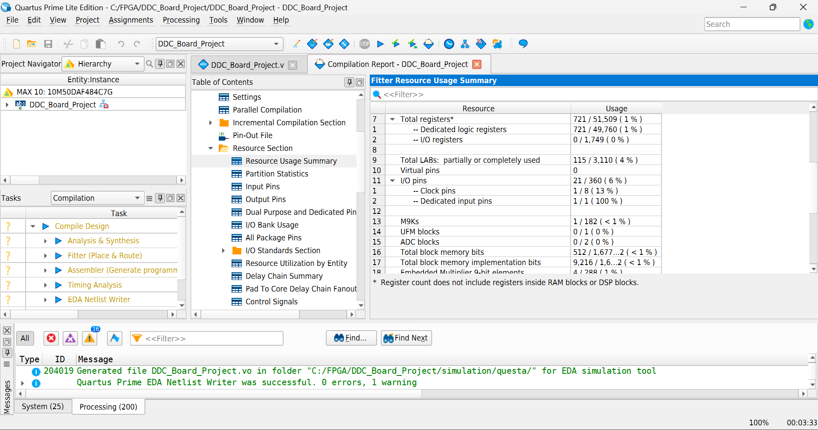
Figure 16. Detailed fitted resources showing dedicated registers, I/O registers, one M9K block and the distinction between useful and implemented memory bits.
The useful capture storage is 512 bits, but the FPGA allocates a physical M9K block of 9216 bits. The useful payload occupies about 5.56% of that block. This does not mean that 512 bits consume 5.56% of the device memory. At device level the relevant allocation is one of 182 blocks. Both the payload requirement and physical allocation are useful, but they answer different questions.
Quartus reports four embedded multiplier 9-bit elements for the fitted design. This is a device resource reporting unit rather than a count of four independent application mixer channels. The application has two signed products, one for I and one for Q. Mapping those products into embedded hardware depends on the device multiplier structure and the synthesis implementation.
The FIR uses coefficient shifts and additions and an iterative divider. The chosen structure leaves substantial unused capacity. That spare capacity could support a deeper buffer or a more selective filter, but resource headroom alone does not establish a feasible extension. Additional logic still needs appropriate arithmetic widths, scheduling and timing constraints.

10 6 Resource and performance tradeoffs
The final design occupied approximately 3.16% of the available logic elements. The dedicated logic registers occupied approximately 1.45% of the 49760 logic-register capacity. One of 182 M9K blocks was used, and four of 288 embedded multiplier 9-bit elements were reported. No PLL, ADC, or user flash memory blocks were used. This leaves substantial capacity for a larger buffer or more selective filter, although additional capacity alone would not guarantee timing closure.
The FIR timing correction was an important implementation step. Spreading accumulation and division across several clocks met the available sample interval while eliminating the earlier excessive single-cycle path. The final positive setup slack and zero total negative slack show that the reported timing checks passed under the applied constraints.
The sequential design used more dedicated registers than the earlier combinational version because it stores arithmetic state and partial results. It used fewer logic elements in the reported builds and met timing. The most important tradeoff was not a small change in area but the ability to complete the necessary operations within each physical clock cycle while meeting the sample throughput.
A fully parallel FIR would be appropriate if the input rate left few clock cycles per sample. Here the ratio is 500, so serial work is practical. The final 43-cycle arithmetic schedule occupies 8.6% of one input interval. This calculation supports the scheduling choice, although the final fitted timing report remains necessary to establish the actual per-cycle implementation result.

11 Engineering assessment and conclusions

11 1 Assessment against the project requirements
The project implemented the required mixer, low-pass filtering, and rate reduction on the DE10-Lite. A PC-writable register controlled reset, acquisition, oscillator selection, and sample readout. The captured data reached the PC through the existing USB-Blaster interface and was used for plotting and frequency analysis. Quartus provided the resource and timing evidence, while hardware measurements and RTL simulation provided complementary checks of numerical behaviour.
The measured difference frequency of 2000.01 Hz is consistent with translating the 20 kHz input using an 18 kHz oscillator. When the oscillator was set to 20 kHz, the output became DC. The mixer scaling naturally gives an approximately half-amplitude baseband term for a real cosine input, so the DC value near 6000 is consistent with a nominal input amplitude of 12000. Small integer differences arise from the quantised input, oscillator lookup values, and fixed-point arithmetic.
Table 20. Assessment against project objectives
Objective | Completed result | Boundary
DDC operation | 2 kHz difference tone and DC observed | Two known digital input cases
Register control | PC selects acquisition and readout fields | Single JTAG source register
PC data processing | Signed CSV analysis and comparison | Finite blocks rather than streaming
Resource reporting | Final fitted counts documented | Counts apply to final build
Working evidence | Hardware records and exact RTL comparison | No analogue front-end testing

The project reaches the required combination of digital conversion, control and PC analysis with the board already available. The measured cases demonstrate a controllable change in baseband behaviour rather than only a fixed waveform. The timing correction also shows that the design was evaluated as an FPGA circuit, with an implementation constraint that had to be resolved before acceptance.

11 2 Evidence strength and remaining uncertainty
Table 21. Evidence and supported conclusions
Evidence | Supported conclusion
Board LED photographs | Programming and basic physical I/O operation
Source and probe tests | PC register writes and FPGA data observation
Saved I/Q captures | Numerical hardware output for both LO settings
Questa PASS transcript | Exact RTL agreement with 32 captured pairs
Quartus timing summary | Positive slack on the reported constrained checks

The board photograph establishes physical response. The JTAG discovery and reads establish access to the programmed source and probe interface. The complete signed arrays establish the measured digital output. The Python calculations connect those arrays to the expected difference frequency. The RTL run checks reproducibility at integer level. Quartus establishes fit and the reported timing result. These are complementary claims.
No calibrated analogue amplitude, clock-frequency measurement or broadband rejection sweep was performed. The 2000.01 Hz figure is a phase estimate based on the nominal output rate. The 5790.53-count magnitude is a statistic of a short integer record. Stating those boundaries keeps the conclusions proportional to the evidence without diminishing the demonstrated digital operation.

11 3 Limitations and possible extensions
The input is an internally generated tone, so analogue acquisition performance, ADC noise, and external receiver behaviour were not evaluated. The short FIR and two tone cases do not establish broadband anti-aliasing performance. The sixteen-pair buffer is sufficient for this demonstration but limits frequency-resolution and spectral measurements. Readout is a block transfer after capture, not continuous streaming. Arithmetic has no general saturation mechanism, so full-scale arbitrary inputs would require an overflow review.
Possible extensions include a larger capture buffer, a FIR designed to explicit spectral requirements, a wider programmable oscillator register, and automated acquisition scripts. External analogue acquisition would additionally require a defined input interface and suitable signal-conditioning hardware. None of these extensions is needed to explain the completed tests.
A larger record would improve spectral analysis and allow an integer number of cycles to be selected for mean calculations. A filter specified for a defined passband and stopband would make the decimator useful over a broader input range. A wider frequency-control field could expose more oscillator steps, but each added mode would need its own range and signal-behaviour checks.
The current output interface is appropriate for a small laboratory record. Continuous streaming would require an explicit throughput budget and buffering policy. A future design should distinguish capture completion, data availability and host consumption so that sample loss can be detected. These are proposed extensions rather than behaviours demonstrated by the present system.

11 4 Engineering lessons
The main implementation lesson is that the sample period and physical clock period are different constraints. A long sample interval creates opportunities for sequential work, but it does not allow an unconstrained combinational path to exceed one board-clock period. Introducing registered arithmetic stages used that opportunity correctly. The final timing result supports the revised structure.
The numerical lesson is that ideal signal identities and fixed-point implementation checks serve different purposes. The identities explain expected frequency and approximate amplitude. Exact comparisons preserve table quantisation, signed shifts and integer division. Both are needed to understand why the output is close to an ideal baseband tone and why its particular integers are repeatable.
The verification lesson is to associate each result with its model boundary. RTL simulation can be performed without the board and does not prove physical JTAG operation. Hardware capture proves actual board output for the tested cases and does not prove all possible stimulus conditions. Clear boundaries make the report more useful than an unrestricted statement that everything works.

11 5 Conclusion
A working DDC was implemented and verified using the DE10-Lite and a PC without additional signal-generation equipment. Both tested oscillator settings produced the expected translated outputs. All thirty-two simulated I/Q pairs matched the recorded hardware values exactly. The final design fitted comfortably within the FPGA and met the reported timing checks. The results demonstrate a practical combination of FPGA signal processing, register control, JTAG data transfer, and PC analysis within the project’s limited hardware resources.
The final evidence consists of the two measured sixteen-pair records, the zero-error simulation comparison, and the fitted resource and multicorner timing reports. The 18 kHz setting translated the internal 20 kHz input to approximately 2 kHz. The 20 kHz setting produced a settled real DC value of 5999 counts with zero Q. The resource allocation remained small, and the sequential FIR eliminated the earlier failing arithmetic path. These results satisfy the intended board-only demonstration of a register-controlled DDC with PC readout and processing.

References
[1] Terasic. DE10-Lite User Manual, version 1.7, and DE10-Lite resource documentation. https://www.terasic.com.tw/cgi-bin/page/archive.pl?Language=English&No=1021&PartNo=4
[2] Intel. Quartus Prime Pro Edition User Guide Debug Tools, version 25.1. Tcl Interface for the In-System Sources and Probes Editor. https://www.intel.com/content/www/us/en/docs/programmable/683819/25-1/tcl-interface-for-the-in-system-sources.html
[3] Intel. Questa Intel FPGA Edition Simulation Quick Start Guide. Document 691279. https://cdrdv2-public.intel.com/691279/ug-20351-691278-691279.pdf

