Arabic Dialect Classification: A Performance Comparison of Specialized and Generalized Language Models

MUTLAQ HIJAZI

Abstract: - This work presents an in-depth analysis of Arabic dialect classification using the MADAR dataset, which encompasses a wide variety of dialectal Arabic texts from 25 cities across the Arab world. This study focuses on five cities: Beirut, Cairo, Doha, Rabat, and Tunis. The primary objective was to evaluate and compare the performance of fine-tuned models such as AraBERT and BERT against general-purpose models like GPT-4 and GPT-4o and pre-trained AraBERT and BERT in the task of Arabic dialect classification. AraBERT and BERT were finetuned and their effectiveness were assessed using metrics such as accuracy, precision, recall, and F1-score. Our findings reveal that while general-purpose models struggle with this task, fine-tuned models, particularly AraBERT, demonstrate superior performance in handling the nuances of Arabic dialects.

1 Introduction
The Arabic language, one of the most widely spoken languages globally, is characterized by significant linguistic diversity. While Modern Standard Arabic (MSA) is the formal language used in official communications, media, and education across the Arab world, it is not the native spoken language for most Arabic speakers. Instead, everyday communication happens in various regional dialects, collectively referred to as Dialectal Arabic. These dialects differ significantly from MSA and from each other in terms of phonology, morphology, syntax, and lexicon, making the task of dialect identification both linguistically interesting and computationally challenging. Dialectal Arabic is not a monolithic entity; it comprises a spectrum of dialects that vary not only between countries but also within them. For instance, the Arabic spoken in Cairo, Egypt, is markedly different from that spoken in Rabat, Morocco, or Beirut, Lebanon. This diversity poses a unique challenge for natural language processing (NLP) tasks, particularly for applications requiring accurate dialect identification. The ability to automatically identify the dialect of a given text has important implications for several downstream NLP applications, including machine translation, sentiment analysis, and automatic speech recognition. However, the similarities in script and vocabulary between these dialects and the frequent code-switching between dialects and MSA further complicate this task. Over the past decade, the NLP community has made significant strides in developing models and resources to address the challenges posed by dialectal Arabic. Among these resources, the Multi-Arabic Dialect Applications and Resources (MADAR) project stands out as a comprehensive collection designed to facilitate research in this area. The MADAR dataset includes text from 25 different Arabic cities, offering a rich resource for studying the nuances of Arabic dialects. Despite the availability of such datasets, the task of fine-grained dialect identification remains complex, requiring models that can effectively learn and generalize across different dialects. In recent years, transformer-based models such as BERT (Bidirectional Encoder Representations from Transformer, ChatGPT and other Large Language models have revolutionized NLP, setting new benchmarks in various tasks, including text classification, sentiment analysis, and question answering. BERT's ability to capture contextual relationships within text makes it particularly well-suited for tasks involving linguistic diversity. However, BERT was pre-trained primarily on English text, limiting its effectiveness when applied to languages with different structures, such as Arabic. To address this limitation, AraBERT, a BERT variant specifically pre-trained on Arabic text, was developed. AraBERT has shown promising results in several Arabic NLP tasks, including dialect identification. The advent of large-scale, general-purpose language models like GPT-4 has further expanded the horizons of NLP. These models, trained on vast amounts of text data from diverse sources, are designed to perform well across a wide range of tasks without task-specific fine-tuning. However, their effectiveness in specialized tasks, such as Arabic dialect identification, remains to be thoroughly evaluated. This paper presents a comparative study of several state-of-the-art models for the task of Arabic dialect identification, focusing on five cities selected from the MADAR dataset: Beirut, Cairo, Doha, Rabat, and Tunis. We evaluate the performance of fine-tuned models like BERT and AraBERT against general-purpose models like GPT-4 and GPT-4O. The aim of this work is to shed light on the strengths and limitations of these models in handling the linguistic diversity inherent in Arabic dialects. By fine-tuning and evaluating these models on a subset of the MADAR dataset, we seek to identify which model offers the best performance and generalization for this specific task. This work provides a detailed comparison of the performance of BERT, AraBERT, GPT-4, and GPT-4o on the task of Arabic dialect identification. This shows also the impact of fine-tuning on model performance, highlighting the advantages of using models specifically pre-trained on Arabic text. We discuss the challenges associated with Arabic dialect identification and propose future directions for improving model performance in this area.
By exploring these aspects, this contributes to the ongoing research in Arabic NLP and provide insights that could guide future efforts in developing more robust and accurate models for Arabic dialect identification.

2 Related Work
Dialect identification has gained significant attention in the NLP community, particularly for languages like Arabic with substantial regional variations. Previous works have explored various methods for dialect identification, ranging from traditional machine learning techniques to advanced deep learning models. The MADAR dataset itself has been a central focus in this domain, with numerous studies leveraging its rich data for tasks such as machine translation and sentiment analysis [1], [2]. For example, Salameh et al. [3] demonstrated the effectiveness of fine-tuning models like AraBERT for dialect identification but also highlighted challenges such as overfitting in high-dimensional spaces. Bouamor et al. [4] expanded on these findings, providing a comprehensive dataset but also noting the difficulty of generalizing models across all dialects. This work builds on these foundations by comparing the performance of fine-tuned models with that of general-purpose models in the context of Arabic dialect classification.

3 Dataset
The dataset used in this study originates from the MADAR (Multi-Arabic Dialect Applications and Resources) corpus, which is a comprehensive collection of dialectal Arabic text covering 25 cities across the Arab world. The dataset is a product of a collaborative effort between several institutions, including Carnegie Mellon University in Qatar, New York University Abu Dhabi, Columbia University, and the University of Bahrain. The MADAR corpus was created to facilitate the study and processing of Arabic dialects by providing a rich set of linguistic resources. For this research, we selected a subset of the MADAR dataset, focusing on data from five specific cities: Beirut, Cairo, Doha, Rabat, and Tunis. This subset provides a focused yet diverse range of dialectal variations, making it ideal for training and evaluating models on dialect classification tasks. Each text sample in the dataset is labeled with its corresponding city dialect, providing the necessary ground truth for supervised learning. The data used in our study was pre-split into training and testing sets by the MADAR project. The dataset composition for each city is as follows:
City | Train Samples | Test Samples
 | 19,953 | 12,551
  Beirut
Cairo | 19,953 | 12,551
Doha | 19,953 | 12,551
Rabat | 19,953 | 12,551
Tunis | 19,953 | 12,551
Table 1. Dataset details
This structured split ensures that the models can be fine-tuned and tested effectively, with a balanced distribution of data across the five selected dialects.

4 Methods
In this work, we approached the problem of Arabic dialect classification by fine-tuning pre-trained language models on our selected subset of the MADAR dataset. Our primary focus was on two models: AraBERT and BERT. AraBERT is a version of BERT specifically tailored for the Arabic language, and it has been pre-trained on a large corpus of Arabic text. This model is particularly suited for tasks involving Arabic, as it incorporates language-specific nuances and structures. We fine-tuned the AraBERT model (aubmindlab/bert-base-arabertv2) for the sequence classification task, adapting it to the specific challenge of dialect identification. This involved further training the model on the labeled dataset from the five selected cities, allowing it to learn the distinct features of each dialect. Similarly, we fine-tuned a more generic BERT model (bert-base-multilingual-cased) on the same dataset, providing a baseline for comparison.
For both models, the fine-tuning process involved optimizing the models' parameters using the AdamW optimizer. A linear learning rate scheduler with warm-up steps was employed to maintain stable training and prevent overfitting. The fine-tuning was conducted over 10 epochs, during which we monitored key performance metrics, including accuracy, precision, recall, and F1-score, to track the models' learning and adjustment to the task.
In addition to these fine-tuned models, we also evaluated the performance of GPT-4 and GPT-4o, and the pre-trained AraBERT and BERT without performing any fine-tuning, which are considered to be general-purpose language models. To evaluate GPT-4 and GPT-4o, both models were tested using a prompt-based approach. We queried these models directly to classify the dialects of given text samples and compared their performance against the fine-tuned models.

5 Experiments
The experimental setup was designed to provide a rigorous and consistent evaluation of the different models. The fine-tuning and pre-trained models classification of AraBERT and BERT were conducted using Google Colab, leveraging a T4 GPU to accelerate the process. The dataset was tokenized using the appropriate tokenizers for each model, and the resulting tokens were fed into the models for fine-tuning.
The fine-tuning process for both AraBERT and BERT involved setting the batch size to 16 and the learning rate to 2e-5. Training was conducted over 10 epochs, with the models being evaluated after each epoch to monitor their performance. The evaluation metrics: accuracy, precision, recall, and F1-score were tracked to assess how well the models were learning to distinguish between the five dialects. For GPT-4 and GPT-4o, the experimental procedure differed. Instead of conventional fine-tuning, these models were tested directly using a prompt-based method. We provided them with sentences from the test set and asked them to classify the dialects. Their predictions were then compared against the true labels, and the same evaluation metrics were calculated.
The experiments were designed to allow for a direct comparison between the specialized, fine-tuned models (AraBERT and BERT) and the general-purpose models (AraBERT, BERT, GPT-4 and GPT-4o), providing insights into their respective strengths and weaknesses in handling Arabic dialect classification.

6 Results
The results of our experiments demonstrate a clear distinction in performance between the fine-tuned, specialized models and the general-purpose models. As illustrated in Table 2, fine-tuned AraBERT achieved the best overall performance, significantly outperforming the other models with an accuracy of 81% and an F1-score of 0.81. This result emphasizes the importance of using a model specifically pre-trained on Arabic text for tasks such as dialect classification. Fine-tuned BERT also performed well, though slightly below AraBERT. BERT reached an accuracy of 77% and an F1-score of 0.77, which is notably higher than the performance of general-purpose models like GPT-4 and GPT-4O. This result highlights the benefit of fine-tuning, even for models not specifically designed for Arabic. On the other hand, both GPT-4 and GPT-4O struggled significantly with the task, achieving accuracies of only 22.9% and F1-scores of 0.15. Despite their strength in other NLP tasks, their inability to classify Arabic dialects effectively without fine-tuning demonstrates that general-purpose models require further adaptation to perform well in specialized tasks like this. When looking at the pre-trained versions of BERT and AraBERT, both models exhibited lower performance compared to their fine-tuned counterparts. Pre-trained BERT achieved an accuracy of 20.04% and an F1-score of 0.11, while pre-trained AraBERT performed slightly better, with an accuracy of 20.12% and an F1-score of 0.06. These results suggest that while pre-trained models can capture some linguistic features, they require fine-tuning on specific tasks to reach their full potential and also backs that general-purpose models must go through further adaptations to handle specialized tasks.

Model | Accuracy | Precision | Recall | F1
GPT-4 | 22. 9% | 0.38 | 0.22 | 0.15
GPT-4o | 22. 9% | 0.38 | 0.22 | 0.15
BERT(pre-trained) | 20.04% | 0.12 | 0.2 | 0.11
AraBERT(pre-trained) | 20.12% | 0.18 | 0.20 | 0.06
BERT )fine-tuned) | 77% | 0.77 | 0.77 | 0.77
AraBERT(find-tuned) | 81% | 0.81 | 0.81 | 0.81
Table 2. Results table
Figure 1 illustrates the F1-score over epochs for both BERT and AraBERT. As can be seen, AraBERT consistently maintains a higher F1-score across all epochs, indicating its superior performance in dialect classification. Similarly, Figure 2 shows the recall over epochs, where AraBERT again outperforms BERT, particularly in the later epochs. Figure 3 displays the precision over epochs, highlighting that AraBERT is more accurate in identifying true positives.
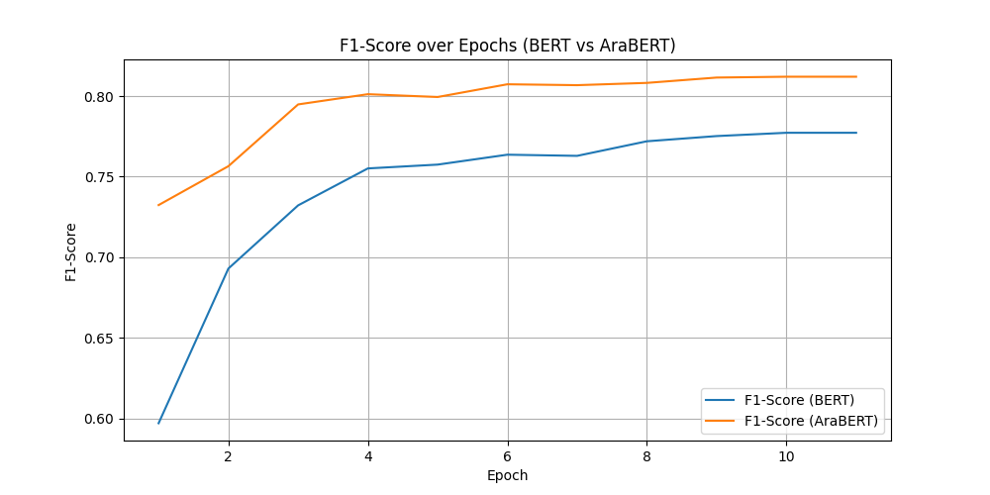
Figure 1: F1-Score over Epochs (BERT vs. AraBERT) AraBERT shows a consistently higher F1-score compared to BERT, particularly in later epochs.

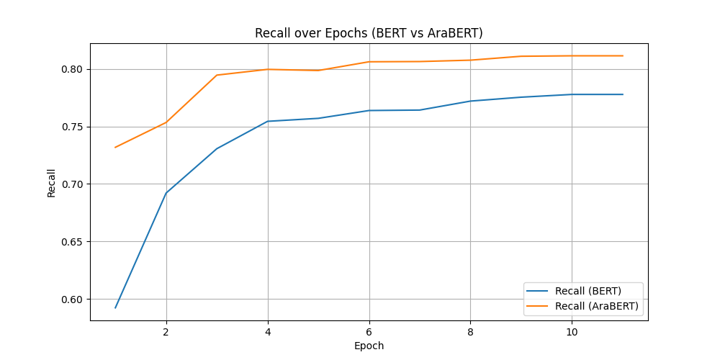
Figure 2: Recall over Epochs (BERT vs. AraBERT) AraBERT demonstrates higher recall across all epochs, indicating better sensitivity in identifying the correct dialect.

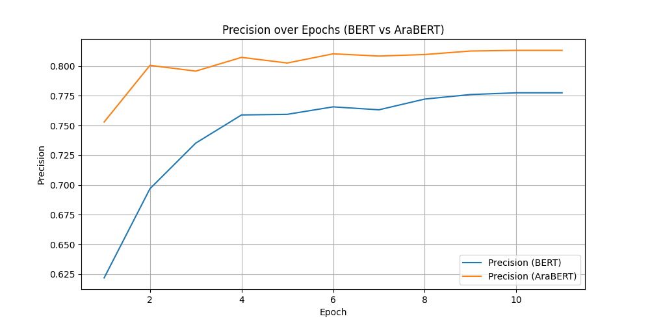 Figure 3: Precision over Epochs (BERT vs. AraBERT)
AraBERT maintains higher precision, demonstrating its accuracy in predicting true positives. Additionally, the loss curves (Figures 4 and 5) for both models show that while both AraBERT and BERT were learning effectively, AraBERT's validation loss remained more stable, suggesting better generalization. Figure 6, which compares the validation accuracy of both models, reinforces AraBERT's superior performance, with a consistently higher validation accuracy throughout the training process.

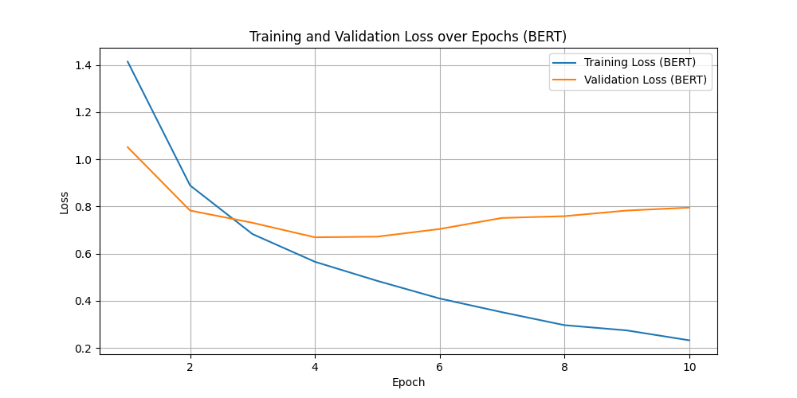
Figure 4: Training and Validation Loss over Epochs (BERT)

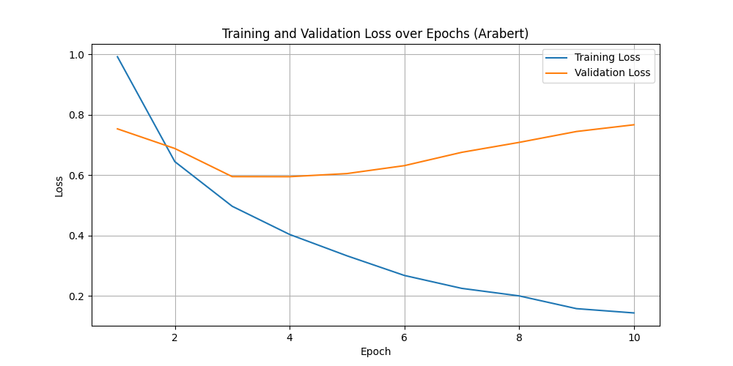
Figure 5: Training and Validation Loss over Epochs (AraBERT)

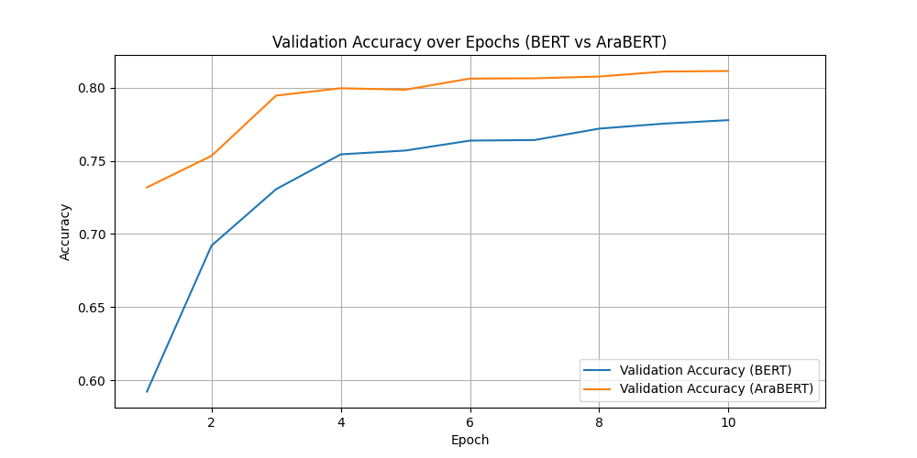
Figure 6: Validation Accuracy over Epochs (BERT vs. AraBERT)

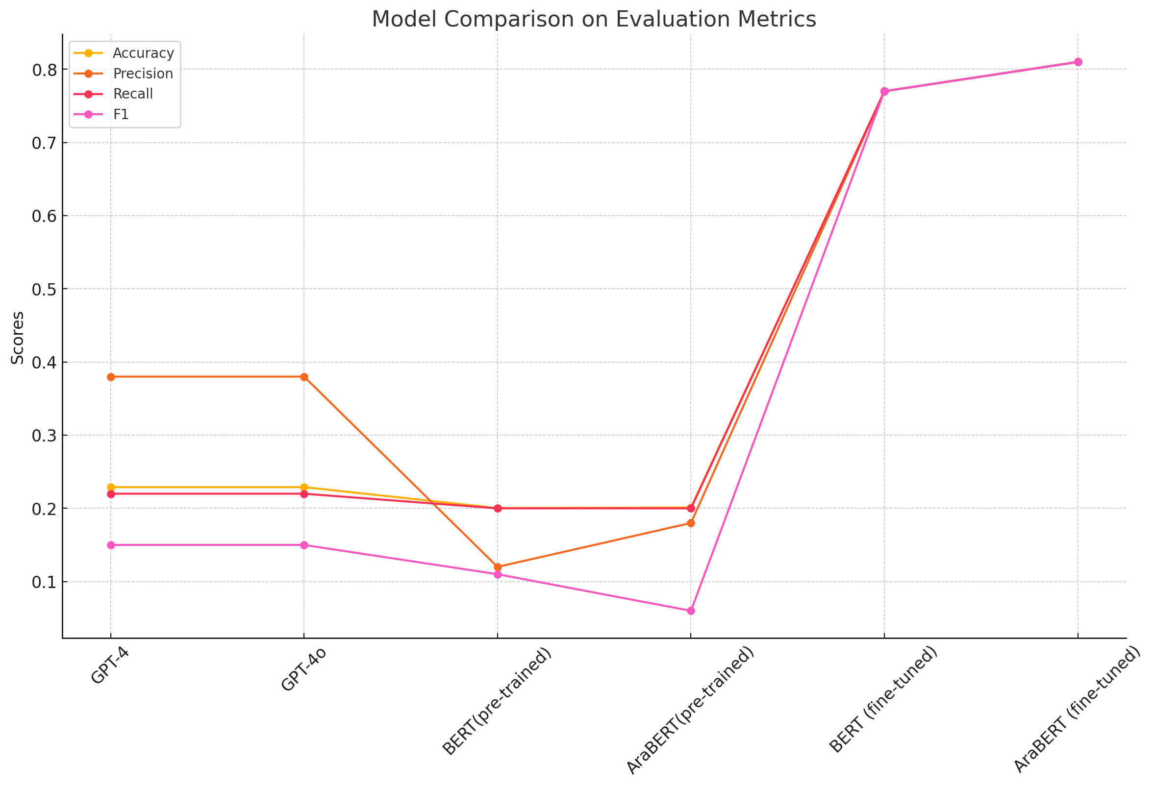
Figure 7: Performance Comparison (All Models)
In the results illustrated by the line charts for accuracy, precision, recall, and F1-score, there is a clear gap in performance among the models tested. Interestingly, general-purpose models like GPT-4 and GPT-4o, along with pre-trained versions of BERT and AraBERT, showed limited effectiveness in handling the task. In contrast, the fine-tuned AraBERT model notably excelled, outperforming all others across these metrics followed by the fine-tuned BERT model. This suggests that for tasks as specialized as Arabic dialect classification, fine-tuned models are far superior. They seem to handle the nuances of the task much better than general-purpose models, which struggle significantly in comparison (Figure 7).
7 Discussion
This study highlights the critical importance of using specialized models, like AraBERT, for the nuanced task of Arabic dialect identification. Our results show a stark contrast in performance between pre-trained and fine-tuned models. While pre-trained versions of BERT and AraBERT showed limited effectiveness, their fine-tuned counterparts excelled, demonstrating superior capabilities in handling the linguistic complexities of Arabic dialects. This underlines the necessity of language-specific pretraining and subsequent fine-tuning to capture the nuanced differences between dialects effectively, which is crucial for tasks that require fine-grained linguistic discrimination. AraBERT, when fine-tuned, consistently outperformed not only its pre-trained version but also the more generic BERT and the general-purpose models like GPT-4 and GPT-4O across all evaluated metrics. This suggests that the architectural adaptations and training tailored to the Arabic language significantly enhance model performance. Conversely, the general-purpose models, including ChatGPT variants, struggled considerably with this specialized task, highlighting their limitations when applied without task-specific adjustments. The slight overfitting observed in both BERT and AraBERT during later training epochs and the underperformance of pre-trained models suggest areas for improvement. Regularization techniques or additional rounds of fine-tuning could help mitigate this overfitting, enhancing the models' generalization capabilities across various Arabic dialects. Expanding the training set to include a broader range of dialects could also improve the robustness and accuracy of these models.

8 Conclusions
In conclusion, this work demonstrates that fine-tuned models like AraBERT and BERT significantly outperform general-purpose models like their pre-trained counterparts and models such GPT-4 and GPT-4o in the task of Arabic dialect classification. The results underscore the necessity of language-specific models for natural language processing tasks involving complex linguistic variations. AraBERT's superior performance across all metrics highlights its suitability for dialect classification, making it a valuable tool for applications such as translation and voice recognition in Arabic.

References:
[1] Houda Bouamor, Sabit Hassan, Nizar Habash, et al. "The MADAR Shared Task on Arabic Fine-Grained Dialect Identification." Proceedings of the Fourth Arabic Natural Language Processing Workshop, 2019.

[2] Ossama Obeid, Mohammad Salameh, Houda Bouamor, et al. "ADIDA: Automatic Dialect Identification for Arabic." Proceedings of the NAACL-HLT 2019, Demonstrations, pages 6–11, 2019.

[3] Mohammad Salameh, Houda Bouamor, and Nizar Habash. "Fine-grained Arabic dialect identif ication." Proceedings of the International Conference on Computational Linguistics, pages 1332–1344, 2018.

[4] Marcos Zampieri, Shervin Malmasi, Preslav Nakov, et al. "Findings of the VarDial Evaluation Campaign 2017." Proceedings of the Workshop on NLP for Similar Languages, Varieties, and Dialects, pages 1–15, 2017.

[5] Mutlaq Hijazi. "Arabic Dialects Classification Models." GitHub repository, https://github.com/Mutlaq0/Dialects.git. Accessed on 2024.

