Create the patient table
CREATE TABLE patients (
date DATE,
pid VARCHAR(20) PRIMARY KEY NOT NULL,
p_name VARCHAR(100) NOT NULL,
age INTEGER,
weight INTEGER,
gender VARCHAR(20),
location VARCHAR(100),
phone_no VARCHAR(20),
disease VARCHAR(100),
doctor_name VARCHAR(100),
doctor_id INTEGER
);
PRAGMA table_info(patients);
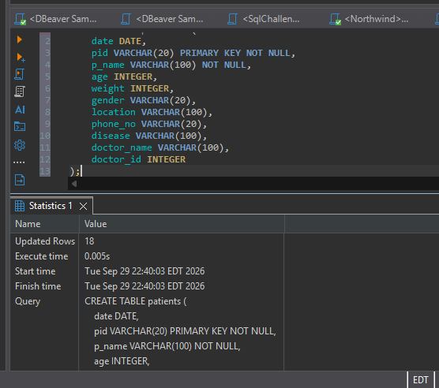
confirms that all eleven required columns exist. The pid row has pk = 1, identifying the primary key.
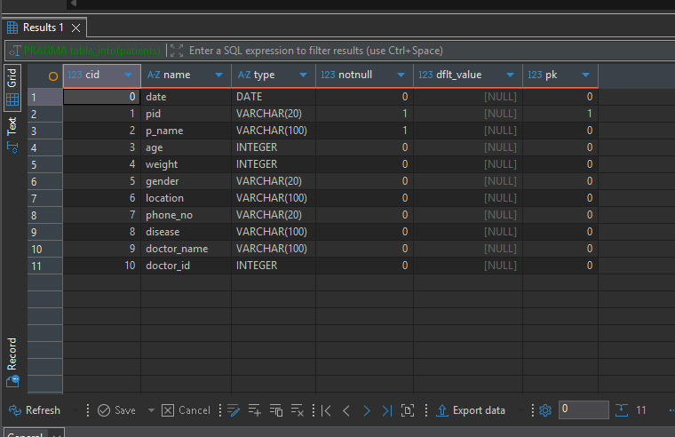

The column names match the CSV. Patient IDs and phone numbers use VARCHAR because they identify records rather than quantities. The patient ID is the primary key. Weight is stored as a whole number because all supplied weights are whole numbers. Dates are converted from DD-MM-YYYY to YYYY-MM-DD before insertion. For example, 15-06-2019 becomes 2019-06-15. All other source values, including spelling and gender, are preserved.

- Insert values into the patient’s table.
INSERT INTO patients (
date, pid, p_name, age, weight, gender,
location, phone_no, disease, doctor_name, doctor_id
)
VALUES (
'2019-06-15', 'AP2021', 'Sarath', 67, 76, 'Male',
'chennai', '5462829', 'Cardiac', 'Mohan', 21
);

I inserted the first patient to check that the query worked, then added the remaining seven patients. I used a SELECT query to confirm that all eight records were present and displayed the correct patient IDs, names, diagnoses, and doctor assignments.
INSERT INTO patients (
date, pid, p_name, age, weight, gender,
location, phone_no, disease, doctor_name, doctor_id
)
VALUES
('2019-02-13', 'AP2022', 'John', 62, 80, 'Male',
'banglore', '1234731', 'Cancer', 'Suraj', 22),

('2018-01-08', 'AP2023', 'Henry', 43, 65, 'Male',
'Kerala', '9028320', 'Liver', 'Mehta', 23),

('2020-02-04', 'AP2024', 'Carl', 56, 72, 'Female',
'Mumbai', '9293829', 'Asthma', 'Karthik', 24),

('2017-09-15', 'AP2025', 'Shikar', 55, 71, 'Male',
'Delhi', '7821281', 'Cardiac', 'Mohan', 21),

('2018-07-22', 'AP2026', 'Piysuh', 47, 59, 'Male',
'Haryana', '8912819', 'Cancer', 'Suraj', 22),

('2017-03-25', 'AP2027', 'Stephen', 69, 55, 'Male',
'Gujarat', '8888211', 'Liver', 'Mehta', 23),

('2019-04-22', 'AP2028', 'Aaron', 75, 53, 'Male',
'Banglore', '9012192', 'Asthma', 'Karthik', 24);

SELECT *
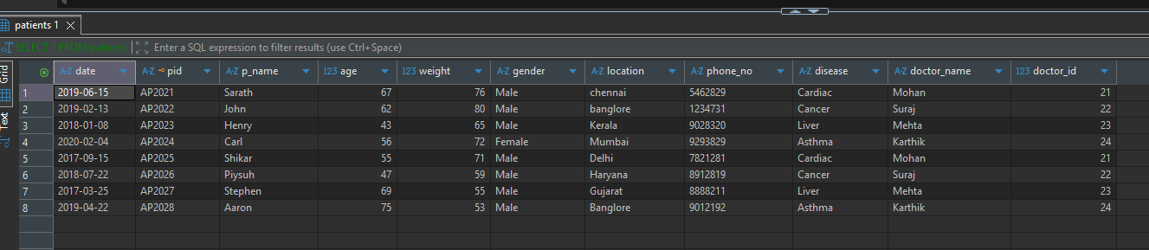
FROM patients;

Display the total number of patients in the table.
SELECT COUNT(*) AS TotalPatients
FROM patients;
COUNT(*) counts every record. There are 8 records and 8 distinct patient IDs in this dataset, so the table contains 8 patients.
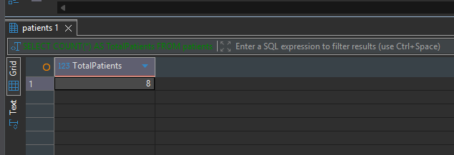

- Write queries for various other tasks such as displaying patient names with the current date, modifying patient names to uppercase, counting characters in patient names, combining patient and doctor names, extracting the year from dates, and identifying duplicate entries in the doctor name column.
  - Write a query to display the patient id and patient name with the current date
SELECT pid,
p_name,
DATE('now', 'localtime') AS CurrentDate
FROM patients;
DATE('now', 'localtime') displays the current date for each patient. This does not filter patients by visit date or alter their recorded dates. The captured date is 2026-09-29 in Atlanta/GA.
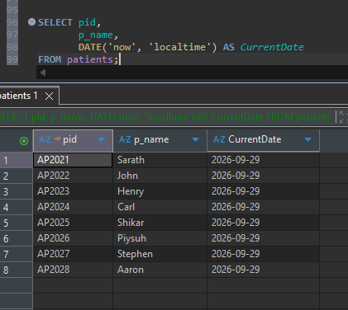

  - Write a query to display the old patient name and the new patient name in uppercase
SELECT p_name AS OldPatientName,
UPPER(p_name) AS NewPatientName
FROM patients;
UPPER(p_name) displays each name in uppercase beside its original value. AS gives each result column an alias. For example, Sarath becomes SARATH. This SELECT leaves the stored names unchanged.
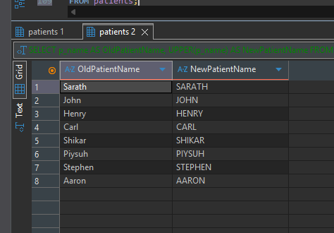
  - Write a query to display the patients' names along with the total number of characters in their name
SELECT p_name,
LENGTH(p_name) AS TotalCharacters
FROM patients;
LENGTH(p_name) counts the characters in each supplied name. Stephen has 7 characters, while John and Carl each have 4. These dataset names use ordinary Latin letters, so the character counts are unambiguous.
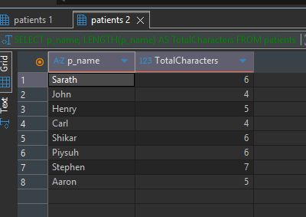

  - Write a query to combine the patient's name and the doctor's name in a new column
SELECT p_name,
doctor_name,
p_name || ' - ' || doctor_name AS PatientDoctor
FROM patients;
The || operator concatenates text. The literal ' - ' adds a separator. PatientDoctor is a calculated result column, for example Sarath - Mohan; it is not a new stored column in the patients table.
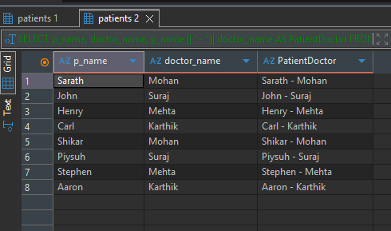

  - Write a query to extract the year for a given date and place it in a separate column
SELECT date,
STRFTIME('%Y', date) AS VisitYear
FROM patients;
STRFTIME('%Y', date) extracts the four-digit year from each ISO-formatted date. CAST(... AS INTEGER) returns a numeric year. The recorded years range from 2017 to 2020.
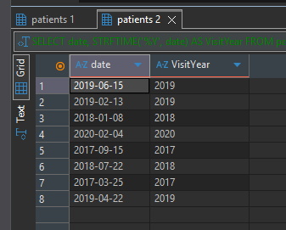

  - Write a query to display duplicate entries in the doctor name column
SELECT doctor_name,
COUNT(*) AS TotalOccurrences
FROM patients
GROUP BY doctor_name
HAVING COUNT(*) > 1;
GROUP BY collects records with the same doctor name. HAVING COUNT(*) > 1 keeps names occurring more than once. Karthik, Mehta, Mohan, and Suraj each occur twice. These repeated names reflect doctors assigned to different patients; they are not proof of duplicate patient records and should not be deleted on that basis.
