University Database Design Project
- Database Entities and Attributes
The proposed university database uses four main entities: Student, Program, Course, and Enrollment. Each entity represents a major object that the university needs to store and manage.
Entity | Attributes | Purpose
STUDENT | StudentID (PK); FirstName; LastName; DateOfBirth; Email; ProgramID (FK) | Stores student details and links each student to a program.
PROGRAM | ProgramID (PK); ProgramName; Department; DegreeLevel | Stores the academic programs offered by the university.
COURSE | CourseID (PK); CourseName; Credits; ProgramID (FK) | Stores courses and identifies the program that offers each course.
ENROLLMENT | EnrollmentID (PK); StudentID (FK); CourseID (FK); EnrollmentDate; Grade | Records a student's enrollment in a course and supports academic-progress tracking.
PK = Primary Key. FK = Foreign Key.
- Relationships and Relationship Types
Relationship | Type | Summary
Program → Student | One-to-Many (1:M) | One program can have many students; each student belongs to one program.
Program → Course | One-to-Many (1:M) | One program can offer many courses; each course belongs to one program.
Student → Enrollment | One-to-Many (1:M) | One student can have many enrollment records; each enrollment record belongs to one student.
Course → Enrollment | One-to-Many (1:M) | One course can have many enrollment records; each enrollment record refers to one course.
Student ↔ Course | Many-to-Many (M:N) | A student can enroll in many courses, and a course can contain many students. Enrollment resolves this relationship.

ER Diagram
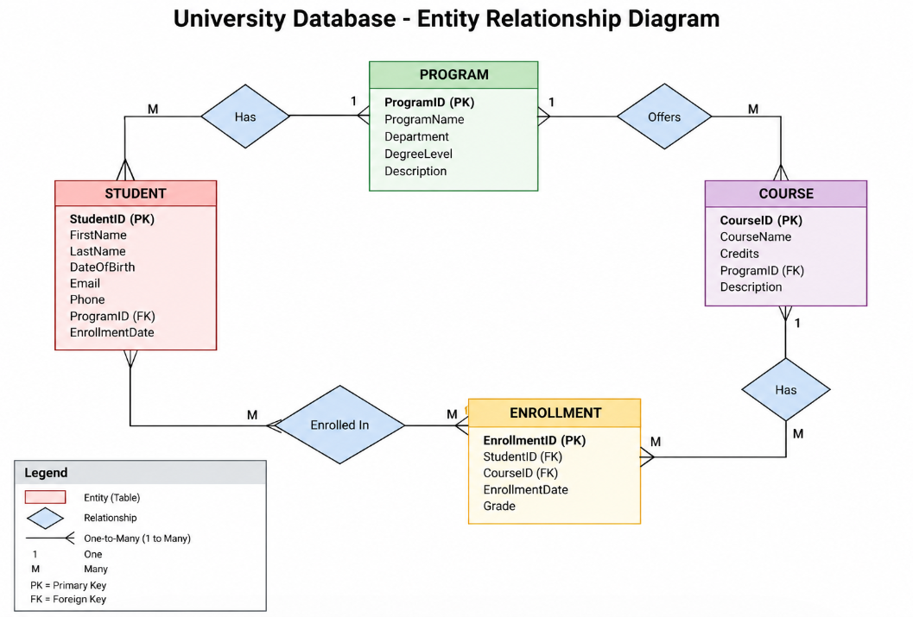

Summary
This design allows the university to store student and program information, identify courses offered by each program, record course enrollments, and track academic progress through grades. Primary keys uniquely identify records, while foreign keys connect related entities and support data consistency.

