DATA STRUCTURES

1.1 Basic Definitions

Data structures
This is the study of methods of representing objects, the design of algorithms to manipulate the representations, the proper encapsulation of objects in a reusable form, and the evaluation of the cost of the implementation, including the measurement of the complexity of the time and space requirements.

Abstraction
This is the separation between what a data structure represents and what an algorithm accomplishes, from the implementation details of how things are actually carried out. I.e, hiding the unnecessary details

Data Abstraction
Hiding of the representational details

Data Types
A data type consists of: a domain (= a set of values) and a set of operations; the kind of data variables may “hold”.

Example 1:
Boolean or logical data type provided by most programming languages.
- Two values: true, false.
- Many operations, including AND, OR, NOT, etc.

Example 2:
The data type fraction. How can we specify the domain and operations that define fractions? It seems straightforward to name the operations; fractions are numbers so all the normal arithmetic operations apply, such as addition, multiplication, and comparison. In addition there might be some fraction-specific operations such as normalizing a fraction by removing common terms from its numerator and denominator - for example, if we normalized 6/9 we'd get 2/3.
But how do we specify the domain for fractions, i.e. the set of possible values for a fraction?

Structural and Behavioral Definitions
There are two different approaches to specifying a domain: we can give a structural definition, or we can give a behavioral definition. Let us see what these two are like.

Structural Definition of the domain for `Fraction'
The value of a fraction is made of three parts (or components):
- A sign, which is either + or -
- A numerator, which may be any non-negative integer
- A denominator, which may be any positive integer (not zero, not negative).
This is called a structural definition because it defines the values of type `fraction' by imposing an internal structure on them (they have 3 parts...). The parts themselves have specific types, and there may be further constraints. For example, we could have insisted that a fraction's numerator and denominator have no common divisor (in that case we wouldn't need the normalize operation - 6/9 would not be a fraction by this definition).

Behavioral Definition of the domain for `Fraction'
The alternative approach to defining the set of values for fractions does not impose any internal structure on them. Instead it just adds an operation that creates fractions out of other things, such as
CREATE_FRACTION(N,D)
Where N is any integer, D is any non-zero integer.
The values of type fraction are defined to be the values that are produced by this function for any valid combination of inputs.

The parameter names were chosen to suggest its intended behavior: CREATE_FRACTION(N,D) should return a value representing the fraction N/D (N for numerator, D for denominator).

You are probably thinking, this is crazy, CREATE_FRACTION could be any old random function, how do we guarantee that CREATE_FRACTION(N,D) actually returns the fraction N/D?

The answer is that we have to constrain the behavior of this function, by relating it to the other operations on fractions. For example, one of the key properties of multiplication is that:

NORMALIZE ((N/D) * (D/N)) = 1/1
This turns into a constraint on CREATE_FRACTION:

NORMALIZE (CREATE_FRACTION(N,D) * CREATE_FRACTION(D,N)) = CREATE_FRACTION(1,1)
So you see CREATE_FRACTION cannot be any old function, its behavior is highly constrained, because we can write down lots and lots of constraints like this.

And that's the reason we call this sort of definition behavioral, because the definition is strictly in terms of a set of operations and constraints or axioms relating the behavior of the operations to one another.

In this style of definition, the domain of a data type - the set of permissible values - plays an almost negligible role. Any set of values will do, as long as we have an appropriate set of operations to go along with it.

1.2 Common Structures
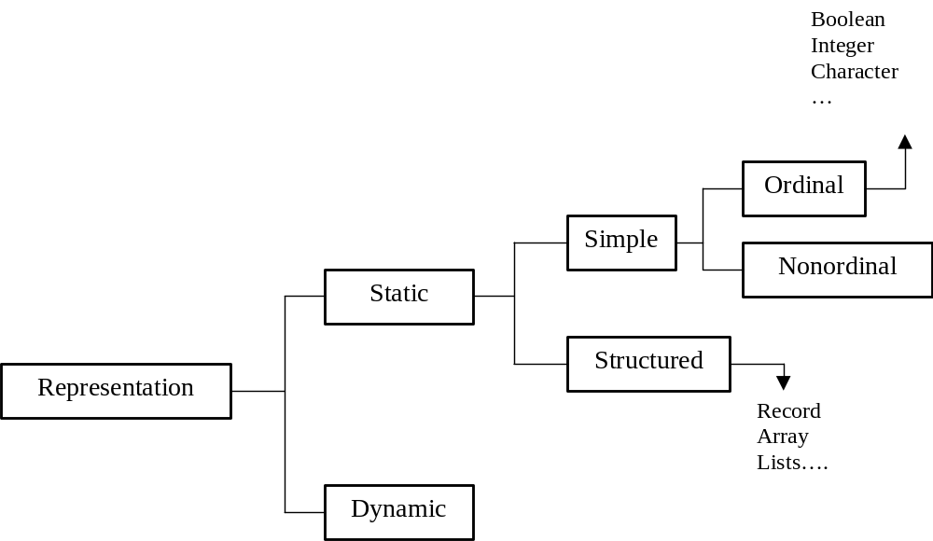

Atomic/Simple Data Types
These are data types that are defined without imposing any structure on their values. Boolean, our first example, is an atomic type. So are characters, as these are typically defined by enumerating all the possible values that exist on a given computer.

Structured Data Types
The opposite of atomic is structured. A structured data type has a definition that imposes structure upon its values. As we saw above, fractions normally are a structured data type.
In many structured data types, there is an internal structural relationship, or organization, that holds between the components.
For example, if we think of an array as a structured type, with each position in the array being a component, then there is a structural relationship of `followed by': we say that component N is followed by component N+1.

Structural Relationships
Not all structured data types have this sort of internal structural relationship. Fractions are structured, but there is no internal relationship between the sign, numerator, and denominator. But many structured data types do have an internal structural relationship, and these can be classified according to the properties of this relationship.

Linear Structure:
The most common organization for components is a linear structure. A structure is linear if it has these 2 properties:
- Property P1:Each element is `followed by' at most one other element.
- Property P2:No two elements are `followed by' the same element.
An array is an example of a linearly structured data type. We generally write a linearly structured data type like this: A->B->C->D (this is one value with 4 parts).

- Counter example 1 (violates P1): A points to B and C B<-A->C
- Counter example 2 (violates P2): A and B both point to C A->C<-B

Tree Structure
Dropping Constraint P1: If we drop the first constraint and keep the second we get a tree structure or hierarchy: no two elements are followed by the same element. This is a very common structure too, and extremely useful.

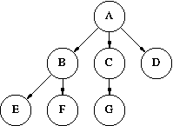

Counter example 1 is a tree, but counter example 2 is not.

A is followed by B C D, B by E F, C by G. We are not allowed to add any more arcs that point to any of these nodes (except possibly A - see cyclic structures below).

Graph Structure
Dropping both P1 and P2:

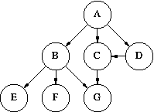

If we drop both constraints, we get a graph. In a graph, there are no constraints on the relations we can define.

Cyclic Structures:
All the examples we've seen are acyclic. This means that there is no sequence of arrows that leads back to where it started. Linear structures are usually acyclic, but cyclic ones are not uncommon.

Example of cyclic linear structure: A B C D A

Trees are virtually always acyclic.

Graphs are often cyclic, although the special properties of acyclic graphs make them an important topic of study.

Example: Add an edge from G to D, and from E to A.

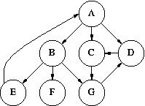

1.3 Structured Data Types

Arrays
Arrays are physically sequential, fixed size collections of homogeneous objects. Further, objects with the structure have the random access property.
They are physically sequential in that the data objects are stored in consecutive memory locations.
They are homogeneous in that they are made up of objects that are all the same type.
The random access property means that the time it takes to access one object in the structure does not depend on what object in he structure had been accessed previously.

An array type is appropriate for representing an abstract data type when the following three conditions are satisfied:
- The data objects in the abstract data type are composed of homogeneous objects
- The solution requires the representation of a fixed, predetermined number of objects
- There is an ordering that can be placed on the objects in the abstract data type

Declaring an array requires two steps:
- Determine the exact specification of the data objects that appear in the array
- Determine the sequential relationships between the data objects and form a suitable subrange of the appropriate ordinal data type to represent the sequential relationship

Records
Records are physically sequential, fixed size collections of heterogeneous objects. Further, objects with the structure have the random access property.

To determine whether a record is the appropriate means for representing an object, the following conditions should be addressed:
- Is there a fixed predetermined number of components that come together to form the structure?
- Are the data objects, called components, that come together form the object heterogeneous, all different types, or possibly the same type but unrelated or independent?

Steps in declaring a record:
- Determine the exact specification of the data types that come together to form the record structure
- Determine the names of each component so that each name indicates the role the component plays in determining the record’s value.

