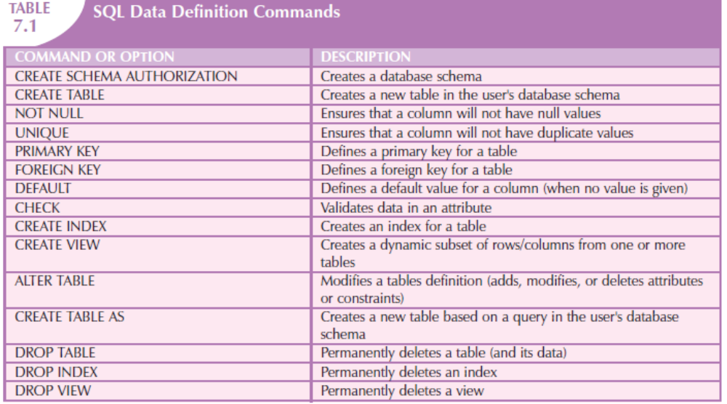

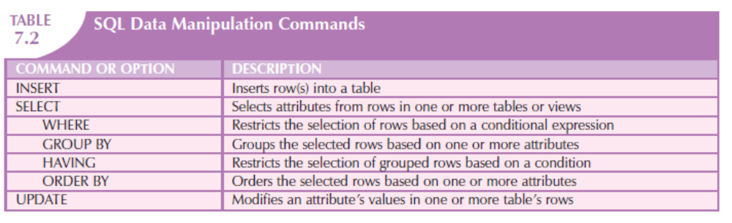

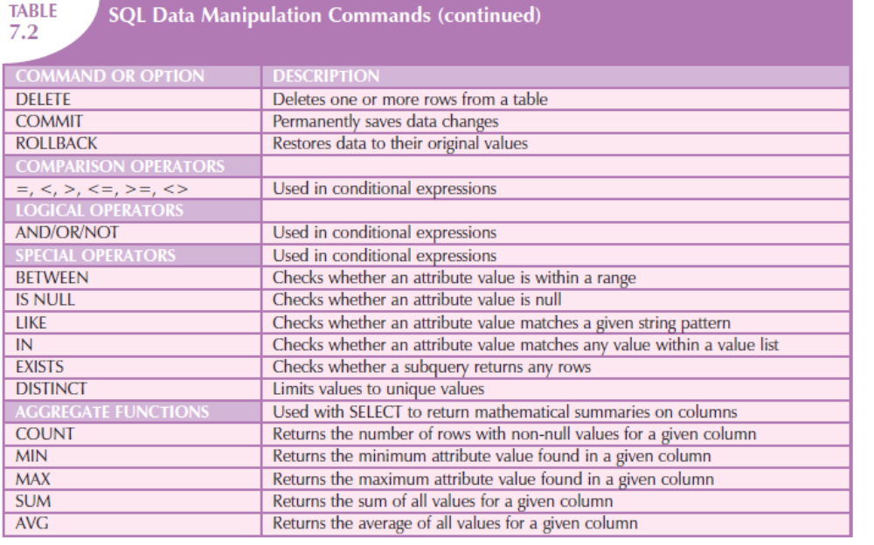

Before you can use a new RDBMS, you must complete two tasks: first, create the database structure, and second, create the tables that will hold the end-user data.

The Database Schema
In the SQL environment, a schema is a group of database objects—such as tables and indexes—that are related to each other. Usually, the schema belongs to a single user or application. A single database can hold multiple schemas belonging to different users or applications. Think of a schema as a logical grouping of database objects, such as tables, indexes, and views. Schemas are useful in that they group tables by owner (or function) and enforce a first level of security by allowing each user to see only the tables that belong to that user.

CREATE SCHEMA AUTHORIZATION {creator};
Therefore, if the creator is JONES, use the command:
CREATE SCHEMA AUTHORIZATION JONES;

However, the command is seldom used directly—that is, from the command line. if you log on as JONES, you can only use CREATE SCHEMA AUTHORIZATION JONES
Note: For most RDBMSs, the CREATE SCHEMA AUTHORIZATION is optional. That is why this chapter focuses on the ANSI SQL commands required to create and manipulate tables.

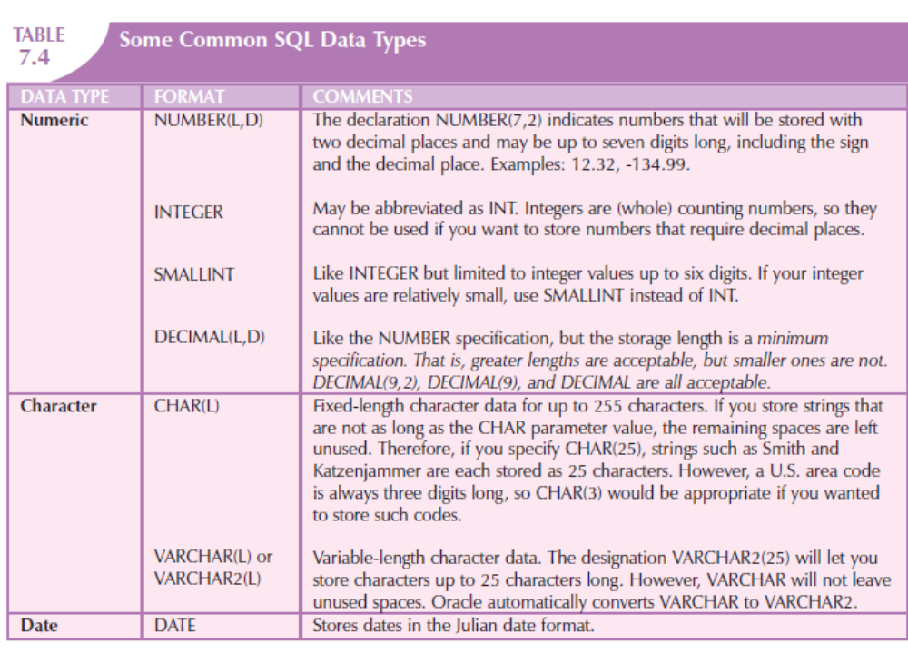

Other Data Types

Bit-string data types are either of fixed length n—BIT(n)—or varying length—BIT VARYING(n), where n is the maximum number of bits.

A Boolean data type has the traditional values of TRUE or FALSE. In SQL, because of the presence of NULL values, a three-valued logic is used, so a third possible value for a Boolean data type is UNKNOWN.

A timestamp data type (TIMESTAMP) includes the DATE and TIME fields, plus a minimum of six positions for decimal fractions of seconds and an optional WITH TIME ZONE qualifier.

Another data type related to DATE, TIME, and TIMESTAMP is the INTERVAL data type. This specifies an interval—a relative value that can be used to increment or decrement an absolute value of a date, time, or timestamp. Intervals are qualified to be either YEAR/MONTH intervals or DAY/TIME
intervals.

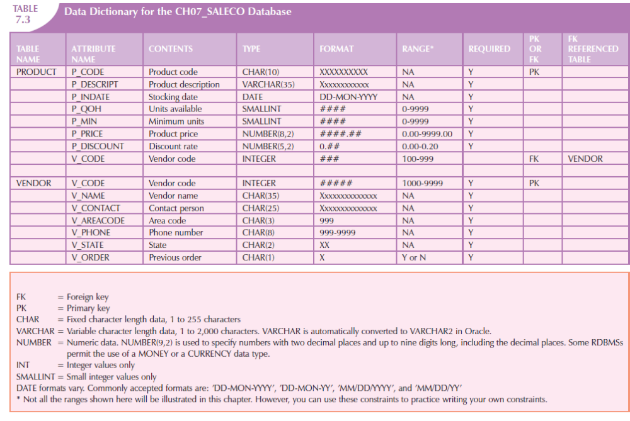
We shall use the following data model for subsequent exercises.
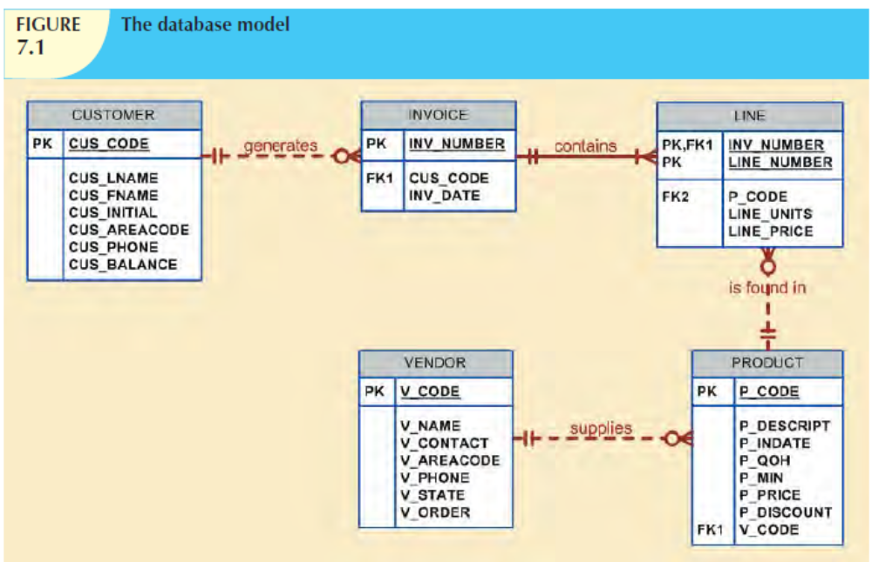

Creating Table Structures

CREATE TABLE syntax shown next.
CREATE TABLE tablename (
column1 data type [constraint] [,
column2 data type [constraint] ] [,
PRIMARY KEY (column1 [, column2]) ] [,
FOREIGN KEY (column1 [, column2]) REFERENCES tablename] [,
CONSTRAINT constraint ] );
Note:
Because the PRODUCT table contains a foreign key that references the VENDOR table, create the VENDOR table first. (In fact, the M side of a relationship always references the 1 side. Therefore, in a 1:M relationship, you must always create the table for the 1 side first.)

CREATE TABLE VENDOR (
V_CODE INTEGER NOT NULL UNIQUE,
V_NAME VARCHAR(35) NOT NULL,
V_CONTACT VARCHAR(15) NOT NULL,
V_AREACODE CHAR(3) NOT NULL,
V_PHONE CHAR(8) NOT NULL,
V_STATE CHAR(2) NOT NULL,
V_ORDER CHAR(1) NOT NULL,
PRIMARY KEY (V_CODE));

- The NOT NULL specifications for the attributes ensure that a data entry will be made. When it is crucial to have the data available, the NOT NULL specification will not allow the end user to leave the attribute empty (with no data entry at all). Because this specification is made at the table level and stored in the data dictionary, application programs can use this information to create the data dictionary validation automatically.
- The UNIQUE specification creates a unique index in the respective attribute. Use it to avoid having duplicated values in a column.
- The primary key attributes contain both a NOT NULL and a UNIQUE specification. Those specifications enforce the entity integrity requirements. If the NOT NULL and UNIQUE specifications are not supported, use PRIMARY KEY without the specifications. (For example, if you designate the PK in MS Access, the NOT NULL and UNIQUE specifications are automatically assumed and are not spelled out.)
- The entire table definition is enclosed in parentheses. A comma is used to separate each table element (attributes, primary key, and foreign key) definition.

CREATE TABLE PRODUCT (
P_CODE VARCHAR(10) NOT NULL UNIQUE,
P_DESCRIPT VARCHAR(35) NOT NULL,
P_INDATE DATE NOT NULL,
P_QOH SMALLINT NOT NULL,
P_MIN SMALLINT NOT NULL,
P_PRICE NUMBER(8,2) NOT NULL,
P_DISCOUNT NUMBER(5,2) NOT NULL,
V_CODE INTEGER,
PRIMARY KEY (P_CODE),
FOREIGN KEY (V_CODE) REFERENCES VENDOR ON UPDATE CASCADE);

CREATE TABLE CUSTOMER (
CUS_CODE NUMBER PRIMARY KEY,
CUS_LNAME VARCHAR(15) NOT NULL,
CUS_FNAME VARCHAR(15) NOT NULL,
CUS_INITIAL CHAR(1),
CUS_AREACODE CHAR(3) DEFAULT '615' NOT NULL
CHECK(CUS_AREACODE IN ('615','713','931')),
CUS_PHONE CHAR(8) NOT NULL,
CUS_BALANCE NUMBER(9,2) DEFAULT 0.00,
CONSTRAINT CUS_UI1 UNIQUE (CUS_LNAME, CUS_FNAME));

CREATE TABLE INVOICE (
INV_NUMBER NUMBER PRIMARY KEY,
CUS_CODE NUMBER NOT NULL REFERENCES CUSTOMER(CUS_CODE),
INV_DATE DATE DEFAULT SYSDATE NOT NULL,
CONSTRAINT INV_CK1 CHECK (INV_DATE > TO_DATE('01-JAN-2010','DD-MON-YYYY')));

CREATE TABLE LINE (
INV_NUMBER NUMBER NOT NULL,
LINE_NUMBER NUMBER(2,0) NOT NULL,
P_CODE VARCHAR(10) NOT NULL,
LINE_UNITS NUMBER(9,2) DEFAULT 0.00 NOT NULL,
LINE_PRICE NUMBER(9,2) DEFAULT 0.00 NOT NULL,
PRIMARY KEY (INV_NUMBER, LINE_NUMBER),
FOREIGN KEY (INV_NUMBER) REFERENCES INVOICE ON DELETE CASCADE,
FOREIGN KEY (P_CODE) REFERENCES PRODUCT(P_CODE),
CONSTRAINT LINE_UI1 UNIQUE(INV_NUMBER, P_CODE));

- If you are working with a composite primary key, all of the primary key’s attributes are contained within the parentheses and are separated with commas. For example, the LINE table has a primary key that consists of the two attributes INV_NUMBER and LINE_NUMBER. Therefore, you would define the primary key by typing:
- PRIMARY KEY (INV_NUMBER, LINE_NUMBER),
- The order of the primary key components is important because the indexing starts with the first-mentioned
- attribute, then proceeds with the next attribute, and so on. In this example, the line numbers would be ordered
- within each of the invoice numbers:
INV_NUMBER LINE_NUMBER
1001 1
1001 2
1002 1
1003 1
1003 2

- The ON UPDATE CASCADE specification ensures that if you make a change in any VENDOR’s V_CODE, that change is automatically applied to all foreign key references throughout the system (cascade) to ensure that referential integrity is maintained. (Although the ON UPDATE CASCADE clause is part of the ANSI standard, some RDBMSs, such as Oracle, do not support ON UPDATE CASCADE. If your RDBMS does not support the clause, delete it from the code shown here.)
- An RDBMS will automatically enforce referential integrity for foreign keys. That is, you cannot have an invalid entry in the foreign key column; at the same time, you cannot delete a vendor row as long as a product row references that vendor.
- The command sequence ends with a semicolon. (Remember, your RDBMS may require that you omit the
- semicolon.) be used to illustrate several types of joins.

DATA MANIPULATION COMMANDS
Basic SQL data manipulation commands INSERT, SELECT, COMMIT, UPDATE, ROLLBACK, and DELETE.

SQL requires the use of the INSERT command to enter data into a table. The INSERT command’s basic syntax looks
like this:
INSERT INTO tablename VALUES (value1, value2, ... , valuen)

Because the PRODUCT table uses its V_CODE to reference the VENDOR table’s V_CODE, an integrity violation will occur if those VENDOR table V_CODE values don’t yet exist. Therefore, you need to enter the VENDOR rows before the PRODUCT rows.
INSERT INTO VENDOR
VALUES (21225,'Bryson, Inc.','Smithson','615','223-3234','TN','Y');
INSERT INTO VENDOR
VALUES (21226,'Superloo, Inc.','Flushing','904','215-8995','FL','N');
and so on, until all of the VENDOR table records have been entered.

INSERT INTO PRODUCT
VALUES ('11QER/31','Power painter, 15 psi., 3-nozzle','03-Nov-09',8,5,109.99,0.00,25595);
INSERT INTO PRODUCT
VALUES ('13-Q2/P2','7.25-in. pwr. saw blade','13-Dec-09',32,15,14.99, 0.05, 21344);

Inserting Rows with Null Attributes
Thus far, you have entered rows in which all of the attribute values are specified. But what do you do if a product does not have a vendor or if you don’t yet know the vendor code? In those cases, you would want to leave the vendor code null. To enter a null, use the following syntax:

INSERT INTO PRODUCT
VALUES ('BRT-345','Titanium drill bit','18-Oct-09', 75, 10, 4.50, 0.06, NULL);

Incidentally, note that the NULL entry is accepted only because the V_CODE attribute is optional—the NOT NULL declaration was not used in the CREATE TABLE statement for this attribute.

Inserting Rows with Optional Attributes
There might be occasions when more than one attribute is optional. Rather than declaring each attribute as NULL in the INSERT command, you can indicate just the attributes that have required values. You do that by listing the attribute names inside parentheses after the table name. For the purpose of this example, assume that the only required attributes for the PRODUCT table are P_CODE and P_DESCRIPT:

INSERT INTO PRODUCT(P_CODE, P_DESCRIPT) VALUES ('BRT-345','Titanium drill bit');

Saving Table Changes
Any changes made to the table contents are not saved on disk until you close the database, close the program you are using, or use the COMMIT command. If the database is open and a power outage or some other interruption occurs before you issue the COMMIT command, your changes will be lost and only the original table contents will be retained.
COMMIT,

For the class

Create the tables and populate with the following data items. We shall use this tables for subsequent exercises.

