TASK 3
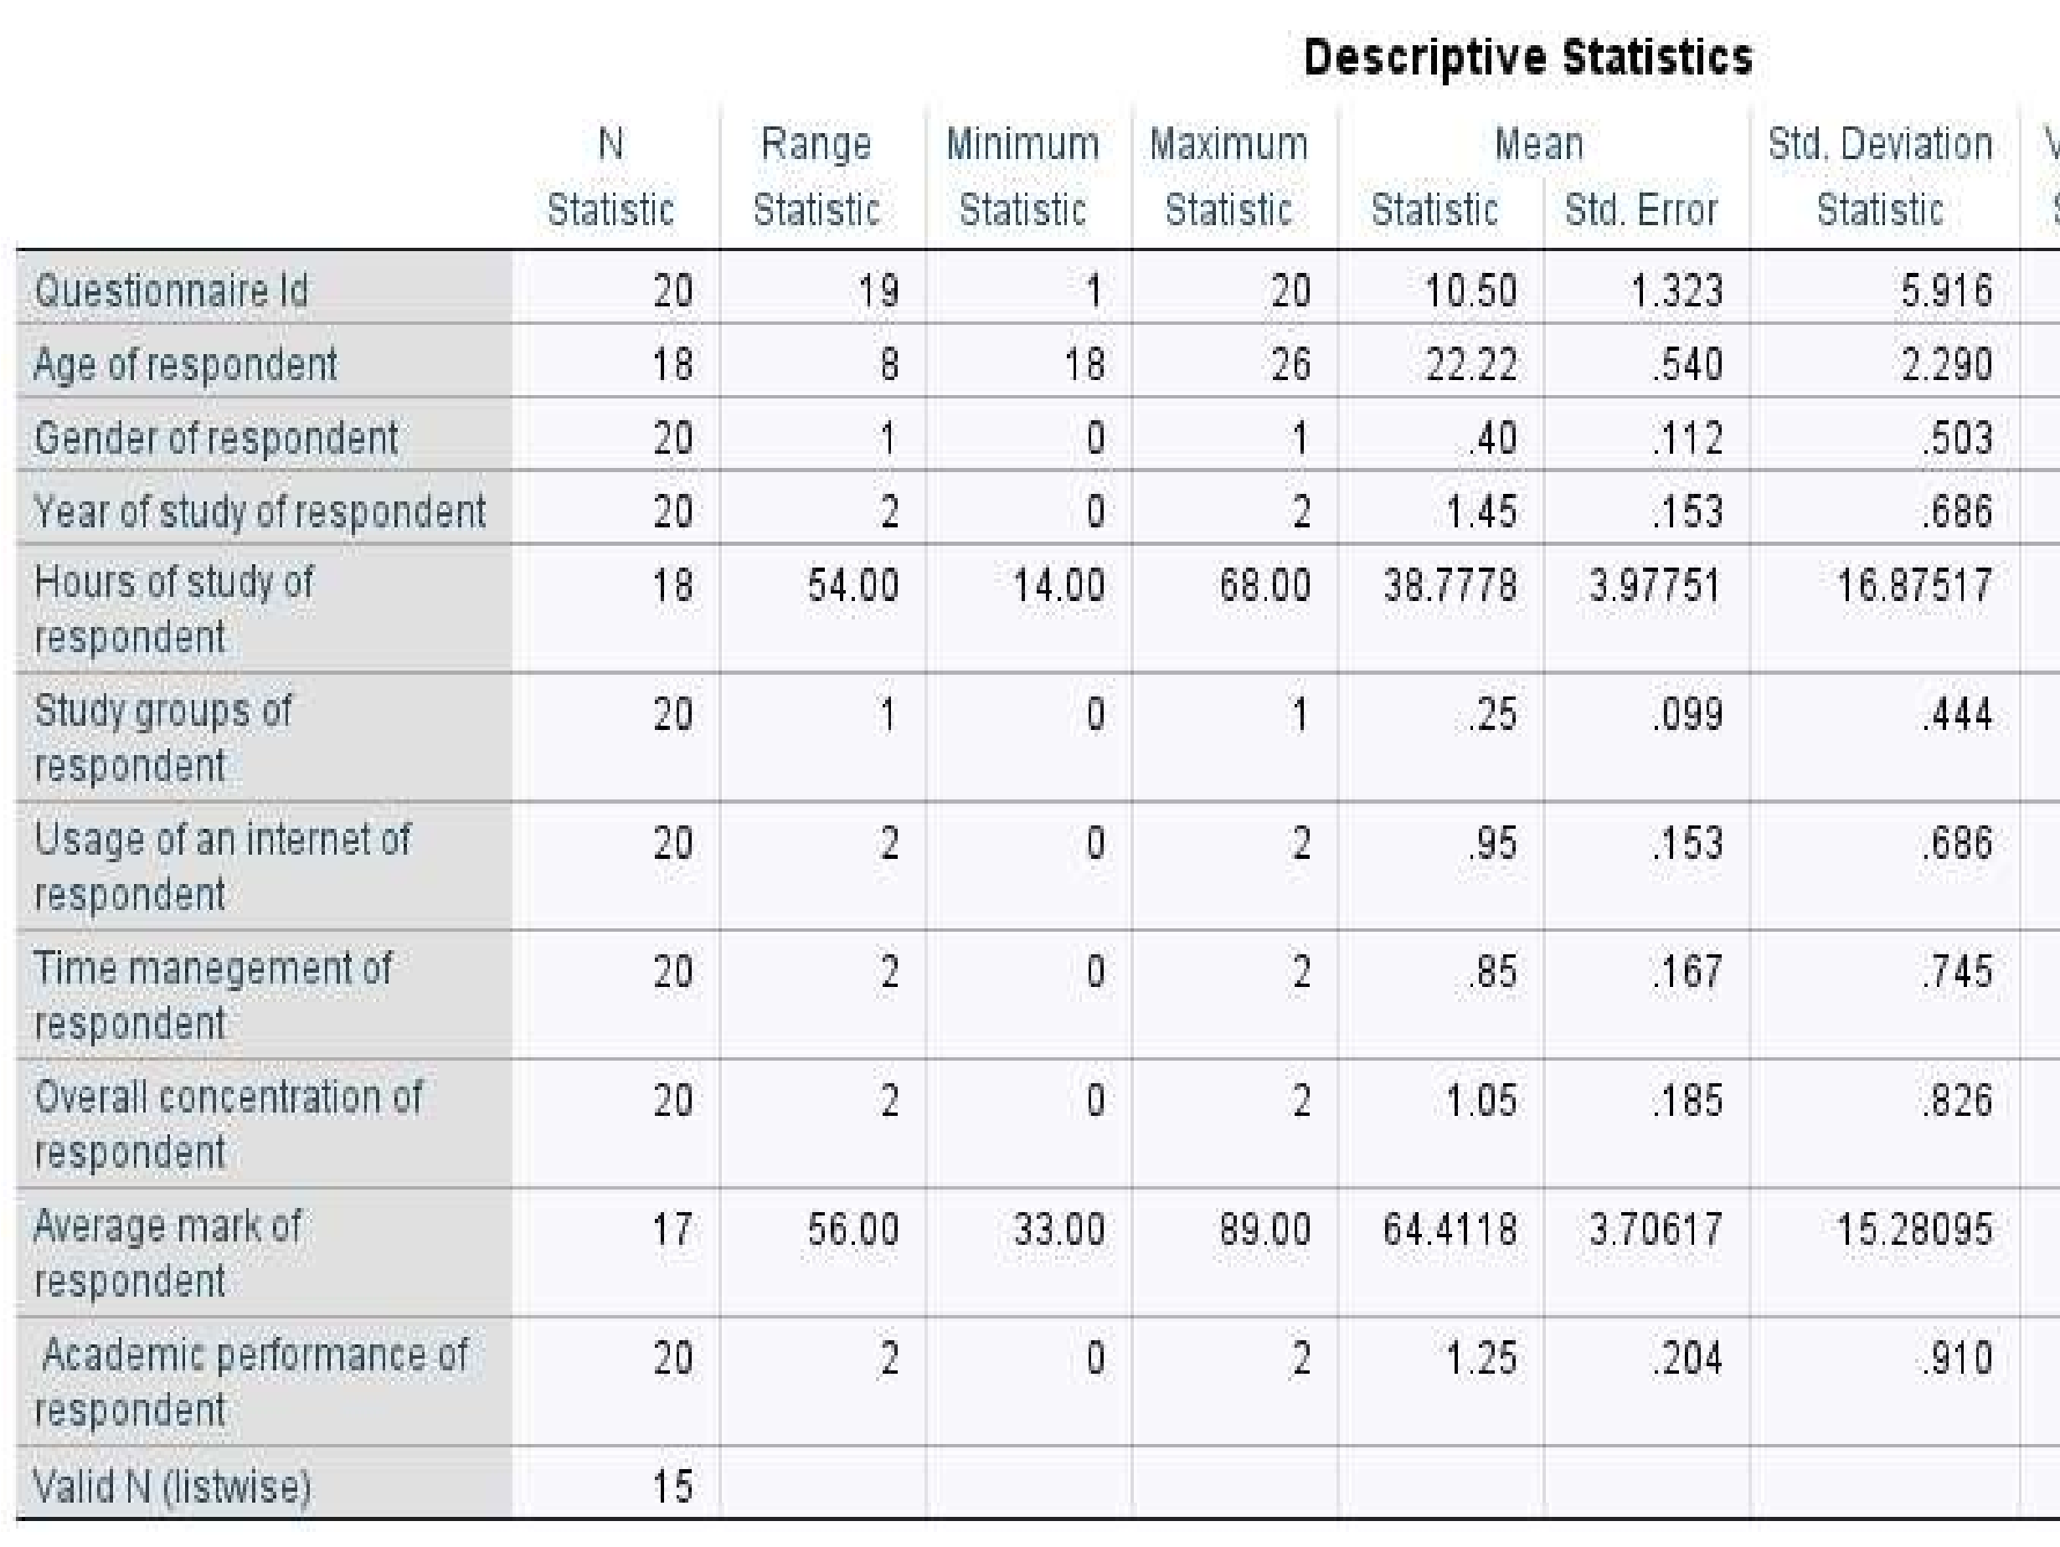
There's high variability in both study hours and academic performance.
- Internet use is high, but study group participation is very low.
- Gender distribution leans slightly toward one group (mean = 1.45).
- The average academic mark (64.41%) suggests modest performance across students

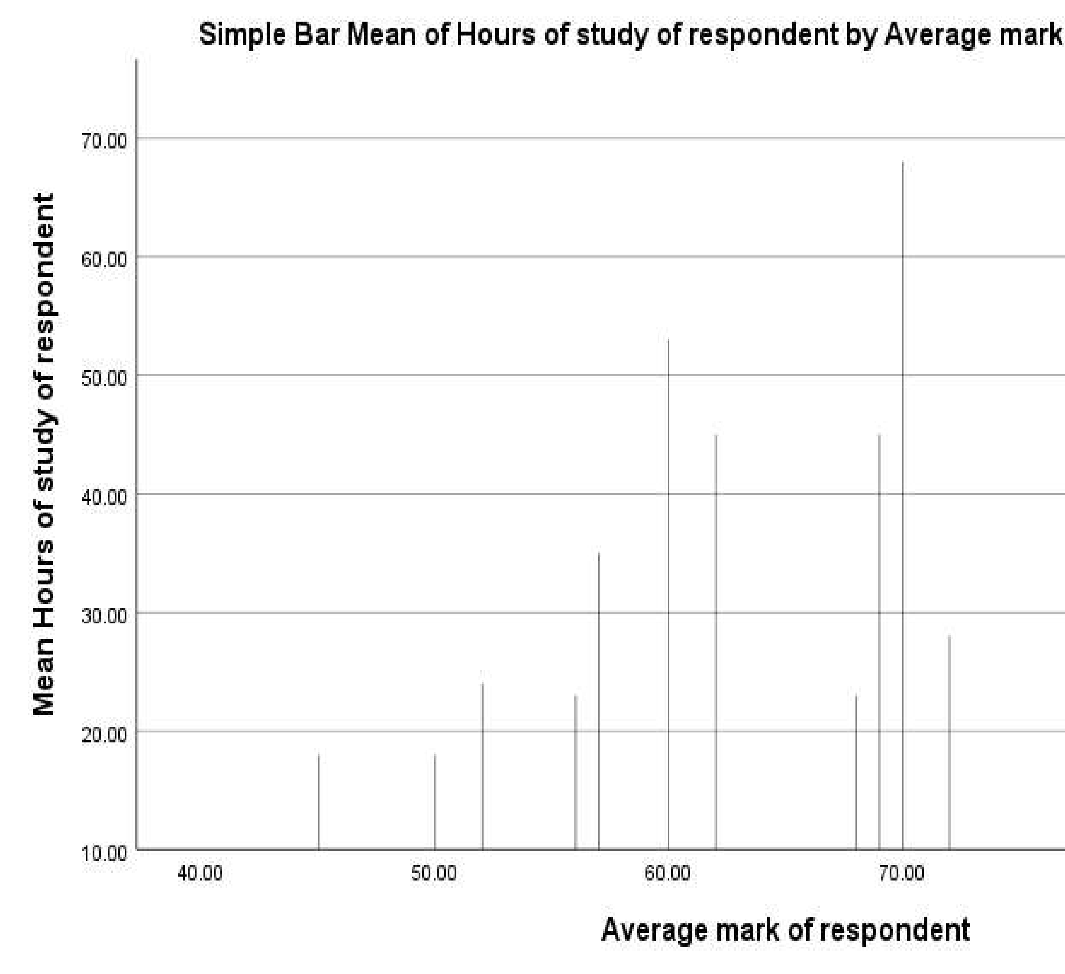
Each bar represents the average number of study hours for respondents who received a specific average mark.
  - As average marks increase, the mean study hours also tend to increase.
  - For example:
  - Students with marks around 40–50 studied less (around 20–30 hours).
  - Students with marks around 70–90 studied more (often 40+ hours).
  - This suggests a positive relationship between hours of study and academic performance
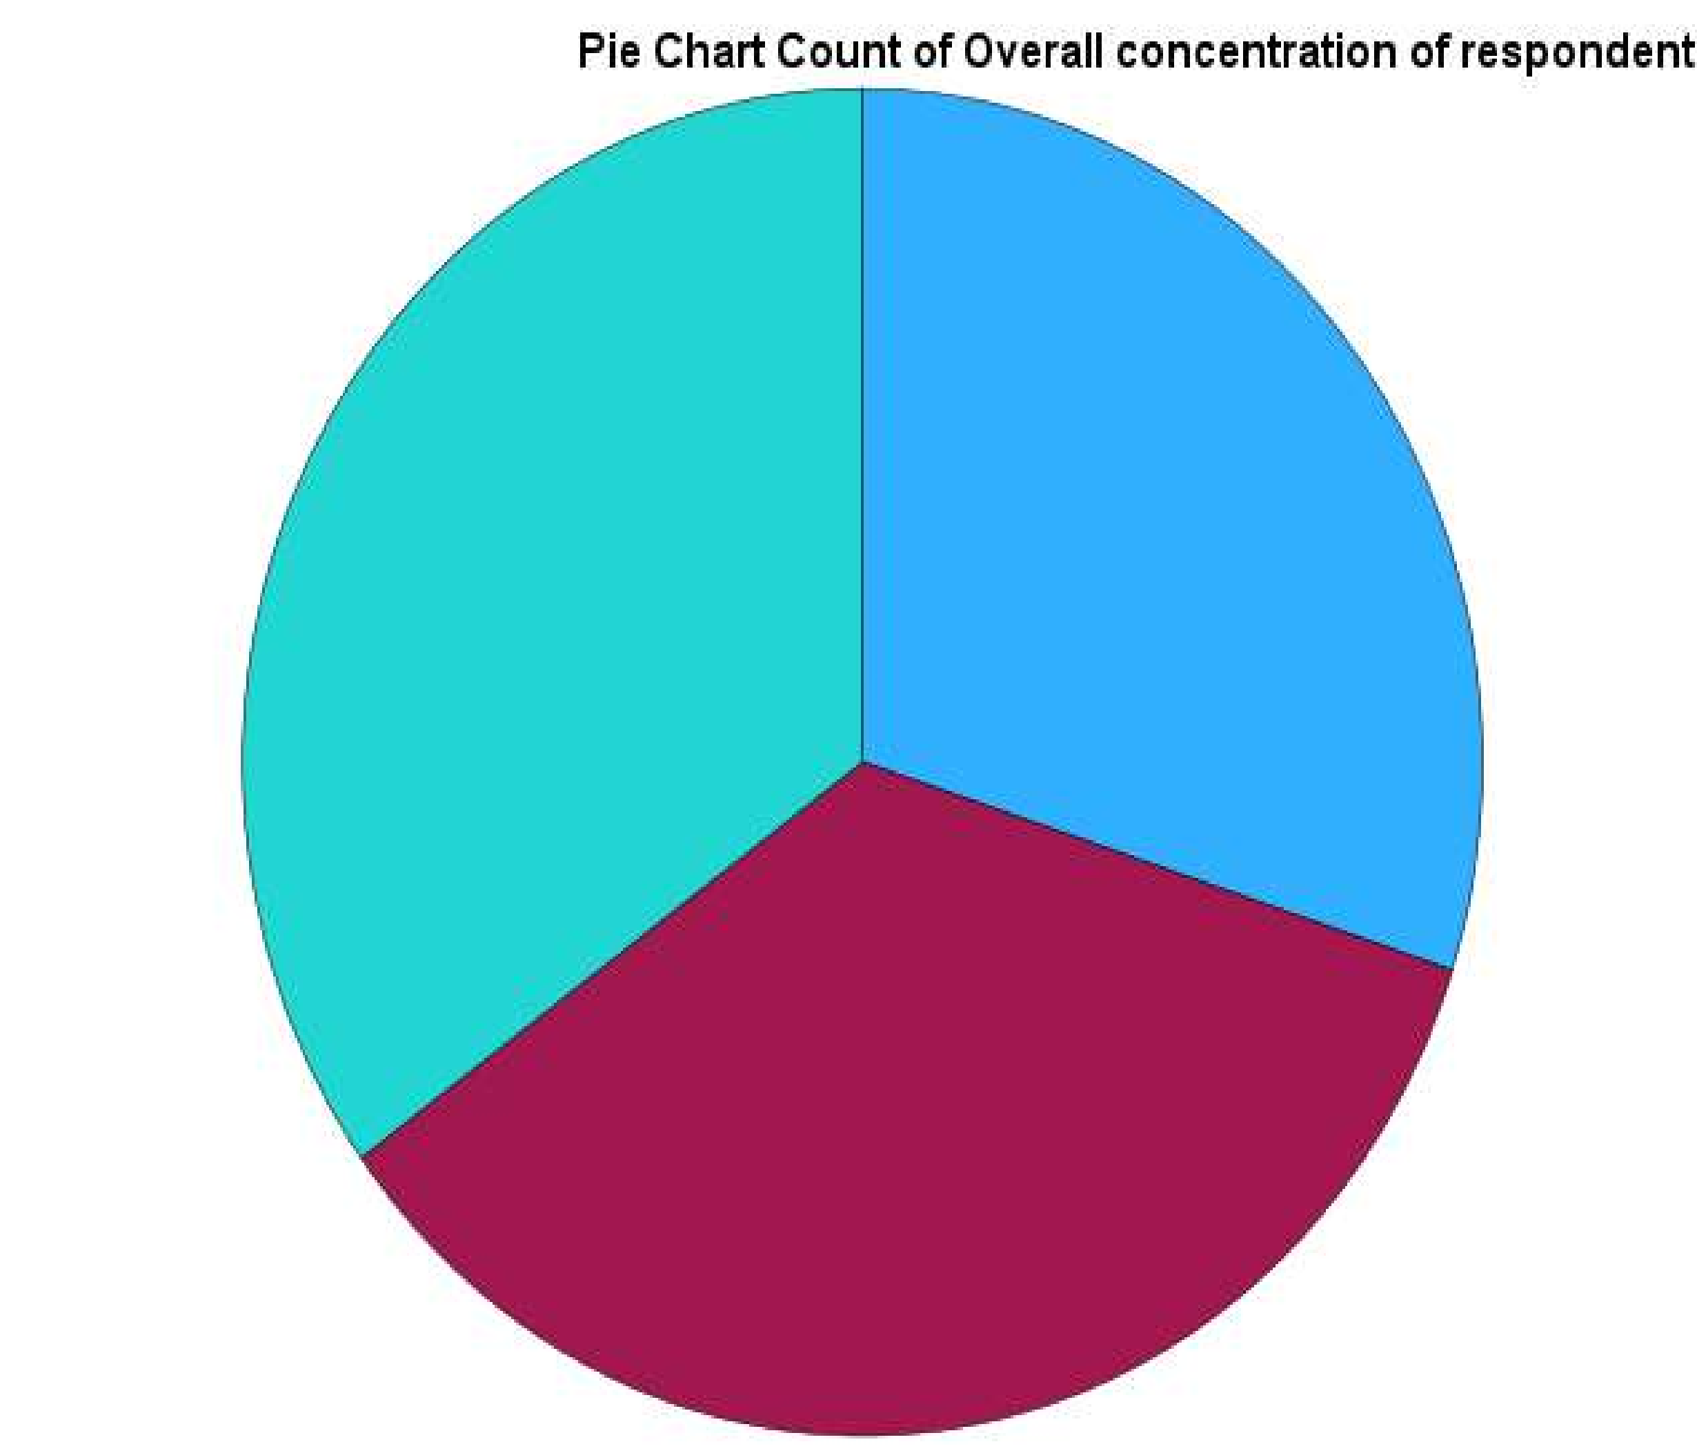

The segments appear almost equal, meaning the number of respondents who rated their concentration as Poor, Fair, or
Good are roughly the same. This suggests a balanced distribution there’s no single category that dominates Respondents are nearly evenly split in how they rate their overall concentration. About one-third report Poor concentration, one-third Fair, and one-third Good. This shows variability in how students perceive their focus or attention ability.

Case Processing Summary
Cases
Valid  N |  | Percent | Missing |  | Total  N | Percent
 |  |  | N | Percent
Study groups of respondent * Academic performance of respondent | 20 | 100.0% | 0 | 0.0% | 20 | 100.0%

Study groups of respondent * Academic performance of respondent Crosstabulation
Count
 | Academic performance of respondent |  |  |  | Total
 | Not satisfied |  | Somewhat  satisfied | Very satisfied
Study groups of respondent | Alone | 5 | 2 | 8 | 15
 | In a Group | 1 | 1 | 3 | 5
Total |  | 6 | 3 | 11 | 20
The data hints that students studying in a group are slightly more likely to report being very satisfied than those studying alone. But the sample size is small, and the counts in some cells are low — this limits confidence in any effect. Without output from a chi-square test (including p-value and expected counts), we cannot confirm a statistically significant relationship.

Correlations
Questionnaire  Id |  |  | Age of respondent
Questionnaire Id | Pearson Correlation | 1 | .064
 | Sig. (2-tailed) |  | .802
 | N | 20 | 18
Age of respondent | Pearson Correlation | .064 | 1
 | Sig. (2-tailed) | .802
 | N | 18 | 18

As one summary puts it:
“High p-value means you cannot reject the null hypothesis that the population correlation = 0.” Another note:
“A sample correlation of 0.064 with p = 0.802 just means inconclusive you can’t generalize to the population”

INTRODUCTION.

This report analyzes survey data collected from 20 respondents on various academic and personal study factors, including age, gender, study hours, internet usage, concentration, and academic performance. The objective is to understand patterns that may influence students’ academic outcomes.

METHODOLOGY.

The data was collected by just asking all the students in a classroom but the minimum of 20 students was selected with no repeatition.

CONCLUSION.

Age of Respondents ranged from 18 to 26 years, with a mean of 22.22, indicating a young adult university population. Gender was nearly balanced but slightly skewed toward one gender (mean = 1.45), suggesting a modest majority of either males or females depending on coding. Study and Academic Habits Average hours of study per week: Mean = 38.78 hours, but with a high standard deviation (16.88), indicating large variation among students. Average academic mark: Mean = 64.41%, with scores ranging from 33% to 89%, also showing high variation. Time management and overall concentration were rated on a scale (likely 0–2), with average ratings of
0.85 and 1.05 respectively — showing moderate self-assessment. Graphical Analysis
Bar Chart: Hours of Study vs. Academic Marks
- The chart shows that students with higher average marks tend to report more study hours.
- This suggests a positive relationship between study time and academic performance.
- However, large error bars indicate variability — not all high-performing students study extensively, and not all long-hour studiers perform best.

Pie Chart: Overall Concentration
•The respondents’ self-reported concentration levels are almost evenly split among “Poor”, “Fair”, and “Good”.
•This reflects diversity in attention and focus skills within the group, which could impact performance or study behavior.

Correlation (r) between Questionnaire Id and Age of respondent was computed as r = 0.064, indicating an extremely weak, nearly zero linear relationship.
The p-value for the test was p = 0.802, far above typical significance threshold α = 0.05, meaning the result is not statistically significant. The analysis included ≈ 18 observations, a notably small sample size. P-value limits: A high p-value does not prove the absence of a relationship—it merely fails to prove it exists. You simply lack evidence, not that the effect is zero.
Effect size calibration: Statistical significance does not imply real-world importance, and vice versa: an effect may be practically important even if not significant in a small sample.
Replication concerns: Small, under-powered studies are vulnerable to the replication crisis, where published effects often fail to replicate due to overestimated effect sizes or chance frills. A Pearson correlation was conducted to examine the relationship between questionnaire ID and age of respondent. The analysis yielded r = 0.064, p = 0.802 (N ≈ 18), indicating a negligible linear association.
The high p-value indicates insufficient evidence to reject the null hypothesis that the true population correlation is zero. However, due to the small sample size, the statistical power was low—such that only a correlation of moderate to large size (roughly |r| ≥ 0.6) would likely be detectable. This leaves substantial uncertainty around the estimate, and a wide confidence interval likely would encompass zero. Visual inspection (via scatterplot) is recommended to assess potential outliers or non-linear trends. A non-parametric alternative (Spearman’s rho) may be informative. Crucially, a non-significant result should not be interpreted as proof of no effect, only that no effect was reliably detected under these conditions. Future studies with larger samples are needed to estimate the true population relationship with adequate precision.

