

**2024-2025-O‘QUV YILIDА UMUMTA’LIM MАKTАBLАRINING**

**9-SINF O‘QUVCHILАRI UCHUN YAKUNIY NAZORAT IMTIHONINI O‘TKAZISH BO‘YICHA MATEMATIKA FANIDAN SPETSIFIKATSIYASI**

**Tuzuvchilar: S.F.Salayev, M.X.Komilov, Sh.T.Kojamuratova** Pedagogik mahorat vaxalqaro baholash ilmiy-amaliy markazi mutaxassislari.

**Taqrizchilar: M. A. Mirzaxmedov** Pedagogik mahorat va xalqaro baholash ilmiy-amaliy markazi eksperti.

**D.E. Shnol-** Taʼlim bo‘yicha xalqaro ekspert.

**OʻZBEKISTON RESPUBLIKASI MAKTABGACHA VA MAKTAB TAʼLIMI VAZIRINING 2025-yil 20-fevraldagi “2024/2025-oʻquv yilida umumiy oʻrta taʼlim muassasalarida oʻquvchilarning yakuniy davlat attestatsiyasini tashkil etish va oʻtkazish toʻgʻrisida”gi 65-son buyrug‘i**

O‘quvchilarning matematika fanidan olgan bilim, ko‘nikma va malakalarini aniqlash uchun 2024– 2025-o‘quv yilida 9-sinflarda yakuniy imtihon yozma shaklda o‘tkaziladi.

**I. 9-sinflarda matematika fanidan yakuniy attestatsiya variantining tuzilishi.**

Imtihon ishining har bir varianti ikki qismdan iborat bo‘lib, shakli va murakkablik darajasi turlicha bo‘lgan 16 ta topshiriqni o‘z ichiga oladi (5-jadval).

**1-qism** 11 ta qisqa javobli topshiriqdan tashkil topgan. Bunda javob bitta son, birligi bilan yozilgan kattalik koʻrinishida berilishi kerak.

**2-qism** kengaytirilgan javobli 5 ta topshiriqni o‘z ichiga oladi, ularda masalaning yechimini asoslab, chizmalari bilan taqdim etish lozim.

Har bir imtihon variantining savol va topshiriqlari matematika fani bo‘yicha umumtaʻlim maktablarning 5-, 6-, 7-, 8-, 9-sinflari mavzularini, Sonlar va amallar, Algebra va funksiya, Statistika va ehtimollik hamda Geometriya va o‘lchash mazmun sohalarini qamrab olgan. Shuningdek, tavsiyada bilishga oid savollar, qo‘llashga va mulohazaga oid topshiriqlar bo‘yicha baholash mezonlari keltirilgan.

Har bir variantda o‘quvchiga 16 tadan (10 ta algebra, 6 ta geometriya) savol beriladi. Savollarning 4 tasi (2 ta algebra, 2 ta geometriya) bilishga, 10 tasi (7 ta algebra, 3 ta geometriya) qo‘llashga, 2 tasi (1 ta algebra, 1 ta geometriya) mulohazaga oid bo‘ladi. Variant topshiriqlarini bajarish uchun 180 daqiqa vaqt beriladi.

Oʻquvchilarning yozma ishlari algebra 100 ball va geometriya 100 ball asosida baholanadi:

0 – 29% – “qoniqarsiz”;

30–65% – “qoniqarli”;

66–85% – “yaxshi”;

86–100% – “a’lo”.

Javoblar varaqasini to‘ldirish shartlari:

qisqa javobli topshiriqlarning javoblari faqat raqamlarda yoki bosma harflarda, topshiriqda so‘ralgan o‘lchov birliklarida (bosma harflarda) yozilishi kerak, aks holda 0 ball qo‘yiladi, bunda har bir katakka bitta simvol yozilishi kerak;

har bir katakka faqat bitta raqam yoziladi, agar javob manfiy son bo‘lsa, minus belgisi alohida katakka yoziladi, o‘nli kasr bo‘lsa vergul ham alohida katakka yoziladi, burchakning qiymati so‘ralgan topshiriqlarda burchak gradus o‘lchov birligida gradus belgisisiz yoziladi;

kengaytirilgan javobli topshiriqlar alohida javob varag‘iga yoziladi va baholovchi fan ekspertlari tomonidan belgilangan mezonlar asosida tekshiriladi. Har bir topshiriq uchun batafsil baholash mezonlari berilgan bo‘lib, unda har bir ball (noldan maksimal ballgacha) qanday holatda qo‘yilishi aniq ko‘rsatiladi;

har bir topshiriq uchun belgilangan balldan yuqori ball qoʻyilishiga yoʻl qoʻyilmaydi.

1-jadval

*Sinov materiallarining qismlar boʻyicha taqsimoti*

|  |  |  |  |  |  |  |  |
| --- | --- | --- | --- | --- | --- | --- | --- |
| **Qism** | **Topshiriqlar soni** | **Algebra** | **Geometriya** | **Topshiriq shakli** | **Algebra bali** | **Geometriya bali** | **Qism ulushi %** |
| 1-qism | 11 | 7 | 4 | Javobi yoziladigan | 63 | 64 |  |
| 2-qism | 5 | 3 | 2 | Toʻliq yechimi keltirilgan | 37 | 36 |  |
| Jami | 16 | 10 | 6 |  | 100 | 100 | 100 |

2-jadval

*Mazmun sohalari boʻyicha topshiriqlarning taqsimoti*

|  |  |  |  |  |  |
| --- | --- | --- | --- | --- | --- |
| **Mazmun soha** | **Topshiriqlar soni** | **Topshiriqlarning foizi** | **Qisqa javobli bali** | **Toʻliq javobli bali** | **Jami ball** |
| Sonlar va amallar | 3 | 18 | 27 |  | 27 |
| Algebra va funksiya | 6 | 38 | 27 | 37 | 64 |
| Ehtimollar nazariyasi va statistika | 1 | 6 | 9 |  | 9 |
| Geometriya va o‘lchash | 6 | 38 | 64 | 36 | 100 |

3-jadval

*Baholanadigan koʻnikmalar taqsimoti*

|  |  |  |  |
| --- | --- | --- | --- |
| **Fan** | **Bilish** | **Qoʻllash** | **Mulohaza** |
| Algebra | 2 | 7 | 1 |
| Geometriya | 2 | 3 | 1 |
| Jami | 4 | 10 | 2 |

B-bilish, reproduktiv darajadagi topshiriqlarining mazmuni o‘quvchilar tomonidan o‘quv materiali qayta ishlanmasdan, ularning xotira qobiliyatini aniqlovchi, qonuniyatlar, xossalar, formula, tushuncha va atamalarning mohiyatini bilish, ***yodda saqlash va tanish, odatiy vaziyatlarda*** qo‘llashga qaratilgan.

Q-qo‘llash, produktiv o‘quv topshiriqlari – o‘quvchilardan o‘rganilgan mavzuga oid qonun va qonuniyatlar, xossalar va formulalarni qo‘llash, berilgan topshiriqlarga mos usullarni tanlash, tahlil qilish, taqqoslash, qiyoslash*,* ***bir nechta qonun va qonuniyatlarni*** bir vaqtda qo‘llab, umumlashtirish va xulosa yasashni talab qiladi.

M-mulohaza, intellektual darajadagi topshiriqlar o‘zlashtirilgan bilim, ko‘nikma va malakalarni ***notanish vaziyatlarda*** qo‘llash, tahlil qilish, sintezlash, qiyosiy taqqoslash, qonun va qonuniyatlarni qo‘llab, umumlashtirishni talab qiladi.

4-jadval

*Sinov materiallari ballarining taqsimoti*

|  |  |  |  |
| --- | --- | --- | --- |
|  | **Qisqa javobli bali/soni** | **Toʻliq yechimli bali/soni** | **Jami** |
| Algebra | 9 ball / 7 ta | 12 ball/ 2 ta, 13 ball / 1 ta | 100 |
| Geometriya | 16 ball / 4 ta | 18 ball / 2 ta | 100 |

5-jadval

*Topshiriqlarda baholanadigan koʻnikmalar*

|  |  |  |  |  |  |  |
| --- | --- | --- | --- | --- | --- | --- |
| **Topshiriq tartib raqami** | **Boʻlim nomi** | **Baholanadigan koʻnikmalar** | **Koʻnikma darajasi** | **Topshiriq shakli** | **Ball** | **Qism** |
| **Algebra** | | | | | |  |
| 1 | Hisoblashga doir mashqlar yechish (Kasrlar ustida amallar bajarish.  Ratsional ko‘rsatkichli daraja xossalari, darajali ildiz xossalari) | Sonli ifodalarni qiymatini topishda, kasrlar ustida to‘rt amallarni bajarish qoidalarida, daraja xossalaridan, ildiz xossalaridan foydalana oladi | B | Qisqa javobli | 9 | I |
| 2 | Qisqa ko‘paytirish formulalarining tadbiqlari | Algebraik ifodalar ustida amallar bajarishda, ifodalarni soddalashtirishda qisqa ko‘paytirish formulalaridan foydalana oladi | Q | Qisqa javobli | 9 | I |
| 3 | Kombinatorika masalalari. Ma’lumotlar tahlili | Kombinatorika masalalarini yechishda qo‘shish va ko‘paytirish xossalarini, guruhlash va o‘rin almashtirish formulalarini qo‘llay oladi, berilgan sonli qator ko‘rinishidagi ma’lumotlarni tahlil qila oladi | B | Qisqa javobli | 9 | I |
| 4 | Kvadrat funksiyalar | Kvadrat funksiya grafigini chiza oladi, grafikka qarab funksiyaning aniqlanish va qiymatlar sohasini;  funksiyaning o‘sish va kamayish oraliqlarini aniqlay oladi | Q | Toʻliq yechimli | 13 | II |
| 5 | Matnli masalalar | Foiz, harakat va ishga doir matnli masalalarni yecha oladi | Q | Qisqa javobli | 9 | I |
| 6 | Tenglamalar | Chiziqli, kvadrat va modul qatnashgan tenglamalarni yecha oladi, yechish usullarini masalalar yechishda qo‘llay oladi | Q | Qisqa javobli | 9 | I |
| 7 | Tengsizliklar | Chiziqli tengsizliklar va tengsizliklar sistemasi, kvadrat tengsizlik, modul qatnashgan tengsizliklarni yecha oladi, yechimni sonlar o‘qida tasvirlay oladi, yechimni sonli oraliq ko‘rinishida tasvirlay oladi | Q | Toʻliq yechimli | 12 | II |
| 8 | Tenglamalar va tenglamalar sistemasi yordamida masalalar yechish | Masalalar yechishda tenglamalar va tenglamalar sistemasi yechish usullarini qo‘llay oladi | M | Toʻliq yechimli | 12 | II |
| 9 | Trigonometriya elementlari | Trigonometrik funksiyalarni burchaklardagi qiymatini aniqlay oladi, bir-biri bilan bog‘lay oladi | Q | Qisqa javobli | 9 | I |
| 10 | Progressiyalar. | Progressiyalarga doir matnli masalalarni yecha oladi | Q | Qisqa javobli | 9 | I |
| **Geometriya** | | | | | |  |
| 11 | Burchak | Noma’lum burchak qiymatlarini topishda parallellik alomatlarini qo‘llay oladi; soat va minut millari hosil qilgan burchak qiymatlarini topa oladi; uchburchakning noma’lum burchaklari qiymatlarini topa oladi | B | Qisqa javobli | 16 | I |
| 12 | Uchburchaklar. Pifagor teoremasi | Uchburchaklar elementlarini bir-biri bilan bog‘lay oladi, uchburchak yuzini topishga doir masalalar yechishda Pifagor teoremasini tadbiq qila oladi | Q | Toʻliq yechimli | 18 | II |
| 13 | To‘rtburchaklar: kvadrat, to‘g‘ri to‘rtburchak, parallelogramm, romb va trapetsiya | Chizma bilan berilgan to‘rtburchaklar: kvadrat, to‘g‘ri to‘rtburchak, parallelogramm, romb va trapetsiya xossalarini keltira oladi, perimetri va yuzini topa oladi | Q | Qisqa javobli | 16 | I |
| 14 | Aylana va doira | Aylana uzunligi va doira, doira bo‘laklari yuzini aniqlay oladi; masalalar yechishda aylanadagi metrik munosabatlardan foydalana oladi, aylana va doira tenglamasini tuza oladi | B | Qisqa javobli | 16 | I |
| 15 | Muntazam ko‘pburchaklar va ularga ichki va tashqi chizilgan aylana | Muntazam ko‘pburchaklar tomoni bilan unga ichki va tashqi chizilgan aylana radiusini bog‘lay oladi | Q | Qisqa javobli | 16 | I |
| 16 | Sinuslar va kosinuslar teoremalari tadbiqlari. Uchburchaklarning o‘xshashligi | Uchburchak elementlarini topishda, sinuslar, kosinuslar teoremalari va o‘xshashlik xossalarini tadbiq qila oladi | M | Toʻliq yechimli | 18 | II |

**Foydalanilgan adabiyotlar**

1. Matematika 5-sinf darslik. I va II qism. B.Xaydarov. Toshkent 2020.
2. Matematika 6-sinf darslik. Sh.Ismailov (va boshqalar). Toshkent 2022.
3. Algebra 7-sinf darslik. A.Akmalov (va boshqalar). Toshkent: Respublika ta’lim markazi 2022.
4. Geometriya 7-sinf darslik. B.Xaydarov, N.Tashtemirova. I.Asrorov. Toshkent: Respublika ta’lim markazi 2022.
5. Algebra: 8-sinf darslik. Sh.A.Alimov, A.R.Xalmuxamedov, M.A.Mirzaxmedov. Toshkent: “O‘qituvchi” 2019.
6. Geometriya: 8-sinf darslik. A.A.Rahimqoriyev. Toshkent: “O‘zbekiston” 2019.
7. Algebra 9-sinf darslik. Sh.A.Alimov, A.R.Xalmuxammedov, M.A.Mirzaxmedov. Toshkent: “O‘qituvchi”, 2019.
8. Geometriya 9-sinf darslik. B.Q.Xaydarov, E.S.Sariqov, A.Sh.Qo‘chqorov. Toshkent: “Huquq va Jamiyat”, 2019.

**9 sinf yakuniy imtihon materiallari Algebra topshiriqlari**

**I. Hisoblashga doir mashqlar yechish (Kasrlar ustida amallar bajarish. Ratsional ko‘rsatkichli daraja xossalari, darajali ildiz xossalari)**

1. Hisoblang:

Javob:___________________________________

2. Hisoblang:

Javob:___________________________________

3. Hisoblang:

Javob:___________________________________

4. Hisoblang:

Javob:___________________________________

5. Hisoblang:

Javob:___________________________________

6. Hisoblang:

Javob:___________________________________

7. Hisoblang:

Javob:___________________________________

8. Hisoblang:

Javob:___________________________________

9. Hisoblang:

Javob:___________________________________

10. Hisoblang:

Javob:___________________________________

11. Hisoblang:

Javob:___________________________________

12. Hisoblang:

Javob:___________________________________

13. Hisoblang:

Javob:___________________________________

14. Hisoblang:

Javob:___________________________________

15. Hisoblang:

Javob:___________________________________

16. Hisoblang:

Javob:___________________________________

17. Hisoblang:

Javob:___________________________________

18. Hisoblang:

Javob:___________________________________

19. Hisoblang:

Javob:___________________________________

20. Hisoblang:

Javob:___________________________________

**II. Qisqa ko‘paytirish formulalarining tadbiqlari**

1. Ifodani soddalashtiring:

Javob:___________________________________

2. Ifodani soddalashtiring:

Javob:___________________________________

3. Ifodani soddalashtiring:

Javob:___________________________________

4. Ifodani soddalashtiring:

Javob:___________________________________

5. Ifodani soddalashtiring:

Javob:___________________________________

6. Ifodani soddalashtiring:

Javob:___________________________________

7. Ifodani soddalashtiring:

Javob:___________________________________

8. Ifodani soddalashtiring:

Javob:___________________________________

9. Ifodani soddalashtiring:

Javob:___________________________________

10. Ifodani soddalashtiring:

Javob:___________________________________

11. Ifodani soddalashtiring:

Javob:___________________________________

12. Ifodani soddalashtiring:

Javob:___________________________________

13. Ifodani soddalashtiring:

Javob:___________________________________

14. Ifodani soddalashtiring:

Javob:___________________________________

15. Ifodani soddalashtiring:

Javob:___________________________________

16.Ifodani soddalashtiring:

Javob:___________________________________

17. Ifodani soddalashtiring:

Javob:___________________________________

18. Ifodani soddalashtiring:

Javob:___________________________________

19. Ifodani soddalashtiring:

Javob:___________________________________

20. Ifodani soddalashtiring:

Javob:___________________________________

**III. Kombinatorika masalalari. Ma’lumotlar tahlili**

1. Maktab kutubxonasida informatika bo‘yicha 4 xil, xorijiy tillarni o‘rganish bo‘yicha 5 xil va matematika bo‘yicha 3 xil qo‘llanma bor. Jasur ikki xil sohadagi qo‘llanmalardan bittadan olib, bilimlarini mustahkamlamoqchi. Nechta turli usulda tanlash mumkin?

Javob:___________________________________

2. Sizga ingliz tilidagi 7 ta qiziqarli kitob tavsiya qilindi. Ushbu oyda o‘z bilimlaringizni oshirish uchun ulardan 3 tasini tanlab o‘qimoqchisiz. Siz bu tanlovni nechta usulda amalga oshirishingiz mumkin?

Javob:___________________________________

3. Ekologik tanlovda ishtirok etgan 12 ta maktab orasidan tabiatni asrash, chiqindilarni qayta ishlash va suvni tejash bo‘yicha 1-, 2-, 3-o‘rinlar belgilanmoqda. Bu mukofotli o‘rinlar maktablar orasida necha xil usul bilan taqsimlanishi mumkin?

Javob:___________________________________

4. Ikkita har xil juft raqamdan tashkil topgan nechta ikki xonali son mavjud?

Javob:___________________________________

5. Onlayn ta’lim platformasida 3 xil grafik dizayn, 4 xil dasturlash va 2 xil ingliz tili kurslari mavjud. Dilshod ikki xil yo‘nalishdan bittadan kurs olib, mustaqil ta’lim olishga qaror qildi. U nechta xil usulda kurslarni tanlashi mumkin?

Javob:___________________________________

6. Maktabdagi til kursida 8 xil chet tili mashg‘ulotlari mavjud. Siz bu yil davomida kamida 4 tasida qatnashib, bilim doirangizni kengaytirmoqchisiz. Bu kurslarni necha xil usulda tanlashingiz mumkin?

Javob:___________________________________

7. "Toza shahar" ekologik loyihasida qatnashayotgan 10 ta guruh orasidan 1 ta guruh ekologiya bo‘yicha "Eng yaxshi loyiha", 1 ta guruh "Eng yaxshi suvni tejash g‘oyasi", yana 1 ta guruh "Eng yaxshi tabiatni asrash loyihasi" nominatsiyasida g‘olib bo‘ladi. Ushbu nominatsiyalar nechta usulda taqsimlanishi mumkin?

Javob:___________________________________

8. Raqamlari turli va 4 dan katta bo‘lmagan nechta ikki xonali son mavjud?

Javob:___________________________________

9. Elektronika do‘konida 6 xil sichqoncha (mouse), 3 xil klaviatura va 5 xil flesh-xotira mavjud. Sanjar bu mahsulotlardan turli nomdagi ikkita mahsulot sotib olishni istaydi. Sanjarning nechta turli tanlov varianti mavjud?

Javob:___________________________________

10. Xalqaro ta’lim dasturiga qatnashish imkoniyati sifatida 6 xil xorijiy mamlakatda o‘quv seminarlari mavjud. Siz ulardan aynan 2 ta mamlakatga borib bilim olishni rejalashtiryapsiz. Nechta turli xil tanlov amalga oshira olasiz?

Javob:___________________________________

11. Maktabda o'tkazilgan ekologik aksiyada qatnashgan 15 o‘quvchidan 1-o‘ringa – "Atrof-muhit posboni", 2-o‘ringa – "Tabiat himoyachisi", 3-o‘ringa – "Suvni tejash faoli" medallari beriladi. Ushbu medallar nechta usulda taqsimlanishi mumkin?

Javob:___________________________________

12. Raqamlari turli va 5 dan katta bo‘lmagan nechta ikki xonali son mavjud?

Javob:___________________________________

13. Texnologiyalar markazida xorijiy tillarni o‘rgatuvchi 3 xil mobil dastur, dasturlashni o‘rgatuvchi 4 xil mobil dastur hamda matematikani oson o‘zlashtirish uchun 2 xil mobil dastur mavjud. Sarvinoz turli nomdagi ikki xil soha bo‘yicha ikkita dasturni smartfoniga yuklab olmoqchi bo‘lsa, nechta usulda tanlovni amalga oshirishi mumkin?

Javob:___________________________________

14. Internetdagi ilmiy-ta’limiy vebinarda 5 xil mavzuda veb-darslar e'lon qilindi. Siz shulardan aynan 3 ta eng kerakli va foydalisini tanlab ko‘rmoqchisiz. Sizning tanlovingiz nechta turli usulda amalga oshiriladi?

Javob:___________________________________

15. Hududdagi ekologik muammolarni hal qilish bo‘yicha 8 xil loyiha orasidan hakamlar 1-o‘rin (tabiatni asrash), 2-o‘rin (atrof-muhitni toza saqlash), 3-o‘rin (suv resurslarini tejash) uchun eng yaxshi loyihalarni tanlaydi. Ushbu tanlov necha xil usulda amalga oshiriladi?

Javob:___________________________________

16. Ikkita har xil toq raqamdan tashkil topgan nechta ikki xonali son mavjud?

Javob:___________________________________

17. Elektronika aksessuarlari sotiladigan do‘konda 6 xil smart-soat, 8 xil simsiz quloqchin va 5 xil portativ quvvatlagich (power bank) mavjud. Sevinch opa ushbu do‘kondan turli nomdagi ikkita mahsulot xarid qilishni rejalashtiryapti. Sevinch opa nechta turli usul bilan xarid amalga oshirishi mumkin?

Javob:___________________________________

18. Sport bilan shug’ullanishingiz uchun ustozingiz sizga 5 xil sport mashg‘ulotlarini tavsiya qildi. Siz ulardan 2 tasini tanlamoqchisiz. Buni necha xil usulda amalga oshirish mumkin?

Javob:___________________________________

19. Ekologik video-roliklar tanlovida ishtirok etgan 9 ta jamoa orasidan "Eng yaxshi tabiatni muhofaza qilish videosi", "Eng yaxshi ekologik targ‘ibot videosi" va "Eng yaxshi suvni tejash videosi" nominatsiyalari bo‘yicha mukofotlar topshiriladi. Mukofotlar jamoalar orasida necha xil usul bilan taqsimlanishi mumkin?

Javob:___________________________________

20. Har bir raqami 6 dan kichik bo‘lmagan raqamlardan tashkil topgan nechta ikki xonali son mavjud?

Javob:___________________________________

**IV. Kvadrat funksiyalar**

1. funksiya grafigini chizing. Grafik asosida quyidagilarni aniqlang:

1) Funksiya grafigi koordinata tekisligining qaysi choraklarida o‘tishini;

2) Koordinata o‘qlari bilan kesishish nuqtalari;

3) Aniqlanish sohasi (ya’ni, ning qanday qiymatlari uchun funksiya mavjud);

4) Qiymatlar to‘plami (ya’ni, qanday qiymatlar qabul qiladi);

5) O‘sish va kamayish oraliqlari;

Yechish:

Javob:___________________________________

2. funksiya grafigini chizing. Grafik asosida quyidagilarni aniqlang:

1) Funksiya grafigi koordinata tekisligining qaysi choraklarida o‘tishini;

2) Koordinata o‘qlari bilan kesishish nuqtalari;

3) Aniqlanish sohasi (ya’ni, ning qanday qiymatlari uchun funksiya mavjud);

4) Qiymatlar to‘plami (ya’ni, qanday qiymatlar qabul qiladi);

5) O‘sish va kamayish oraliqlari;

Yechish:

Javob:___________________________________

3. funksiya grafigini chizing. Grafik asosida quyidagilarni aniqlang:

1) Funksiya grafigi koordinata tekisligining qaysi choraklarida o‘tishini;

2) Koordinata o‘qlari bilan kesishish nuqtalari;

3) Aniqlanish sohasi (ya’ni, ning qanday qiymatlari uchun funksiya mavjud);

4) Qiymatlar to‘plami (ya’ni, qanday qiymatlar qabul qiladi);

5) O‘sish va kamayish oraliqlari;

Yechish:

Javob:___________________________________

4. funksiya grafigini chizing. Grafik asosida quyidagilarni aniqlang:

1) Funksiya grafigi koordinata tekisligining qaysi choraklarida o‘tishini;

2) Koordinata o‘qlari bilan kesishish nuqtalari;

3) Aniqlanish sohasi (ya’ni, ning qanday qiymatlari uchun funksiya mavjud);

4) Qiymatlar to‘plami (ya’ni, qanday qiymatlar qabul qiladi);

5) O‘sish va kamayish oraliqlari;

Yechish:

Javob:___________________________________

5. funksiya grafigini chizing. Grafik asosida quyidagilarni aniqlang:

1) Funksiya grafigi koordinata tekisligining qaysi choraklarida o‘tishini;

2) Koordinata o‘qlari bilan kesishish nuqtalari;

3) Aniqlanish sohasi (ya’ni, ning qanday qiymatlari uchun funksiya mavjud);

4) Qiymatlar to‘plami (ya’ni, qanday qiymatlar qabul qiladi);

5) O‘sish va kamayish oraliqlari;

Yechish:

Javob:___________________________________

6. funksiya grafigini chizing. Grafik asosida quyidagilarni aniqlang:

1) Funksiya grafigi koordinata tekisligining qaysi choraklarida o‘tishini;

2) Koordinata o‘qlari bilan kesishish nuqtalari;

3) Aniqlanish sohasi (ya’ni, ning qanday qiymatlari uchun funksiya mavjud);

4) Qiymatlar to‘plami (ya’ni, qanday qiymatlar qabul qiladi);

5) O‘sish va kamayish oraliqlari;

Yechish:

Javob:___________________________________

7. funksiya grafigini chizing. Grafik asosida quyidagilarni aniqlang:

1) Funksiya grafigi koordinata tekisligining qaysi choraklarida o‘tishini;

2) Koordinata o‘qlari bilan kesishish nuqtalari;

3) Aniqlanish sohasi (ya’ni, ning qanday qiymatlari uchun funksiya mavjud);

4) Qiymatlar to‘plami (ya’ni, qanday qiymatlar qabul qiladi);

5) O‘sish va kamayish oraliqlari;

Yechish:

Javob:___________________________________

8. funksiya grafigini chizing. Grafik asosida quyidagilarni aniqlang:

1) Funksiya grafigi koordinata tekisligining qaysi choraklarida o‘tishini;

2) Koordinata o‘qlari bilan kesishish nuqtalari;

3) Aniqlanish sohasi (ya’ni, ning qanday qiymatlari uchun funksiya mavjud);

4) Qiymatlar to‘plami (ya’ni, qanday qiymatlar qabul qiladi);

5) O‘sish va kamayish oraliqlari;

Yechish:

Javob:___________________________________

9. funksiya grafigini chizing. Grafik asosida quyidagilarni aniqlang:

1) Funksiya grafigi koordinata tekisligining qaysi choraklarida o‘tishini;

2) Koordinata o‘qlari bilan kesishish nuqtalari;

3) Aniqlanish sohasi (ya’ni, ning qanday qiymatlari uchun funksiya mavjud);

4) Qiymatlar to‘plami (ya’ni, qanday qiymatlar qabul qiladi);

5) O‘sish va kamayish oraliqlari;

Yechish:

Javob:___________________________________

10. funksiya grafigini chizing. Grafik asosida quyidagilarni aniqlang:

1) Funksiya grafigi koordinata tekisligining qaysi choraklarida o‘tishini;

2) Koordinata o‘qlari bilan kesishish nuqtalari;

3) Aniqlanish sohasi (ya’ni, ning qanday qiymatlari uchun funksiya mavjud);

4) Qiymatlar to‘plami (ya’ni, qanday qiymatlar qabul qiladi);

5) O‘sish va kamayish oraliqlari;

Yechish:

Javob:___________________________________

11. funksiya grafigini chizing. Grafik asosida quyidagilarni aniqlang:

1) Funksiya grafigi koordinata tekisligining qaysi choraklarida o‘tishini;

2) Koordinata o‘qlari bilan kesishish nuqtalari;

3) Aniqlanish sohasi (ya’ni, ning qanday qiymatlari uchun funksiya mavjud);

4) Qiymatlar to‘plami (ya’ni, qanday qiymatlar qabul qiladi);

5) O‘sish va kamayish oraliqlari;

Yechish:

Javob:___________________________________

12. funksiya grafigini chizing. Grafik asosida quyidagilarni aniqlang:

1) Funksiya grafigi koordinata tekisligining qaysi choraklarida o‘tishini;

2) Koordinata o‘qlari bilan kesishish nuqtalari;

3) Aniqlanish sohasi (ya’ni, ning qanday qiymatlari uchun funksiya mavjud);

4) Qiymatlar to‘plami (ya’ni, qanday qiymatlar qabul qiladi);

5) O‘sish va kamayish oraliqlari;

Yechish:

Javob:___________________________________

13. funksiya grafigini chizing. Grafik asosida quyidagilarni aniqlang:

1) Funksiya grafigi koordinata tekisligining qaysi choraklarida o‘tishini;

2) Koordinata o‘qlari bilan kesishish nuqtalari;

3) Aniqlanish sohasi (ya’ni, ning qanday qiymatlari uchun funksiya mavjud);

4) Qiymatlar to‘plami (ya’ni, qanday qiymatlar qabul qiladi);

5) O‘sish va kamayish oraliqlari;

Yechish:

Javob:___________________________________

14. funksiya grafigini chizing. Grafik asosida quyidagilarni aniqlang:

1) Funksiya grafigi koordinata tekisligining qaysi choraklarida o‘tishini;

2) Koordinata o‘qlari bilan kesishish nuqtalari;

3) Aniqlanish sohasi (ya’ni, ning qanday qiymatlari uchun funksiya mavjud);

4) Qiymatlar to‘plami (ya’ni, qanday qiymatlar qabul qiladi);

5) O‘sish va kamayish oraliqlari;

Yechish:

Javob:___________________________________

15. funksiya grafigini chizing. Grafik asosida quyidagilarni aniqlang:

1) Funksiya grafigi koordinata tekisligining qaysi choraklarida o‘tishini;

2) Koordinata o‘qlari bilan kesishish nuqtalari;

3) Aniqlanish sohasi (ya’ni, ning qanday qiymatlari uchun funksiya mavjud);

4) Qiymatlar to‘plami (ya’ni, qanday qiymatlar qabul qiladi);

5) O‘sish va kamayish oraliqlari;

Yechish:

Javob:___________________________________

16. funksiya grafigini chizing. Grafik asosida quyidagilarni aniqlang:

1) Funksiya grafigi koordinata tekisligining qaysi choraklarida o‘tishini;

2) Koordinata o‘qlari bilan kesishish nuqtalari;

3) Aniqlanish sohasi (ya’ni, ning qanday qiymatlari uchun funksiya mavjud);

4) Qiymatlar to‘plami (ya’ni, qanday qiymatlar qabul qiladi);

5) O‘sish va kamayish oraliqlari;

Yechish:

Javob:___________________________________

17. funksiya grafigini chizing. Grafik asosida quyidagilarni aniqlang:

1) Funksiya grafigi koordinata tekisligining qaysi choraklarida o‘tishini;

2) Koordinata o‘qlari bilan kesishish nuqtalari;

3) Aniqlanish sohasi (ya’ni, ning qanday qiymatlari uchun funksiya mavjud);

4) Qiymatlar to‘plami (ya’ni, qanday qiymatlar qabul qiladi);

5) O‘sish va kamayish oraliqlari;

Yechish:

Javob:___________________________________

18. funksiya grafigini chizing. Grafik asosida quyidagilarni aniqlang:

1) Funksiya grafigi koordinata tekisligining qaysi choraklarida o‘tishini;

2) Koordinata o‘qlari bilan kesishish nuqtalari;

3) Aniqlanish sohasi (ya’ni, ning qanday qiymatlari uchun funksiya mavjud);

4) Qiymatlar to‘plami (ya’ni, qanday qiymatlar qabul qiladi);

5) O‘sish va kamayish oraliqlari;

Yechish:

Javob:___________________________________

19. funksiya grafigini chizing. Grafik asosida quyidagilarni aniqlang:

1) Funksiya grafigi koordinata tekisligining qaysi choraklarida o‘tishini;

2) Koordinata o‘qlari bilan kesishish nuqtalari;

3) Aniqlanish sohasi (ya’ni, ning qanday qiymatlari uchun funksiya mavjud);

4) Qiymatlar to‘plami (ya’ni, qanday qiymatlar qabul qiladi);

5) O‘sish va kamayish oraliqlari;

Yechish:

Javob:___________________________________

20. funksiya grafigini chizing. Grafik asosida quyidagilarni aniqlang:

1) Funksiya grafigi koordinata tekisligining qaysi choraklarida o‘tishini;

2) Koordinata o‘qlari bilan kesishish nuqtalari;

3) Aniqlanish sohasi (ya’ni, ning qanday qiymatlari uchun funksiya mavjud);

4) Qiymatlar to‘plami (ya’ni, qanday qiymatlar qabul qiladi);

5) O‘sish va kamayish oraliqlari;

Yechish:

Javob:___________________________________

**V. Matnli masalalar**

1. Belgilangan ishni 15 kishi 12 kunda bajarishi mumkin. 4 kun ishlagandan so‘ng, beshinchi kuni ularga yordam berish uchun 5 kishi kelib qo‘shildi. Qolgan ish necha kunda tugatilgan?

Javob:___________________________________

2. A va B shaharlar orasidagi masofa 210 km. A shahardan piyoda sayohatchi, B shahardan esa elektrovelosipedchi bir vaqtning o‘zida yo‘lga chiqishadi. Ular uchrashganida sayohatchi 42 km yo‘l bosgan bo‘ladi. Agar sayohatchining tezligi 6 km/h bo‘lsa, elektrovelosipedchining tezligini toping.

Javob:___________________________________

3. Laylo 5 kishidan iborat oilasi uchun palov tayyorlamoqchi bo‘lib, 500 gramm go‘sht sotib oladi. Ertasi kuni ularga 15 nafar mehmon kelishi ma’lum bo‘ldi. Laylo palovni barchaga tayyorlashi uchun qancha go‘sht sotib olishi kerak?

Javob:___________________________________

4. Suv sarfi birinchi oyda 10 % ga kamaydi, ikkinchi oyda esa yana 15 % ga kamaydi. Ikki oy davomida suv sarfi jami necha foizga kamaygan?

Javob:___________________________________

5. Bir ishni 10 kishi 8 kunda bajara oladi. 2 kundan so‘ng (uchinchi kuni) ularga yordam berish uchun bir nechta kishi kelib qo‘shildi va qolgan ish 4 kunda bajarildi. Nechta kishi kelib qo‘shilgan?

Javob:___________________________________

6. Maktabdan uyga 12 km masofa bor. O‘quvchi va o‘qituvchi bir vaqtning o‘zida, biri maktabdan uyga, boshqasi uydan maktabga qarab yo‘lga chiqdi. Ular uchrashganda o‘quvchi 4 km yurgan bo‘ladi. Agar o‘quvchi 4 km/h tezlikda yurgan bo‘lsa, o‘qituvchining tezligini toping.

Javob:___________________________________

7. Taxmina 4 kishidan iborat oilasi uchun palov tayyorlamoqchi bo‘lib, 500 gramm go‘sht sotib oladi. Ertasi kuni ularga 12 nafar mehmon kelishi ma’lum bo‘ldi. Taxmina palovni barchaga tayyorlashi uchun qancha go‘sht sotib olishi kerak?

Javob:___________________________________

8. Suv sarfi birinchi oyda 15 % ga kamaydi, ikkinchi oyda esa yana 10 % ga kamaydi. Ikki oy davomida suv sarfi jami necha foizga kamaygan?.

Javob:___________________________________

9. Ishchilar belgilangan vazifani 15 kunda bajara olishadi, 5 kundan so‘ng ularga yana 8 kishi qo‘shildi va birgalikda qolgan ishni 6 kunda tugallashdi. Ishchilar dastlab necha kishi edilar?

Javob:___________________________________

10. Daryo bo‘yidagi yugurish yo‘lagi 15 km. Ikki do‘st daryoning qarama-qarshi uchidan bir vaqtning o‘zida yugurishga tushdi. Ular uchrashganda biri 6 km bosib o‘tgan bo‘ladi. Agar uning tezligi 8 km/h bo‘lsa, ikkinchi do‘stning tezligini toping.

Javob:___________________________________

11. Oilasi uchun palov tayyorlashda Feruza 900 gramm go‘sht sotib oladi (bu palov Feruza, eri va 4 farzandi uchun mo‘ljallangan). Ertaga ularga 12 nafar mehmon keladi. Feruza palovni barchaga tayyorlaydi. U qancha go‘sht sotib olishi kerak?

Javob:___________________________________

12. Bir IT kompaniyasining foydasi birinchi chorakda 25 %, ikkinchi chorakda esa 30 % ga oshdi. Ikki chorak natijasida kompaniya foydasi jami necha foizga ortdi?

Javob:___________________________________

13. Bir noutbukni faqat video ko‘rib ishlatilsa, batareya 4 soatga yetadi. Agar video bilan birga yuklab olish (download) ham ishlatilsa, zaryad atigi 2 soatga yetadi. Noutbukni faqat yuklab olish rejimida ishlatilsa, zaryadi necha soatga yetadi?

Javob:___________________________________

14. Ona uydan maktabga qarab 3 km/h tezlikda yura boshladi. Shu vaqtda farzandi maktabdan uyga qarab velosipedda yo‘lga chiqdi. Uy va maktab orasidagi masofa 18 km. Ular uchrashganda ona 6 km yo‘l yurgan bo‘lsa, bolaning tezligini toping.

Javob:___________________________________

15. Oilasi uchun palov tayyorlashda Shaxlo 700 gramm guruch sotib oladi (bu palov Shaxlo, eri va 3 farzandi uchun mo‘ljallangan). Ertaga ularga 15 nafar mehmon keladi. Shaxlo palovni barchaga tayyorlaydi. U qancha guruch sotib olishi kerak?

Javob:___________________________________

16. Uyali aloqa operatori bir oyda internet tezligini 50 % ga oshirdi, keyingi oyda esa 20 % ga kamaytirdi. Natijada umumiy internet tezligi dastlabki tezlikka nisbatan qanday foiz o‘zgarishga uchradi?

Javob:___________________________________

17. Jamshidning telefonida 5 GB internet bor. Agar u faqat YouTube ko‘rsa, bu internet unga 10 soatga yetadi. Agar YouTube va onlayn o‘yin o‘ynasa, 4 soatga yetadi. Unda faqat onlayn o‘yin o‘ynasa, internet necha soatga yetadi?

Javob:___________________________________

18. Toshkent va Samarqand orasidagi masofa 300 km. Bir vaqtning o‘zida qarama-qarshi yo‘nalishda yuk mashinasi va avtomobil yo‘lga chiqdi. Ular uchrashganida yuk mashinasi 120 km yurgan bo‘ladi. Agar yuk mashinasining tezligi 60 km/h bo‘lsa, avtomobilning tezligini toping.

Javob:___________________________________

19. Oilasi uchun palov tayyorlashda Zuxra 900 gramm guruch sotib oladi (bu palov Zuxra, eri va 4 farzandi uchun mo‘ljallangan). Ertaga ularga 18 nafar mehmon keladi. Zuxra palovni barchaga tayyorlaydi. U qancha guruch sotib olishi kerak?

Javob:___________________________________

20. Bir do‘kondagi mahsulot narxi birinchi haftada 10 % ga arzonlashtirildi, ikkinchi haftada esa yana 20 % ga arzonlashtirildi. Umumiy narx kamayishi necha foizni tashkil qiladi?

Javob:___________________________________

**VI. Tenglamalar**

1. Tenglamani yeching:

Javob:___________________________________

2. Tenglamani yeching:

Javob:___________________________________

3. Tenglamani yeching:

Javob:___________________________________

4. Tenglamani yeching:

Javob:___________________________________

5. Tenglamani yeching:

Javob:___________________________________

6. Tenglamani yeching:

Javob:___________________________________

7. Tenglamani yeching:

Javob:___________________________________

8. Tenglamani yeching:

Javob:___________________________________

9. Tenglamani yeching:

Javob:___________________________________

10. Tenglamani yeching:

Javob:___________________________________

11. Tenglamani yeching:

Javob:___________________________________

12. Tenglamani yeching:

Javob:___________________________________

13. Tenglamani yeching:

Javob:___________________________________

14. Tenglamani yeching:

Javob:___________________________________

15. Tenglamani yeching:

Javob:___________________________________

16. Tenglamani yeching:

Javob:___________________________________

17. Tenglamani yeching:

Javob:___________________________________

18. Tenglamani yeching:

Javob:___________________________________

19. Tenglamani yeching:

Javob:___________________________________

20. Tenglamani yeching:

Javob:___________________________________

**VII. Tengsizliklar**

1. Tengsizliklar sistemasini yeching:

Yechish:

Javob:___________________________________

2. Tengsizlikni yeching: .

Yechish:

Javob:___________________________________

3. Tengsizlikni yeching: .

Yechish:

Javob:___________________________________

4. Tengsizlikni yeching: .

Yechish:

Javob:___________________________________

5. Tengsizliklar sistemasini yeching:

Yechish:

Javob:___________________________________

6. Tengsizlikni yeching: .

Yechish:

Javob:___________________________________

7. Tengsizlikni yeching: .

Yechish:

Javob:___________________________________

8. Tengsizlikni yeching: .

Yechish:

Javob:___________________________________

9. Tengsizliklar sistemasini yeching:

Yechish:

Javob:___________________________________

10. Tengsizlikni yeching: .

Yechish:

Javob:___________________________________

11. Tengsizlikni yeching: .

Yechish:

Javob:___________________________________

12. Tengsizlikni yeching: .

Yechish:

Javob:___________________________________

13. Tengsizliklar sistemasini yeching:

Yechish:

Javob:___________________________________

14. Tengsizlikni yeching: .

Yechish:

Javob:___________________________________

15. Tengsizlikni yeching:

Yechish:

Javob:___________________________________

16. Tengsizlikni yeching: .

Yechish:

Javob:___________________________________

17. Tengsizliklar sistemasini yeching:

Yechish:

Javob:___________________________________

18. Tengsizlikni yeching: .

Yechish:

Javob:___________________________________

19. Tengsizlikni yeching: .

Yechish:

Javob:___________________________________

20. Tengsizlikni yeching: .

Yechish:

Javob:___________________________________

**VIII. Tenglamalar va tenglamalar sistemasi yordamida masalalar yechish**

1. Onlayn kurslar. Alisher 3 ta dasturlash kursi va 2 ta ingliz tili kursiga yozilib, 500000 so‘m to‘ladi. Nodira esa 2 ta dasturlash va 4 ta ingliz tili kursiga 520000 so‘m to‘ladi. Har bir kurs qancha turadi?

Javob:___________________________________

2. O‘quv markazida fan to‘plamlari. Komil matematika bo‘yicha 2 ta va fizika bo‘yicha 3 ta test to‘plami sotib olib, 85000 so‘m to‘ladi. Dildora 3 ta matematika va 1 ta fizika to‘plamiga 75000 so‘m to‘ladi. Har bir fan test to‘plamining narxini toping.

Javob:___________________________________

3. Elektron qurilmalar. Bahodir 1 ta planshet va 2 ta simsiz quloqchin olib, 3200000 so‘m to‘ladi. Sohiba esa 2 ta planshet va 1 ta quloqchin uchun 4100000 million so‘m to‘ladi. 1 ta planshet va 1 ta simsiz quloqchin narxini toping.

Javob:___________________________________

4. Robototexnika darslari. Maktabda 4 ta elektronika to‘plami va 3 ta datchik to‘plamiga 260000 so‘m to‘landi. Boshqa bir maktab 2 ta elektronika to‘plami va 4 ta datchik to‘plami uchun 240000 so‘m to‘ladi. Har bir to‘plamning narxini toping.

Javob:___________________________________

5. Kutubxona obunasi. Ikrom 5 ta ilmiy jurnal va 2 ta badiiy kitob uchun 145000 so‘m to‘ladi. Lola 3 ta jurnal va 4 ta kitob uchun 155000 so‘m to‘ladi. Har birining narxini toping.

Javob:___________________________________

6. Xarid masalasi. Javohir supermarketdan 3 kg olma va 2 kg banan xarid qilib, jami 46000 so‘m to‘ladi. Uning ukasi Diyor esa 2 kg olma va 4 kg banan olib, 56000 so‘m to‘ladi. 1 kg olma va 1 kg banan narxini toping.

Javob:___________________________________

7. Ta’lim grantlari. Ilmiy tanlovda g‘olib bo‘lgan o‘quvchilardan biri 2 ta grant va 3 ta sertifikat uchun 560000 so‘m mukofot oldi. Boshqasi 4 ta grant va 1 ta sertifikat uchun 700000 so‘m oldi. Grant va sertifikat uchun beriladigan mukofat pullarini aniqlang.

Javob:___________________________________

8. Mobil ilovalar obunasi. Javohir bir oyda 2 ta til o‘rganish va 4 ta texnologik ilovaga obuna bo‘lib, 120000 so‘m to‘ladi. Nilufar esa 3 ta til va 1 ta texnologik ilovaga 110000 so‘m to‘ladi. Har bir ilova obunasi necha so‘m?

Javob:___________________________________

9. Olimpiada tayyorlov. Ilyos 3 ta fizika va 2 ta informatika darsida qatnashib, 230000 so‘m to‘ladi. Matluba 4 ta fizika va 3 ta informatika darsiga 340000 so‘m to‘lagan. Har bir fan uchun dars narxini aniqlang.

Javob:___________________________________

10. Kompyuter kurslari. Umida 2 ta grafik dizayn va 5 ta ofis dasturlari bo‘yicha kursga yozilib, 400000 so‘m to‘ladi. Sardor esa 4 ta grafik va 2 ta ofis kursiga 440000 so‘m to‘laydi. Har bir kursning narxini toping.

Javob:___________________________________

11. Xalqaro sertifikat imtihonlari. Aziz 1 ta IELTS va 2 ta ICDL imtihoni uchun 2400000 so‘m to‘ladi. Sevinch 2 ta IELTS va 1 ta ICDL uchun 3000000 so‘m to‘ladi. Har bir imtihon narxini toping.

Javob:___________________________________

12. Vebinar to‘plami. 3 ta marketing vebinari va 4 ta IT vebinari 280000 so‘mga tushdi. 2 ta marketing va 2 ta IT vebinari 180000 so‘m bo‘ldi. Har bir vebinarning narxini aniqlang.

Javob:___________________________________

13. Kompyuter jihozlari. Nodir 2 ta sichqoncha va 3 ta klaviaturaga 460000 so‘m to‘ladi. Akmal esa 3 ta sichqoncha va 1 ta klaviaturaga 410000 so‘m to‘ladi. Har birining narxini toping.

Javob:___________________________________

14. Robot kurslari ishtiroki. Azamat 4 ta nazariy va 2 ta amaliy darsga qatnashib, 500000 so‘m to‘ladi. Shahlo 3 ta nazariy va 4 ta amaliy darsga 640000 so‘m to‘lagan. Har bir dars turi narxini toping.

Javob:___________________________________

15. Elektron kitoblar. Muhammad 5 ta biologiya va 2 ta kimyo elektron kitobini 155000 so‘mga sotib oldi. Durdona esa 3 ta biologiya va 3 ta kimyo kitobiga 165000 so‘m to‘lagan. Har birining narxini toping.

Javob:___________________________________

16. Coding bootcamp. Bekzod 2 oy Python, 3 oy JavaScript kursiga qatnashib, 780000 so‘m to‘ladi. Akrom esa 4 oy Python va 1 oy JavaScript uchun 760000 so‘m to‘lagan. Har bir kursning bir oylik narxini aniqlang.

Javob:___________________________________

17. Til bilish platformasi. 2 oy ingliz va 3 oy nemis tilini o‘rgangan o‘quvchi 630000 so‘m to‘lagan. 4 oy ingliz va 1 oy nemis tilini o‘rgangan o‘quvchi 610000 so‘m to‘lagan. Har bir til kursi uchun oyiga necha so‘m turadi?

Javob:___________________________________

18. Elektron doskalar va proyektorlar. Bir maktab 2 ta elektron doska va 1 ta proyektorga 6,5 million so‘m to‘ladi. Boshqa maktab 3 ta doska va 2 ta proyektorga 10 million so‘m to‘lagan. Elektron doska va proyektor narxini toping.

Javob:___________________________________

19. Dasturiy litsenziyalar. Muassasa 5 ta antivirus va 3 ta ofis dasturi uchun 870000 so‘m to‘ladi. Boshqa tashkilot 2 ta antivirus va 4 ta ofis dasturiga 740000 to‘lagan. Har birining narxini toping.

Javob:___________________________________

20. O‘quv fanlariga tayyorlov. Ziyod 3 ta tarix va 2 ta geografiya kursiga qatnashib, 460000 so‘m to‘lagan. Umid 2 ta tarix va 3 ta geografiya uchun 430000 so‘m to‘ladi. Har bir kurs qancha turadi?

Javob:___________________________________

**IX. Trigonometriya elementlari**

1. Agar va bo‘lsa, va ni toping.

Javob:___________________________________

2. Agar va bo‘lsa, va ni toping.

Javob:___________________________________

3. Agar va bo‘lsa, va ni toping.

Javob:___________________________________

4. Agar va bo‘lsa, va ni toping.

Javob:___________________________________

5. Agar va bo‘lsa, va ni toping.

Javob:___________________________________

6. Agar va bo‘lsa, va ni toping.

Javob:___________________________________

7. Agar va bo‘lsa, va ni toping.

Javob:___________________________________

8. Agar va bo‘lsa, va ni toping.

Javob:___________________________________

9. Agar va bo‘lsa, va ni toping.

Javob:___________________________________

10. Agar va bo‘lsa, va ni toping.

Javob:___________________________________

11. Agar va bo‘lsa, va ni toping.

Javob:___________________________________

12. Agar va bo‘lsa, va ni toping.

Javob:___________________________________

13. Agar va bo‘lsa, va ni toping.

Javob:___________________________________

14. Agar va bo‘lsa, va ni toping.

Javob:___________________________________

15. Agar va bo‘lsa, va ni toping.

Javob:___________________________________

16. Agar va bo‘lsa, va ni toping.

Javob:___________________________________

17. Agar va bo‘lsa, va ni toping.

Javob:___________________________________

18. Agar va bo‘lsa, va ni toping.

Javob:___________________________________

19. Agar va bo‘lsa, va ni toping.

Javob:___________________________________

20. Agar va bo‘lsa, va ni toping.

Javob:___________________________________

**X. Progressiyalar**

1. Asror 10 kun davomida matematikadan berilgan mustaqil ish topshiriqlarini to’liq bajarib tugatishni reja qildi. U birinchi kuni 7 ta topshiriqni bajardi. Ikkinchi kundan boshlab har kuni bir kun oldingi bajargan topshiriqlar sonini 3 ta ga orttirib bajara boshladi. Asror rejasini belgilagan muddatda amalga oshirgan bo‘lsa, unga mustaqil ish uchun nechta topshiriq berilganligini aniqlang.

Javob:___________________________________

2. Bir bog‘bon bahor mavsumida har kuni ko‘proq ko‘chat ekishga qaror qildi. U birinchi kuni 6 ta ko‘chat ekdi. Ikkinchi kundan boshlab har kuni oldingi kunga nisbatan 4 tadan ko‘proq ekib bordi. Agar u bu ishni 9 kun davomida bajargan bo‘lsa, jami nechta ko‘chat ekkan?

Javob:___________________________________

3. Bir ustaxona ishchisi har kuni detallar yig‘ishni ko‘paytirib bordi. Birinchi kuni 15 ta detal yig‘di. Ikkinchi kundan boshlab har kuni avvalgi kunga qaraganda 2 ta ko‘proq detal yig‘di. Agar ishchi 10 kun ishlagan bo‘lsa, jami nechta detal yig‘gan?

Javob:___________________________________

4. Bir rassom yangi kolleksiya ustida ishlamoqda. U birinchi kuni 3 ta eskiz chizdi. Ikkinchi kundan boshlab har kuni avvalgi kundagiga nisbatan 1 ta ortiq eskiz chizadi. Rassom 14 kun davomida shu tempda ishlagan bo‘lsa, jami nechta eskiz chizilgan?

Javob:___________________________________

5. Bir talaba kurs ishining yozma qismini bo‘lib-bo‘lib bajarishga qaror qildi. Birinchi kuni 250 ta so‘z yozdi, ikkinchi kundan boshlab har kuni avvalgi kundan 100 ta so‘z ko‘proq yozib bordi. 7 kun ichida u kurs ishining jami nechta so‘zini yozgan?

Javob:___________________________________

6. Bir laboratoriyada o‘stirilayotgan o‘simlik har 2 kunda shunchalik tez rivojlanadiki, barglar soni har 2 kunda 3 baravarga oshadi. 1-aprelda o‘simlikda 8 ta barg bo‘lsa, 7-aprelga kelib nechta barg bo‘ladi?

Javob:___________________________________

7. Bir blogerning YouTube kanali tez ommalashmoqda. Obunachilar soni har 3 kunda 2 baravarga ortmoqda. 1-fevralda 500 nafar obunachisi bor edi. 13-fevralga kelib kanalida nechta obunachi bo‘ladi?

Javob:___________________________________

8. Bir ilmiy tajribada bakteriyalar har 4 soatda 3 baravarga ko‘paymoqda. Tajriba boshida 100 ta bakteriya bo‘lgan bo‘lsa, 16 soatdan keyin ularning soni nechta bo‘ladi?

Javob:___________________________________

9. Bir talaba o‘zining loyiha faylini fleshka orqali do‘stlariga tarqatmoqda. Har bir olgan kishi keyingi kuni yana 2 kishiga tarqatadi va ertasi kuni yana shu jarayon davom etadi. Agar boshlang‘ichda 1 ta nusxa bo‘lgan bo‘lsa, 7-kuni tarqatilgan nusxalar soni nechta bo‘ladi?

Javob:___________________________________

10. Bir yolg‘on xabar telegramda har 6 soatda ikki baravarga ko‘payib tarqalmoqda. 1-aprel soat 00:00 da 5 kishiga yetgan bo‘lsa, 2-aprel 00:00 ga kelib nechta kishiga yetadi?

Javob:___________________________________

11. Doston har kuni dars o‘qish vaqtini oshirib boradi. U birinchi kuni 20 daqiqa o‘qidi. Ikkinchi kundan boshlab har kuni avvalgi kunga qaraganda 5 daqiqa orttirdi. 12-kuni u nechta daqiqa o‘qigan?

Javob:___________________________________

12. Malika sog‘lig‘i uchun har kuni yurish masofasini oshirib bordi. Birinchi kuni 1 km yurdi. Ikkinchi kundan boshlab har kuni avvalgi kunga qaraganda, har kuni 0,3 km orttirdi. 15-kuni u necha kilometr yurdi?

Javob:___________________________________

13. Sevara ingliz tilidan so‘z yodlashni boshladi. Birinchi kuni 8 ta so‘z yodladi. Ikkinchi kundan boshlab har kuni avvalgi kunga qaraganda 2 tadan ko‘proq so‘z yodlab bordi. 15-kuni nechta so‘z yodlagan?

Javob:___________________________________

14. Ixtiyor oshpazlikni o‘rganmoqda. Birinchi kuni u 3 ta taom pishirishni o‘rgandi. Ikkinchi kundan boshlab har kuni 1 ta ko‘proq taom tayyorlashni o‘rgandi. 25-kuni nechta taom pishirishni o‘rgangan?

Javob:___________________________________

15. Laylo har kuni o‘ziga maqsad belgilab, uni bajarmoqda. Birinchi kuni 4 ta topshiriq bajardi. Ikkinchi kundan boshlab har kuni avvalgi kunga qaraganda 1 ta orttirib bordi. 18-kuni u nechtasini bajargan?

Javob:___________________________________

16. Bir daraxt urug‘i tuproqqa tushgandan so‘ng har bosqichda 2 ta yangi o‘simlik hosil qiladi. Boshlanishida 1 ta urug‘ bo‘lgan bo‘lsa, 7 bosqichda jami nechta o‘simlik yetishtiriladi?

Javob:___________________________________

17. Bir talaba onlayn kursdan mamnun bo‘lib, uni 2 do‘stiga tavsiya qiladi (bu bir bosqich). Har bir keyingi foydalanuvchi ham aynan 2 kishiga tavsiya qiladi. Boshlanishida 1 kishi tavsiya qilgan bo‘lsa, 6 bosqichdan keyin jami nechta odam bu kursdan xabardor bo‘lgan bo‘ladi?

Javob:___________________________________

18. Bir kompyuter virusi har 12 soatda 5 ta qurilmaga tarqalmoqda (bu bir bosqich). Boshlanishida faqat bitta qurilmaga tushgan bo‘lsa, 4 bosqichli tarqalishdan so‘ng jami nechta qurilmaga tarqaladi?

Javob:___________________________________

19. Bir yangi ochilgan podkast dastlab 1 kishi tomonidan tinglandi. Har haftada tinglovchilar soni 2 baravarga ortib bordi, chunki har bir tinglovchi uni ikki do‘stiga tavsiya qilardi. 6 haftadan keyin jami nechta tinglovchi podkastni eshitgan bo‘lishi mumkin?

Javob:___________________________________

20. Yerga yaqin orbitadagi sun’iy yo‘ldosh signalini yubordi. Signal har 2 soniyada 3 ta yangi qurilmaga yetadi va ular navbatdagi 2 soniyada yana 3 ta qurilmaga uzatadi.  
Agar dastlabki signal 1 ta qurilmaga tushgan bo‘lsa, 5 ta uzatish bosqichidan so‘ng jami nechta qurilmaga signal yetgan bo‘ladi?

Javob:___________________________________

**9 sinf yakuniy imtixon materiallari Geometriya topshiriqlari**

**XI. Burchak**

1. Ikki parallel to‘g‘ri chiziq kesuvchi bilan kesilganda 8 ta burchak hosil bo‘ladi. Ulardan ikkitasining yig‘indisi 100° ga teng. Burchaklar ichidan kattasining qiymatini toping.

Javob:___________________________________

2. To‘g‘ri burchakli uchburchakning o‘tkir burchaklaridan biri ikkinchisidan 20° katta. Uchburchakning burchaklarini toping.

Javob:___________________________________

3. Parallelogrammning bir burchagi ikkinchisidan 5 marta katta. Parallelogrammning burchaklarini toping.

Javob:___________________________________

4. Teng yonli uchburchakning asosidagi burchagi uchidagi burchagidan 30° katta. Uchburchak burchaklarini toping.

Javob:___________________________________

5. Ikki parallel to‘g‘ri chiziq kesuvchi bilan kesilganda 8 ta burchak hosil bo‘ladi. Ulardan ikkitasining yig‘indisi 80° ga teng. Burchaklar ichidan kattasining qiymatini toping.

Javob:___________________________________

6. To‘g‘ri burchakli uchburchakning o‘tkir burchaklaridan biri ikkinchisidan 70° katta. Uchburchak burchaklarini toping.

Javob:___________________________________

7. Parallelogrammning bir burchagi ikkinchisidan 2 marta katta. Parallelogrammning burchaklarini toping.

Javob:___________________________________

8. Teng yonli uchburchakning asosidagi burchagi uchidagi burchagidan 15° katta. Uchburchak burchaklarini toping.

Javob:___________________________________

9. Ikki parallel to‘g‘ri chiziq kesuvchi bilan kesilganda 8 ta burchak hosil bo‘ladi. Ulardan ikkitasining yig‘indisi 60° ga teng. Burchaklar ichidan kattasining qiymatini toping.

Javob:___________________________________

10. To‘g‘ri burchakli uchburchakning o‘tkir burchaklaridan biri ikkinchisidan 40° katta. Uchburchak burchaklarini toping.

Javob:___________________________________

11. Parallelogrammning bir burchagi ikkinchisidan 4 marta katta. Parallelogrammning burchaklarini toping.

Javob:___________________________________

12. Teng yonli uchburchakning asosidagi burchagi uchidagi burchagidan 15° kichik. Uchburchak burchaklarini toping.

Javob:___________________________________

13. Ikki parallel to‘g‘ri chiziq kesuvchi bilan kesilganda 8 ta burchak hosil bo‘ladi. Ulardan ikkitasining yig‘indisi 160° ga teng. Burchaklar ichidan kichigining qiymatini toping.

Javob:___________________________________

14. To‘g‘ri burchakli uchburchakning o‘tkir burchaklaridan biri ikkinchisidan 60° katta. Uchburchak burchaklarini toping.

Javob:___________________________________

15. Parallelogrammning bir burchagi ikkinchisidan 3 marta katta. Parallelogrammning burchaklarini toping.

Javob:___________________________________

16. Teng yonli uchburchakning asosidagi burchagi uchidagi burchagidan 45° katta. Uchburchak burchaklarini toping.

Javob:___________________________________

17. Ikki parallel to‘g‘ri chiziq kesuvchi bilan kesilganda 8 ta burchak hosil bo‘ladi. Ulardan ikkitasining farqi 20° ga teng. Burchaklar ichidan kichigining qiymatini toping.

Javob:___________________________________

18. To‘g‘ri burchakli uchburchakning o‘tkir burchaklaridan biri ikkinchisidan 50° katta. Uchburchak burchaklarini toping.

Javob:___________________________________

19. Parallelogrammning bir burchagi ikkinchisidan 8 marta katta. Parallelogrammning burchaklarini toping.

Javob:___________________________________

20. Teng yonli uchburchakning asosidagi burchagi uchidagi burchagidan 18° kichik. Uchburchak burchaklarini toping.

Javob:___________________________________

**XII. Uchburchaklar. Pifagor teoremasi**

1. to‘g‘ri burchakli uchburchakning o‘tkir burchagidan katetga tushirilgan mediananing uzunligi 10 cm ga teng. Agar katetning uzunligi 16 cm ga teng bo‘lsa, uchburchakning gipotenuzasi uzunligini toping.

Yechish:

Javob:___________________________________

2. To‘g‘ri burchakli uchburchakning o‘tkir burchaklarining medianalari 12 cm va 16 cm ga teng bo‘lsa, uning gipotenuzasi uzunligini toping.

Yechish:

Javob:___________________________________

3. o‘tkir burchakli uchburchakning burchagidan tomoniga uzunligi 12 cm bo‘lgan balandlik o‘tkazilgan. Agar cm, cm, cm bo‘lsa, kesma uzunligini toping.

Yechish:

Javob:___________________________________

4. to‘rtburchakda , , cm, cm, cm. tomondan shunday nuqta olinganki bunda cm bo‘ladi. kesma uzunligini toping.

Yechish:

Javob:___________________________________

5. to‘g‘ri burchakli uchburchakda va AB=9 cm. gipotenuzada shunday nuqta olinganki, cm bo‘ladi. Agar cm bo‘lsa, kesma uzunligini toping.

Yechish:

Javob:___________________________________

6. to‘g‘ri burchakli uchburchakda va . katetda shunday nuqta olinganki, va cm bo‘ladi. kesma uzunligini toping.

Yechish:

Javob:___________________________________

7. , va kesmalar shunday joylashgan: , . Agar cm, cm va cm bo‘lsa, kesma uzunligini toping (ikkala holni ham qarang).

Yechish:

Javob:___________________________________

8. teng yonli uchburchakda cm. tomondan shunday nuqta olinganki bunda cm, cm bo‘ladi. kesma uzunligini toping.

Yechish:

Javob:___________________________________

9. To‘g‘ri burchakli uchburchakning o‘tkir burchaklaridan biri ikkinchisidan marta katta. Agar gipotenuzaga tushirilgan balandlik cm bo‘lsa, gipotenuza va kichik katet yig‘indisini toping.

Yechish:

Javob:___________________________________

10. to‘g‘ri burchakli uchburchakning katetlari cm va cm. to‘g‘ri burchagi uchidan gipotenuzaga balandlik va mediana tushirilgan, masofani toping.

Yechish:

Javob:___________________________________

11. to‘g‘ri burchakli uchburchakning o‘tkir burchagidan katetga tushirilgan mediananing uzunligi 8 cm ga teng. Agar katetning uzunligi 12 cm ga teng bo‘lsa, uchburchakning gipotenuzasi uzunligini toping.

Yechish:

Javob:___________________________________

12. To‘g‘ri burchakli uchburchakning o‘tkir burchaklarining medianalari 17 cm va 11 cm ga teng bo‘lsa, uning gipotenuzasi uzunligini toping.

Yechish:

Javob:___________________________________

13. o‘tkir burchakli uchburchakning burchagidan tomoniga uzunligi 16 cm bo‘lgan balandlik o‘tkazilgan. Agar cm, cm, cm bo‘lsa, kesma uzunligini toping.

Yechish:

Javob:___________________________________

14. to‘rtburchakda , , cm, cm, cm. tomondan shunday nuqta olinganki bunda cm bo‘ladi. kesma uzunligini toping.

Yechish:

Javob:___________________________________

15. to‘g‘ri burchakli uchburchakda va AB=8 cm. gipotenuzada shunday nuqta olinganki, cm bo‘ladi. Agar cm bo‘lsa, kesma uzunligini toping.

Yechish:

Javob:___________________________________

16. to‘g‘ri burchakli uchburchakda va . katetda shunday nuqta olinganki, va cm bo‘ladi. kesma uzunligini toping.

Yechish:

Javob:___________________________________

17. , va kesmalar shunday joylashgan: , . Agar cm, cm va cm bo‘lsa, kesma uzunligini toping (ikkala holni ham qarang).

Yechish:

Javob:___________________________________

18. teng yonli uchburchakda cm. tomondan shunday nuqta olinganki bunda cm, cm bo‘ladi. kesma uzunligini toping.

Yechish:

Javob:___________________________________

19. To‘g‘ri burchakli uchburchakning o‘tkir burchaklaridan biri ikkinchisidan marta katta. Agar gipotenuzaga tushirilgan balandlik cm bo‘lsa, gipotenuza va kichik katet yig‘indisini toping.

Yechish:

Javob:___________________________________

20. to‘g‘ri burchakli uchburchakning katetlari cm va cm. to‘g‘ri burchakgi uchidan gipotenuzaga balandlik va mediana tushirilgan, masofani toping.

Yechish:

Javob:___________________________________

**XIII. To‘rtburchaklar: kvadrat, to‘g‘ri to‘rtburchak, parallelogramm, romb va trapetsiya**

1. Rasmda tasvirlangan trapetsiya yuzini toping. Bu yerda, , cm, cm, .

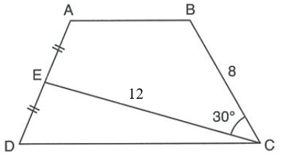

Javob:___________________________________

2. Rasmda tasvirlangan trapetsiya yuzini toping. Bu yerda, cm, cm, cm2.

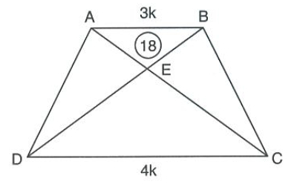

Javob:___________________________________

3. Rasmda tasvirlangan trapetsiya yuzini toping. Bu yerda, cm, cm, va diagonal burchakning bissektrisasi.

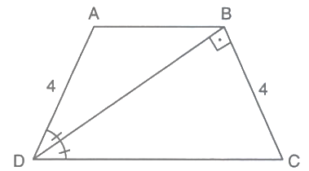

Javob:___________________________________

4. Rasmda tasvirlangan trapetsiya yuzini toping. Bu yerda, cm, cm, va .

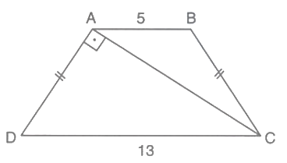

Javob:___________________________________

5. Rasmda tasvirlangan trapetsiya yuzini toping. Bu yerda, cm, cm, va .

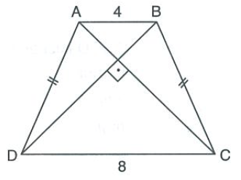

Javob:___________________________________

6. Rasmda tasvirlangan trapetsiya yuzini toping. Bu yerda, cm, va .

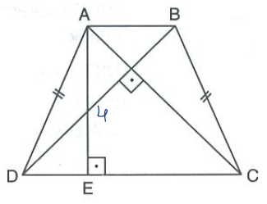

Javob:___________________________________

7. Rasmda tasvirlangan trapetsiya yuzini toping. Bu yerda, cm, cm, , va nuqta diagonallar kesishish nuqtasi.

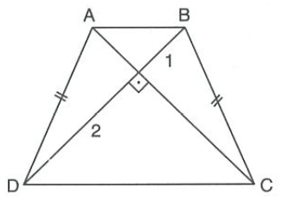

Javob:___________________________________

8. Rasmda tasvirlangan rombning yuzini toping. Bu yerda, cm, .

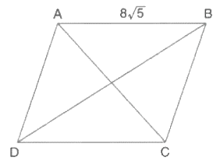

Javob:___________________________________

9. Rasmda tasvirlangan trapetsiya yuzini toping. Bu yerda, cm, cm, , va nuqta diagonallar kesishish nuqtasi.

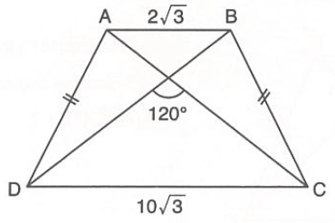

Javob:___________________________________

10. Rasmda tasvirlangan to‘g‘ri burchakli trapetsiya yuzini toping. Bu yerda, cm, cm, .

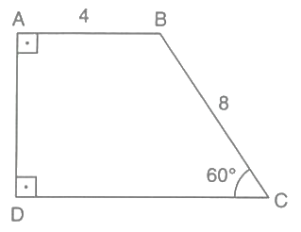

Javob:___________________________________

11. Rasmda tasvirlangan to‘g‘ri burchakli trapetsiya yuzini toping. Bu yerda, cm, cm, cm va - burchakning bissektrisasi.

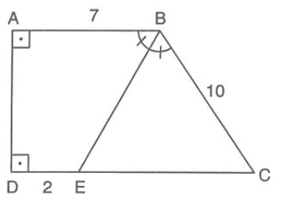

Javob:___________________________________

12. Rasmda tasvirlangan to‘g‘ri burchakli trapetsiya yuzini toping. Bu yerda, cm, cm va - burchakning bissektrisasi.

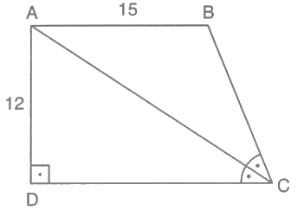

Javob:___________________________________

13. Rasmda tasvirlangan uchburchak yuzini toping. Bu yerda, kvadrat, cm, cm, cm.

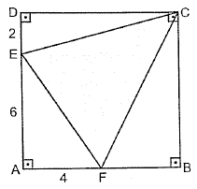

Javob:___________________________________

14. Rasmda tasvirlangan trapetsiya yuzini toping. Bu yerda, cm, cm, va .

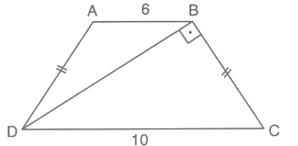

Javob:___________________________________

15. Rasmda tasvirlangan trapetsiya yuzini toping. Bu yerda, cm, cm, va .

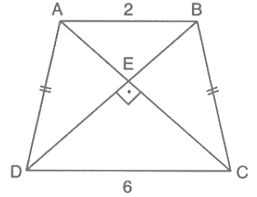

Javob:___________________________________

16. Rasmda tasvirlangan to‘g‘ri burchakli trapetsiya yuzini toping. Bu yerda, cm, cm, va - burchakning bissektrisasi.

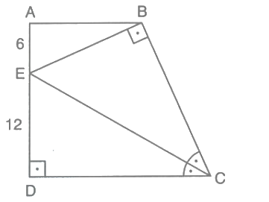

Javob:___________________________________

17. Rasmda tasvirlangan parallelogramm yuzini toping. Bu yerda, cm, cm, cm, va .

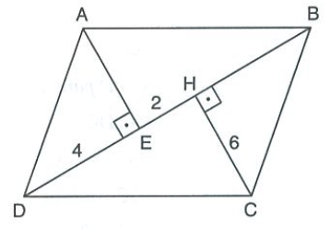

Javob:___________________________________

18. Rasmda tasvirlangan parallelogramm yuzini toping. Bu yerda, cm, cm, cm, .

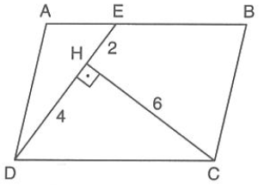

Javob:___________________________________

19. Rasmda tasvirlangan parallelogramm yuzini toping. Bu yerda, cm, cm, cm, cm, cm, cm va cm2.

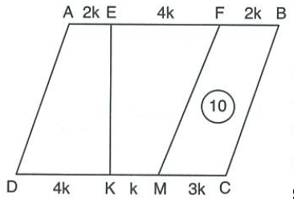

Javob:___________________________________

20. Rasmda tasvirlangan parallelogramm yuzini toping. Bu yerda, cm, cm, cm. – burchakning bissektrisasi, – burchakning bissektrisasi.

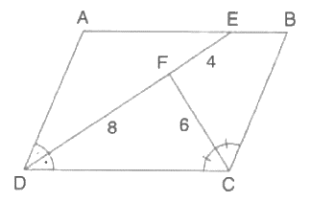

Javob:___________________________________

**XIV. Aylana va doira**

1. Rasmda berilgan ma’lumotlardan foydalanib, burchakning qiymatini toping ( nuqta – aylana markazi).

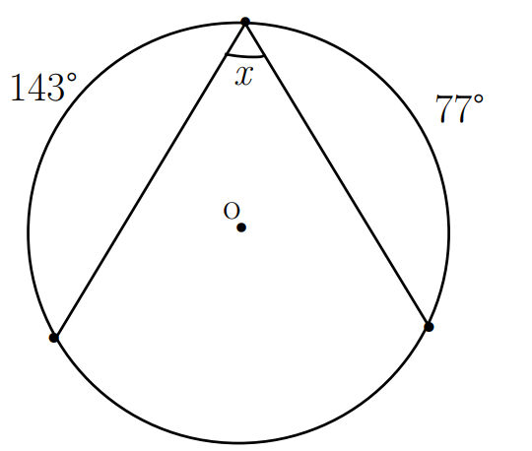

Javob:___________________________________

2. Rasmda berilgan ma’lumotlardan foydalanib, yoyning qiymatini toping ( nuqta – aylana markazi).

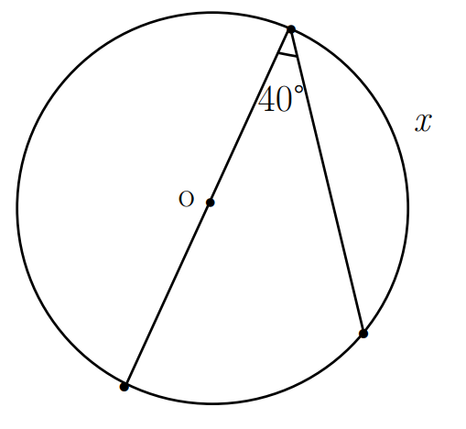

Javob:___________________________________

3. Rasmda berilgan ma’lumotlardan foydalanib, yoyning qiymatini toping ( nuqta – aylana markazi).

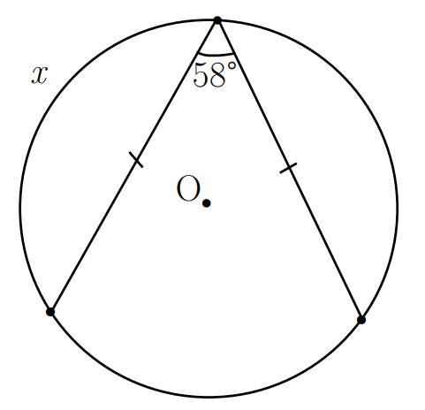

Javob:___________________________________

4. Rasmda berilgan ma’lumotlardan foydalanib, burchakning qiymatini toping ( nuqta – aylana markazi).

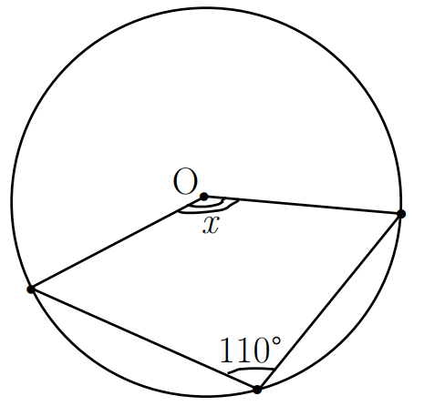

Javob:___________________________________

5. Rasmda berilgan ma’lumotlardan foydalanib, yoyning qiymatini toping.

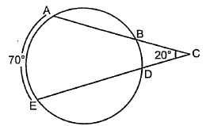

Javob:___________________________________

6. Rasmda berilgan ma’lumotlardan foydalanib, burchakning qiymatini toping.

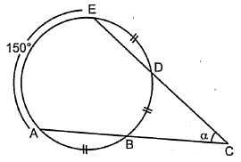

Javob:___________________________________

7. Rasmda berilgan ma’lumotlardan foydalanib, burchakning qiymatini toping.

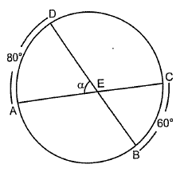

Javob:___________________________________

8. Rasmda berilgan ma’lumotlardan foydalanib, yoyning qiymatini toping.

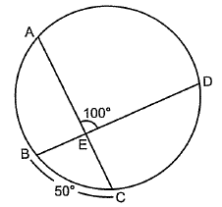

Javob:___________________________________

9. Rasmda berilgan ma’lumotlardan foydalanib, burchakning qiymatini toping.

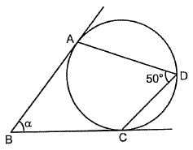

Javob:___________________________________

10. Rasmda berilgan ma’lumotlardan foydalanib, burchakning qiymatini toping.

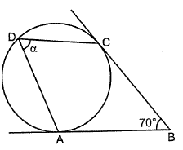

Javob:___________________________________

11. Rasmda berilgan ma’lumotlardan foydalanib, aylana radiusi qiymatini toping ( nuqta – aylana markazi).

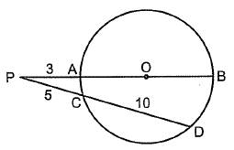

Javob:___________________________________

12. Rasmda berilgan ma’lumotlardan foydalanib, kesma uzunligini toping.

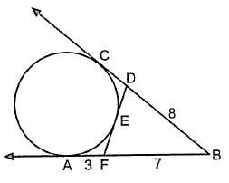

Javob:___________________________________

13. Rasmda berilgan ma’lumotlardan foydalanib, kesma uzunligini toping.

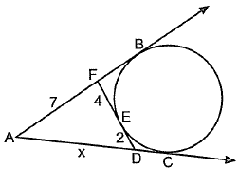

Javob:___________________________________

14. Rasmda berilgan ma’lumotlardan foydalanib, kesma uzunligini toping.

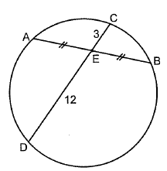

Javob:___________________________________

15. Rasmda berilgan ma’lumotlardan foydalanib, ning qiymatini toping.

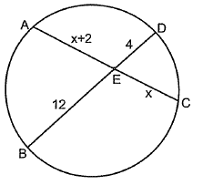

Javob:___________________________________

16. Rasmda berilgan ma’lumotlardan foydalanib, kesma uzunligini toping.

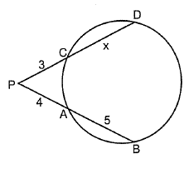

Javob:___________________________________

17. Rasmda berilgan ma’lumotlardan foydalanib, kesma uzunligini toping.

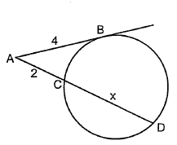

Javob:___________________________________

18. Rasmda berilgan ma’lumotlardan foydalanib, aylana uzunligini toping.

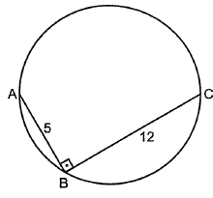

Javob:___________________________________

19. Rasmda berilgan ma’lumotlardan foydalanib, doira yuzini toping.

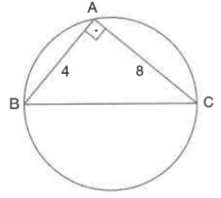

Javob:___________________________________

20. Rasmda berilgan ma’lumotlardan foydalanib, doira yuzini toping.

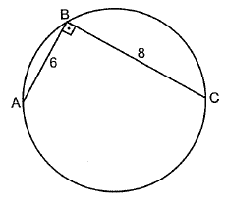

Javob:___________________________________

**XV. Muntazam ko‘pburchaklar va ularga ichki va tashqi chizilgan aylana**

1. Tomoni cm bo‘lgan teng tomonli uchburchakka aylana ichki chizilgan. Bu aylanaga kvadrat ichki chizilgan. Kvadrat tomonining uzunligini toping.

Javob:___________________________________

2. Aylana tomoni 12 cm bo‘lgan kvadratga ichki chizilgan. Bu aylanaga teng tomonli uchburchak ichki chizilgan. Uchburchak tomonining uzunligini toping.

Javob:___________________________________

3. Tomoni 6 cm bo‘lgan muntazam oltiburchak aylanaga ichki chizilgan. Aylanaga muntazam uchburchak tashqi chizilgan. Uchburchak tomonining uzunligini toping.

Javob:___________________________________

4. Tomoni 4 cm bo‘lgan kvadratga aylana tashqi chizilgan va bu aylana muntazam oltiburchakka ichki chizilgan. Oltiburchak tomonining uzunligini toping.

Javob:___________________________________

5. Tomoni ​ cm bo‘lgan teng tomonli uchburchakka aylana ichki chizilgan. Bu aylana ichiga kvadrat ichki chizilgan. Kvadrat tomonining uzunligini toping.

Javob:___________________________________

6. Aylana tomoni 8 cm bo‘lgan kvadratga ichki chizilgan. Bu aylanaga teng tomonli uchburchak ichki chizilgan. Uchburchak tomonining uzunligini toping.

Javob:___________________________________

7. Tomoni 5 cm bo‘lgan muntazam oltiburchak aylanaga ichki chizilgan. Aylanaga muntazam uchburchak tashqi chizilgan. Uchburchak tomonining uzunligini toping.

Javob:___________________________________

8. Tomoni 12 cm bo‘lgan kvadratga aylana tashqi chizilgan va bu aylana muntazam oltiburchakka ichki chizilgan. Oltiburchak tomonining uzunligini toping.

Javob:___________________________________

9. Tomoni cm bo‘lgan uchburchakka aylana ichki chizilgan. Bu aylanaga kvadrat ichki chizilgan. Kvadrat tomonining uzunligini toping.

Javob:___________________________________

10. Aylana tomoni cm bo‘lgan kvadratga ichki chizilgan. Bu aylanaga teng tomonli uchburchak ichki chizilgan. Uchburchak tomonining uzunligini toping.

Javob:___________________________________

11. Tomoni cm bo‘lgan muntazam oltiburchak aylanaga ichki chizilgan. Aylanaga muntazam uchburchak tashqi chizilgan. Uchburchak tomonining uzunligini toping.

Javob:___________________________________

12. Diagonali 4 cm bo‘lgan kvadratga aylana tashqi chizilgan va bu aylana muntazam oltiburchakka ichki chizilgan. Oltiburchak tomonining uzunligini toping.

Javob:___________________________________

13. Tomoni cm bo‘lgan teng tomonli uchburchakka aylana ichki chizilgan. Bu aylanaga kvadrat ichki chizilgan. Kvadrat tomonining uzunligini toping.

Javob:___________________________________

14. Aylana tomoni cm bo‘lgan kvadratga ichki chizilgan. Bu aylanaga teng tomonli uchburchak ichki chizilgan. Uchburchak tomonining uzunligini toping.

Javob:___________________________________

15. Tomoni 4 cm bo‘lgan muntazam oltiburchak aylanaga ichki chizilgan. Aylanaga muntazam uchburchak tashqi chizilgan. Uchburchak tomonining uzunligini toping.

Javob:___________________________________

16. Tomoni 6 cm bo‘lgan kvadratga aylana tashqi chizilgan va bu aylana muntazam oltiburchakka ichki chizilgan. Oltiburchak tomonining uzunligini toping.

Javob:___________________________________

17. Tomoni cm bo‘lgan teng tomonli uchburchakka aylana ichki chizilgan. Bu aylanaga kvadrat ichki chizilgan. Kvadrat tomonining uzunligini toping.

Javob:___________________________________

18. Aylana tomoni 6 cm bo‘lgan kvadratga ichki chizilgan. Bu aylanaga teng tomonli uchburchak ichki chizilgan. Uchburchak tomonining uzunligini toping.

Javob:___________________________________

19. Tomoni cm bo‘lgan muntazam oltiburchak aylanaga ichki chizilgan. Aylanaga muntazam uchburchak tashqi chizilgan. Uchburchak tomonining uzunligini toping.

Javob:___________________________________

20. Diagonali 4 cm bo‘lgan kvadratga aylana tashqi chizilgan va bu aylana muntazam oltiburchakka ichki chizilgan. Oltiburchak tomonining uzunligini toping.

Javob:___________________________________

**XVI. Sinuslar va kosinuslar teoremalari tadbiqlari. Uchburchaklarning o‘xshashligi**

1. uchburchakning tomonlari , , . nuqta tomonning o‘rtasi, nuqta esa tomonda shunday joylashganki, bunda bo‘ladi. kesma uzunligini toping. (cm)

Yechish:

Javob:___________________________________

2. Asoslari 6 cm va 12 cm, balandligi cm bo‘lgan teng yonli trapetsiya berilgan. Uning diagonallari diagonallar kesishgan nuqtada qanday uzunlikdagi kesmalarga bo‘linadi? (cm)

Yechish:

Javob:___________________________________

3. Yon tomoni 8 cm bo‘lgan teng yonli uchburchakka radiusi 16 cm bo‘lgan aylana tashqi chizilgan. Uchburchak asosining uzunligini toping. (cm)

Yechish:

Javob:___________________________________

4. Asoslari , bo‘lgan trapetsiyaning balandligi 3 cm. va to‘g‘ri chiziqlar nuqtada kesishadi. uchburchak yuzini toping. (cm²)

Yechish:

Javob:___________________________________

5. uchburchakning tomonlari , . nuqta tomonning o‘rtasi, nuqta esa tomonda shunday joylashganki, bunda bo‘ladi. kesma uzunligini toping. (cm)

Yechish:

Javob:___________________________________

6. Asoslari 4 cm va 12 cm, balandligi ​ cm bo‘lgan teng yonli trapetsiya berilgan. Uning diagonallari diagonallar kesishgan nuqtada qanday uzunlikdagi kesmalarga bo‘linadi? (cm)

Yechish:

Javob:___________________________________

7. Yon tomoni 8 cm, asosi 6 cm bo‘lgan teng yonli uchburchakda yon tomoniga tushirilgan mediana uzunligini toping. (cm)

Yechish:

Javob:___________________________________

8. Asoslari , bo‘lgan trapetsiyaning balandligi 6 cm. Trapetsiyaning diagonallari nuqtada kesishadi. uchburchak yuzini toping. (cm²)

Yechish:

Javob:___________________________________

9. Radiuslari 6 cm va 8 cm bo‘lgan ikkita aylana bir burchak ichida joylashgan va bir-biriga tegib turadi. Burchak uchidan kichik aylana markazigacha bo‘lgan masofani toping. (cm)

Yechish:

Javob:___________________________________

10. Asoslari , bo‘lgan trapetsiyada diagonal o‘tkazilgan. Ma’lumki, . Diagonallar nuqtada kesishgan bo‘lsa, kesma uzunligini toping. (cm)

Yechish:

Javob:___________________________________

11. Yon tomoni 12 cm bo‘lgan teng yonli uchburchakka radiusi 9 cm bo‘lgan aylana tashqi chizilgan. Uchburchak asosining uzunligini toping. (cm)

Yechish:

Javob:___________________________________

12. Asoslari , bo‘lgan trapetsiyaning balandligi 6 cm. va to‘g‘ri chiziqlar nuqtada kesishadi. uchburchak yuzini toping. (cm²)

Yechish:

Javob:___________________________________

13. Radiuslari 4 cm va 6 cm bo‘lgan ikkita aylana bir burchak ichida joylashgan va bir-biriga tegib turadi. Burchak uchidan kichik aylana markazigacha bo‘lgan masofani toping. (cm)

Yechish:

Javob:___________________________________

14. Asoslari , bo‘lgan trapetsiyada diagonal o‘tkazilgan. Ma’lumki, . Diagonallar nuqtada kesishgan bo‘lsa, kesma uzunligini toping. (cm)

Yechish:

Javob:___________________________________

15. Yon tomoni 12 cm bo‘lgan teng yonli uchburchakka radiusi 24 cm bo‘lgan aylana tashqi chizilgan. Uchburchak asosining uzunligini toping. (cm)

Yechish:

Javob:___________________________________

16. Asoslari , bo‘lgan trapetsiyaning balandligi 15 cm. Trapetsiyaning diagonallari nuqtada kesishadi. uchburchak yuzini toping. (cm²)

Yechish:

Javob:___________________________________

17. Radiuslari 10 cm va 15 cm bo‘lgan ikkita aylana bir burchak ichida joylashgan va bir-biriga tegib turadi. Burchak uchidan kichik aylana markazigacha bo‘lgan masofani toping. (cm)

Yechish:

Javob:___________________________________

18. Asoslari 4 cm va 8 cm, balandligi ​ cm bo‘lgan teng yonli trapetsiya berilgan. Uning diagonallari diagonallar kesishgan nuqtada qanday uzunlikdagi kesmalarga bo‘linadi? (cm)

Yechish:

Javob:___________________________________

19. Yon tomoni 12 cm, asos tomoni 4 cm bo‘lgan teng yonli uchburchakda yon tomonga tushirilgan mediana uzunligini toping. (cm)

Yechish:

Javob:___________________________________

20. Asoslari , bo‘lgan trapetsiyaning balandligi 4 cm. Trapetsiyaning diagonallari nuqtada kesishadi. uchburchak yuzini toping. (cm²)

Yechish:

Javob:___________________________________