Cat_1: Computational Finance

Joy Kendi

2025-09-10

library(tidyverse)

## ── Attaching core tidyverse packages ──────────────────────── tidyverse 2.0.0 ──  
## ✔ dplyr 1.1.4 ✔ readr 2.1.5  
## ✔ forcats 1.0.0 ✔ stringr 1.5.1  
## ✔ ggplot2 3.5.1 ✔ tibble 3.2.1  
## ✔ lubridate 1.9.4 ✔ tidyr 1.3.1  
## ✔ purrr 1.0.4   
## ── Conflicts ────────────────────────────────────────── tidyverse_conflicts() ──  
## ✖ dplyr::filter() masks stats::filter()  
## ✖ dplyr::lag() masks stats::lag()  
## ℹ Use the conflicted package (<http://conflicted.r-lib.org/>) to force all conflicts to become errors

library(ggplot2)  
  
# Question 1  
mu <- 0.15  
V_Bar <- 0.04  
delta_v <- 0.2  
kappa_v <- 1  
S0 <- 0.5  
V0 <- V_Bar  
Time_T <- 1  
Step_Size <- 1000  
N_Simulations <- 10000  
dt <- Time_T/Step_Size  
Corr <- c(-0.5, 0, 0.5)  
  
Sim_SV <- function(rho, delta_v, seed = 42){  
 set.seed(seed)  
   
 S <- matrix(NA_real_, nrow = N_Simulations, ncol = Step_Size +1 )  
 V <- matrix(NA_real_, nrow = N_Simulations, ncol = Step_Size +1 )  
   
 S[,1] <- S0  
 V[,1]<- V0  
   
 for (t in 1:Step_Size) {  
 z1 <- rnorm(N_Simulations)  
 z2 <- rho* z1 + sqrt(1-rho^2) * rnorm(N_Simulations)  
   
 V_T <- pmax(V[,t], 0)  
   
 V[, t+1] <- pmax(  
 V[, t] + kappa_v * (V_Bar - V[, t]) * dt +  
 delta_v * sqrt(V_T) * sqrt(dt) * z2,  
 0  
 )  
  
 S[, t+1] <- S[, t] * exp((mu - 0.5 * V_T) * dt + sqrt(V_T * dt) * z1)  
   
 }  
   
 tibble(  
 Final_S = S[, Step_Size + 1],  
 rho = factor(rho),  
 delta_v = delta_v  
 )  
}  
  
set.seed(123)  
  
RhoTest <- map_dfr(Corr, ~Sim_SV(rho = .x, delta_v = 0.2))  
  
RhoTest |>  
 ggplot(aes(x = Final_S, fill = rho))+  
 geom_density(alpha = 0.5) +  
 scale_x_log10()+  
 labs(  
 title = "Log-Scale Density of S at t=1",  
 x = "Log Scale",  
 y = "Density"  
 )

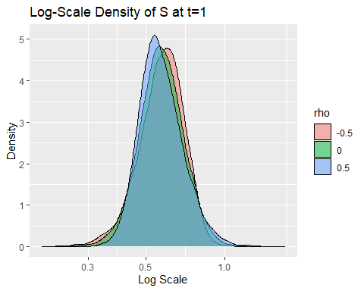

Delta_Array <- c(0.5, 1, 1.5)  
New_RhoTest <- map_dfr(Delta_Array, ~Sim_SV(rho = 0, delta_v = .x))  
  
New_RhoTest |>  
 ggplot(aes(x = Final_S, fill = factor(delta_v)))+  
 geom_density(alpha = 0.5)+  
 labs(  
 title = " Effect of δv on Final Stock Price",  
 x = "Stock Price",  
 y = "Density",  
 fill = "δv"  
 )

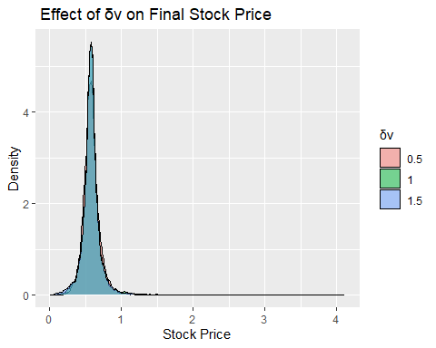

New_RhoTest |>  
 ggplot(aes(x = Final_S, fill = factor(delta_v)))+  
 geom_density( alpha = 0.5) +  
 scale_x_log10()+  
 labs(  
 title = "Effect of δv ",  
 x = "Log Scale",  
 y = "Density",  
 fill = "δv"  
 )

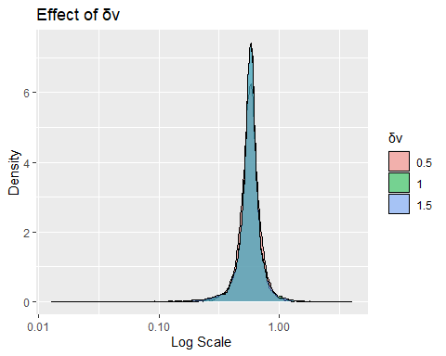

lognorm_dist <- RhoTest |>  
 group_by(rho) |>  
 summarise(  
 mu_hat = mean(log(Final_S)),  
 sigma_hat = sd(log(Final_S)),  
 .groups = "drop"  
 )  
  
lognorm_dist

## # A tibble: 3 × 3  
## rho mu_hat sigma_hat  
## <fct> <dbl> <dbl>  
## 1 -0.5 -0.559 0.201  
## 2 0 -0.560 0.198  
## 3 0.5 -0.560 0.195

Difference <- RhoTest |>  
 group_by(rho) |>  
 summarise(x = list(seq(min(Final_S), quantile(Final_S, 0.999), length.out = 500)))|>  
 unnest(x) |>  
 left_join(lognorm_dist, by = "rho") |>  
 mutate(dln = dlnorm(x, meanlog = mu_hat, sdlog = sigma_hat))  
   
ggplot(RhoTest, aes(x = Final_S, color = rho)) +  
 geom_density(aes(fill = rho), alpha = 0.3)+  
 geom_line(data = Difference, aes(x=x, y = dln, color = rho),  
 linewidth = 1) +  
 scale_x_log10()+  
 labs(  
 title = "Empirical Vs Log-Normal Densities",  
 x="Log Scale",  
 y = "Density"  
 )

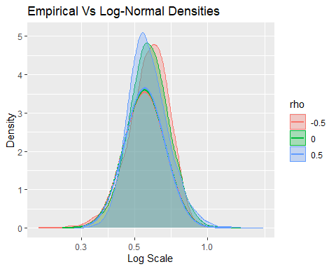

#Question 2  
# a) GBM Discretization  
S0 <- 100  
r <- 0.05  
sigma <- 0.2  
Time_T <- 1  
N <- 50  
M <- 100000  
dt <- Time_T/N  
Simm <- (1:N)*dt  
  
set.seed(1)  
  
GBM <- function(M,N,dt,S0, r, sigma){  
 z <- matrix(rnorm(M*N), nrow = M, ncol = N)  
 incr <- (r - 0.5* sigma^2) * dt + sigma * sqrt(dt) * z  
 log_s <- cbind(log(S0), t(apply(incr, 1,cumsum)))  
 S <- exp(log_s)  
 S  
}  
  
paths <- GBM(M,N,dt,S0,r,sigma)  
S_grid <- paths[, -1, drop = FALSE]  
S_T <- S_grid[, N]  
S_Bar <- rowMeans(S_grid)  
  
payoff_x <- pmax(S_T - S_Bar, 0)  
discrete_x <- exp(-r * Time_T) * payoff_x  
  
Cmc <- mean(discrete_x)  
SE_Cmc <- sd(discrete_x)/sqrt(M) #Standard Error  
CI_Cmc <- Cmc + c(-1,1) * 1.96 * SE_Cmc # Confidence Interval  
  
list(  
 CMC = Cmc,  
 CI95 = CI_Cmc  
)

## $CMC  
## [1] 0.05777076  
##   
## $CI95  
## [1] 0.05725176 0.05828976

# b) Control Variate  
Asian_Call <- function(S0, r, sigma, Time_T, N){  
 ti <- (1:N)*(Time_T/N)  
 Summ_t <- sum(ti)  
 Summ_min <- sum(pmin(rep(ti, each =N), rep(ti, times = N)))  
   
 M_G <- log(S0) + (r - 0.5 * sigma^2) * (Summ_t/N)  
 V_G <- (sigma^2 / N^2) * Summ_min  
   
 Var_ST <- sigma^2 * Time_T  
 Cov <- (sigma^2/N) * Summ_t  
 Var_ex <- Var_ST + V_G -2 * Cov  
 sigma_ex <- sqrt(Var_ex/Time_T)  
   
 S1 <- S0  
 S2 <- exp(M_G + 0.5 * V_G - r * Time_T)  
   
 d1 <- (log(S1/S2)+0.5 * sigma_ex^2 * Time_T)/(sigma_ex* sqrt(Time_T))  
 d2 <- d1 - sigma_ex * sqrt(Time_T)  
   
 mu_Y <- S1 * pnorm(d1) - S2 * pnorm(d2)  
 mu_Y  
}  
  
mu_Y <- Asian_Call(S0, r, sigma, Time_T, N)  
Geo_S <- exp(rowMeans(log(S_grid)))  
payoff_y <- pmax(S_T - Geo_S, 0)  
discrete_y <- exp(-r * Time_T) * payoff_y  
  
theta_hat <-cov(discrete_x, discrete_y) / var(discrete_y)  
z <- discrete_x+ theta_hat * (mu_Y - discrete_y)  
  
Ccv <- mean(z)  
SE_Ccv <- sd(z)/sqrt(M)  
CI_Ccv <- Ccv + c(-1,1) * 1.96 * SE_Ccv  
  
list(  
 CCV = Ccv,  
 CI95_Ccv = CI_Ccv,  
 theta_hat = theta_hat,  
 mu_Y = mu_Y  
)

## $CCV  
## [1] 5.784387  
##   
## $CI95_Ccv  
## [1] 5.784374 5.784400  
##   
## $theta_hat  
## [1] 0.9675969  
##   
## $mu_Y  
## [1] 5.978259

# c)  
Var_MC <- var(discrete_x)  
Var_CV <- var(z)  
VR <- 100*(1 - Var_CV/Var_MC)  
  
tibble(  
 estimator = c("Plain MC", "With Control Variate"),  
 price = c(Cmc, Ccv),  
 SE = c(SE_Cmc, SE_Ccv),  
 CI_Low = c(CI_Cmc[1], CI_Ccv[1]),  
 CI_High = c(CI_Cmc[2], CI_Ccv[2])  
) |>  
 print()

## # A tibble: 2 × 5  
## estimator price SE CI_Low CI_High  
## <chr> <dbl> <dbl> <dbl> <dbl>  
## 1 Plain MC 0.0578 0.000265 0.0573 0.0583  
## 2 With Control Variate 5.78 0.00000651 5.78 5.78

cat(sprintf("Variance Reduction: %.1f%%\n", VR)) # Variance Reduction: 99%, 0.1% of the variance is uncorrelated to the plain MC

## Variance Reduction: 99.9%

# d) CI   
CV_Price <- function(M,N,sigma, seed=1){  
 set.seed(seed)  
 dt<- Time_T/N  
 S_Paths <- GBM(M,N,dt,S0,r,sigma)  
 S_grid <- S_Paths[,-1,drop = FALSE]  
 S_T <- S_grid[,N]  
 S_Bar <- rowMeans(S_grid)  
 X<- exp(-r * Time_T) * pmax(S_T -S_Bar,0)  
   
 G <- exp(rowMeans(log(S_grid)))  
 Y <- exp(-r *Time_T) * pmax(S_T - G, 0)  
 MuY <- Asian_Call(S0, r, sigma, Time_T, N)  
   
 theta <- cov(X,Y)/var(Y)  
 z <- X + theta * (MuY - Y)  
   
 c(MC = mean(X), SE_MC = sd(X)/sqrt(M),  
 CV = mean(z), SE_Cv = sd(z)/sqrt(M)  
 )  
}  
  
Ms <- round(exp(seq(log(1e3), log(1e5), length.out = 6)))  
res_m <- map_dfr(Ms, \(m) {  
 out <- CV_Price(M = m, N = N, sigma = sigma, seed = 123)  
 tibble(  
 M = m,  
 mc_low = out["MC"] - 1.96 * out["SE_MC"],  
 mc_high = out["MC"] + 1.96 * out["SE_MC"],  
 cv_low = out["CV"] - 1.96 * out["SE_Cv"],  
 cv_high = out["CV"] + 1.96 * out["SE_Cv"]  
 )  
})  
  
res_m |>  
 mutate(  
 width_mc = mc_high - mc_low,  
 width_cv = cv_high - cv_low  
 ) |>  
 pivot_longer(starts_with("width_"), names_to = "method", values_to = "width") |>  
 mutate(method = recode(method, width_mc = "MC", width_cv = "CV")) |>  
 ggplot(aes(x = M, y = width, color = method)) +  
 geom_line() + geom_point() +  
 scale_x_log10() +  
 labs(title = "95% CI width vs simulations M",  
 x = "log scale", y = "CI width") +  
 theme_minimal()

