**UNEP Agreements Database Portal Documentation** 

|  |  |
| --- | --- |
| **Project Name:** | UNEP AGREEMENTS DATABASE PORTAL |
| **Date:** | 21/10/2021 |
| **Release:** | Draft |
| **Author:** | Young Israel Izere |
| **Owner:** | CSD/ Enterprise Solutions |
| **Client(s):** |  |

**Document Revision History**

|  |  |  |  |  |
| --- | --- | --- | --- | --- |
| **Version** | **Date of Revision** | **Changes** | | **Author** |
| **Change Made** | **Section** |  |
|  |  |  |  |  |
|  |  |  |  |  |

**Document Approval**

|  |  |  |  |  |
| --- | --- | --- | --- | --- |
| **Name** | **Title** | **Date** | **Version** | **Sign** |
| Saiful Ridwan | Chief ESS |  |  |  |

**Distribution**

This document has been shared with the following persons:

|  |  |  |  |
| --- | --- | --- | --- |
| **Name** | **Title** | **Date of Issue** | **Version** |
|  |  |  |  |

# **Table of Contents**

**Table of Contents** 2

**Introduction** 2

**Purpose of the Document** 3

**Background** 3

**Project Rationale** 3

**Project Context** 4

**Project Scope** 4

**Timeline/Schedule** 4

**Business Requirements** 5

**User Role Matrix: Roles and Permissions matrix** 6

**Design Approach** 7

**Implementation Approach, Tools and Resources** 9

**Implemented Functionalities** 10

**Pending Functionalities** 11

**Links & Resources** 12

# **Introduction**

Currently, UNEP contracts and IT license documents are accessed and managed from SharePoint, OneDrive and independent other document management platforms. The process of drafting, managing and storing SLAs & IT Licenses is differently handled by focal points and occur in separate platforms. This leads to having a fragmented approach in regard to accessing or managing contract/agreement documents. Furthermore, versioning and searching for a contract document can be tedious.

This project proposed the construction of a single and shared database portal that should host all UNEP contract documents (SLAs, IT Licenses, Subscription, GPML data terms of use, and so on) into one platform for easy accessibility and effective management of contract documents.

## **Purpose of the Document**

This document provides a high-level overview of the UNEP Agreements Database Portal project that was implemented. It highlights the project rationale, context, scope, functional requirements & non-functional requirements, user roles and permissions, project implementation tools, and methodology.

## **Background**

Drafting agreement documents is done through Microsoft Word or SharePoint Word editor. The SharePoint platform is also used to store SLA documents in a SharePoint folder. The process of establishing a contract document involves the creation of a draft document whose content might refer to an already existing agreement document. This might involve searching for the related document(s) from the SharePoint folder, local storage or any other folders storing current SLAs documents. The draft is edited and refined to fit the new context depending on the definition of services offered. This draft is continually updated/refined until it’s confirmed and signed. A copy of the confirmed contract document is finally uploaded and stored in the SharePoint folder.

Challenges come in the management and organization process of the contract documents. Searching for content relating to a certain SLA document can be tedious due to the disorganization and absence of a common and structured database that would contain contract documents.

## **Project Rationale**

Different agreements/contracts are usually established between UNEP entities (sections) and external service providers. Agreement documents detail the scope of the provided services to the receiving entities. Therefore, the process of drafting, confirming and signing such contracts is common and usual in UNEP sections through focal points. Drafting and managing contract documents become a hectic and time-consuming process. While drafting a document one might need some information that relates or refer to an already existing/previous document. Searching or filtering the target content become time-consuming, since he/she might need to browser through SharePoint, OneDrive or Outlook mails. In some scenarios the person in charge of drafting such a document might need to email or reach out to his/her colleagues to get the required content information - relating to contract draft.

The database portal, therefore, was built to have all contract content and documents stored into a single platform where users shall be able to access and search for relevant contract-related information. Also, this platform has been designed to assist focal points in uploading and storing agreement documents.

Therefore, this will contribute to minimizing the time and complexities that are involved in the retrieval and management process of overall contract documents.

## **Project Context**

The database portal will store all past and current contract documents – SLAs, IT License documents and subscription documents. By default, all UNEP team members shall be able to login and access all existing documents while focal points shall have additional permissions to upload contract documents.

## **Project Scope**

The key product of this project was a fully functional database for all agreement documents to be accessed and accessed by UNEP team members. While, the short-term objective was to have all relevant SLAs documents uploaded to the database portal from the current SLAs including IT Licenses, this portal is accessible to all UNEP team members.

## **Timeline/Schedule**

*Development, maintenance and support of the database portal was done during the internship period.*

# **Business Requirements**

Below are the database’s functional and non-functional requirements that were defined by the users who are meant to interact with the portal.

|  |  |  |
| --- | --- | --- |
|  | **Requirement** | **Required/ Desirable** |
|  | The contracts database portal should allow team members to easily login and access contract documents. | Required |
|  | The portal should allow focal points to upload, edit and update contract document together with its relevant information – SLA start data, end date, service provider, service offered. | Required |
|  | The portal should include search functionalities such that it is easy to search for a target document. | Required |
|  | The portal should be a single and well-organized repository for all agreement documents – SLAs, IT Licenses, Data use Licenses, subscriptions. | Required |
|  | The portal should be usable (ease to learn and use) for all users. | Required |
|  | The database platform should be a well-structured database infrastructure. | Required |
|  | The users of the portal should have different permissions: by default, all users shall be able view content while a restricted numbers of users (those who will be in charge of editing and uploading SLA documents) should be able to manage (create-retrieve-update-delete) the documents. | Required |
|  | SLA documents should be orderable by ID, date and title. | Required |
|  | The contract documents should be classified according to their specific category. A contract document might be SLA document, IT Licenses or subscription. | Required |

# **User Role Matrix: Roles and Permissions matrix**

|  |  |  |  |  |
| --- | --- | --- | --- | --- |
|  | **Users** | | | |
|  | **Admin user**: System administrator | **Focal point users**: Rosemary Njenga & Winfred Gaceri | **Normal users:** all other UNEP members |
| **Roles** | Access contract documents: prior to authentication (prior to logging into the Database portal). | X | X | X |
| View contract documents and the related metadata | X | X | X |
| Upload contract documents together with the related metadata | X | X |  |
| Update permissions: Update/replace contract document records. | X | X |  |
| Remove permission: Delete/Remove contracting document records. | X | X |  |
| Search for contract document information | X | X | X |
| Download contract documents. | X | X | X |

# **Design Approach**

The UNEP Agreements Database was designed as an SQL-like database system. It comprises of 4 main lists (tables) among which well-structured relationships are defined. The 4 lists are: The “Agreements” which consists of the document records and corresponding metadata, the “Receiving Divisions” list which consists of data related to the UNEP divisions that receive the services that are defined by the Agreement contracts, the “Service Providers” list which consist of the data regarding Service Provider entities, as well as the “Users” list which consists of data regarding the users of the portal and their differing access permissions.

A comprehensible data model of the database tables/lists structure is depicted in the below Entity Relation Diagram (ERD):

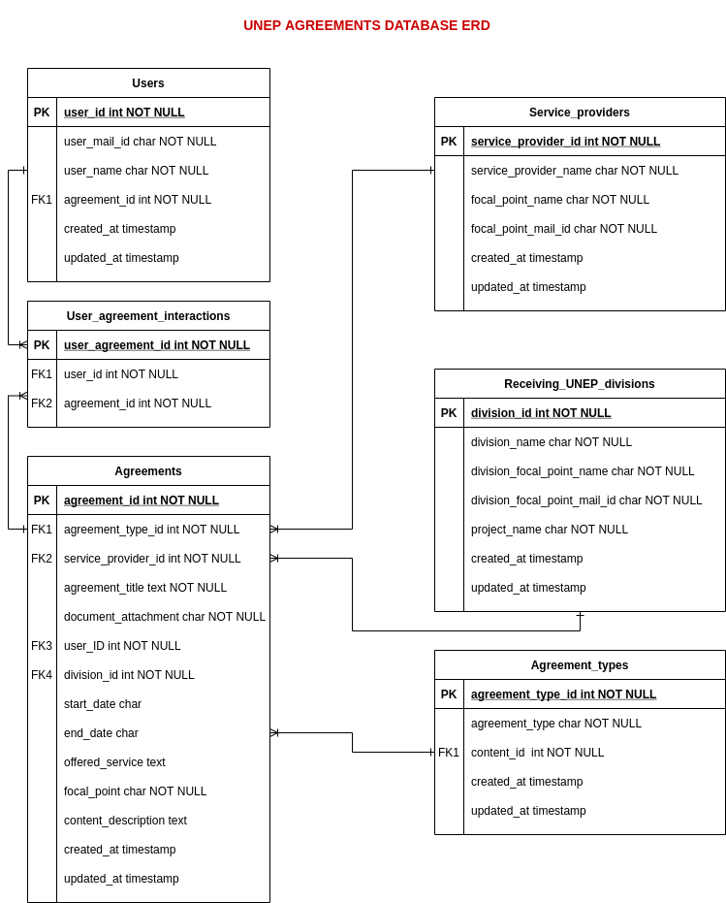

# **Implementation Approach, Tools and Resources**

The UNEP Agreements Database Portal was implemented based on the **Microsoft Power Platform** - mainly, **PowerApps, Power Automate and SharePoint Server**.

A PowerApps Canvas Application was built to act as an interface that allows users to access and interact with the list of Agreement documents. The Canvas Application is accessible on the UNEP Microsoft PowerApps Development environment (**ENV-DEPT-DEV-UNEP**) as “**UNEP Agreements Database Portal (Tablet)**” - Web link:

*https://apps.powerapps.com/play/58308a5d-6a0f-4238-9d09-25ba8d49b645?tenantId=0f9e35db-544f-4f60-bdcc-5ea416e6dc70*

A SharePoint Server was used as a database to host backend data and SQL relationships among the lists of Agreements, Service Providers and UNEP Receiving divisions. SharePoint sits on top of SQL Server, which is a relational database management system. SharePoint uses lists with columns and data types to store data in an SQL-like data structure. The SharePoint server site of the database portal is accessible and currently co-owned by [@Silas Mangeni](mailto:silas.mangeni@un.org) on: *https://unitednations.sharepoint.com/sites/UNEPICT*

Power Automate was used and integrated with the PowerApps application as a tool to automate SLA Expiration notification email flows. The Power Automate Flows are accessible on the UNEP Microsoft Power Automate Development environment (**ENV-DEPT-DEV-UNEP**). Two flows were built: “**NotifyAdminOfExpiredSLAs**” (link: *https://emea.flow.microsoft.com/manage/environments/c68f0039-9ca9-4e13-bd5b-79f2859350b4/flows/shared/b36188c8-3220-4980-8f9c-8b9c9fd9cfe9/details*) and “**Export to Excel - 2**” (link: [*https://emea.flow.microsoft.com/manage/environments/c68f0039-9ca9-4e13-bd5b-79f2859350b4/flows/shared/54064601-730d-40c8-ac38-dae21eaf7ba5/details*](https://emea.flow.microsoft.com/manage/environments/c68f0039-9ca9-4e13-bd5b-79f2859350b4/flows/shared/54064601-730d-40c8-ac38-dae21eaf7ba5/details))

All the Above resources are shared, accessible, and owned by [@Silas Mangeni](mailto:silas.mangeni@un.org) who has as well direct management rights on the application portal implementing tools.

**Conceptual Framework**

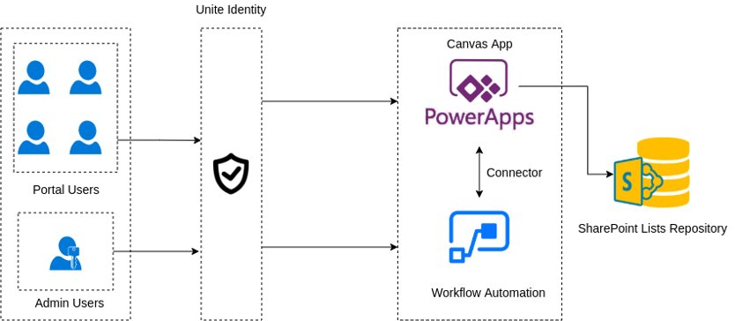

Users (UNEP members) can access the Agreements Database Portal Canvas Application prior to getting authenticated by the “Unite Identity” authentication system which is implicitly integrated into the UNEP Power Platform. The Power Automate flows are connected and integrated with the PowerApps Canvas Application which is a presentation layer to the SharePoint Server Lists Repository.

# **Implemented Functionalities**

The following are the key portal features that were completed as part of the implementation of project:

1. **Search, sorting and filter features**

Through the Power Apps application, users are able to:

* Search through contract records and other related information and documents based on the Agreements key/search words.
* Agreement documents data can be filtered based on the agreement types specification (SLAs, Contract, Subscription), as well as – filtering based on “Receiving divisions” or “Service Providers”.
* Agreements documents can be sorted by title, agreement type, start date and/or end date (expiration date).

1. **CRUD functionalities**

The portal also acts as a management platform for all contract documents. This implies that admin users ([@Winfred Gaceri](mailto:winfred.gaceri@un.org) or @Rosemary Njenga) have the ability/permissions to create (upload), retrieve, replace or remove contract contents, as well as update or edit information related to the “Receiving divisions” and “Service providers” data depending on the specific Agreements.

1. **SharePoint Server**

The SharePoint site (*https://unitednations.sharepoint.com/sites/UNEPICT*) was created to act as a database hosting server for the Agreement documents.

1. **Power Automate Flows**

Two Power Automate flows were created:

* **NotifyAdminOfExpiredSLAs:** is meant to send automated notification emails to the administrator users (Winfred Gaceri and Rosemary Njenga) to notify them about the list of Agreement lists which are about to expire (7 days prior to expiration).
* **Export to Excel:** is meant to export the metadata of the list of Agreements into the user’s SharePoint OneDrive folder when they trigger this action by clicking on the “Export list” button in the PowerApps canvas application.

1. **PowerApps Canvas Application**

The PowerApps Canvas Application acts as a frontend/presentation layer to the SharePoint Server Lists Repository. This application is, hence, an interface that allows users to access and interact with the list of Agreement documents.

# **Pending Functionalities**

The following are the features that were not fully completed as part of the implementation of project:

1. **Pulling The Receiving UNEP Divisions from the Datawarehouse**

Due to the fact that it was noticed (by [@Silas Mangeni](mailto:silas.mangeni@un.org) ) that each user would need to have a premium Microsoft account to enable/implement this feature, the implementation of this functionality was put on hold.

1. **Use of the ESS-NOREPLY Email for the Agreements documents notification email**

Currently, SLA Expiration notification emails are being sent using the standard PowerApps email account (*microsoft@powerapps.com*).

The implementation of this feature (use of ESS-NOREPLY Email instead of *microsoft@powerapps.com*) shall require that either Ray Goh, Winfred Gaceri or whoever has access to the ESS-noreply email account grant access to Silas Mangeni or the developer who will be in charge of maintaining the database portal, access rights to “Send on behalf” (inside the 365 Admin Center) - the email notifications using this ESS-noreply email instead of the PowerApps Email.

1. **Deployment of the PowerApps Canvas Application to the UNEP Microsoft Power Platform Production Environment**

Currently, the UNEP Database Portal Application is hosted on the UNEP Power Apps development environment. Therefore, this application needs to be deployed on the UNEP Power Apps Production environment. For this reason, [@Silas Mangeni](mailto:silas.mangeni@un.org) will either needs to deploy the application to the production environment, or Ray Goh might have to grant access permission to the incoming developer in order to allow them to access and deploy to the Production environment.

# **Links & Resources**

Link to the PowerApps Canvas Application: *https://apps.powerapps.com/play/58308a5d-6a0f-4238-9d09-25ba8d49b645?tenantId=0f9e35db-544f-4f60-bdcc-5ea416e6dc70*

Link to the “**NotifyAdminOfExpiredSLAs**” Power Automate Flow: *https://emea.flow.microsoft.com/manage/environments/c68f0039-9ca9-4e13-bd5b-79f2859350b4/flows/shared/b36188c8-3220-4980-8f9c-8b9c9fd9cfe9/details*

Link to the “**Export to Excel**” Power Automate Flow: [*https://emea.flow.microsoft.com/manage/environments/c68f0039-9ca9-4e13-bd5b-79f2859350b4/flows/shared/54064601-730d-40c8-ac38-dae21eaf7ba5/details*](https://emea.flow.microsoft.com/manage/environments/c68f0039-9ca9-4e13-bd5b-79f2859350b4/flows/shared/54064601-730d-40c8-ac38-dae21eaf7ba5/details)

Link to the SharePoint Server Site: *https://unitednations.sharepoint.com/sites/UNEPICT*