WalmartDataAnalysisWithMySQL

Walmart Sales data analysis to answer the following questions.

**Products**

1. How many unique product lines does the data have?

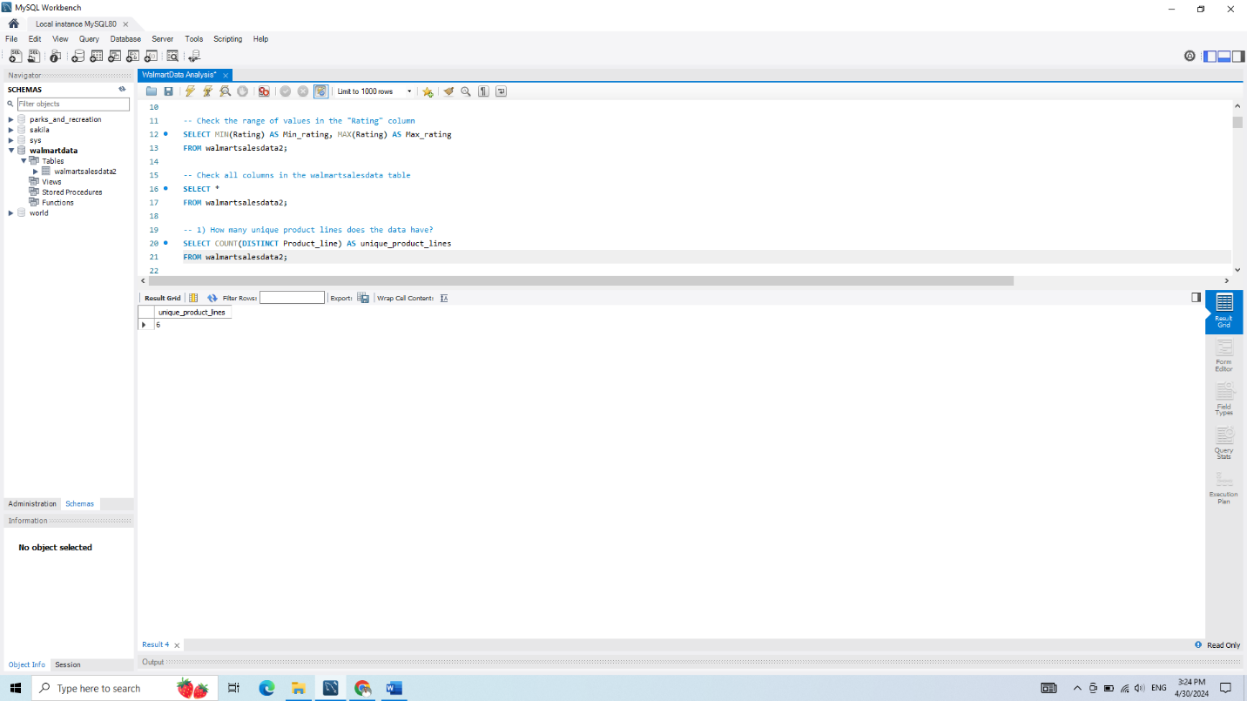

There are 6 unique product lines.

1. What is the most common payment method?

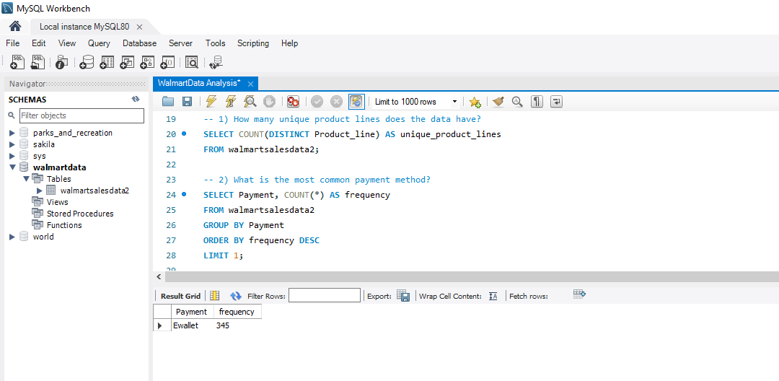The most common payment method is Ewallet

1. What is the most selling product line?

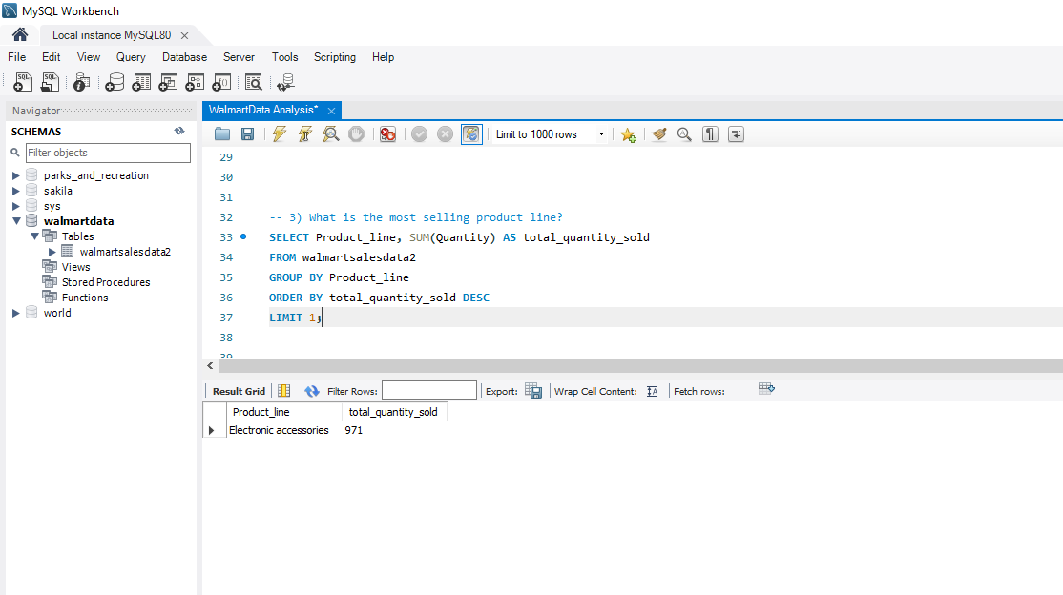

The most selling product is Electronic Accessories

1. What is the total revenue?

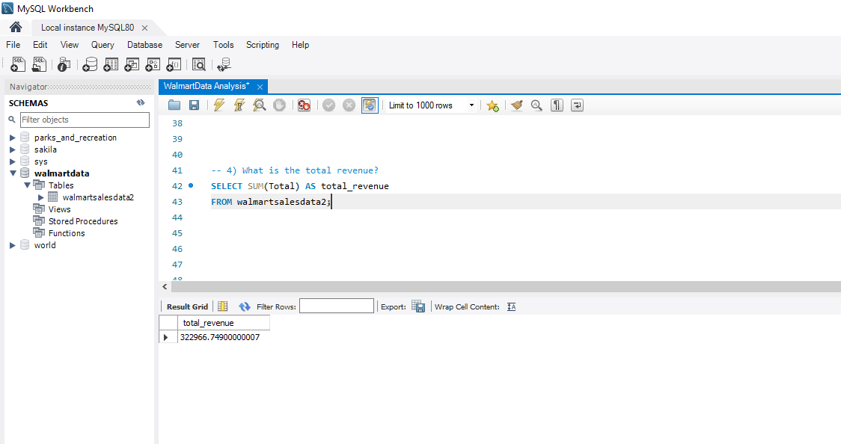The total Revenue 322966.749

1. What product line had the largest revenue?

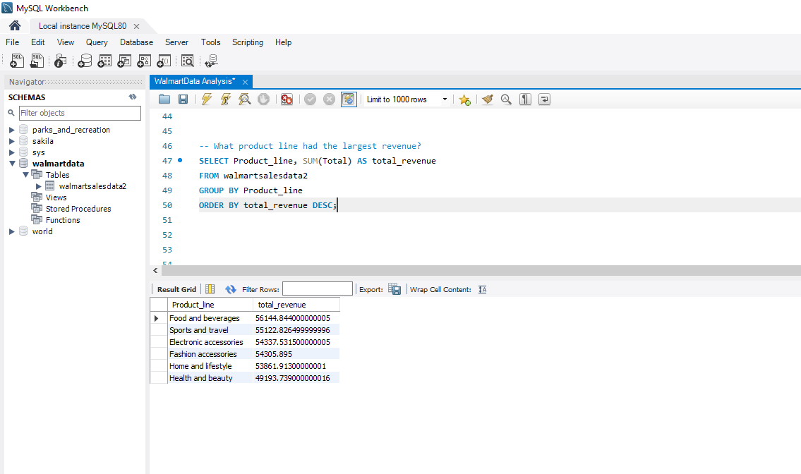

Food and beverages is the product line with the largest revenue with Total Revenue = 56144.844

1. What is the city with the largest revenue?

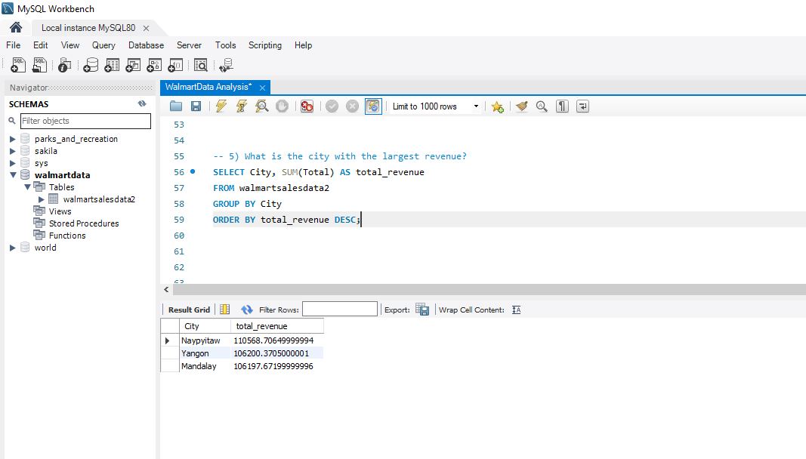

Naypyitaw is the city with the Total Revenue with 110568.70649999994

1. What product line had the largest VAT?

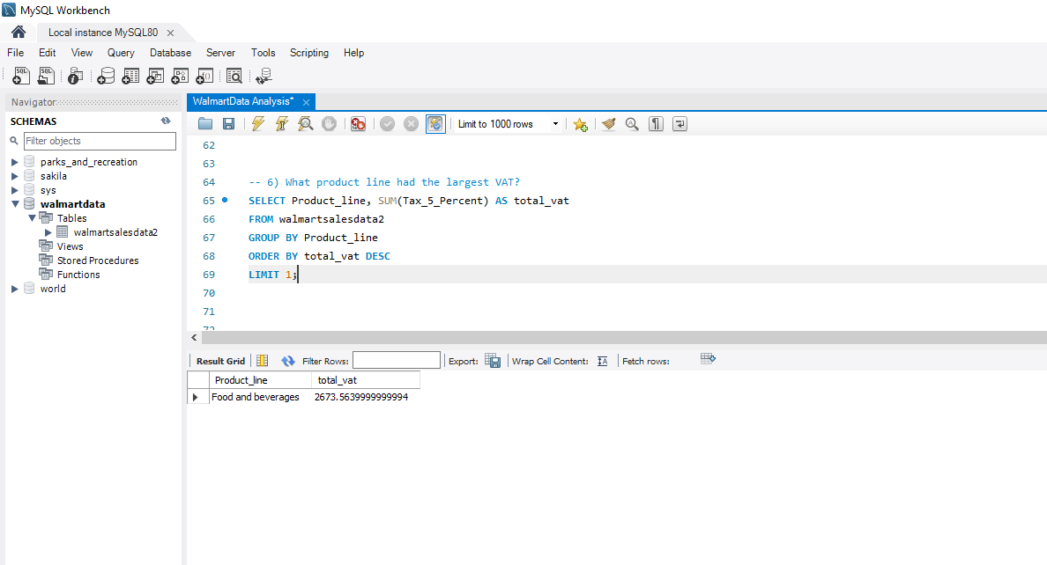Food and beverages had the largest VAT with Total VAT of 2673.564

1. Fetch each product line and add a column to those product line showing "Good", "Bad". Good if its greater than average sales.

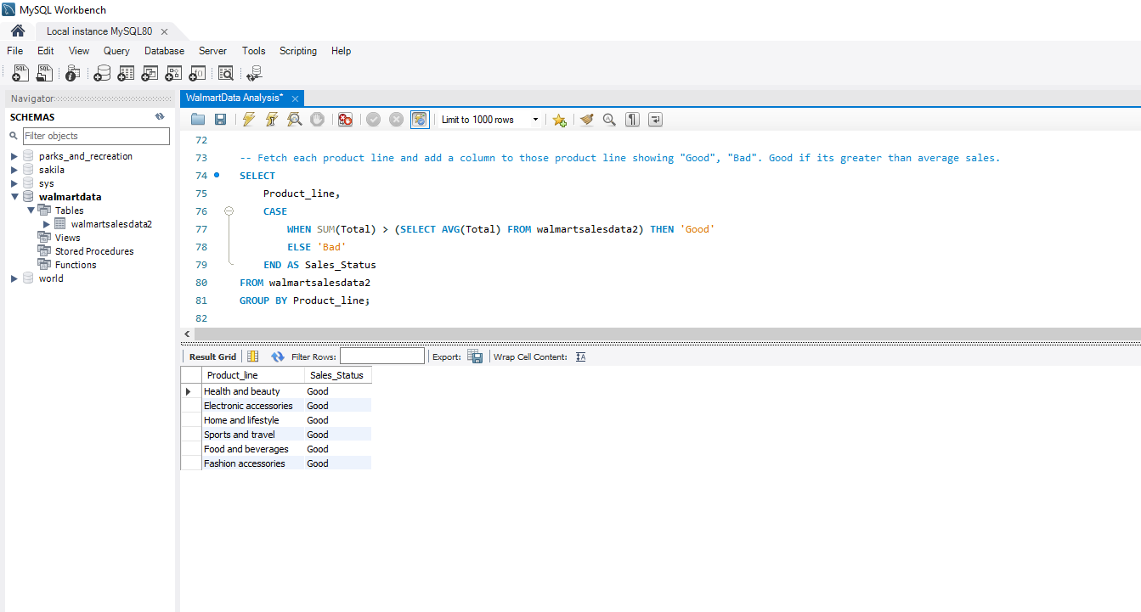

1. Which branch sold more products than average product sold?

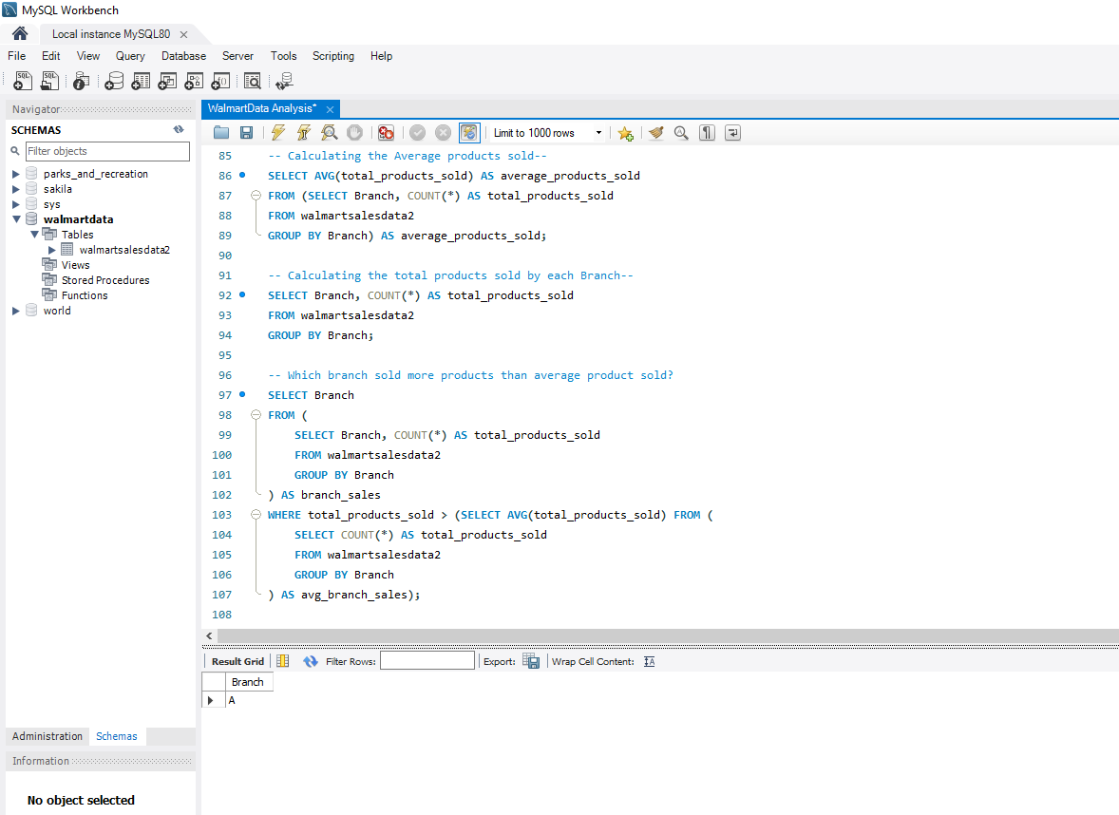

Branch A sold more products than average products sold.

1. What is the most common product line by gender?

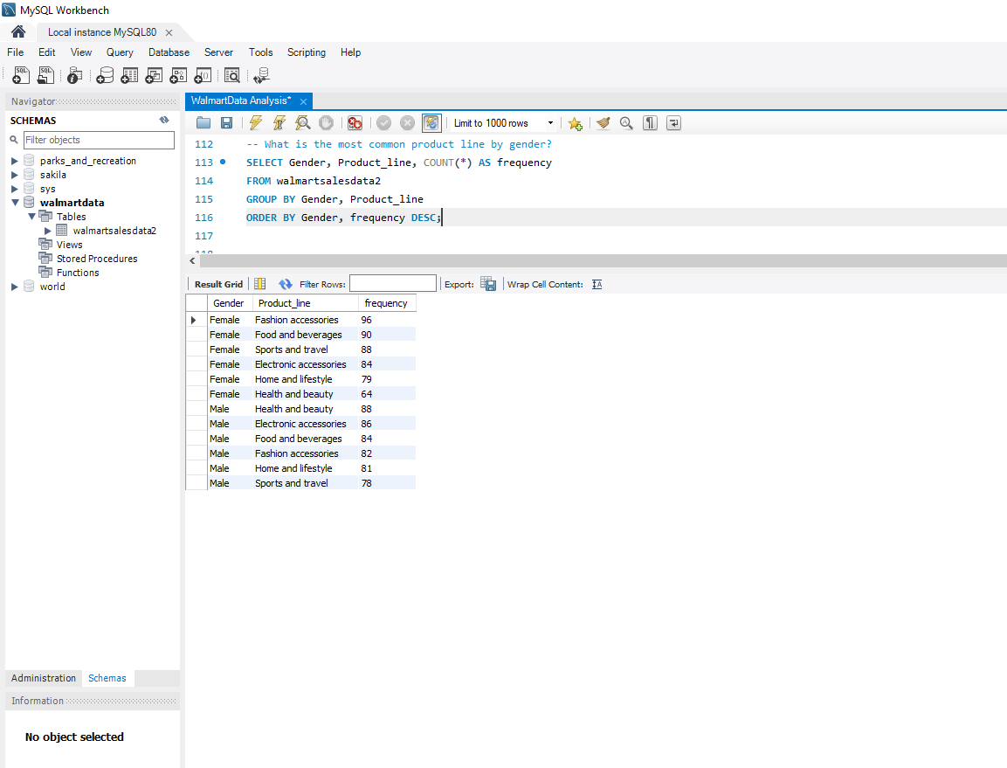

|  |  |  |
| --- | --- | --- |
| **Gender** | **Product_line** | **frequency** |
| Female | Fashion accessories | 96 |
| Female | Food and beverages | 90 |
| Female | Sports and travel | 88 |
| Female | Electronic accessories | 84 |
| Female | Home and lifestyle | 79 |
| Female | Health and beauty | 64 |
| Male | Health and beauty | 88 |
| Male | Electronic accessories | 86 |
| Male | Food and beverages | 84 |
| Male | Fashion accessories | 82 |
| Male | Home and lifestyle | 81 |
| Male | Sports and travel | 78 |

1. What is the average rating of each product line?

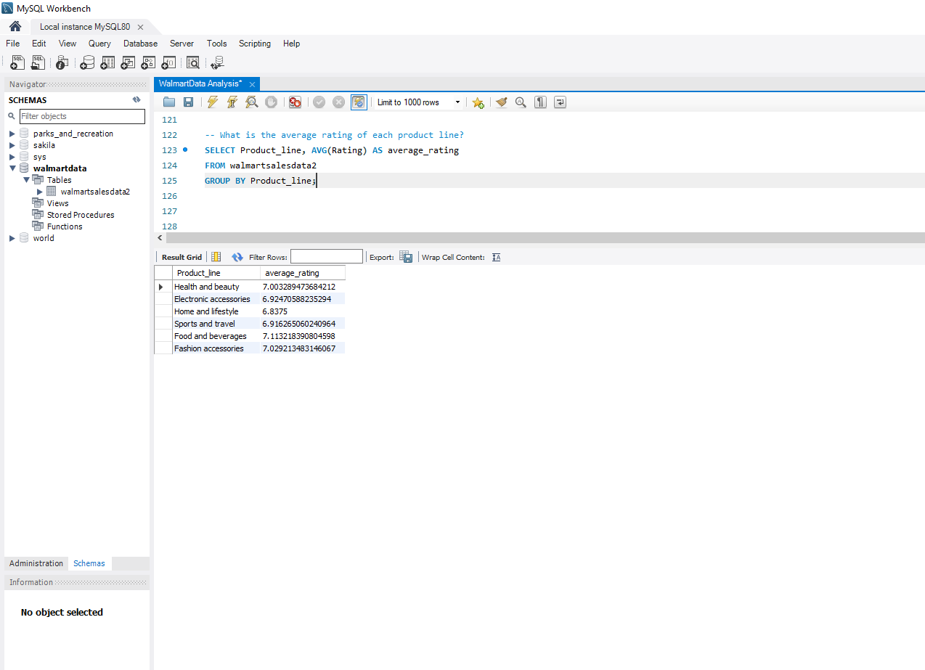

|  |  |
| --- | --- |
| **Product_line** | **Average_rating** |
| Health and beauty | 7.003289473684212 |
| Electronic accessories | 6.92470588235294 |
| Home and lifestyle | 6.8375 |
| Sports and travel | 6.916265060240964 |
| Food and beverages | 7.113218390804598 |
| Fashion accessories | 7.029213483146067 |
|  |  |

**Sales**

1. Which of the customer types brings the most revenue?

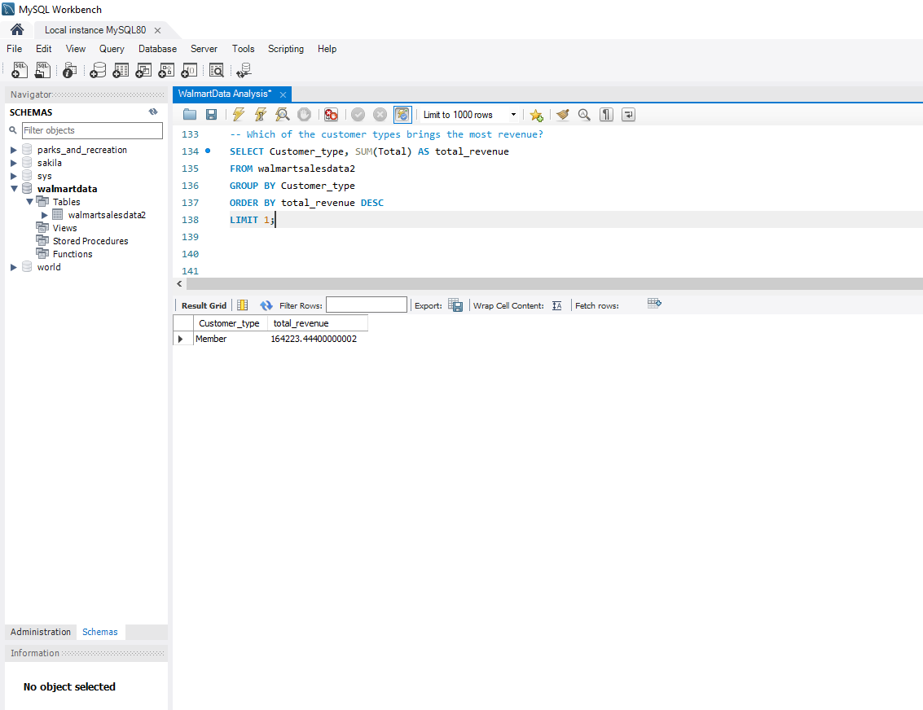

Members brings the most revenue with 164223.44400000002

1. Which city has the largest tax percentage/ VAT (Value Added Tax)?

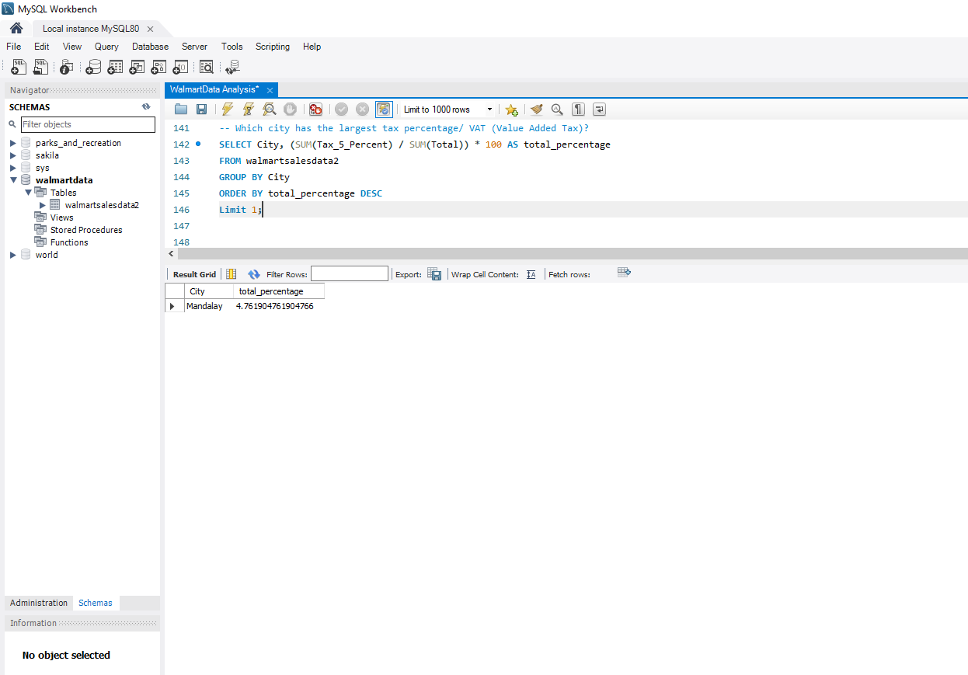Mandalay city has the largest tax percentage with 4.76%

1. Which customer type pays the most VAT?

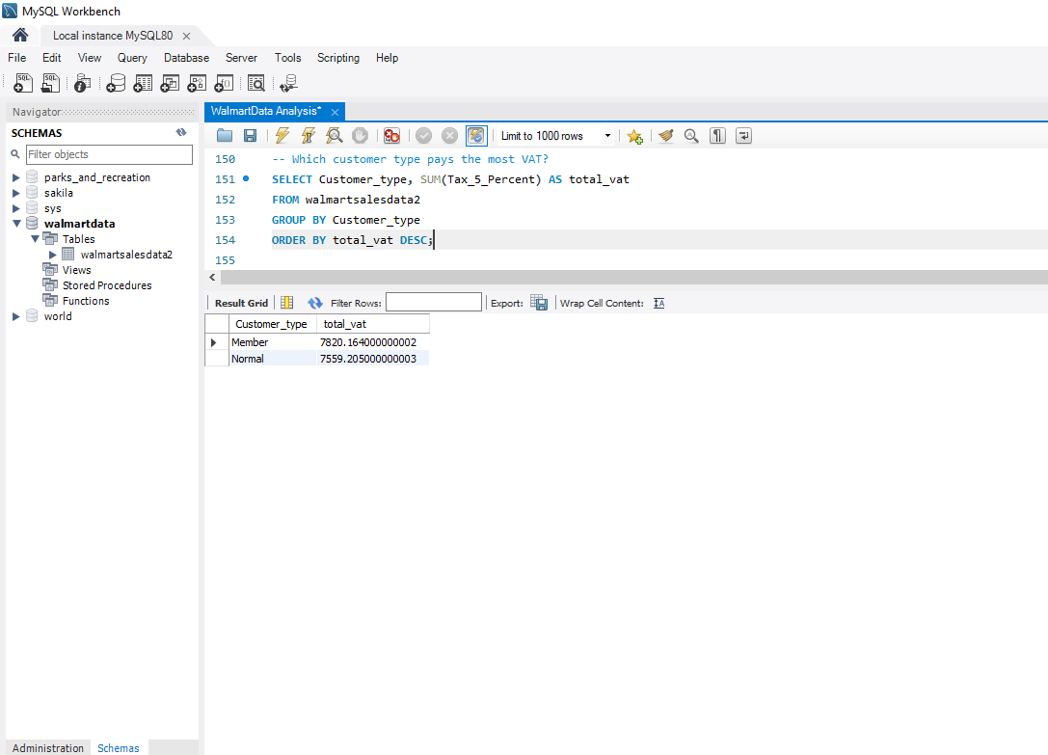Members pay the most VAT with 7820.164000000002

**Customers**

1. How many unique customer types does the data have?

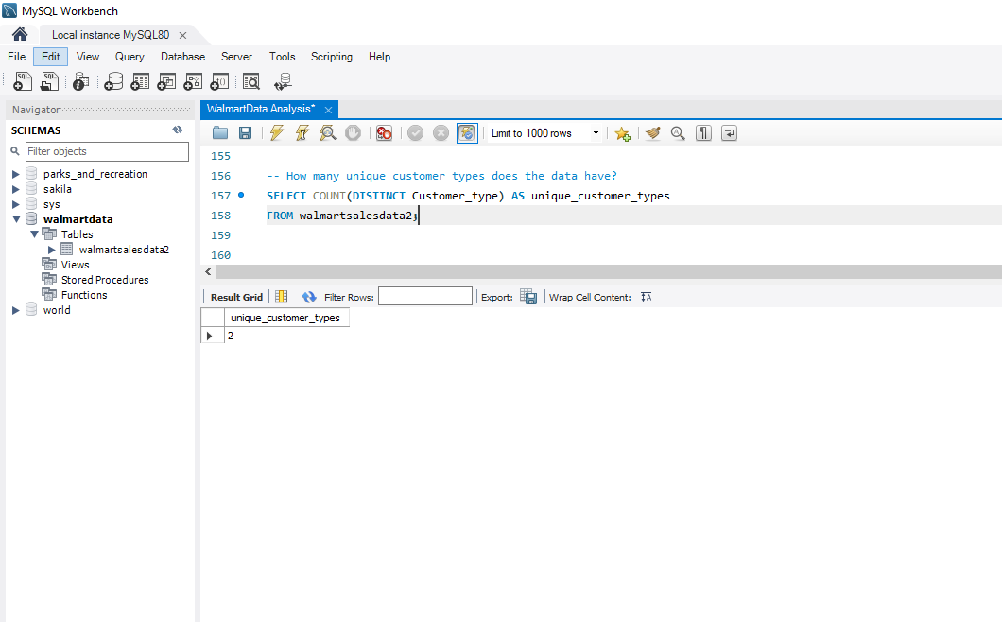The data has 2 unique customer types

1. How many unique payment methods does the data have?

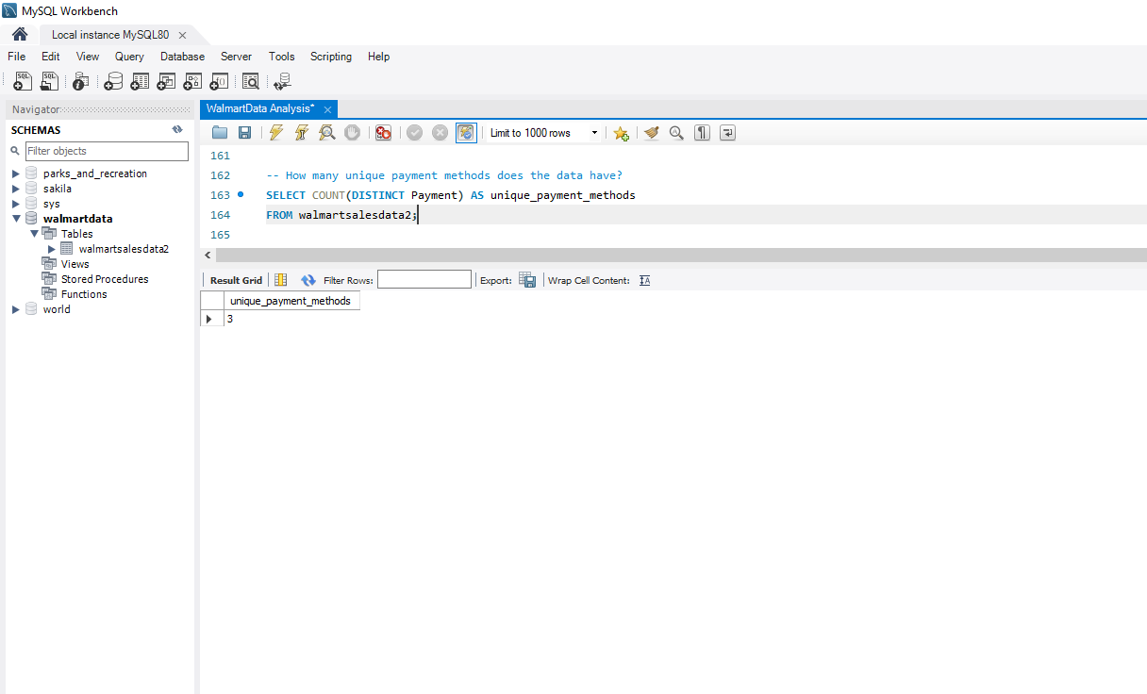There are 3 unique payment methods

1. What is the most common customer type?

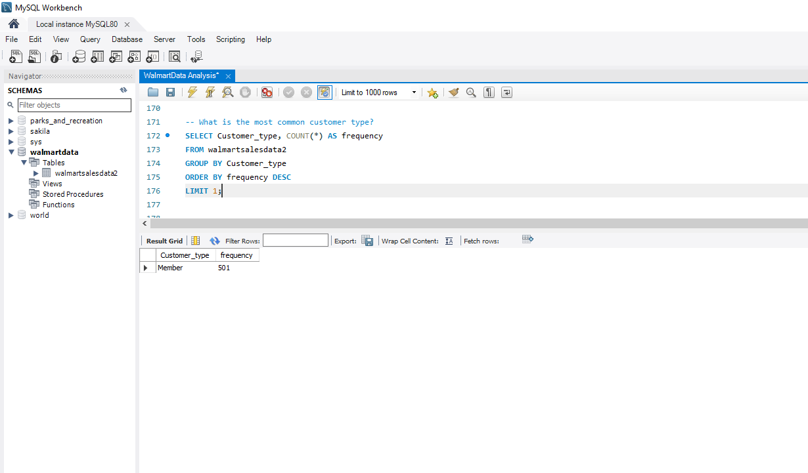The most common customer type is Member

1. What is the gender of most of the customers?

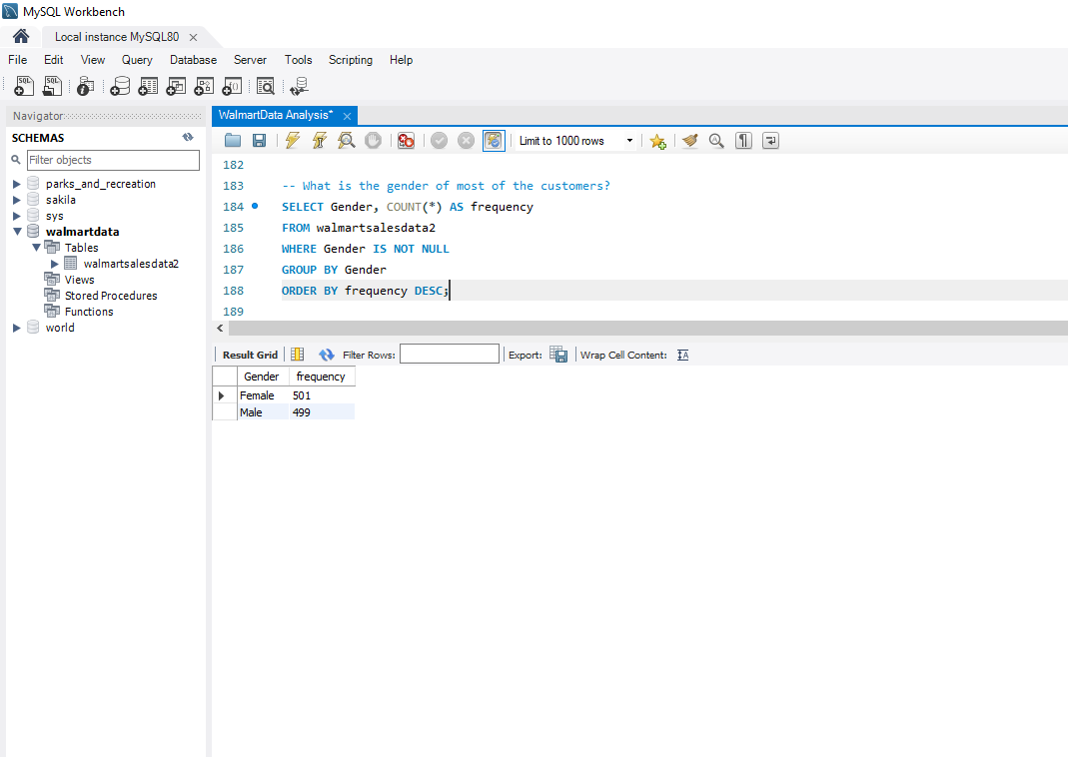The gender of most of the customers is Female

1. What is the gender distribution per branch?

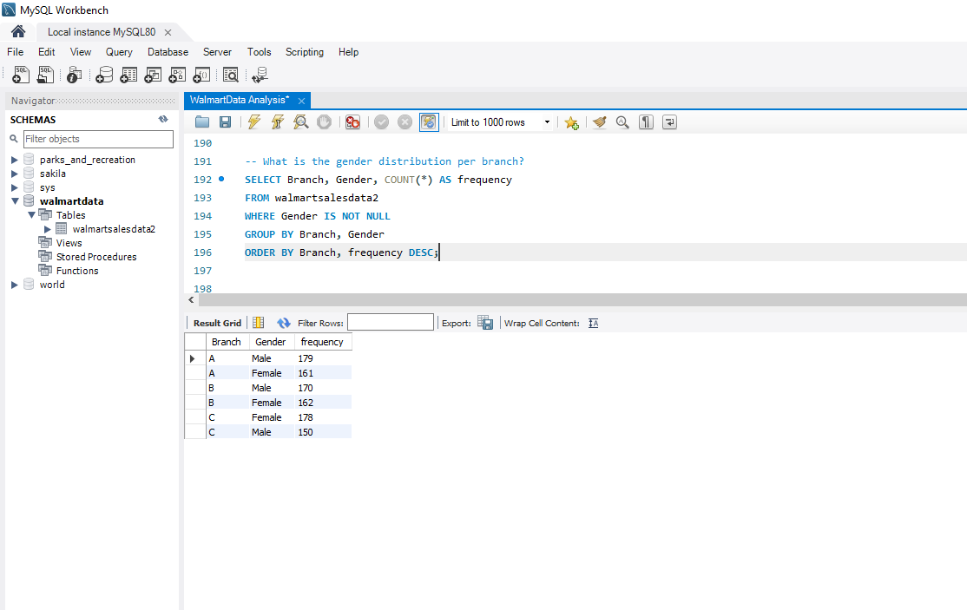

|  |  |  |
| --- | --- | --- |
| **Branch** | **Gender** | **frequency** |
| A | Male | 179 |
| A | Female | 161 |
| B | Male | 170 |
| B | Female | 162 |
| C | Female | 178 |
| C | Male | 150 |

1. Which payment method is most commonly associated with customer ratings?

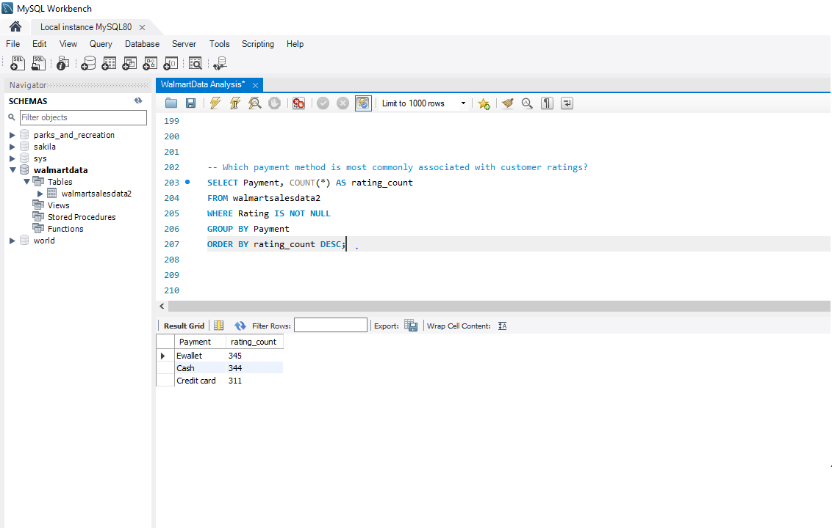

|  |  |
| --- | --- |
| Payment | rating_count |
| Ewallet | 345 |
| Cash | 344 |
| Credit card | 311 |