Cisco Packet Tracer Lab- Bank LAN Network
📌 Overview
This repository documents a full-scale Cisco Packet Tracer simulation of a multi-site bank network. The project demonstrates a hierarchical enterprise design with segmentation, redundancy, routing, edge services, a DMZ, simulated ISP connectivity, and a disaster recovery site.

Network Architecture
- Access Layer: Four Cisco 2960 access switches, each redundantly connected to two Layer 3 distribution switches.
- Distribution Layer: Two Cisco 3650 multilayer switches interconnected using EtherChannel and redundantly connected to the core.
- Core Layer: Three Layer 3 switches connected in a triangular topology, with upstream connectivity toward the edge.
- Network Edge: A Cisco 2911 router connects the internal network, simulated ISP, and DMZ, while implementing NAT/PAT and ACL-based controls.
- Disaster Recovery: A dedicated DR site provides an additional enterprise location and alternative connectivity paths.

Technologies Implemented
- VLANs and Switch Virtual Interfaces (SVIs)
- Inter-VLAN routing
- OSPF dynamic routing
- Basic BGP routing
- Static routing
- Route redistribution
- NAT and PAT
- DHCP, DNS, Mail, and NTP services
- Default gateway configuration
- DMZ implementation
- Access Control Lists (ACLs)
- EtherChannel redundancy
- Disaster recovery implementation
- ISP and Internet connectivity simulation
- Hierarchical network design principles

IP Addressing

WAN and External Addressing
Device | Interface | Address
ISP1 | G0/0 | 10.0.250.2/30
ISP1 | G0/1 | 203.0.112.1/30
ISP1 | G0/2 | 192.0.2.1/30
ISP2 | G0/0 | 192.0.2.2/30
ISP2 | G0/1 | 192.0.21.1/30
ISP2 | G0/2 | 192.0.22.1/30
Firewall / Edge | G0/0.1 | 172.16.10.1/24
Firewall / Edge | G0/1 | 10.0.250.1/30
Firewall / Edge | G0/2 | 10.0.255.2/30
DR (Disaster Recovery) | G0/0.1 | 10.50.0.1/24
DR | G0/1 | 192.0.22.2/30
DR | G0/2 | 10.0.252.2/30

HQ VLAN Summary
VLAN | Purpose | Subnet | Default Gateway
10 | Finance Data | 10.13.10.0/24 | 10.13.10.1
20 | HR Data | 10.14.10.0/24 | 10.14.10.1
30 | Operations Data | 10.15.10.0/24 | 10.15.10.1
40 | IT Data | 10.16.10.0/24 | 10.16.10.1
50 | Server Farm | 10.17.10.0/24 | 10.17.10.1
60 | DMZ | 172.16.10.0/24 | 172.16.10.1
99 | Management | 10.18.99.0/24 | 10.18.99.1
100 | Disaster Recovery | 10.50.0.0/24 | 10.50.0.1
110 | Finance Voice | 10.19.110.0/24 | 10.19.110.1
120 | HR Voice | 10.20.120.0/24 | 10.20.120.1
130 | Operations Voice | 10.21.130.0/24 | 10.21.130.1
140 | IT Voice | 10.22.140.0/24 | 10.22.140.1

Topology Diagram
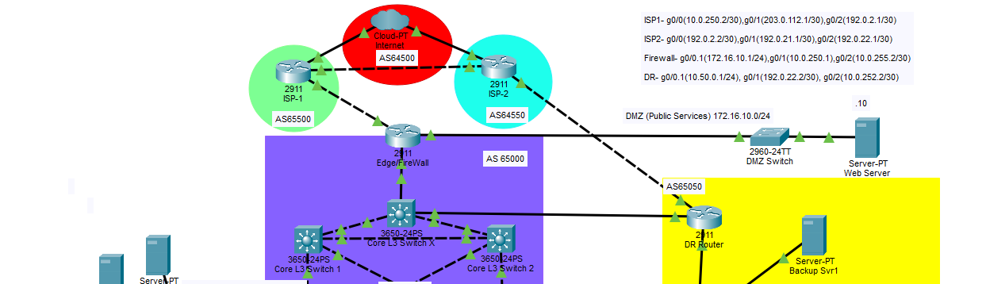
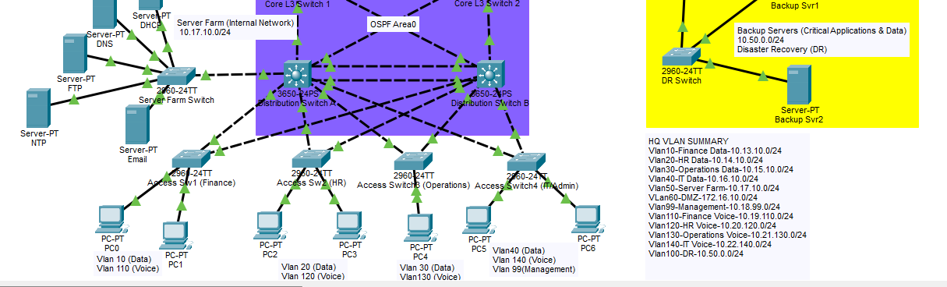
Fig1.1: Screenshot of the multi-tier bank topology implemented on Packet Tracer 9.0.1 (The scale was too big to fit the illustration in one screenshot).

Routing and Connectivity
- OSPF is used for dynamic routing within the enterprise environment.
- Basic BGP is used for simulated external routing within Packet Tracer capabilities.
- Static routes supplement dynamic routing where required.
- Route redistribution exchanges routing information between routing domains.

Security and Enterprise Services
- NAT/PAT translates internal addresses for external connectivity.
- ACLs control traffic between the DMZ and internal network.
- Internal hosts can access DMZ services.
- DMZ servers are restricted from initiating connections toward the internal LAN.
- DHCP provides automated client addressing.
- DNS provides hostname resolution.
- Mail and NTP services are included for enterprise-service testing.

How to Run the Lab
- Install Cisco Packet Tracer 9.0.1 or later.
- Clone or download the repository.
- Open the Packet Tracer project file (.pkt).
- Review the topology diagram and addressing plan.
- Verify device configurations and interface states.
- Run the validation tests.

Troubleshooting Checklist
- Confirm access ports are assigned to the correct VLAN.
- Verify trunks permit all required VLANs.
- Confirm hosts have the correct IP address, subnet mask, and default gateway.
- Ensure SVIs are correctly configured and operational.
- Verify Router-on-a-Stick subinterfaces for the DMZ and DR implementations.
- Confirm NAT translates internal addresses as intended.
- Check routing tables and end-to-end connectivity.
- Check ACLs when expected traffic is blocked.
- Verify BGP-to-OSPF route redistribution where required.

Problems Encountered and Lessons Learned
- Use /30 or /31 addressing for point-to-point links where appropriate to reduce overlap and simplify troubleshooting.
- Use ip helper-address on SVIs when DHCP clients and the DHCP server are in different subnets.
- The PT8200 model did not provide the BGP capability required for this lab, while the Cisco 2911 supported the demonstrated basic BGP configuration.
- Static routes may be required to achieve complete end-to-end reachability.
- The simulated mail service produced SMTP authentication failures during testing.
- NTP synchronization did not propagate to every router and switch; only three multilayer switches and the DR router synchronized at Stratum 2 during testing.
- DHCP and DNS resolution were successfully demonstrated.
- Packet Tracer supports a limited subset of BGP functionality; neighbor configuration, network advertisement, and redistribution were demonstrated, while more advanced features were unavailable.

Platform Limitations
This project is a Cisco Packet Tracer simulation. Some production-grade protocol features and device behaviors are simplified or unavailable. The lab should therefore be evaluated within the capabilities and limitations of Packet Tracer.

Recommended GitHub Repository Structure
Multi-Branch-Bank-Network/
├── README.md
├── packet-tracer/
│ └── Multi-Branch-Bank-Network.pkt
├── topology/
│ └── topology-diagram.png
├── screenshots/
└── docs/

Future Improvements
- Add automated configuration backup and validation scripts.
- Expand monitoring and logging capabilities.
- Add additional branch-site scenarios.
- Perform more WAN resiliency testing.
- Migrate advanced components to a more feature-complete network emulator for expanded BGP functionality.

License and Contributions
No license is currently attached to this project. If the repository is made public, consider adding a formal license file to define reuse and contribution terms. Contributions and improvements are welcome.

