ALINTA TECH SOLUTIONS
Nex — ATS Capital Markets
Technical Architecture & MVP Delivery Plan
Document: Technical guide: current state, target architecture, environments, CI/CD, MVP sprint plan, pilot plan
Version: v0.3 (24 Sep 2026). Replaces v0.2, which was based on the wrong repository
Codebase: Alintatech-Solutions/ats-capital-markets-app, main @ 805753b
Audience: Developers, tech lead, DevOps, QA
Inputs: ATS Trading Platform — Investor Business Plan V1.0; the repository above, including CLAUDE.md, docs/AI_CONTEXT.md, docs/PLATFORM_STATE.md and docs/FRONTEND_UI_APP_SHELL.md; product direction from the founders (24 Sep 2026)
Status: Draft for engineering review
Version 0.3 — 24 September 2026

Contents

Right-click the table of contents and choose "Update Field" if page numbers are missing.

0. What changed in v0.3
v0.1 and v0.2 were written against Mutwila-Alinta/ATS, an early Java prototype. This version is based on the actual application, ats-capital-markets-app. That app is far more advanced, so the plan changes from building the MVP to hardening, splitting and moving a working application.
Topic | v0.2 | v0.3
Starting point | Prototype pricing classes, no services | A working full-stack app: 9 UI modules, 17 priced product types, curve bootstrapping, risk, scenarios, reporting batches, RBAC, K8s/GitOps deployment
Build | Gradle | Maven (keep, as the repo requires)
Microservices | 4 new services built from scratch | Split the existing monolith into 3 services along existing package boundaries (strangler pattern)
AWS runtime | ECS Fargate | EKS + ArgoCD, which keeps the repo's mandated Jenkins → registry → GitOps → ArgoCD flow and reuses the Kustomize manifests
CI/CD | New GitHub Actions | Extend the existing Jenkins pipelines (Jenkinsfile, Jenkinsfile.aws)
UI | Wire an assumed React app | The existing React app is kept; work is limited to performance, code health and look & feel
Dates | MVP 18 Dec 2026; pilot Jan–Apr 2027 | Unchanged

1. Summary for developers
- MVP (v1.0.0, 18 Dec 2026) is today's functionality, made secure, durable and scalable. The work:
  - real Keycloak authentication in place of the auth bypass
  - no in-memory state across replicas
  - a real EOD run in place of the simulated one
  - Flyway-owned schema
  - reports stored in S3
  - the back end split into three services: core-api, pricing-engine and batch-reporting

It runs on Docker Compose and on AWS dev (EKS, af-south-1), deployed by Jenkins → ECR → GitOps → ArgoCD, with automated tests and security gates.
- The UI stays as it is. Work covers pinned dependencies, code splitting, breaking up the two very large components, lint and tests, and look-and-feel polish.
- Pilot: 11 Jan – 30 Apr 2027, on a dedicated AWS pilot environment.
- Reality check: the application logic largely exists, so a 12-week window is achievable. The risk sits in the security, state and EOD fixes and in the AWS platform work. §8.4 lists what to cut if needed.

2. Current state (verified 24 Sep 2026)

2.1 What exists
Area | What's there
Repository layout | backend/ (Spring Boot), frontend/ (React/Vite), docker-compose.yml (postgres, redis, backend, frontend), apps/ats-capital-markets/ (Kustomize base + devops-pipeline overlay), infrastructure/argocd/, Jenkinsfile (GHCR + GitOps + PR previews), Jenkinsfile.aws (build and push to ECR), .github/workflows/pr-preview-cleanup.yml, docs/
Back end | Java 21, Spring Boot 3.3.5, Maven; about 25.5k lines. Uses Web, Data JPA, Batch, Redis, Security + OAuth2 resource server, WebSocket (STOMP), Flyway, Apache POI. Also has H2 for local runs
Back-end packages | trade, refdata, market (curves, snapshots, environments, fixings, OIS curve stripping, bootstrap), pricing (products, foundation, tools), risk, scenario, simulation, reporting (definitions, batches with DAG edges, executions, schedules, CSV output), batch, security (users, 20 roles, 60 permissions), workspace
Pricing coverage (TicketValuationManager implementations) | OIS swap, term swap, IRS swap, bond, bond forward, credit note (incl. z-spread solver and PD term structures), deposit, FX forward, FX swap, equity future, IRS future, listed option, OTC option, TRS
Market data | Curves and nodes, snapshots per date and environment, OIS swap curve definitions with stripping conventions, curve bootstrapping, index fixings, fixing-to-curve mappings, CSV import (preview/commit). Distributed cache: Postgres → Redis → an immutable context held in the JVM
Trade lifecycle | Draft → Pending Approval → Trader Confirmed / Amended / Cancelled; book, amend, cancel, submit-for-approval, approve; portfolio–counterparty gate
Front end | React (unpinned latest), Vite 8, TypeScript, Tailwind 3, zustand, oidc-client-ts (Keycloak PKCE), STOMP risk socket worker, exceljs. About 17k lines. 9 modules: Trade Capture, Trade Blotter, Market Data, Valuation, Risk, Operations, Reporting, Reference Data, User Management. Dark "terminal" theme and fixed app shell (docs/FRONTEND_UI_APP_SHELL.md)
Database | PostgreSQL 16 with 30 JPA tables. Flyway has V1__reporting_module, V2 (Postgres-only backfill) and V3__add_ois_curve_stripping_conventions; all other tables are created by Hibernate ddl-auto: update
Deployment today | Jenkins → GHCR → GitOps repo → ArgoCD → Rancher RKE2. Includes per-PR preview namespaces, Vault + External Secrets Operator, Cloudflare Tunnel, Traefik ingress. Jenkinsfile.aws builds and pushes images to ECR in af-south-1, but has no deploy stage
Tests | Back end: 21 suites, 83 tests, all passing (mvn test, run 24 Sep). Front end: builds (tsc -b && vite build) with no tests or lint. Main bundle 810 KB (185 KB gzipped), exceljs chunk 930 KB

2.2 Gaps that block a pilot (verified in code)
# | Gap | Evidence | Fix (sprint)
G1 | Authentication is bypassed | SecurityConfig.TEMPORARY_AUTH_BYPASS = true lets anyone call /api/**. The OAuth2 resource-server auto-config is excluded in application.yml. Dev-login tokens live in an in-memory map (DevSessionRegistry) | Turn on Keycloak JWT validation; keep dev login only under the local profile (S1)
G2 | In-memory state with 2 replicas | backend-deployment.yaml sets replicas: 2. State is held in ConcurrentHashMaps in DevSessionRegistry, RiskEngineService.jobs, BatchController.progress and SpringDynamicSchedulerService. As a result, sessions and jobs are lost between pods, and scheduled report batches fire on every replica | Redis for job/session state; ShedLock for schedules (S1)
G3 | EOD run is simulated | BatchController just loops 0→100% with Thread.sleep | Real Spring Batch EOD job (S3)
G4 | Schema not owned by migrations | ddl-auto: update (default) vs validate (prod). Flyway covers only reporting and conventions, so there is no reproducible way to create a production database | Flyway baseline migration for the full schema; validate everywhere except local H2 (S0)
G5 | Report files on local disk | LocalFileStorageService writes to ./report-output, which is lost on pod restart and not shared between replicas | S3-backed FileStorageService (MinIO locally) (S1)
G6 | No security scanning; weak AWS pipeline | No SAST, dependency, secret or image scanning in Jenkinsfile. Jenkinsfile.aws uses static AWS keys (ats-dev-aws-credentials) and pushes a mutable latest tag | Add scanning stages; IAM role; immutable tags (S0–S4)
G7 | Front-end maintainability | Unpinned latest for react, typescript, zustand and vite plugin. TradingWorkstation.tsx has 4,374 lines; MdcmModule.tsx has 2,603. No code splitting. Leftover srcFE16Jul/ folder and zip, dump_xlsx_tmp.cjs; sample instruments hard-coded in App.tsx | §7 (S0, S4)
G8 | Observability | No Spring Actuator (custom HealthController). System.out.println in the pricing path. No metrics or traces | Actuator, Micrometer, JSON logs, OpenTelemetry (S0)
G9 | Code hygiene | Placeholder formulas in PricingService.value (/api/pricing/value) next to the real ticket pricers. .txt files and sample JSON/CSV in src/main/java. A stray com.alinta... package. A Test2 file at the root | Remove or relocate (S0)

2.3 Repository rules this plan respects
CLAUDE.md and docs/AI_CONTEXT.md require: Maven (not Gradle); the Jenkins → image registry → GitOps → ArgoCD deployment flow; no manual kubectl/Helm on shared environments; secrets through Vault/External Secrets only; and every platform change recorded in docs/PLATFORM_STATE.md. The AWS move below keeps the same flow and swaps only its components: ECR for GHCR, EKS for RKE2, and AWS Secrets Manager behind External Secrets as another secret store.

3. MVP functional scope — "keep current functionality"
All nine modules and all current products stay. The MVP makes them production-grade.
Module (UI) | Keeps | MVP hardening
Trade Capture | Tickets for all 17 product types; live valuation, expected and realised cashflows from the ticket | Calls go to pricing-engine; valuation audit stored; System.out replaced with structured logs
Trade Blotter | Blotter, amend, cancel, approve, copy | Authorisation checks on every action; append-only trade version/audit history (new)
Market Data | Curves, snapshots, environments, OIS curve stripping, bootstrap, fixings, CSV import | Maker-checker roles enforced (MARKET_DATA_MAKER/CHECKER already exist); cache invalidation across services through Redis
Valuation | Portfolio valuation views | Backed by persisted EOD results as well as ad-hoc runs
Risk | Risk engine jobs (DV01 etc.) and WebSocket updates | Job state in Redis, so any replica can serve status; runs in pricing-engine
Operations | EOD trigger and progress | Real EOD run (§4.7) with progress from Spring Batch metadata
Reporting | Definitions, batches with dependency edges, schedules, execution history, CSV reports (EOD valuations, expected/realised cashflows, positions, blotter, valuation attribution) | Runs in batch-reporting; runs once per schedule (ShedLock); output to S3
Reference Data | Counterparties, roles, portfolios and links, holiday calendars, credit ratings/PD points, audit log | Unchanged; the audit log is extended to trades
User Management | Users and roles (20 roles, 60 permissions) | Users come from Keycloak; roles map to the existing RBAC permission codes

Out of MVP scope: new asset classes, new risk measures, SWIFT/FIX, vendor market-data feeds, pooled multi-tenancy, AI/RPA modules.

4. Target architecture

4.1 Principles
- Split the monolith along existing package boundaries. Carve out services where there is a clear operational reason (scaling or isolation). Don't rewrite working pricing code.
- The pricing library is plain Java. quant-lib holds the pricing/* foundation, tools, market-data maths and per-product calculators, with no Spring or database dependencies. That keeps it testable and reusable by any service.
- Stateless services. All state lives in PostgreSQL, Redis and S3, so any replica can serve any request.
- One deployment flow everywhere. Jenkins builds, tests and scans; pushes images; updates GitOps; ArgoCD deploys. Docker Compose is for local development and CI end-to-end tests only.
- Security and audit by default. Keycloak JWT on every call, and an audit trail for trades, reference data and market data.

4.2 Service split (MVP)
Service | Built from (current packages) | Responsibilities | State | Scales on
core-api | trade, refdata, market (management), security, workspace, scenario, simulation | Trade booking and lifecycle, reference data, market-data CRUD/import/bootstrap/snapshots, users and RBAC, workspace layouts, scenario capture | PostgreSQL schema core; publishes market contexts to Redis | API traffic
pricing-engine | pricing/* (via quant-lib), risk, market read-side (ImmutableMarketDataContext, caches) | Ticket valuation, expected and realised cashflows, risk jobs, and valuation for EOD workers | Stateless. Market context read from Redis (populated by core-api) with a fallback to core-api's internal snapshot API | CPU (HPA)
batch-reporting | reporting/*, batch | Report definitions, batches, schedules, executions; EOD job; files to S3 | PostgreSQL schema reporting + Spring Batch metadata; S3 | Scheduled load
frontend | frontend/ | React SPA via nginx | – | –

Routing needs no separate API gateway. In Docker, the frontend's nginx splits /api/* by path. On Kubernetes, ingress rules do the same:
Path prefix | Service
/api/pricing/**, /api/risk/**, /ws/** (risk socket) | pricing-engine
/api/reporting/**, /api/batch/** | batch-reporting
everything else under /api/** | core-api

After the pilot (candidates, not MVP): split market-data-service and refdata-service out of core-api, and add an event bus (SNS/SQS or MSK) for trade and market-data events.
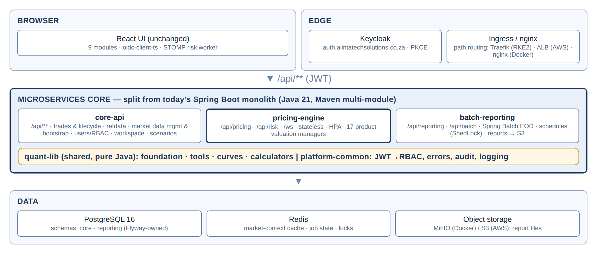
Figure 1 — MVP service split

4.3 Maven multi-module layout
backend/
├── pom.xml # parent (packaging=pom), dependencyManagement, plugins (Spotless, JaCoCo, dependency-check, CycloneDX)
├── quant-lib/ # pure Java: pricing/foundation, tools, math, marketData, instruments, per-product calculators
├── platform-common/ # security (JWT → authorities), error model, audit, logging, OpenAPI config, Redis helpers
├── core-api/ # Spring Boot app (today's CapitalMarketsApplication, minus pricing, risk and reporting)
├── pricing-engine/ # Spring Boot app: PricingController, RiskEngine, market-context readers
└── batch-reporting/ # Spring Boot app: reporting/*, EOD Spring Batch job, S3 storage

Migration approach (behaviour-preserving):
- Create the parent POM and move today's code unchanged into core-api. The 83 tests must stay green.
- Move the pricing foundation, tools and calculators into quant-lib, and the shared security and error code into platform-common.
- Create pricing-engine and move PricingController, the TicketValuationManagers and RiskEngine* into it. In core-api, replace direct calls with a generated client.
- Create batch-reporting the same way, and delete the moved code from core-api.
Each step is its own PR with a preview environment, following the repo's workflow.

4.4 Data architecture
Topic | Target
Schema ownership | Schema core (trades, OIS legs/schedules, refdata, market curves/snapshots/fixings/indices, credit ratings, users/roles/permissions, workspace) is owned by core-api. Schema reporting (report_*, batch_edge, execution_history, Spring Batch BATCH_*, eod_valuation, eod_cashflow) is owned by batch-reporting. pricing-engine has no database
Migrations | Flyway only. Create V0__baseline per schema from the schema Hibernate generates today (review with pg_dump --schema-only, then commit). Existing databases use baseline-on-migrate at version 0. Set ddl-auto: validate in every profile except local H2
Trade audit (new) | Append-only trade_version (trade_id, version, status, full payload JSON, changed_by, changed_at, reason), written on book/amend/cancel/approve. The existing refdata_audit_log pattern is reused for market data
EOD results (new) | eod_run (run_id, business_date, snapshot_id, environment, status, counts), eod_valuation (per trade: PV, currency, measures JSON), eod_cashflow (per trade and leg). Reports read from these tables instead of re-pricing
Redis | Market-context cache (existing DistributedMarketDataCache), risk and EOD job state, dev sessions (local only), ShedLock locks (or JDBC ShedLock)
Object storage | FileStorageService gets an S3FileStorageService (AWS SDK v2). MinIO in Compose, S3 on AWS; keys reports/{date}/{executionId}/...

4.5 Security
- Browser: unchanged. oidc-client-ts runs Authorization Code + PKCE against Keycloak (ats-capital-markets realm, client capital-markets-web).
- Services: remove TEMPORARY_AUTH_BYPASS and stop excluding OAuth2ResourceServerAutoConfiguration. Enable oauth2ResourceServer().jwt(). The existing keycloakRoleConverter is extended to map Keycloak realm roles to the 20 existing role codes and 60 permission codes, so the existing @PreAuthorize checks keep working.
- Dev login: DevTokenAuthenticationFilter and /api/auth/login load only under @Profile("local").
- Service to service: batch-reporting → pricing-engine and core-api use a Keycloak client-credentials token with the existing INTEGRATION_SERVICE_ACCOUNT role.
- Secrets: Vault + External Secrets on RKE2 (today). On AWS, AWS Secrets Manager + External Secrets (ClusterSecretStore/aws-secrets-manager) with IRSA, so no static keys. Nothing secret in images or git.
- Transport: TLS at the ALB (ACM) or Cloudflare. Services are reachable only inside the cluster.

4.6 Key flow: ticket valuation after the split
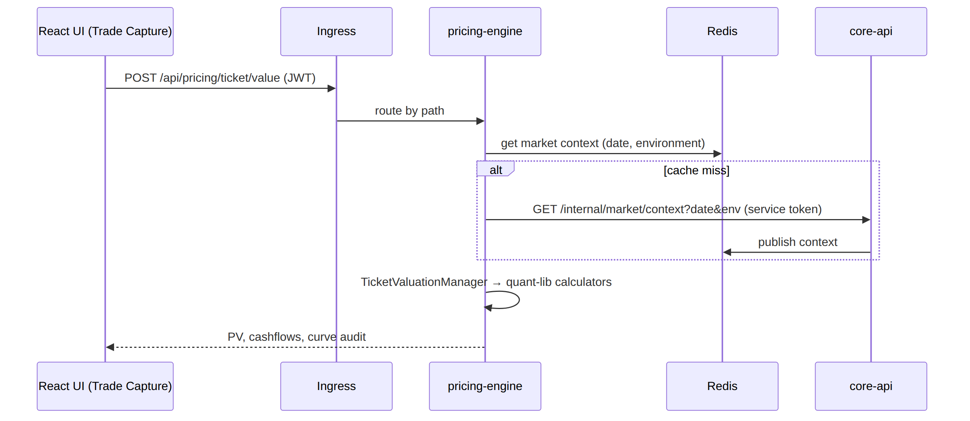
Figure 2 — Ticket valuation after the split

4.7 EOD run (replaces the simulated batch)
Spring Batch job eodValuationJob(businessDate, environment) in batch-reporting:
- Seal: resolve and freeze the market snapshot for businessDate and environment (a core-api snapshot commit, which already exists).
- Read: page through live trades from core-api.
- Process: value in chunks through pricing-engine, with bounded concurrency (reuse BoundedFanOut).
- Write: eod_valuation and eod_cashflow.
- Finish: trigger the dependent report batches (existing DAG edges).
Progress is served over the existing SSE endpoint from Spring Batch step metadata, so any replica can answer. Re-runs are idempotent per (businessDate, environment, snapshotId).

5. Environments and deployment

5.1 Step 1 — Docker
Goal: docker compose up runs the whole stack for local integration work and for CI end-to-end tests. Shared environments still deploy only through Jenkins and GitOps, as the repo rules require.
Compose services: postgres, redis, minio, keycloak (a dev realm export, local only), core-api, pricing-engine, batch-reporting, frontend.
Changes to the current set-up:
Current | Change | Why
One backend/Dockerfile | One Dockerfile per service (build argument MODULE), multi-stage, non-root (already done), HEALTHCHECK on /actuator/health/readiness, JAVA_TOOL_OPTIONS=-XX:MaxRAMPercentage=75 | Three images from one Maven reactor
Custom HealthController | Spring Boot Actuator (liveness/readiness groups, Prometheus endpoint) | K8s probes, metrics
nginx.conf.template with one __BACKEND_UPSTREAM__ | Three upstreams (__CORE_UPSTREAM__, __PRICING_UPSTREAM__, __REPORTING_UPSTREAM__) with path routing as in §4.2; WebSocket upgrade headers on /ws/ | Service split without UI changes
Compose backend/frontend marked "for CI image builds only" | A full-stack Compose file for local integration and CI e2e; docker compose up -d postgres redis stays as the documented day-to-day local set-up | Reproducible end-to-end tests
ddl-auto: update | Flyway baseline + validate | Same schema everywhere
Local report folder | MinIO bucket | Same code path as S3

Done when: from a clean clone, cp .env.example .env && docker compose up -d --wait gives a working UI on :3000 with seed data, and the Playwright smoke suite passes.

5.2 Step 2 — AWS target (af-south-1)
Recommendation: Amazon EKS with ArgoCD, not ECS. The repo already has Kustomize manifests, ArgoCD applications, External Secrets, preview-namespace automation, and a rule that deployment goes through GitOps. EKS keeps all of that. ECS would mean redesigning the deployment flow, which docs/AI_CONTEXT.md explicitly rules out.
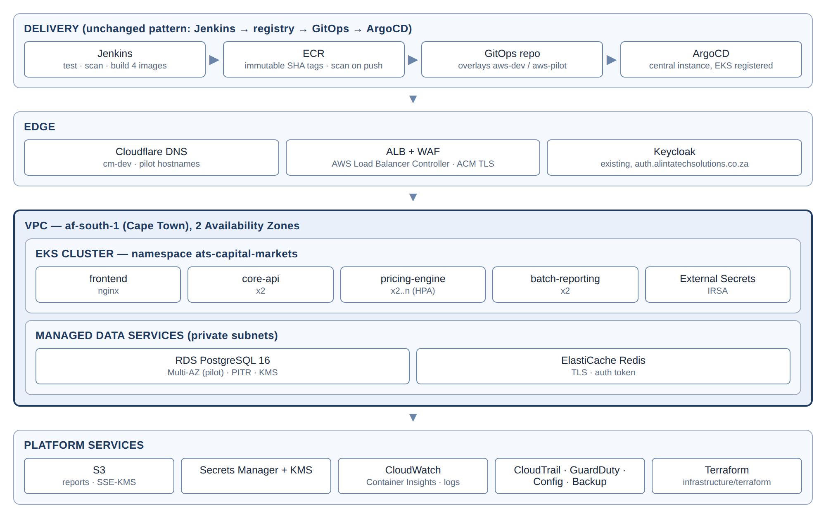
Figure 3 — AWS target (EKS, af-south-1) with GitOps delivery
Component | AWS service | Notes
Container registry | ECR (ats-<env>-core-api, -pricing-engine, -batch-reporting, -frontend) | Extends the existing ats-dev-backend/-frontend repositories. Scan on push, immutable tags, lifecycle policy
Kubernetes | EKS (managed node group, 2 AZs; Karpenter optional later) | Register as an ArgoCD destination (ats-capital-markets-aws-dev, -aws-pilot)
Ingress | AWS Load Balancer Controller (ALB) with an alb ingress class in the aws-* overlays. Traefik stays on RKE2 | The same path routing as §4.2, expressed as ALB ingress rules
Database | RDS PostgreSQL 16 (single-AZ dev, Multi-AZ pilot), PITR, KMS | Matches the PLATFORM_STATE target of a dedicated database outside the cluster
Cache | ElastiCache for Redis (TLS, auth token) | Replaces the in-cluster Redis deployment on AWS
Object storage | S3 (block public access, SSE-KMS, versioning) | Report output
Secrets | Secrets Manager + External Secrets (ClusterSecretStore/aws-secrets-manager), IRSA | Same Kubernetes Secret names and keys as today (capital-markets-db, capital-markets-redis)
Identity | Keep Keycloak at auth.alintatechsolutions.co.za | No change for the UI
DNS/TLS | Cloudflare DNS → ALB (ACM certificate; Cloudflare "Full (strict)") | e.g. cm-dev.alintatechsolutions.co.za (already the APP_URL in Jenkinsfile.aws)
Observability | CloudWatch Container Insights + Fluent Bit; Prometheus/Grafana optional | JSON logs with traceId
Guardrails | CloudTrail, GuardDuty, AWS Config, AWS Backup | Pilot bank due diligence

GitOps layout additions (in this repo or ats-capital-markets-gitops, whichever is canonical):
apps/ats-capital-markets/
├── base/ # + core-api, pricing-engine, batch-reporting deployments/services, HPA, PDBs
└── overlays/
├── devops-pipeline/ # existing (RKE2)
├── aws-dev/ # ALB ingress, ElastiCache/RDS endpoints, ESO aws store, IRSA annotations
└── aws-pilot/ # replicas, Multi-AZ endpoints, stricter resources
infrastructure/argocd/
├── ats-capital-markets-aws-dev.yaml
└── ats-capital-markets-aws-pilot.yaml

Infrastructure as code: add a new infrastructure/terraform/ with modules network, eks (with the ALB controller, ESO and IRSA roles), rds, elasticache, s3, ecr, iam-jenkins (role assumed by Jenkins, replacing static keys) and observability, plus environments aws-dev and aws-pilot. State goes in S3 with locking. Record every applied change in docs/PLATFORM_STATE.md, as the repo requires.
Transition: RKE2 production and PR previews keep running unchanged until the AWS pilot environment is signed off. Whether to cut over production or keep both is decided at pilot exit (D4).

6. CI/CD: containerise, test, scan, deploy (Jenkins)

6.1 Pipeline
We extend the existing Jenkinsfile stages (Checkout → Determine Build Context → Backend Tests → Frontend Build → Build and Push Images → Update GitOps → PR preview stages) and bring Jenkinsfile.aws in line with them.
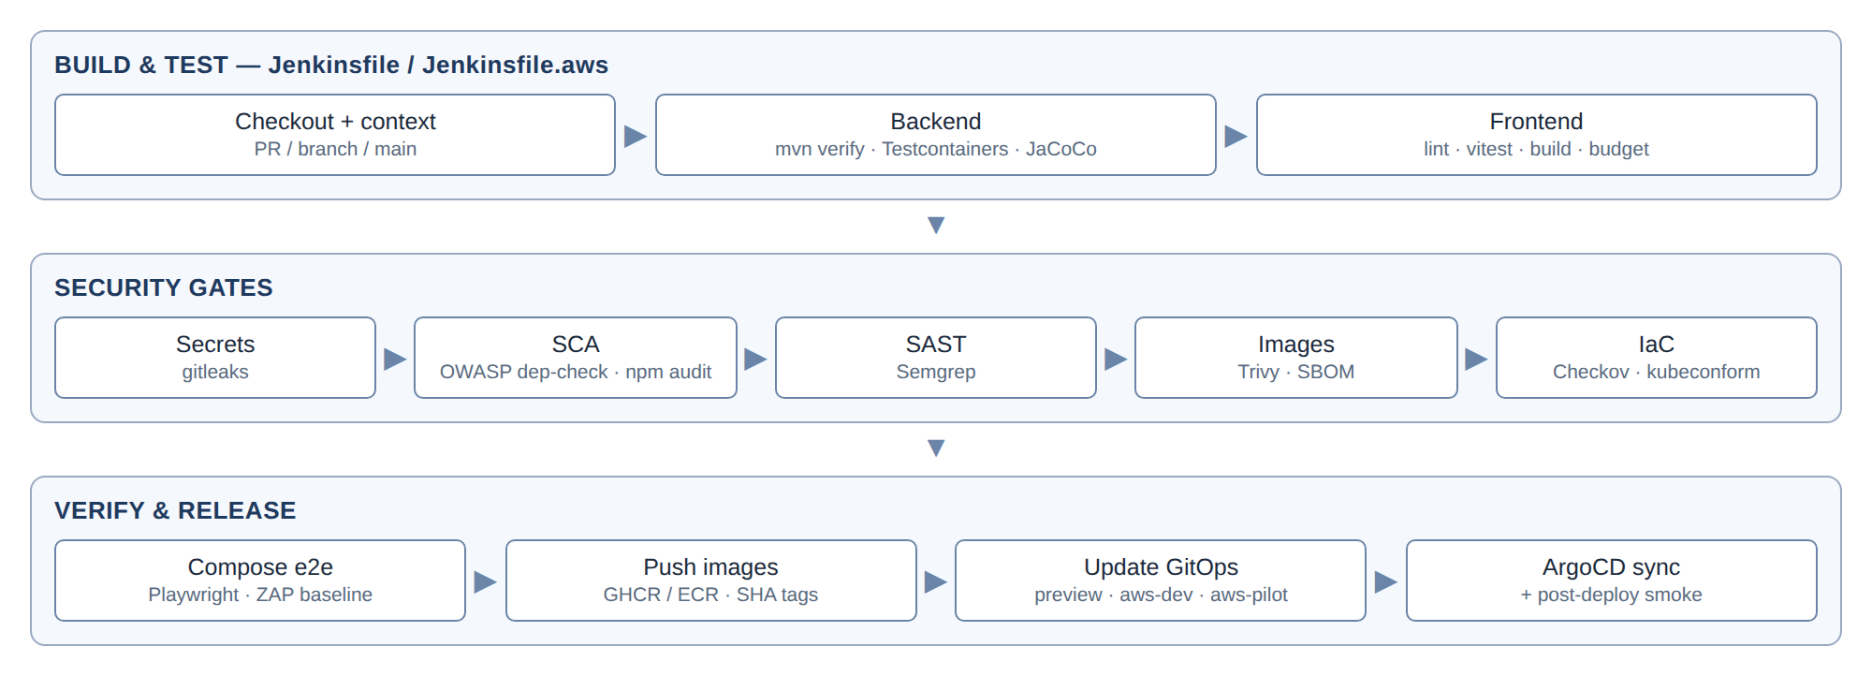
Figure 4 — Jenkins CI/CD with security gates
Stage | Tooling | Gate
Backend build and tests | mvn -B verify (Surefire + Failsafe, Testcontainers PostgreSQL/Redis, JaCoCo) | All tests pass; coverage does not drop (ratchet)
Frontend | npm ci, ESLint, tsc -b, Vitest, vite build | Zero lint errors; tests pass; bundle budget (§7)
Secrets | gitleaks | Zero findings
Dependencies (SCA) | OWASP dependency-check Maven plugin; npm audit --omit=dev | No critical; high findings need a time-boxed waiver
SAST | Semgrep (Java/TS rulesets); GitHub CodeQL optional | No new high findings
Images | Trivy (--severity CRITICAL,HIGH --ignore-unfixed --exit-code 1), ECR scan on push | Blocks on fixable critical/high
SBOM | CycloneDX Maven plugin + Syft for images | Archived per build
IaC and manifests | Checkov (Terraform + Kustomize output), kubeconform | No failed high checks
E2E | docker compose up --wait + Playwright smoke (login → book OIS → value → blotter → report) | Pass
DAST | OWASP ZAP baseline against the Compose stack | No high alerts
Push/deploy | Immutable git-SHA tags (drop latest); GitOps commit; ArgoCD sync | Post-deploy smoke on the preview/AWS URL

Jenkinsfile.aws changes:
- Use an IAM role (Jenkins instance profile or AssumeRole via iam-jenkins) instead of ats-dev-aws-credentials.
- Build all four images.
- Add the test and scan stages above.
- Update the aws-dev overlay image tags in GitOps. Do not deploy directly.

6.2 Test strategy
Level | Scope | Target
Unit — quant-lib | Day counts, calendars, schedules, curves/bootstrap, each product's calculator | Keep all 83 existing tests green. Add golden tests against independent reference values (QuantLib or pilot/Bloomberg) for OIS, bond, deposit and FX forward first. Line coverage ≥ 80% in quant-lib by pilot
Service | Controllers, security (@PreAuthorize per role), trade lifecycle, EOD job | @SpringBootTest + Testcontainers; every endpoint has an authorisation test
Contract | core-api ↔ pricing-engine ↔ batch-reporting | OpenAPI (springdoc) specs committed; generated clients; schema-diff check in CI
Front end | Stores, pricing builders (ticketParameterBuilders.ts, utils/pricing.ts), key components | Vitest + React Testing Library; critical paths covered
E2E | The 9 modules' happy paths | Playwright on Compose (PR) and on preview/AWS dev (post-deploy)
Performance | EOD 10k trades; ticket valuation p95; blotter 5k rows | EOD < 15 min on AWS dev; valuation p95 < 500 ms; blotter p95 < 1 s

7. Front end — efficiency and look & feel
The UI, its modules and its workflows stay as they are. Follow docs/FRONTEND_UI_APP_SHELL.md (fixed app shell, dark terminal theme, sharp corners).
Area | Change
Reproducible builds | Pin every latest dependency (react, react-dom, typescript, zustand, lucide-react, @vitejs/plugin-react) to exact versions; Renovate/Dependabot for upgrades
Bundle and load time | React.lazy per module tab (9 chunks); load exceljs only on export (dynamic import()); manualChunks for vendor code. Budget: initial JS ≤ 150 KB gzipped (today 185 KB main + 256 KB exceljs)
Runtime efficiency | Split TradingWorkstation.tsx (4.4k lines) and MdcmModule.tsx (2.6k lines) into feature subcomponents and hooks with no visual change; memoise grid rows; narrow zustand selectors to avoid re-renders; virtualise long lists (blotter, curve nodes); debounce live re-valuation calls
API layer | Generate TypeScript types from springdoc OpenAPI (openapi-typescript) into src/api/generated; api.ts becomes thin wrappers; one retry and error-toast policy
Look & feel | Consolidate colours and spacing into Tailwind theme tokens; consistent loading skeletons, empty states and error toasts across modules; convert any remaining light-palette components to the dark theme; check keyboard focus and contrast (axe in Playwright)
Code health | Delete srcFE16Jul/, srcFE16Jul.zip, dump_xlsx_tmp.cjs; move the sample instruments in App.tsx to fixtures; add ESLint + Prettier + Vitest; strict TypeScript
Delivery | nginx routes to three upstreams (§5.1); gzip/brotli and cache headers for hashed assets

8. Delivery plan to MVP (28 Sep – 18 Dec 2026)

8.1 Timeline
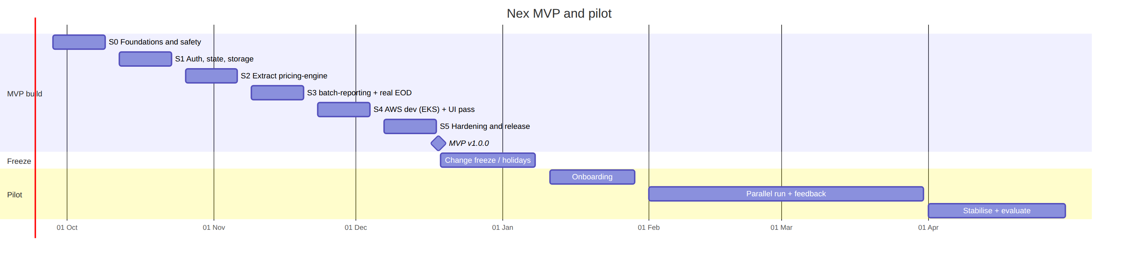
Figure 5 — MVP and pilot timeline

8.2 Sprint backlog
S0 — Foundations and safety (28 Sep – 9 Oct)
- Maven parent POM; move current code into core-api unchanged; 83 tests green in Jenkins.
- Flyway V0__baseline from the current Hibernate schema; ddl-auto: validate (except local H2); verify on an empty Postgres and on a copy of the dev database.
- Spring Boot Actuator, Micrometer, JSON logging; replace System.out.println with SLF4J; springdoc OpenAPI.
- Remove dead code and assets (G9). Mark /api/pricing/value deprecated, and remove it if the UI doesn't use it.
- Front end: pin dependencies; ESLint, Prettier and Vitest set-up; delete leftovers.
- Jenkins: add gitleaks, dependency-check, npm audit, Trivy and SBOM stages (reporting only this sprint; they block from S2).
- Full-stack docker-compose.yml (plus Keycloak dev realm and MinIO) for local and CI use.
- ADRs: 001 service split, 002 EKS + ArgoCD on AWS, 003 Flyway baseline, 004 Redis state, 005 S3 storage.
S1 — Auth, state and storage (12 – 23 Oct)
- Keycloak JWT enabled; TEMPORARY_AUTH_BYPASS removed; Keycloak realm roles mapped to the 20 RBAC roles and permission codes; dev login limited to @Profile("local").
- Authorisation tests per endpoint and role.
- Redis-backed job state for the risk engine and batch progress; ShedLock on SpringDynamicSchedulerService.
- S3FileStorageService (MinIO locally).
- trade_version audit table, written on every lifecycle action; shown in the blotter's trade history.
- Playwright smoke in CI against Compose.
S2 — Extract pricing-engine (26 Oct – 6 Nov)
- quant-lib module (pricing foundation, tools and calculators); platform-common.
- pricing-engine app: PricingController, the TicketValuationManagers, RiskEngine*, STOMP risk socket; market context from Redis, with a fallback to the core-api internal endpoint.
- nginx and ingress path routing; contract tests; generated Java client.
- Golden-value tests for OIS, bond, deposit and FX forward.
- Performance baseline for ticket valuation.
S3 — batch-reporting and real EOD (9 – 20 Nov)
- batch-reporting app: reporting/*, batch; schema reporting.
- Spring Batch eodValuationJob (§4.7); eod_run/eod_valuation/eod_cashflow; SSE progress from job metadata; the Operations module wired to it.
- Report queries read from persisted EOD results; the dependency graph runs after EOD.
- Load test: EOD with 10k synthetic trades.
S4 — AWS dev on EKS and UI pass (23 Nov – 4 Dec)
- Terraform: network, EKS (ALB controller, ESO, IRSA), RDS, ElastiCache, S3, ECR repos, Jenkins IAM role.
- aws-dev Kustomize overlay; ArgoCD application; Secrets Manager entries; cm-dev DNS → ALB.
- Jenkinsfile.aws extended (tests, scans, 4 images, GitOps update, no static keys).
- UI: module code splitting, lazy-loaded exceljs, decomposition of TradingWorkstation/MdcmModule, theme-token and skeleton/toast pass.
- docs/PLATFORM_STATE.md updated.
S5 — Hardening and release (7 – 18 Dec)
- Full Playwright regression on AWS dev; ZAP baseline; all scan gates green.
- RDS restore drill; runbooks (deploy/rollback via GitOps revert, EOD failure, Keycloak user admin, incident response).
- aws-pilot environment provisioned (Multi-AZ RDS, 2+ replicas), empty.
- Tag v1.0.0 on 18 Dec 2026, with release notes and a stakeholder demo.

8.3 MVP acceptance criteria
# | Criterion
AC1 | All 9 modules and 17 product types work as they do today, now running on core-api + pricing-engine + batch-reporting, on Docker Compose and AWS dev
AC2 | No anonymous access: every /api/** call needs a valid Keycloak JWT, and role checks pass the authorisation test suite
AC3 | Killing any single pod loses no session, job, schedule or report file. Scheduled batches run exactly once
AC4 | The EOD run values all live trades for a date and environment, persists the results, and runs the dependent reports. 10k trades complete in < 15 min
AC5 | A new database is created only by Flyway; validate passes in every deployed environment
AC6 | The Jenkins pipeline runs tests, SCA, SAST, secret, image and IaC scans and the e2e suite, with no open critical/high findings. Images use immutable tags; deployment goes only through GitOps and ArgoCD
AC7 | Pricing results are unchanged by the split (a regression suite compares before and after for all product types). Golden tests pass for OIS, bond, deposit and FX forward
AC8 | Front end: dependencies pinned, lint/tests in CI, initial JS ≤ 150 KB gzipped, no visual regressions in the 9 modules
AC9 | RDS restore drill done; runbooks and PLATFORM_STATE.md up to date

8.4 Scope protection
If a sprint slips, cut in this order. Never cut G1–G5 (auth, state, EOD, migrations, storage), tests or security gates.
- Front-end component decomposition (keep code splitting and pinning).
- batch-reporting stays a module inside core-api (the real EOD and ShedLock still ship).
- AWS dev on EKS moves to the first two weeks of January. The Docker Compose MVP and the RKE2 preview flow still ship on 18 Dec.
- Keep extra golden tests to the four listed products.

8.5 Definition of Done
- PR with review; preview environment checked (repo workflow); all Jenkins gates green.
- Tests at the right level; no pricing regression for the product types touched.
- Flyway migration for every schema change.
- Audit written for every state change.
- OpenAPI updated.
- PLATFORM_STATE.md updated for any platform change.

9. Pilot onboarding and feedback (11 Jan – 30 Apr 2027)
Phase | Dates | Activities
Onboarding | 11 – 29 Jan | aws-pilot go-live; Keycloak users/roles for pilot staff (optional federation to their IdP); load reference data (counterparties, portfolios, calendars, credit ratings) and market data (curves, fixings) through the existing import screens; migrate open trades (CSV → booking API); train traders, middle office, risk and operations
Parallel run | 1 Feb – 31 Mar | Daily EOD in Nex alongside the client's current process; automated reconciliation report (PV, cashflows, positions vs the client's figures) in batch-reporting; 2-week pilot sprints releasing through the normal GitOps flow
Stabilise and evaluate | 1 – 30 Apr | Fixes only; performance tuning on real volumes; user survey and interviews; case study; Beta go/no-go and scope

Feedback loop:
- In-app "Feedback" action (header menu), posted to core-api with the module, user and trace ID, and forwarded to the issue tracker (pilot-feedback).
- Weekly session with pilot users.
- Triage: P1 (blocks booking or EOD) gets a hotfix within 1 business day. P2 goes into the next pilot sprint. P3 and enhancements go to the Beta backlog.
- KPIs: reconciliation pass rate, EOD duration, P1/P2 counts, availability, time to book, monthly satisfaction score.
Exit criteria: 20 consecutive business days of reconciliation within tolerance; no open P1 issues and ≤ 3 open P2 issues; ≥ 99.5% availability in business hours; pilot sign-off; production platform decision (D4).

10. After the pilot (outline)
Stage | Window | Focus
Beta | May – Sep 2027 | Split market-data-service and refdata-service; event bus; pre-trade limits; vendor market-data feed; historical VaR/stress in the risk engine; pooled multi-tenancy; SOC 2 Type I readiness; 2–5 clients
GA | Target Q4 2027 | Tiered packaging and feature flags per module; tenant provisioning; SWIFT confirmations through a partner; SOC 2 Type II; AWS Marketplace listing
Scale | 2028+ | AI anomaly detection, RPA hooks, further asset classes and regions

11. Team
Role | FTE | Owns
Tech lead / architect | 1 | Service split, security, ADRs, reviews
Back-end (quant) | 1 | quant-lib, pricing-engine, golden and regression tests
Back-end | 1–2 | core-api, batch-reporting, EOD, Flyway
Front-end | 1 | Front-end efficiency, look & feel, Playwright
DevOps | 1 | Jenkins, Terraform, EKS/GitOps overlays, PLATFORM_STATE.md
Product owner / BA (part-time) | 0.5 | Scope, acceptance, pilot relationship and fixtures

12. Risks
Risk | Impact | Mitigation
Turning on real auth breaks UI flows | High | S1 authorisation test suite; Playwright on previews; roles mapped 1:1 to existing permission codes
Pricing regressions from moving code into quant-lib / pricing-engine | High | Behaviour-preserving moves; before/after regression suite on all 17 product types; golden tests
Flyway baseline differs from live databases | Medium | Generate from Hibernate, diff against dev/prod with pg_dump --schema-only, dry-run on copies
AWS platform work (EKS, IAM, networking) in 2 weeks | Medium | Terraform modules from S0 in parallel by DevOps; the cut rule in §8.4 moves EKS to January without blocking the MVP
Two platforms (RKE2 + AWS) to run | Medium | Same manifests (base + overlays); decide the production target at pilot exit (D4)
Large front-end components slow down change | Medium | Decompose only with tests in place; no visual changes

13. Decisions to confirm in S0
ID | Decision | Recommendation
D1 | AWS runtime | EKS + ArgoCD (keeps GitOps and the manifests); ECS not recommended for this repo
D2 | MVP service split | core-api + pricing-engine + batch-reporting; more splits after the pilot
D3 | GitOps home for AWS overlays | The ats-capital-markets-gitops repo (like previews), with ArgoCD apps per AWS environment
D4 | Production platform after the pilot | Decide at pilot exit: move production to AWS, or run AWS for client tenants and RKE2 internally
D5 | ArgoCD for EKS | Register EKS clusters with the existing central ArgoCD (argocd.alintatechsolutions.co.za) rather than a new instance
D6 | Pilot tenancy | Dedicated aws-pilot environment

Appendix A — Local development
# day-to-day (unchanged from CLAUDE.md)
docker compose up -d postgres redis
cd backend && SPRING_PROFILES_ACTIVE=local mvn -pl core-api spring-boot:run
cd frontend && npm install && npm run dev # http://localhost:5173, proxies /api

# full stack (local integration / CI e2e)
cp .env.example .env
docker compose --profile full up -d --build --wait # http://localhost:3000
cd frontend && npx playwright test

Appendix B — Conventions
- Branches and PRs: feature branch → PR → Jenkins PR build → preview cm-pr<N> → review → merge. Squash merges.
- Tags: SemVer vX.Y.Z for releases; images tagged with the 12-character git SHA; no latest in any deployed manifest.
- API: /api/... stays compatible for the UI. New internal service-to-service endpoints go under /internal/... and need service tokens. ISO-8601 dates.
- Logging: SLF4J JSON with traceId, userId, tradeId where relevant. Never log tokens or personal data.
- Platform changes: always recorded in docs/PLATFORM_STATE.md.

Appendix C — Glossary
Term | Meaning
Strangler pattern | Moving functionality out of a monolith step by step while it keeps running
EKS / ECR / RDS / ElastiCache | AWS managed Kubernetes / container registry / PostgreSQL / Redis
IRSA | IAM Roles for Service Accounts: pods get AWS permissions without static keys
ESO | External Secrets Operator: syncs secrets from Vault or AWS Secrets Manager into Kubernetes
ShedLock | Library that makes a scheduled task run on one replica only
Golden test | A test comparing output with an independent reference value

