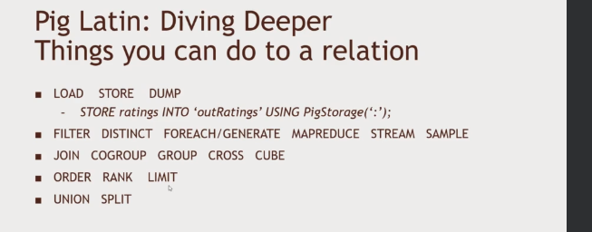
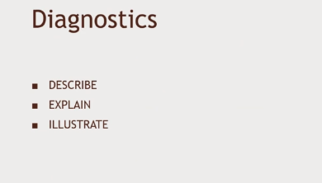
G

gff

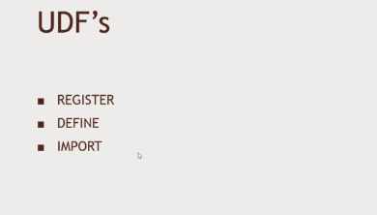

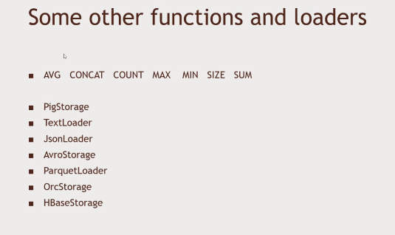
ggghhh

Load Data

Relation_name = LOAD 'Input file path' USING function as schema;

student = LOAD 'hdfs://localhost:9000/pig_data/student_data.txt'
USING PigStorage(',')
as ( id:int, firstname:chararray, lastname:chararray, phone:chararray,
city:chararray );

Store Data

STORE Relation_name INTO ' required_directory_path ' [USING function];

STORE student INTO ' hdfs://localhost:9000/pig_Output/ ' USING PigStorage (',');

Dump Operator
The Dump operator is used to run the Pig Latin statements and display the results on the screen. It is generally used for debugging Purpose.

Syntax
Given below is the syntax of the Dump operator.

Dump Relation_Name
Describe Operator
The describe operator is used to view the schema of a relation.

describe student;

Explain Operator
The explain operator is used to display the logical, physical, and MapReduce execution plans of a relation.

explain Relation_name;

Illustrate Operator

The illustrate operator gives you the step-by-step execution of a sequence of statements.
illustrate Relation_name;

Group Operator

The GROUP operator is used to group the data in one or more relations. It collects the data having the same key.

grunt> Group_data = GROUP Relation_name BY age;

Cogroup Operator

The COGROUP operator works more or less in the same way as the GROUP operator. The only difference between the two operators is that the group operator is normally used with one relation, while the cogroup operator is used in statements involving two or more relations.

COGROUP student_details by age, employee_details by age;

Join Operator

The JOIN operator is used to combine records from two or more relations.

Given below is the syntax of performing self-join operation using the JOIN operator.
To PERFORM SELF JOIN WE NEED TO LOAD THE SAME DATA TWICE AND USE IT AS TWO DIFFERENT RELATIONS
Relation3_name = JOIN Relation1_name BY key, Relation2_name BY key ;
grunt> customers3 = JOIN customers1 BY id, customers2 BY id;

Inner Join
coustomer_orders = JOIN customers BY id, orders BY customer_id;

Left Outer Join
outer_left = JOIN customers BY id LEFT OUTER, orders BY customer_id;

Right Outer Join
Outer_right = JOIN customers BY id RIGHT, orders BY customer_id;

Full Outer Join
outer_full = JOIN customers BY id FULL OUTER, orders BY customer_id;

Using Multiple Keys
Relation3_name = JOIN Relation2_name BY (key1, key2), Relation3_name BY (key1, key2);
JOIN employee BY (id,jobid), employee_contact BY (id,jobid);

Union Operator

The UNION operator of Pig Latin is used to merge the content of two relations. To perform UNION operation on two relations, their columns and domains must be identical.
Relation_name3 = UNION Relation_name1, Relation_name2;

Split Operator

The SPLIT operator is used to split a relation into two or more relations.
SPLIT Relation1_name INTO Relation2_name IF (condition1), Relation2_name (condition2),
SPLIT student_details into student_details1 if age<23, student_details2 if (22<age and age>25);

Filter Operator

The FILTER operator is used to select the required tuples from a relation based on a condition.

Relation2_name = FILTER Relation1_name BY (condition);
filter_data = FILTER student_details BY city == 'Chennai';
Distinct Operator

The DISTINCT operator is used to remove redundant (duplicate) tuples from a relation.

Relation_name2 = DISTINCT Relatin_name1;

Foreach Operator

The FOREACH operator is used to generate specified data
Relation_name2 = FOREACH Relatin_name1 GENERATE (required data);

foreach_data = FOREACH student_details GENERATE id,age,city;

Order By

Relation_name2 = ORDER Relatin_name1 BY (ASC|DESC);

Limit Operator
LIMIT student_details 4;

