Big O is how efficient a code is to execute a task.
Time complexity is measured by number of operations to execute a task. Not the time it takes to run.
Space Complexity memory required to execute a task

scenarios – Omega Ω , theta Θ amd Omicron Ο
Assume you are looping from 1 to 7
Omega is best case scenario Ω

Theta is mid case scenario

and Omicron is worst case scenarios

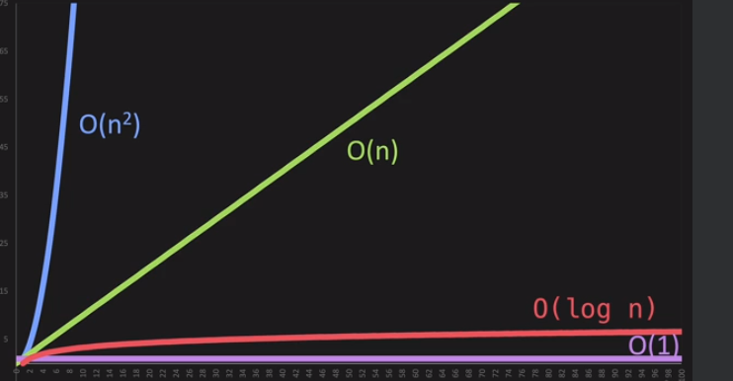

O(n) - Proportional

def print_items(n):
for i in range (n):
print(n);

print_items(10);

drop Constants

def print_items(n):
for i in range (n):
print(n);

for j in range (n):
print(n);

print_items(10);

n + n = 2n -- 2 dropped
o(2n)

O(n²)

n*n = n^2

def print_items(n):
for i in range (n):
for j in range (n):
print(i,j)

print_items(10);

drop non dominants

# n*n + n² = n + n ==> n²

O(log n).py
Data has to be sorted

if we have 8 items 2^3 = 8
means we ill go through 3 steps to find the value

log2 8= 3

Different Inputs

# O(a+b)

def print_ites(a,b):
for i in range (a):
print(i);

for j in range (b):
print(j);

print_ites(2,10)

# O(a*b)
def print_items(a,b):
for i in range (a):
for j in range (b):
print(i,j)

print_items(2,10)

Linked List

Python Lists - Store the list items in consecutive locations in memory (python list)
Liunked List - Store "nodes" anywhere in memory. A Node consists of the list item, plus the address (or something like the address) of where the next node can be found. This is known as a linked list.

A linked list is a collection of objects/nodes, where each node contains both the item stored in the list, as well as a "pointer" to the next node in the list.

Linked lists typically have three instance variables: a head pointer (self.head), a tail pointer (self.tail), and the number of nodes in the list (self.size)

In the above picture, the linked list has 5 nodes, and each node stores a simple string, as well as a pointer to the next node in the list. In class I often draw linked lists and nodes as follows:

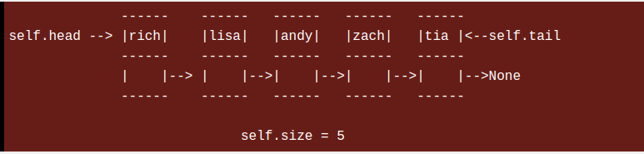
NODE = VALUE + POINTER .
IT IS BASICALLY A DICTIONARY.

{“value” : 4,
|”next” : none
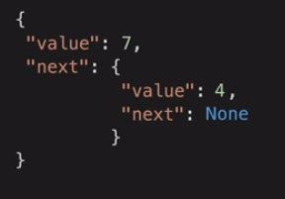
}

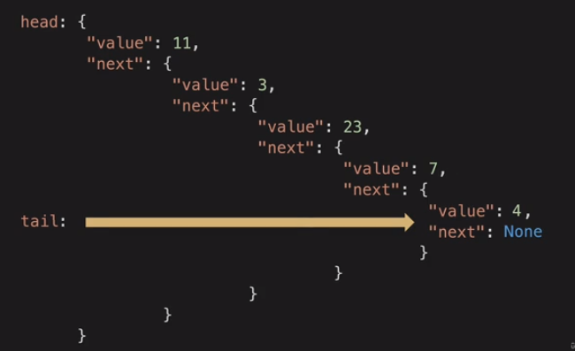
d

in vscode
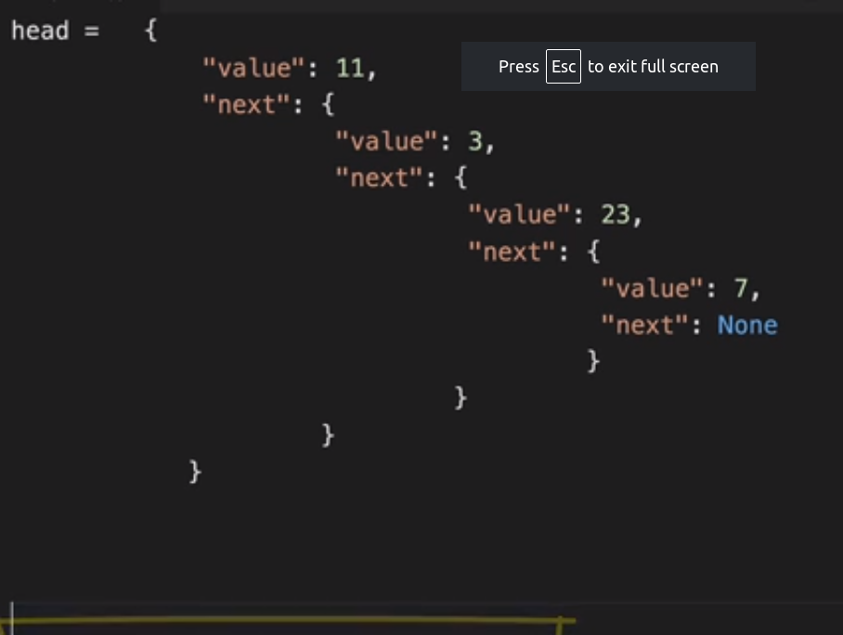
to print 23 = =print([‘next’][‘next’][‘value’])
in actual python = print(my_linked_list.head.next.next.value)

