MODULE-3: IAM

**Sub-task 1 – Create 3 User Groups**

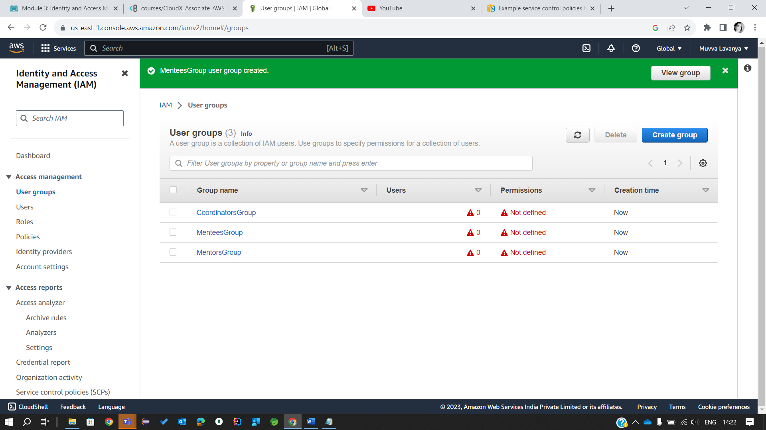

**Sub-task 2 – Create policies and roles**

1.Create a policy named FullAccessPolicyEC2.

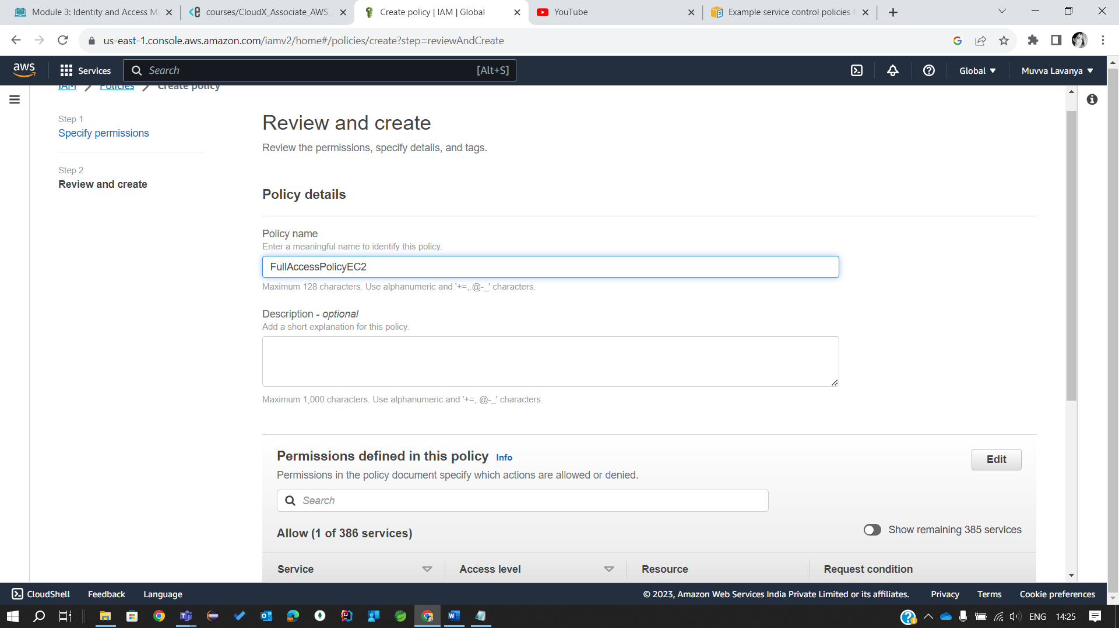

3. create policies for S3:

3.1 FullAccessPolicyS3 – everything’s allowed.

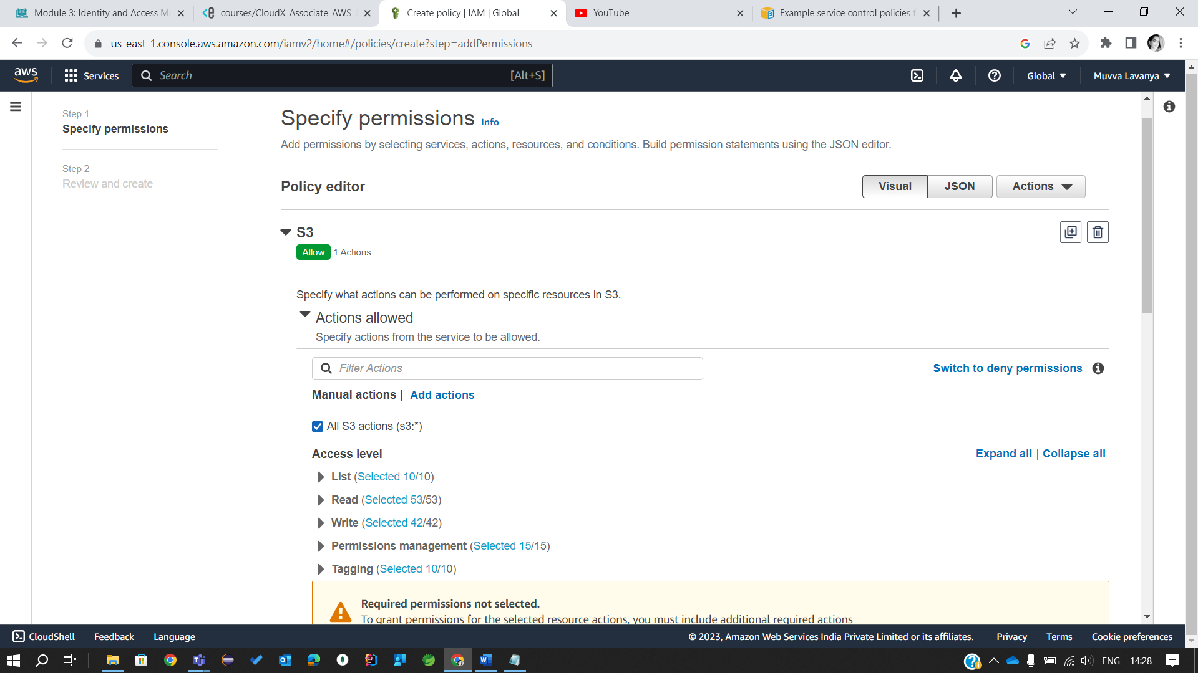

3.2 ReadAccessPolicyS3 – only get and list actions.

4.Create one role of EC2 Type (Trusted Entity) per each policy configured so far (note – these roles won’t be used right now, but might be reused in upcoming EC2 module):

4.1. FullAccessRoleEC2

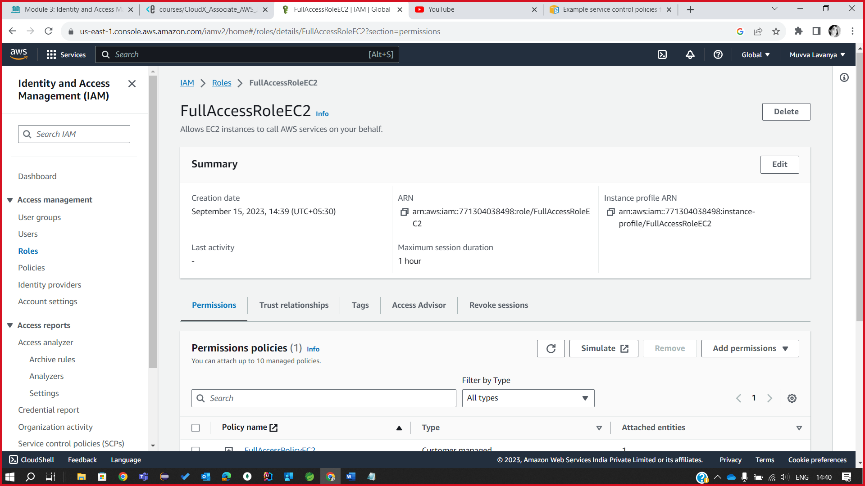

4.2 ReadAccessRoleS3

4.3 ReadAccessRoleS3

5. Create one group per each policy configured so far:

5.1 FullAccessGroupEC2

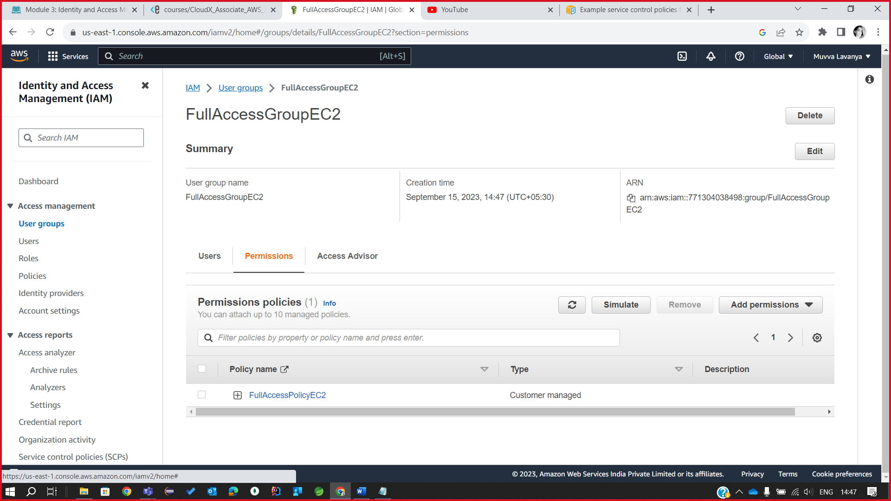

5.2 FullAccessGroupS3

5.3 ReadAccessGroupS3

6. Create 1 user from the 1st group, 1 user from the 2nd group, and 1 user from the 3rd group.

6.1 User-1

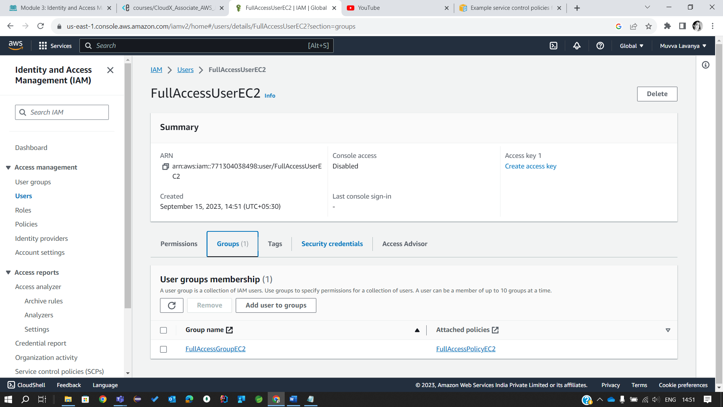

6.2 User-2

6.3 User-3

