MODULE-5 EC2

1. Sub-task 1 – Store Docker image to S3

1. Update your ***Main microservice*** by commenting out the code related to the connection with Database and Queue (integration with those components will be configured in the next modules). Make sure your application can start up without integration with outstanding components.
2. Create Dockerfile image of updated microservice.

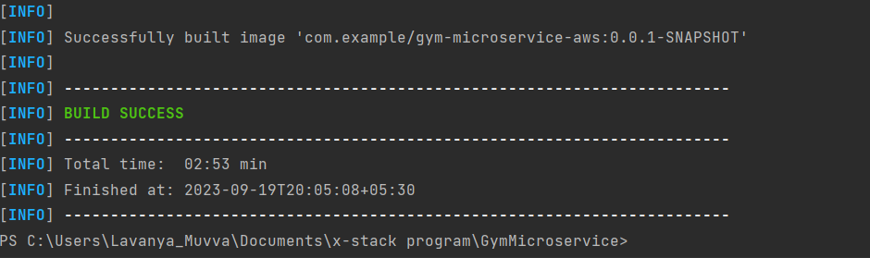

3. Save created in step 2 Docker image as a .tar file using next command:

* docker save -o <*path for generated tar file*> <*image name*>

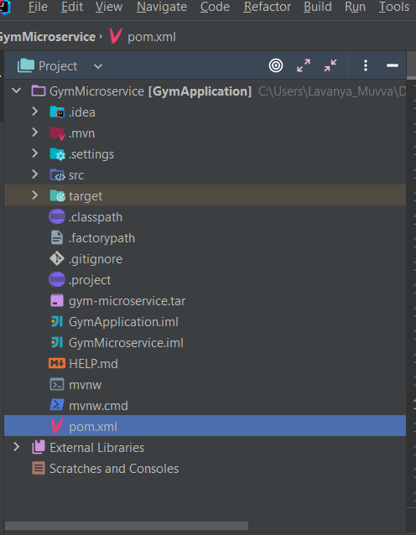

4. Upload saved in step 3 .tar file to S3 bucket. Use bucket from the previous module.

**Sub-task 2 - Create EC2 instance**

1. Create Linux EC2 instance for ***Main microservice*** (choose any free-tier eligible AMI).

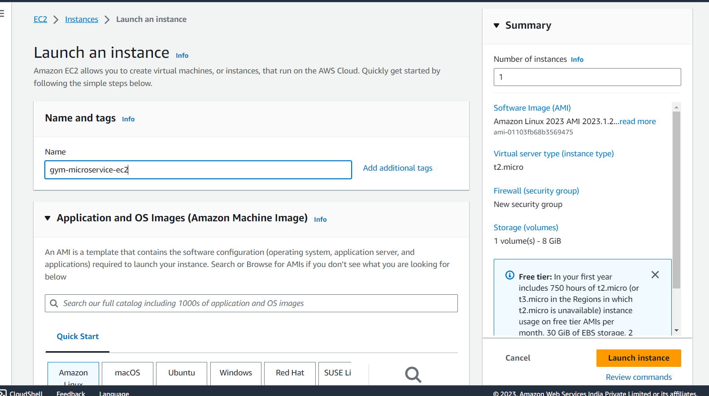

1. Assign it the S3 readonly IAM role from module 2.

3. Configure security group for the EC2 instance so that:

* allow access over HTTP/HTTPS from anywhere
* allows SSH connection from your IP address only

4. Make sure HTTP server(any) is installed and running on the instance. Make sure that it starts whenever the instance boot/reboot.

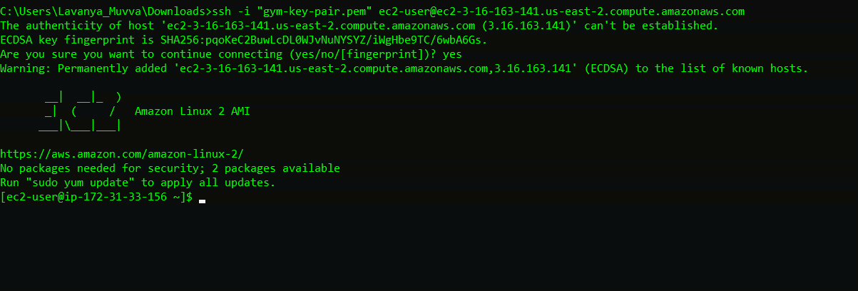

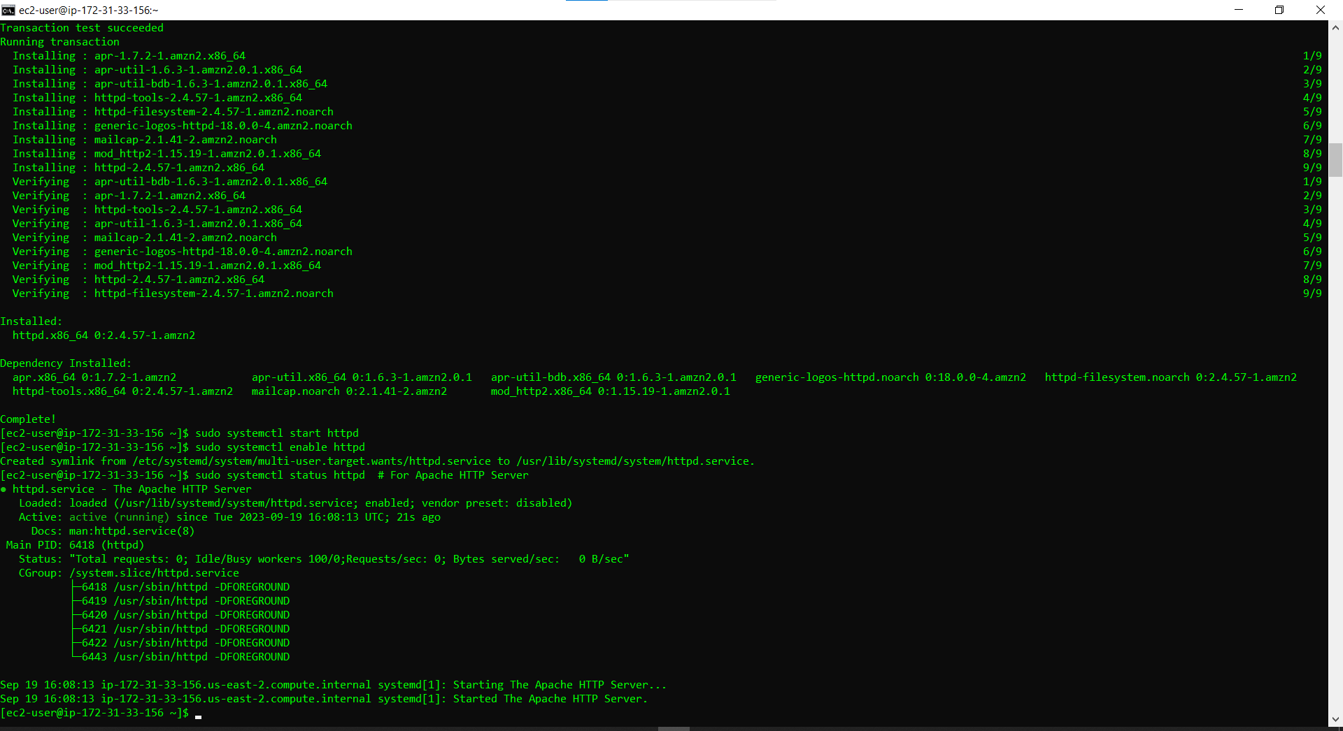

Sub-task 3 - Run Docker container

Download .tar docker image from S3 bucket:

* aws s3 cp s3://your_bucket/your_folder/your_image.tar your_image.tar

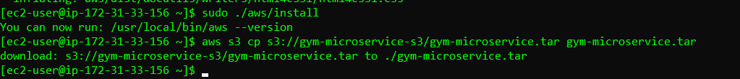

Install Docker on your instance:

* Update the Linux system with sudo yum update -y
* Install the most recent Docker Community Edition package with sudo amazon-linux-extras install docker
* Start docker with sudo service docker start

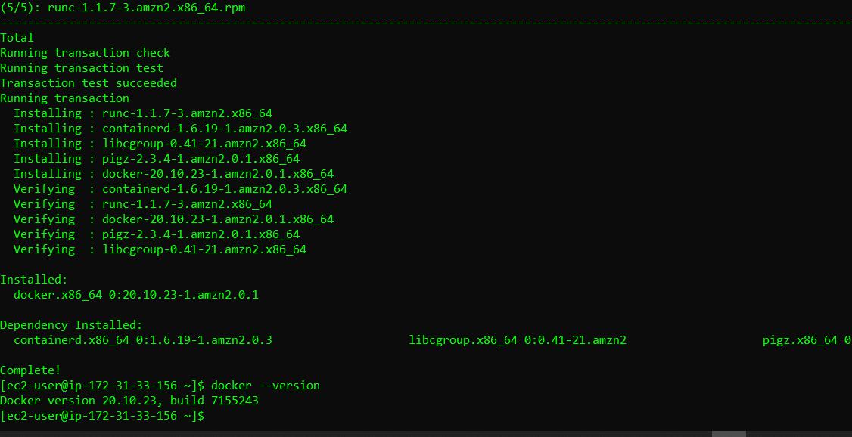

Load docker image from .tar file:

* sudo docker load -i <image-name>.tar

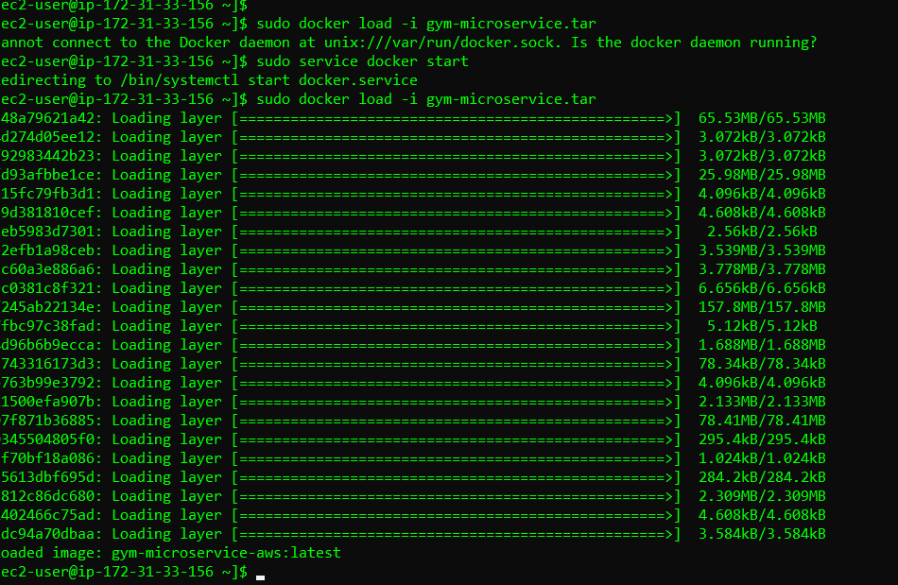

1. Run Docker container
2. Make sure you can call the Health-check endpoint from outside the EC2.

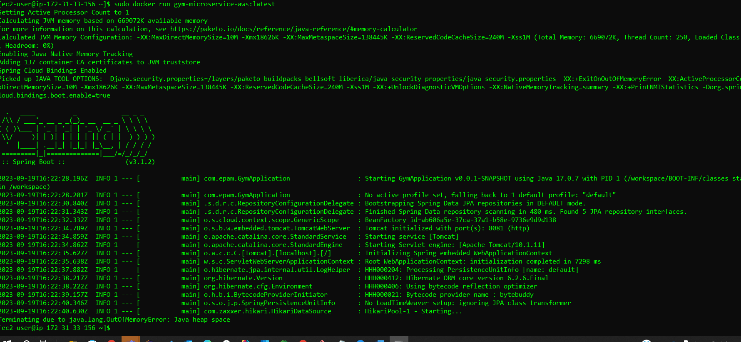

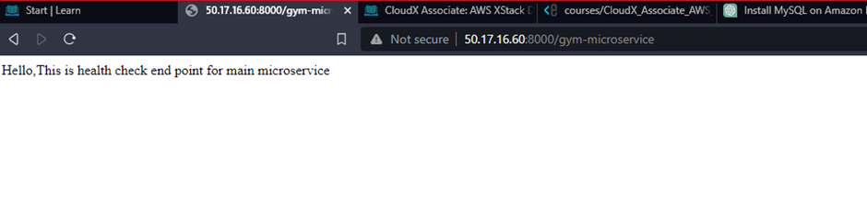

Sub-task 4 – automate EC2 configuration

1. Create a new ***Main microservice*** EC2 instance based on any free-tier Linux AMI and assign it the S3 readonly IAM role from module 2.

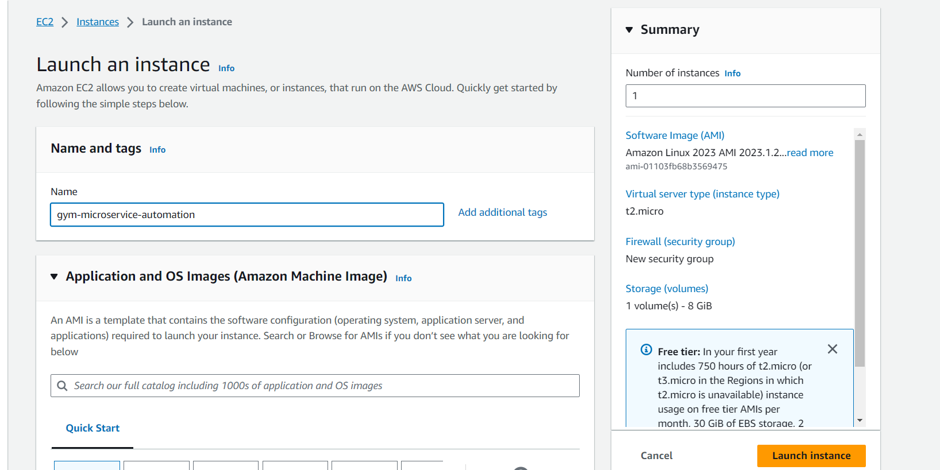

Configure the new EC2 instance so that it does the following steps automatically upon startup (tip – use cloud init directives and user data):

* install HTTP server
* install Docker
* download .tar image from S3
* run Docker container

1. Ensure that you can access the Health check endpoint over HTTP.

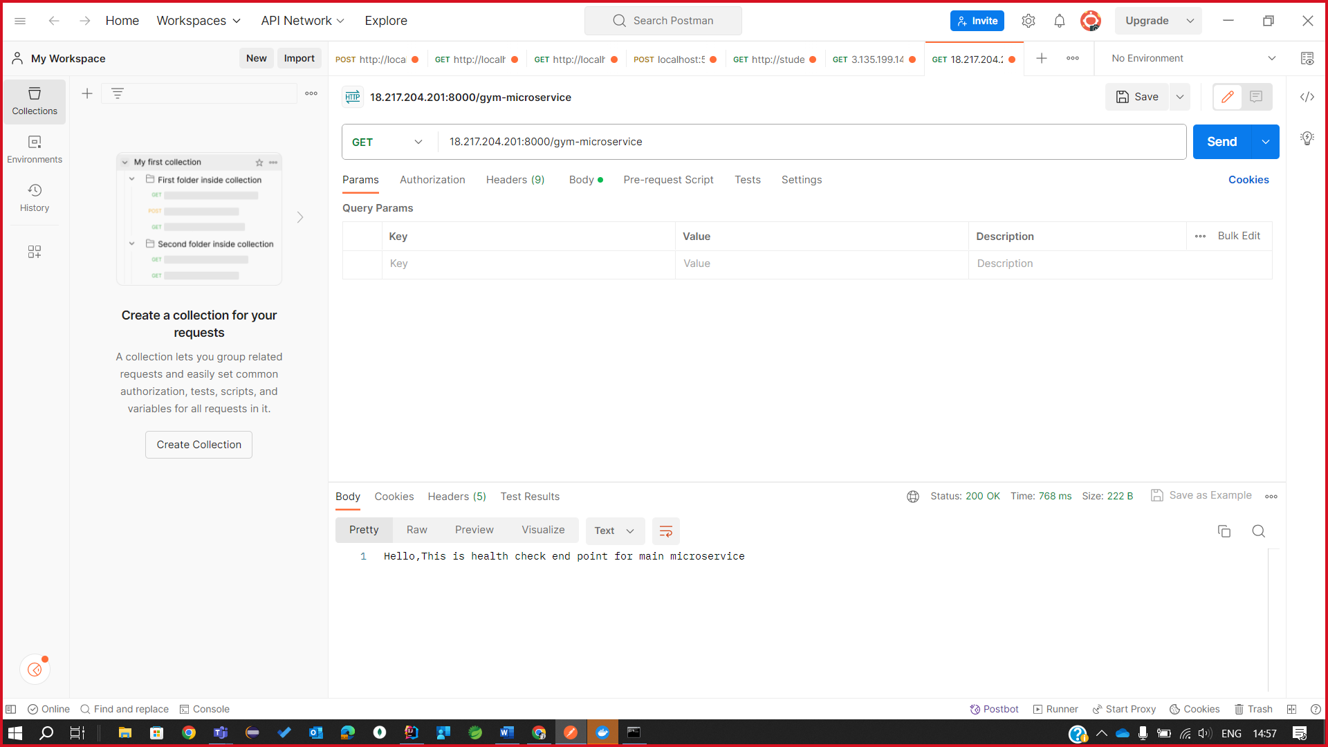

1. Create a custom AMI based on the EC2 instance.

1.Delete the EC2 instance and create another one based on the custom AMI.

**Sub-task 5 - Launch Report microservice instance**

1. Update your ***Report microservice*** by commenting out the code related to the connection with Database and Queue (integration with those components will be configured in the next modules). Make sure your application can start up without integration with outstanding components.
2. Repeat steps from previous 4 sub-tasks for the ***Report microservice***

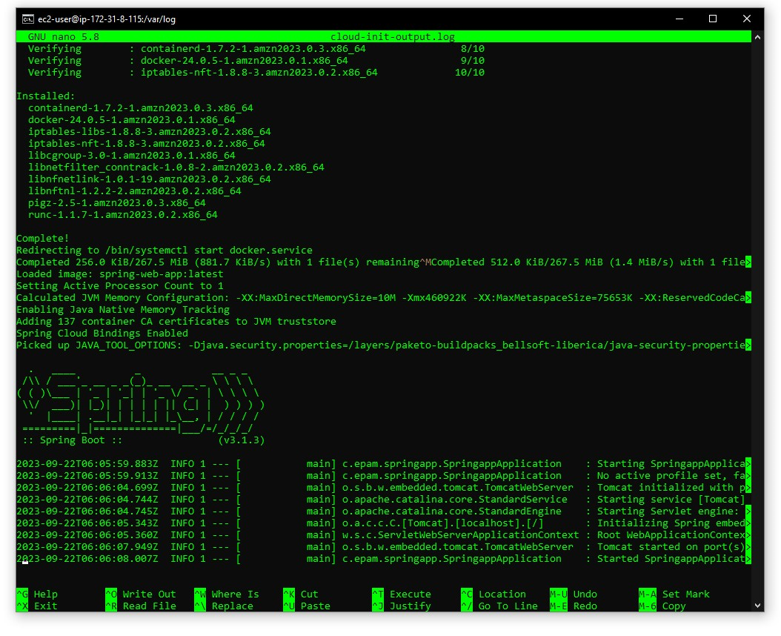

1. Make sure the Health check endpoint is available over HTT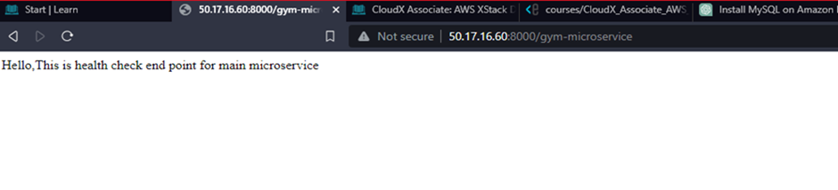

**Sub-task 6 – Introducing EBS basics**

1. Create EBS volume and attach it to the EC2 instance from the second sub-task.

1. Write any file to it and detach from the instance.

1. Attach it to the instance from the fourth sub-task and make sure the file is visible and accessible. A black screen with white text

   Description automatically generated

