MODULE-8 SQS & SNS

Task 1 - Integrate your system with SQS queue

1.Create SQS queue

* Choose queue type according to your application logic (FIFO or Standard)
* The name should be like -Queue

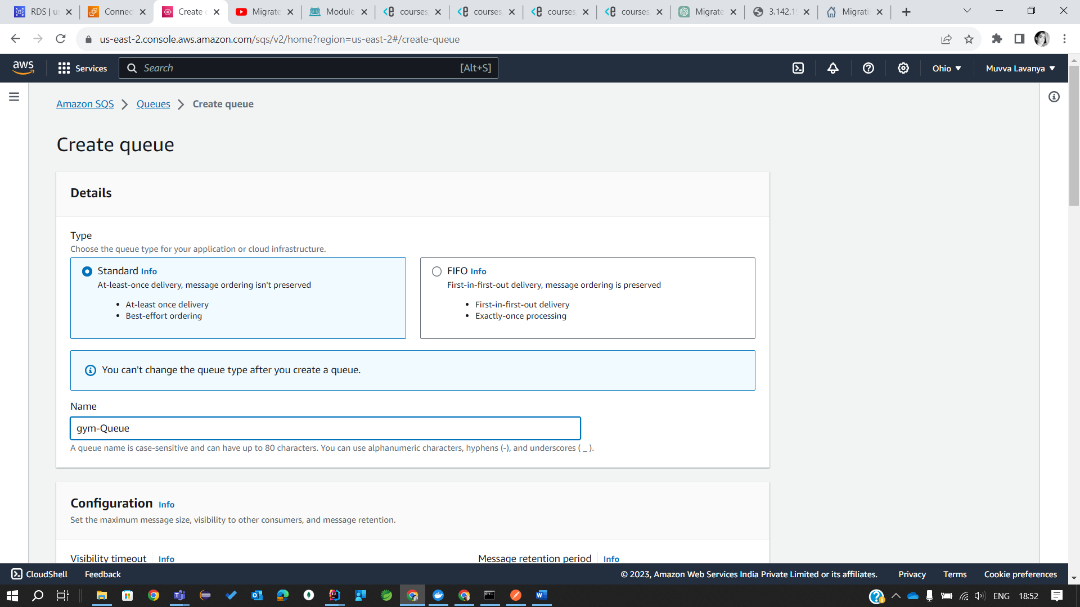

2. Update your ***Main microservice*** application configuration to integrate with the newly created SQS queue instead of ActiveMQ.

3. Replace .tar Docker image uploaded to S3 with the new one.

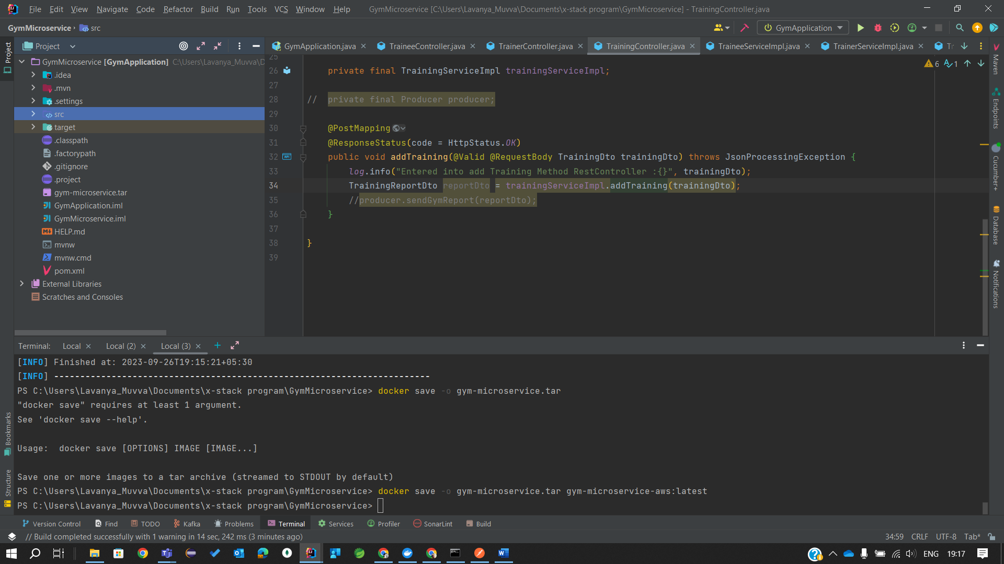

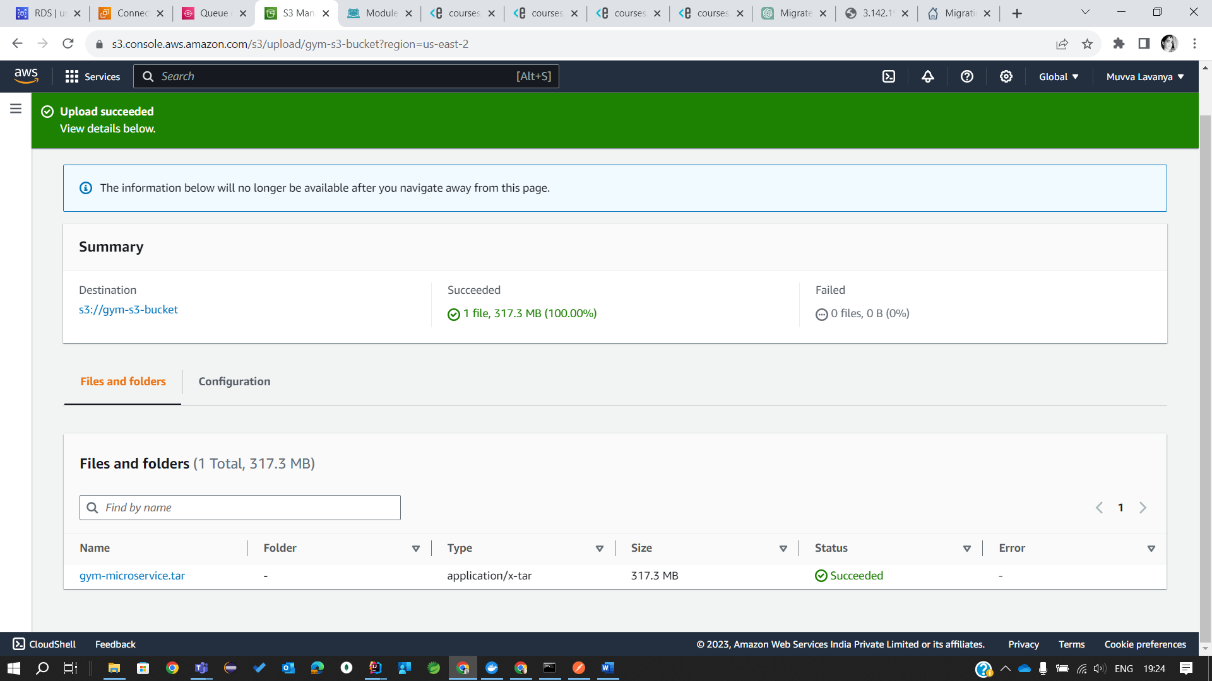

4. Run updated ***Main microservice*** EC2 instance. Verify that application is connected to SQS queue.

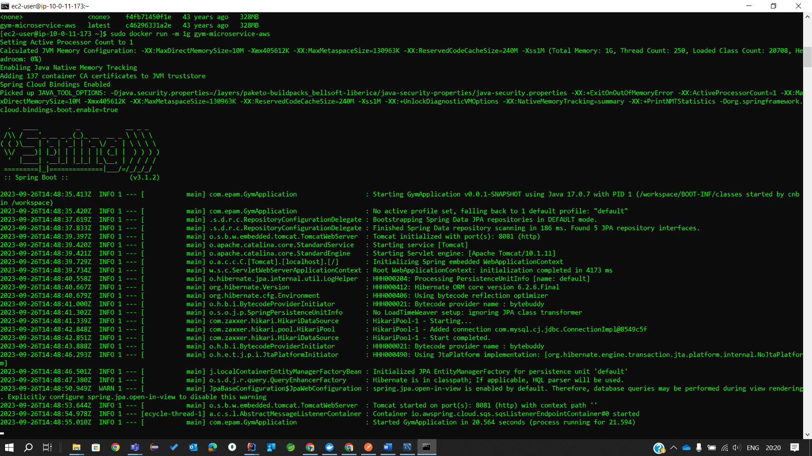

5. Update your ***Report microservice*** application configuration to integrate with the newly created SQS queue instead of ActiveMQ. As for now, comment out all code, connected with the Mongo DB integration to prevent errors on application start up. We will add integration with DynamoDB in the future modules.

6. Replace .tar Docker image uploaded to S3 with the new one.

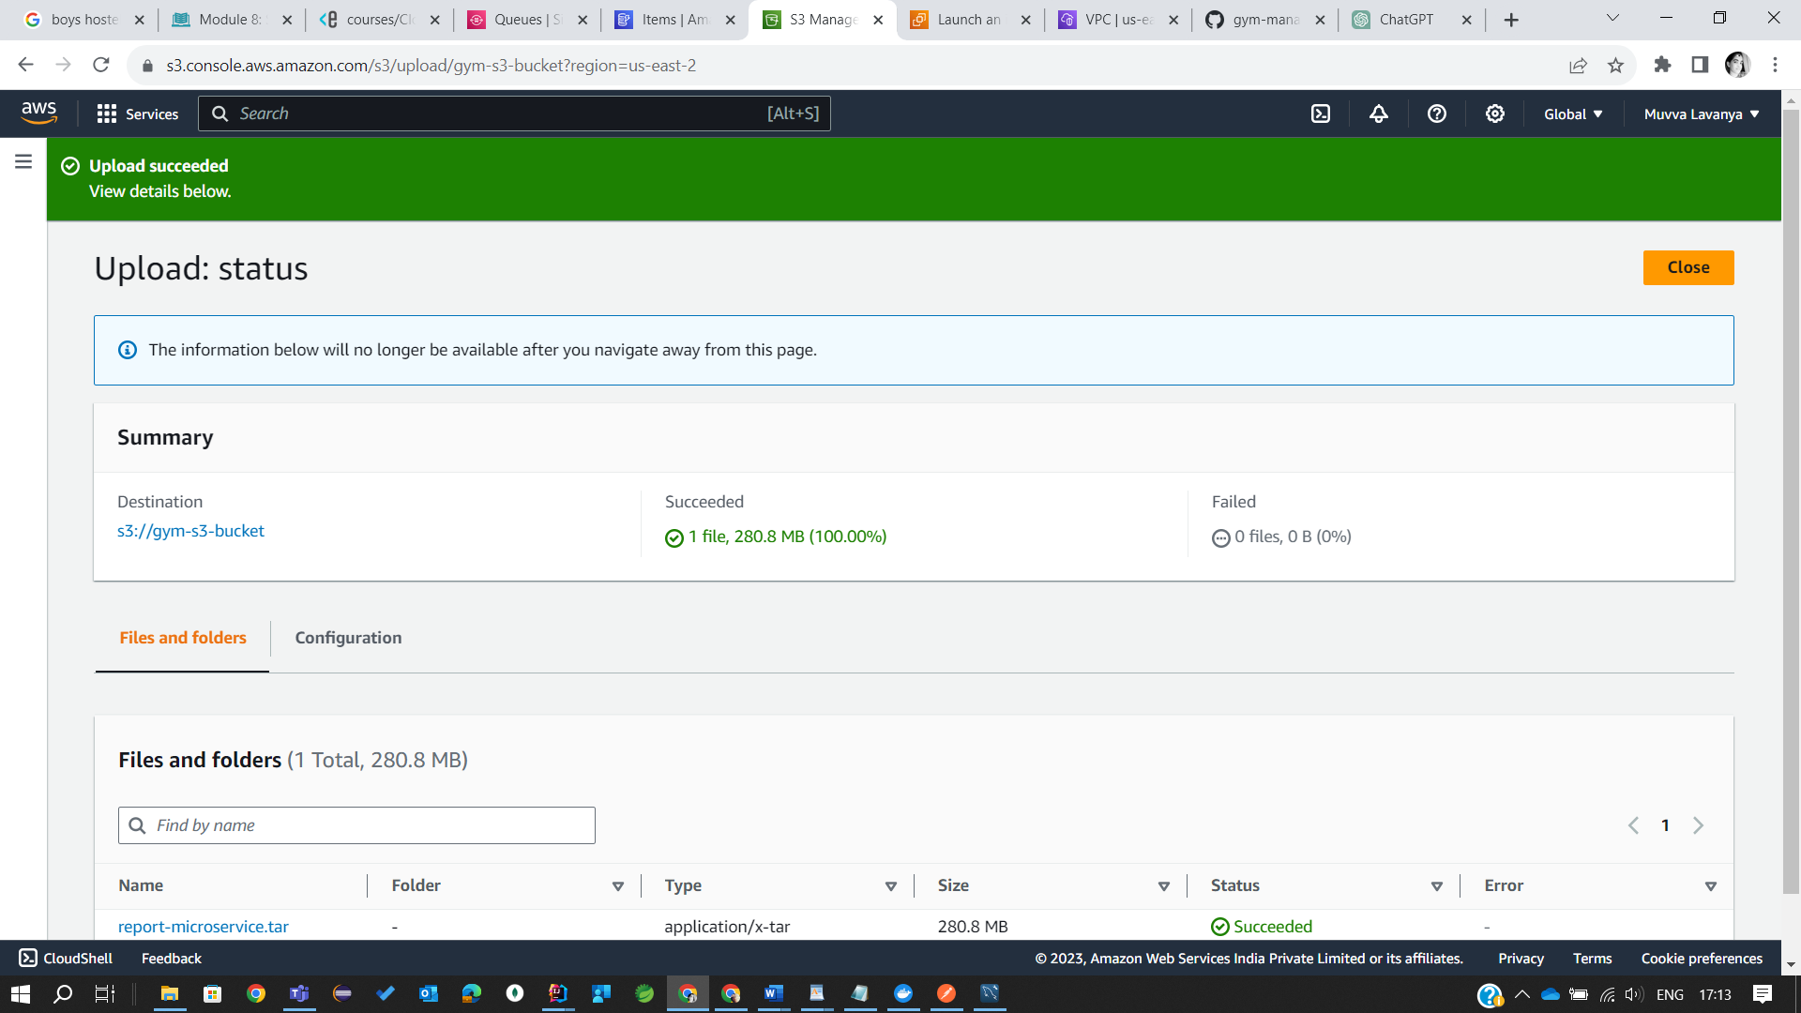

7. Run updated ***Report microservice*** EC2 instance. Verify that application is connected to SQS queue.

1.CREATED REPORT-MICROSERVICE EC2

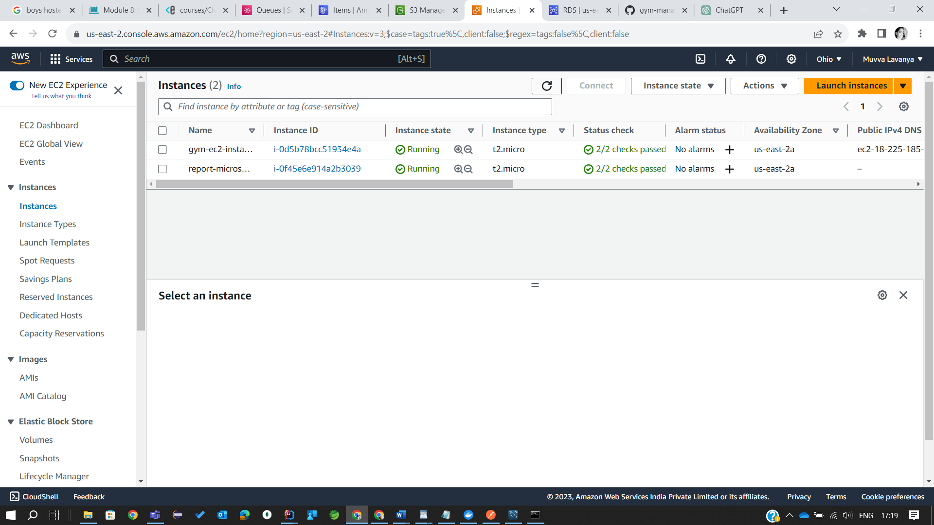

**Task 2 - Create SNS topic**

1. Create SNS topic named -alarm-notification-topic.

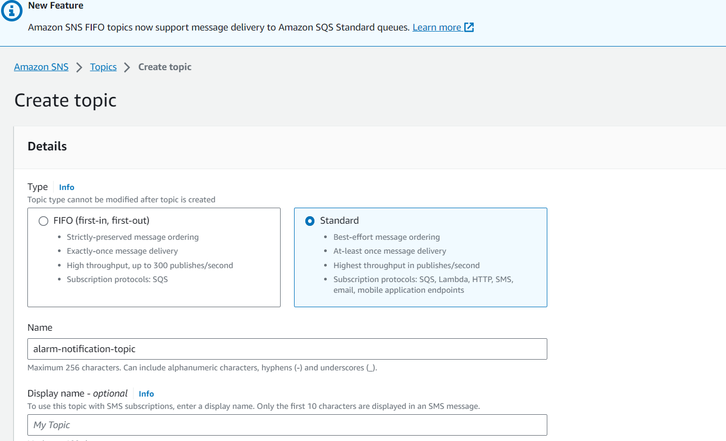

1. In the ***Create subscription dialog box***, enter an email address that you can use to receive the notification, and then choose Create subscription.

3. From your email application, open the message from AWS Notifications and confirm your subscription.

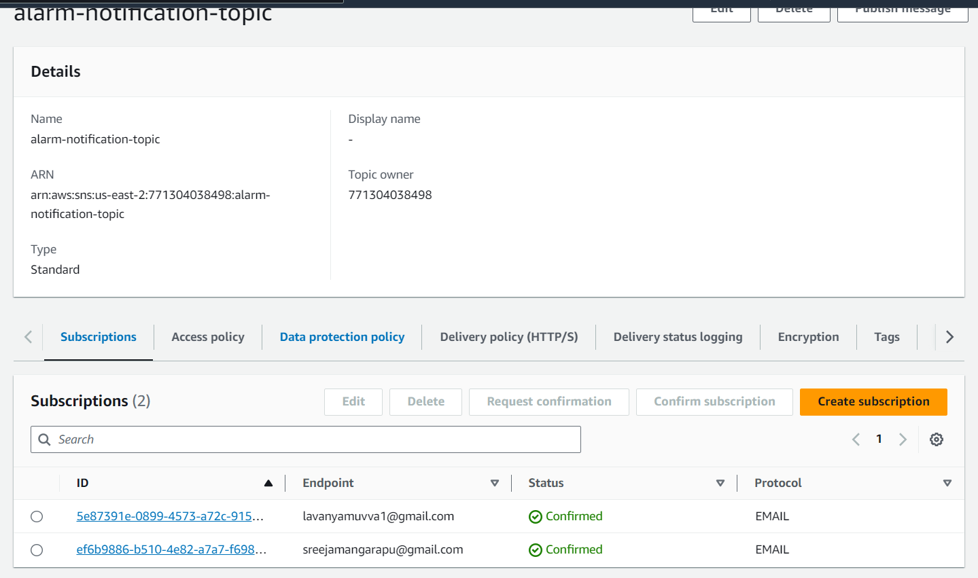

1. Publish some messages manually and check the result in the mailbox.

