MODULE -9 DYNAMODB

Sub-task 1 - Create DynamoDb table

1. Create DynamoDB table with the following structure:

* Trainer Username (Partition Key)
* Trainer First Name
* Trainer Last Name
* Trainee Status (Active, Inactive)
* Years list
  + Months List
    - Trainings duration summary

2. Add **Trainee status** field as a sort key.

3.Creating dynamoDb in aws

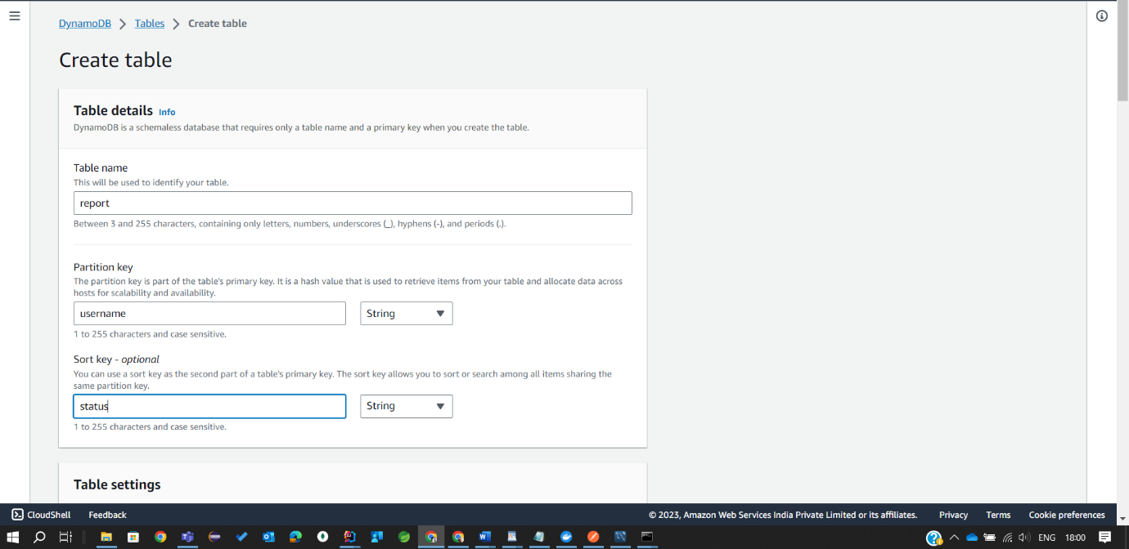

4. Create a Global Secondary Index (GSI):

* Name: ***TrainerName-Index***
* In the ***Partition key*** field, enter ***Trainer First Name*** and set the type as ***String***
* In the ***Sort key*** field enter ***Trainer Last Name*** and set the type as ***String***

5.Optionally: Choose provisioned capacity mode pricing model. Estimate the read and write capacity units required for your use case and set them accordingly during table creation or adjust them later based on your needs.

Finally created DynamoDb table

**Sub-task 2 - Integrate Report microservice with DynamoDB**

1. Update your ***Report microservice*** application configuration to integrate with the newly created DynamoDB Table instead of Mongo DB

1. Replace .tar Docker image uploaded to S3 in [Module 8: SNS/SQS](/epmc-acm-public/aws-associate-training/-/blob/CloudX_Associate_AWS_Java_TShape_Developer_theory_impovements/courses/CloudX_Associate_AWS_Java_TShape_Developer/tasks/sns_sqs/README.md) with the new one.

3. Run updated ***Report microservice*** EC2 instance. Verify that application is connected to DynamoDb.

Report got added to DynamoDb

