**Module #2 :Create AWS Account**

1.Sub-task 1 – Create AWS Account

2. Sub-task 2 – Secure account

1.Created Administrative user

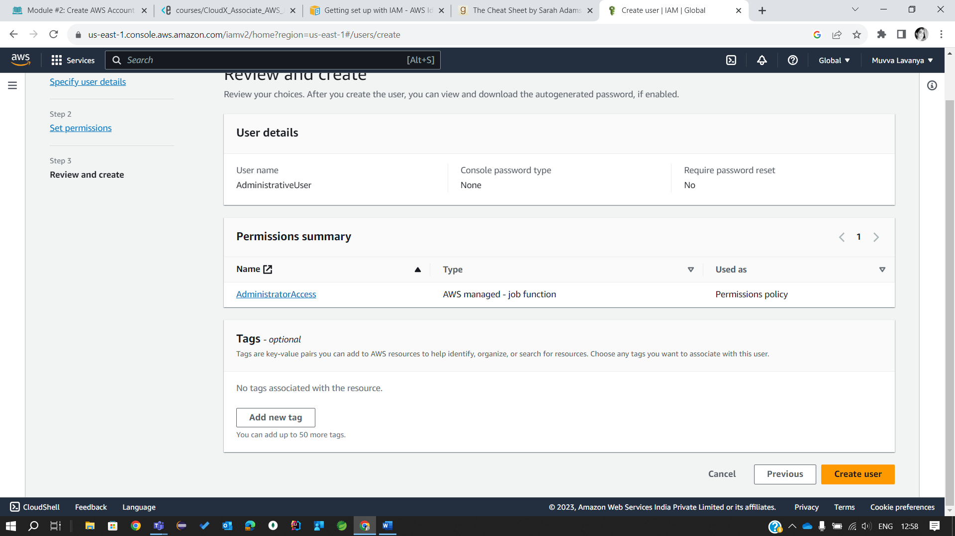

2.Added MFA

3. Logged in as Administrative user

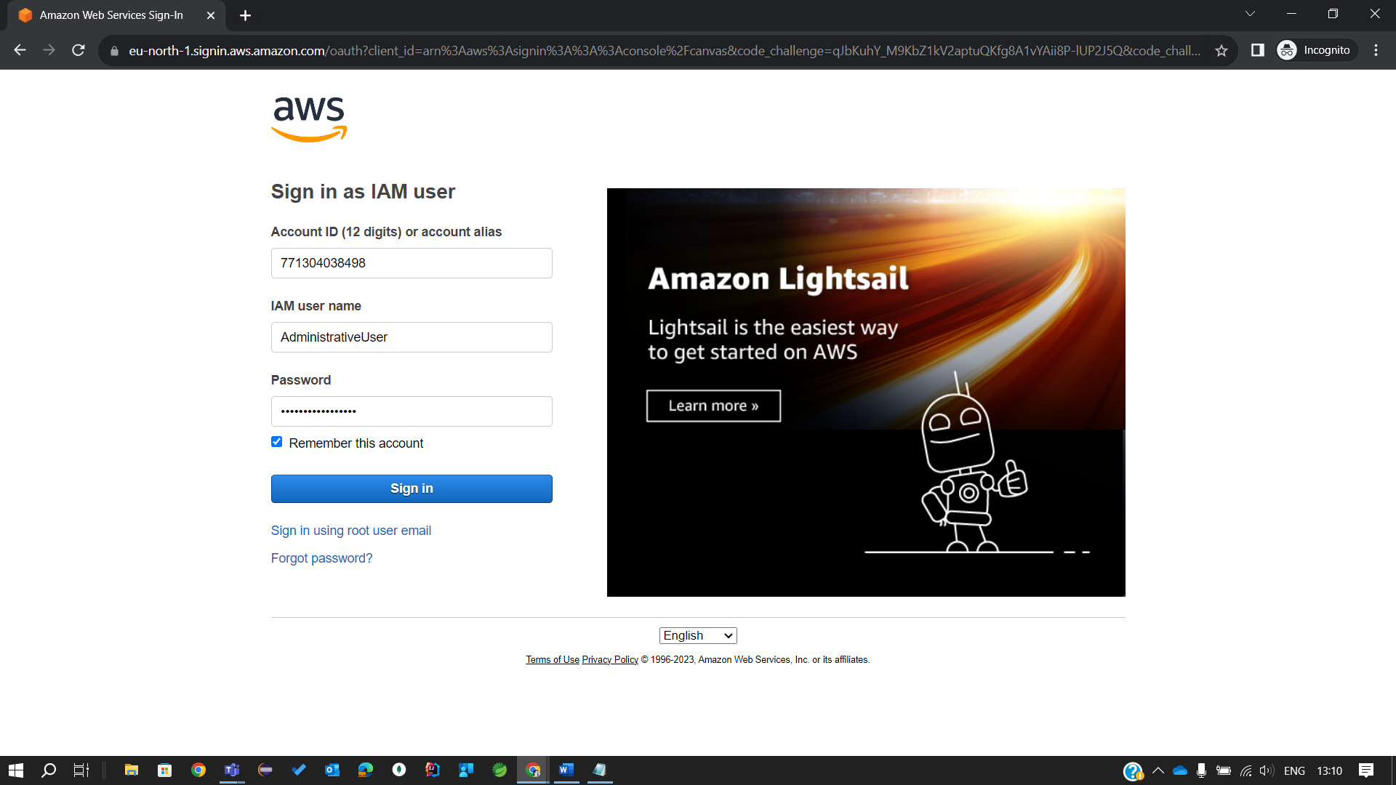

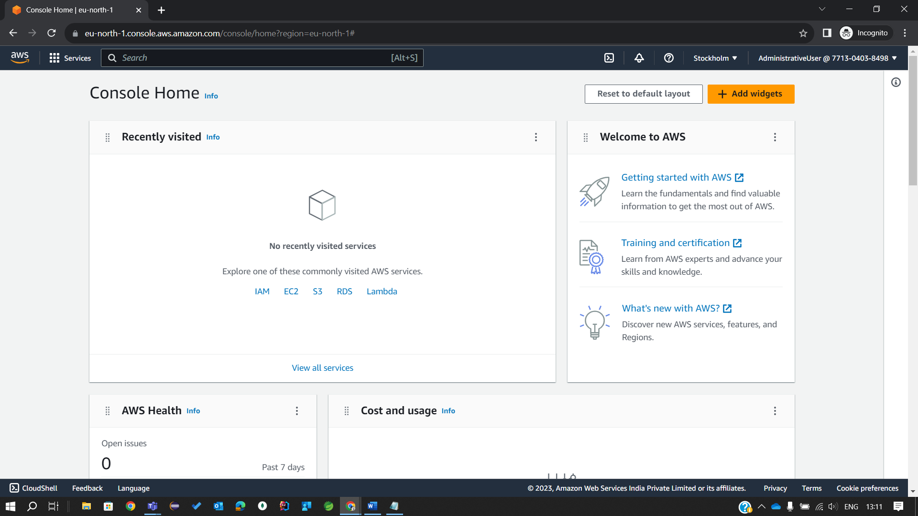

Sub-task 3 – Set Budgets/Alerts

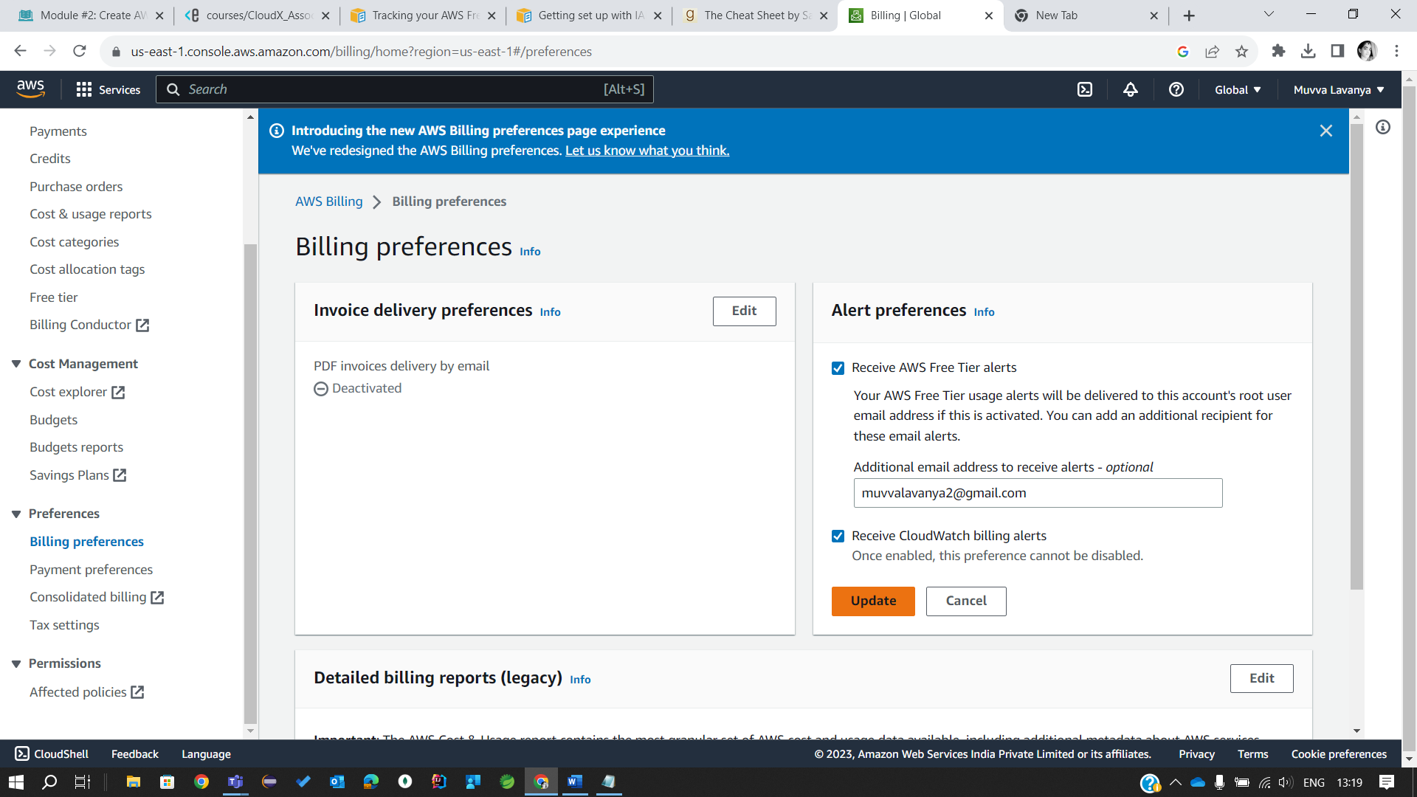

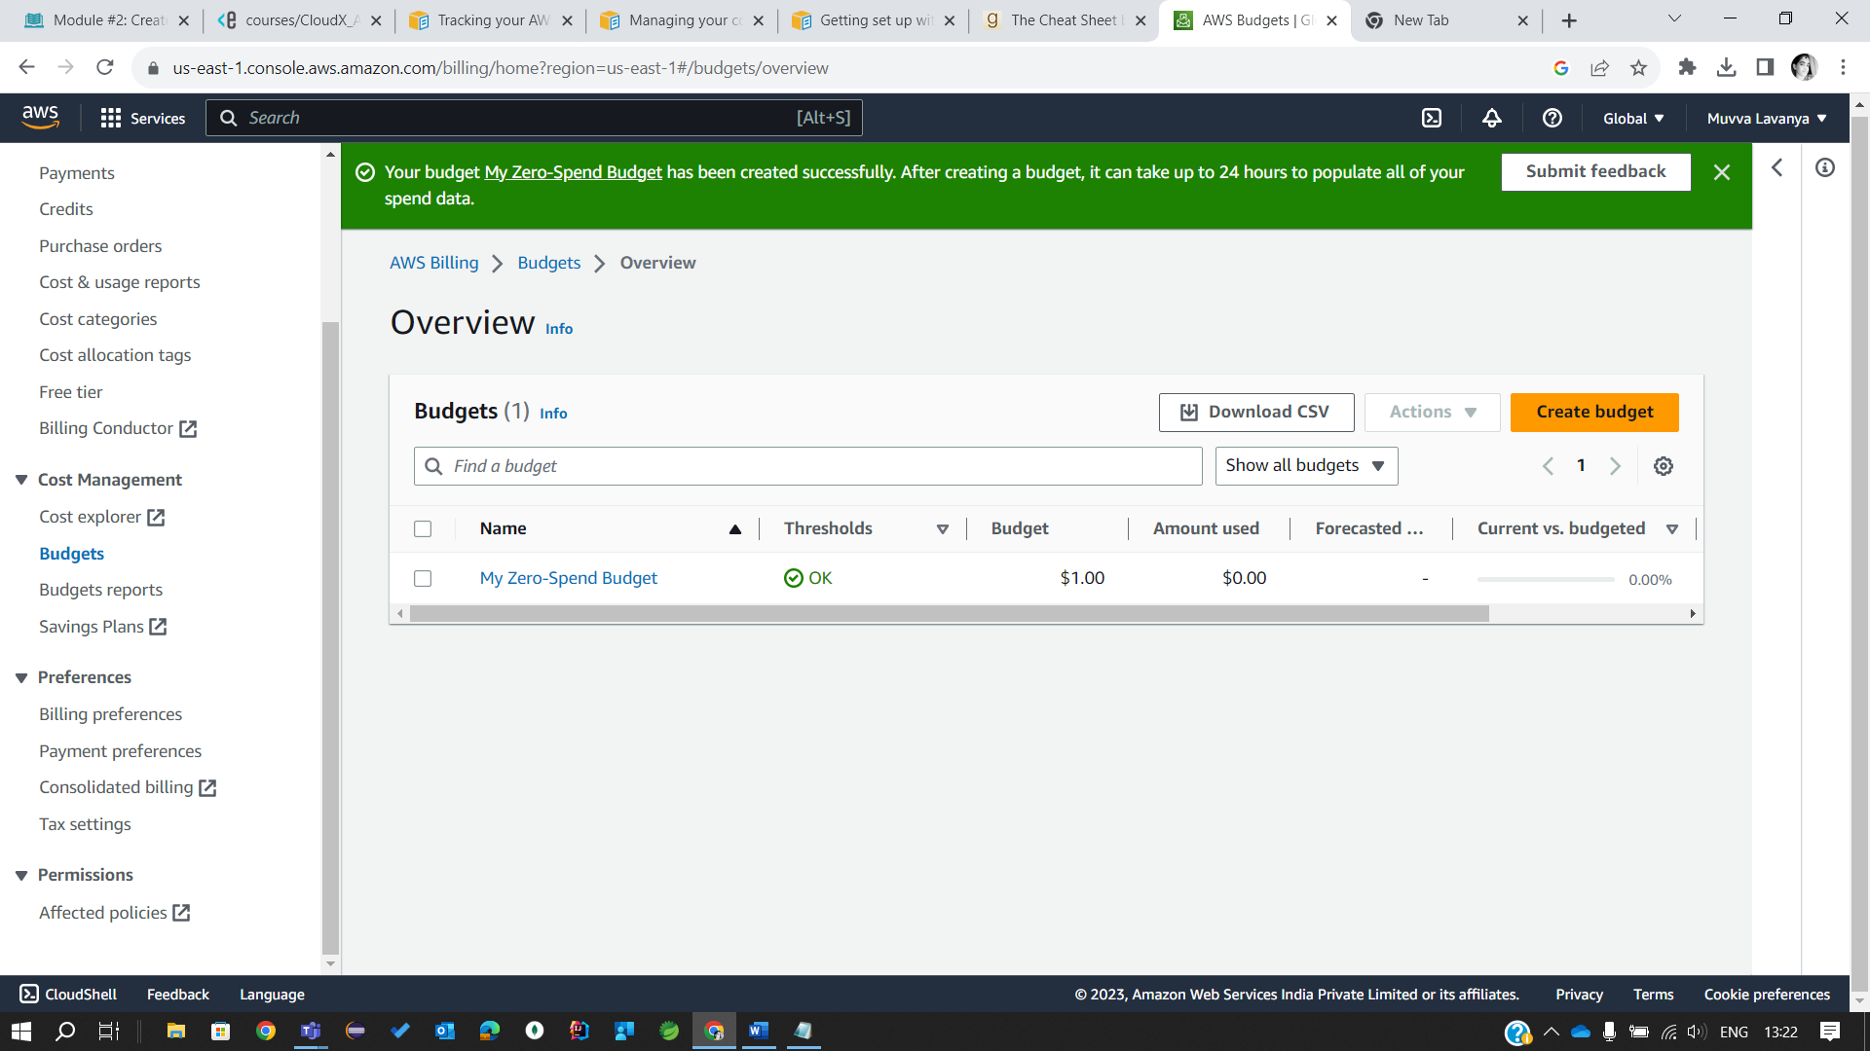

Sub-task 4 – Optional Task - Setup SCP

1.DENY-POLICY

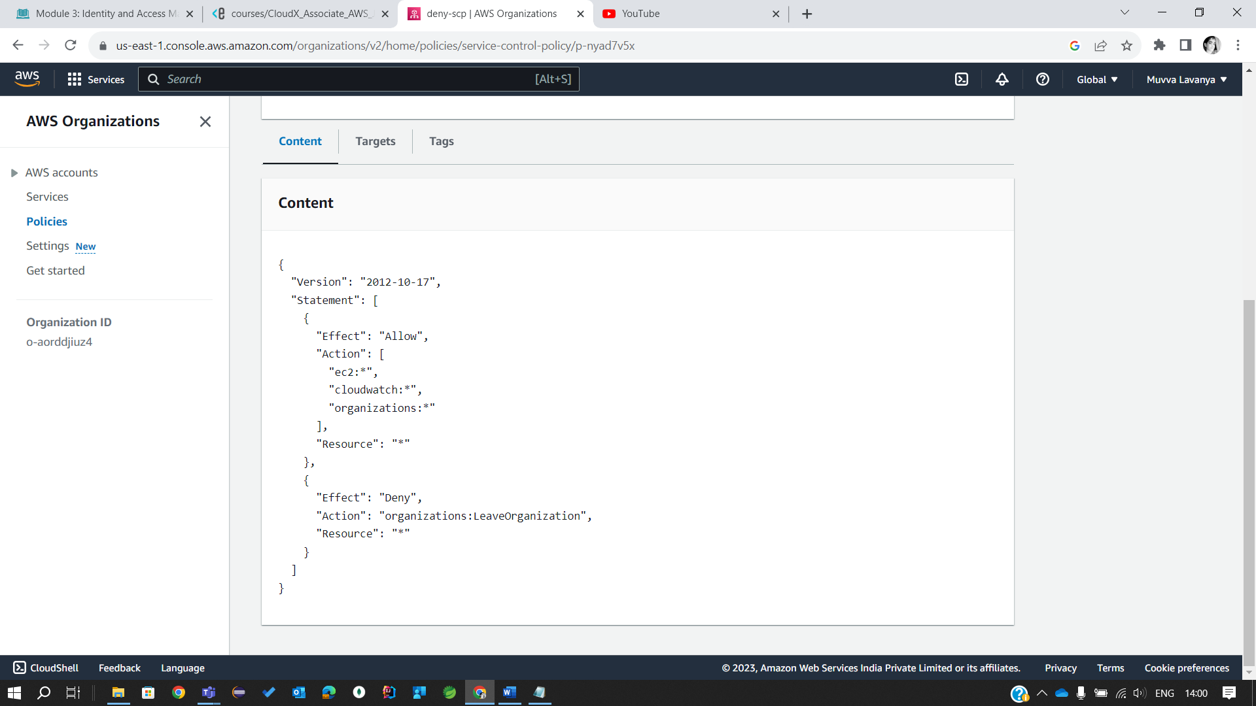

2.ALLOW POLICY



