DATA VISUALIZATION

ELEMENT 1: CLIMATE CHANGE


SAICHANDRA MUVVA
2021/2022

Introduction:

The aim of this research is to criticize the graphs that are published on few journals and articles. these graphs are criticized with the help of quality criteria these are predefined by few published journals .and our portfolio consist of visualizations these are grouped under climate changes, and we will made criticize and evaluate the graph using these quality criteria and module I am thankful to tutor jo noble helped to complete this task for helping in grabbing of few visualizations and quality criteria and constant monitoring of work in the lab session

Quality criteria:

Portfolio:
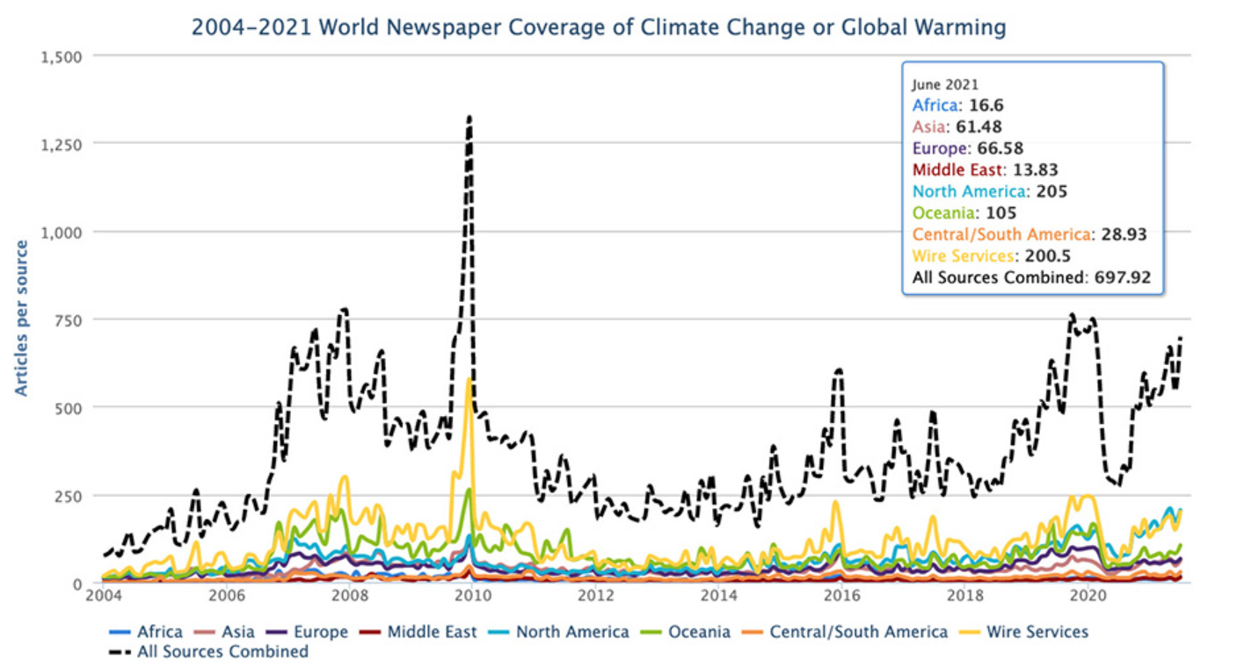
http://sciencepolicy.colorado.edu/icecaps/research/media_coverage/summaries/issue54.html

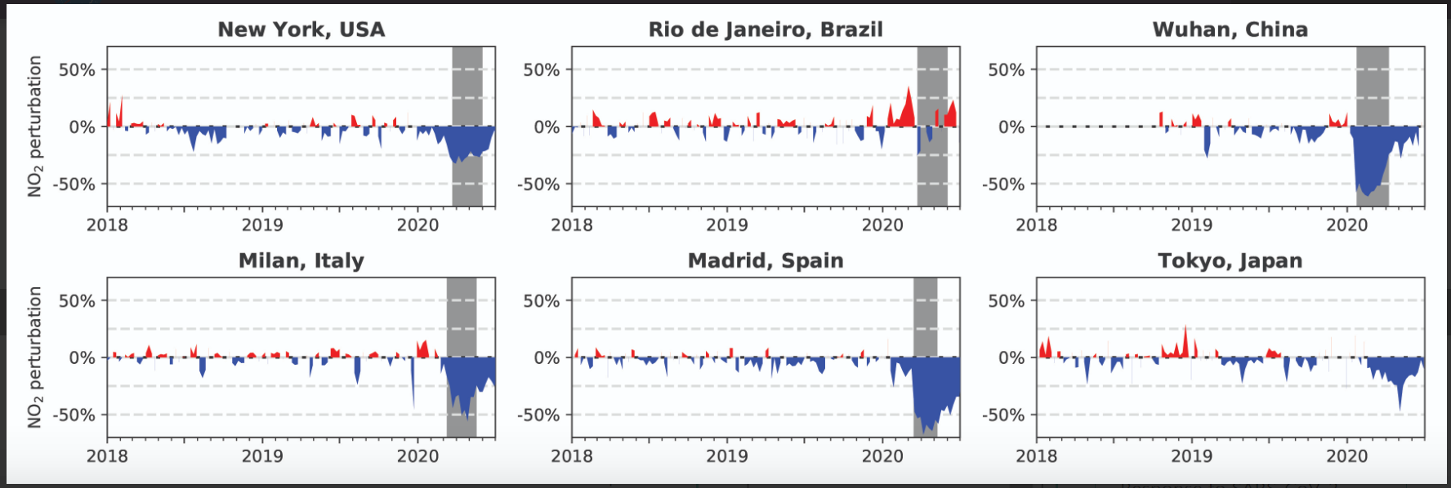
https://www.nas.nasa.gov/SC20/demos/demo25.html
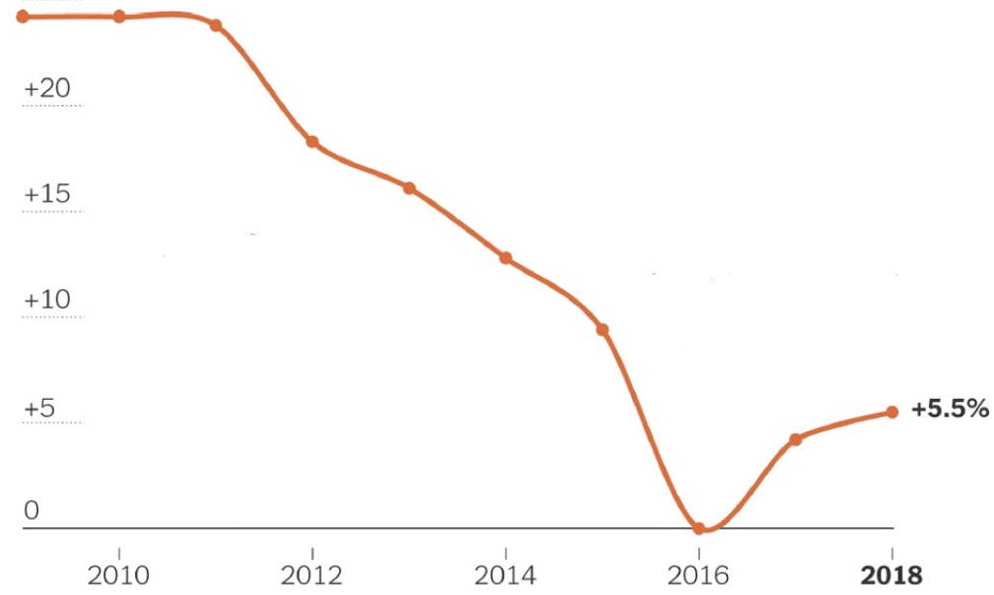
https://www.iqair.com/blog/environmental-justice/are-deaths-by-air-pollution-rising-globally
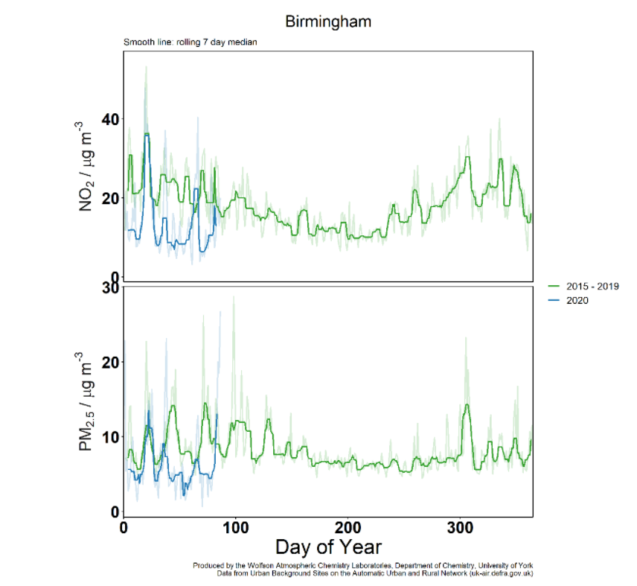
https://ncas.ac.uk/air-pollution-falling-across-uk-cities-latest-data-shows/
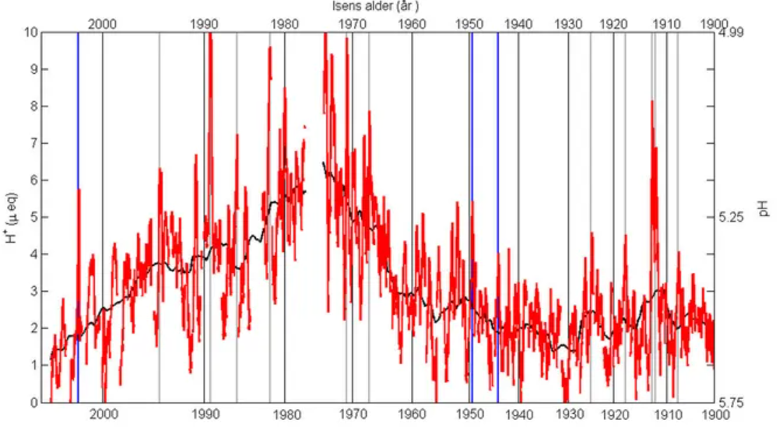https://www.huffingtonpost.co.uk/entry/this-simple-graph-reveals-some-very-good-news-about-air-pollution_n_57e155b8e4b04a1497b6c0af
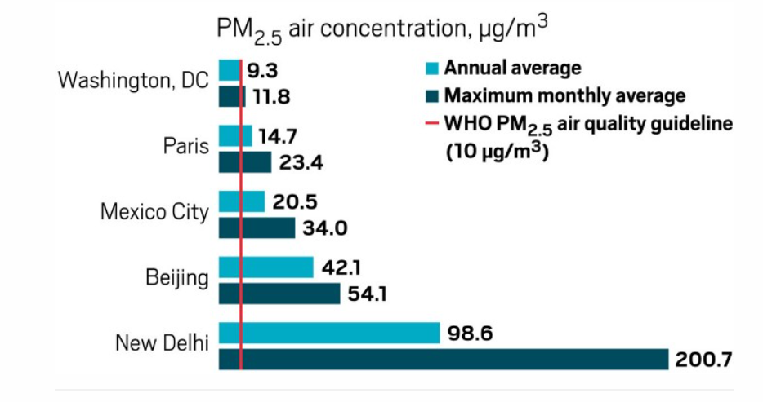
https://cen.acs.org/biological-chemistry/neuroscience/air-pollution-messes-minds/98/i21

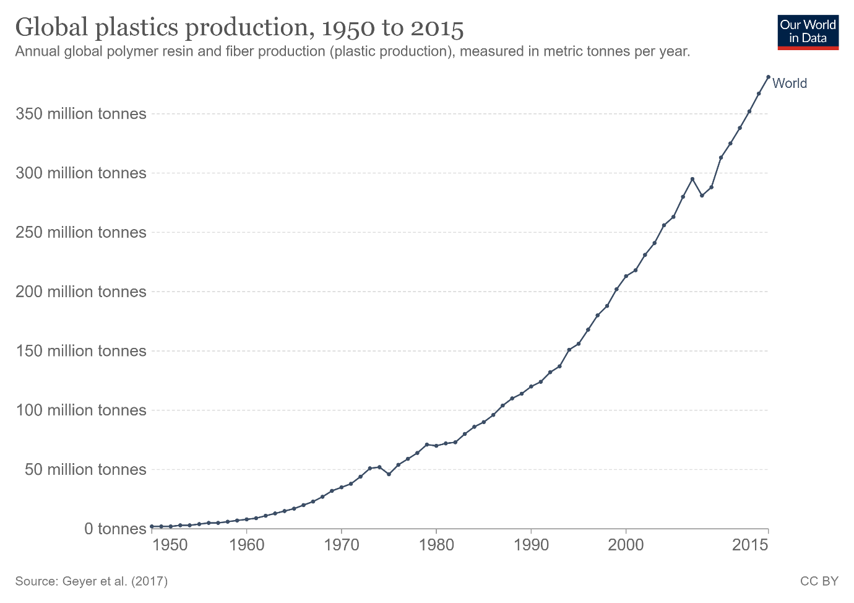 https://ourworldindata.org/plastic-pollution

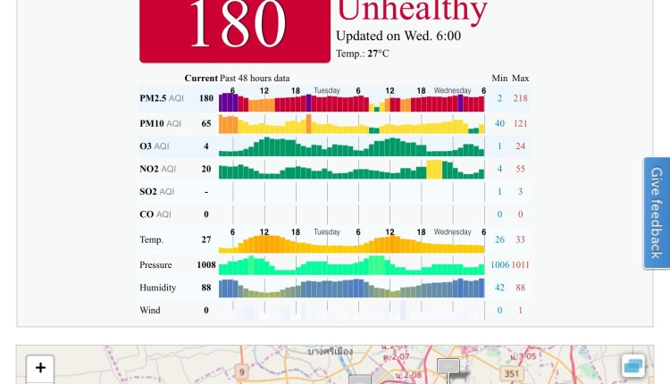

https://startupinthailand.com/news/within-five-years-bangkok-could-be-the-worlds-next-mega-city/thailand-pollution-watch-graph/
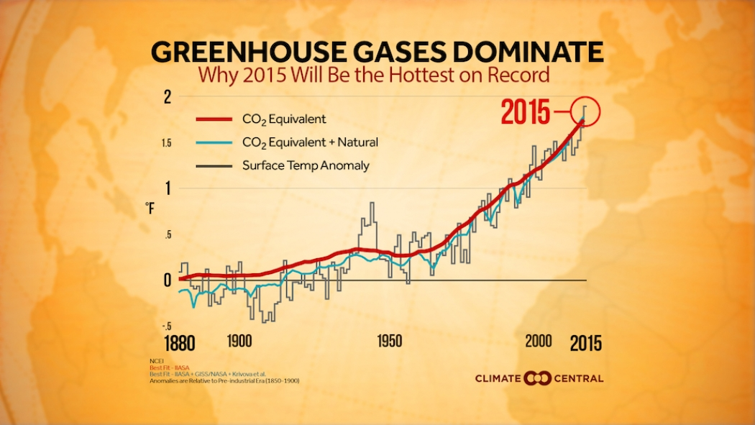https://www.climatecentral.org/news/global-warming-key-driver-record-heat-19734
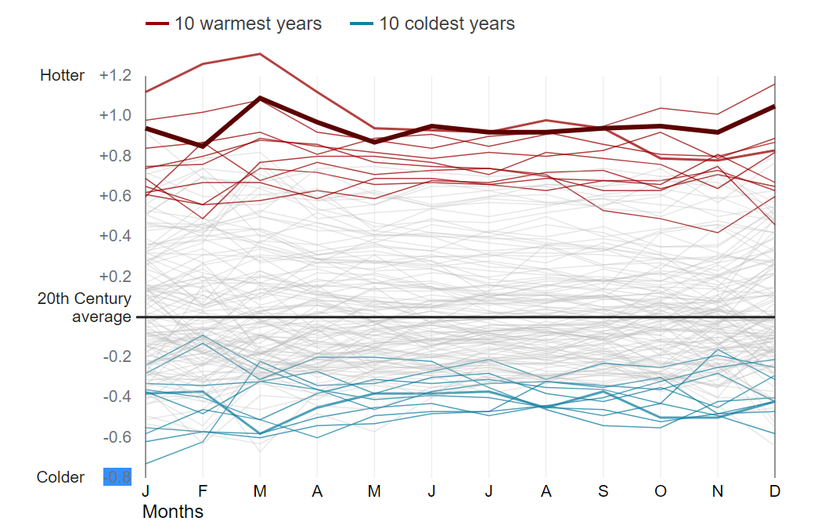 https://www.bbc.co.uk/news/science-environment-46384067

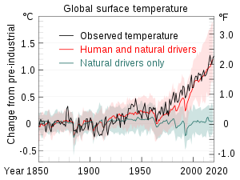

https://en.wikipedia.org/wiki/Climate_change
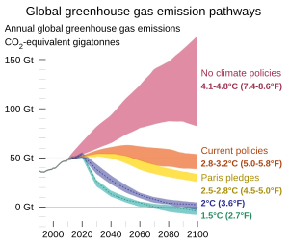
https://en.wikipedia.org/wiki/United_Nations_Environment_Programme
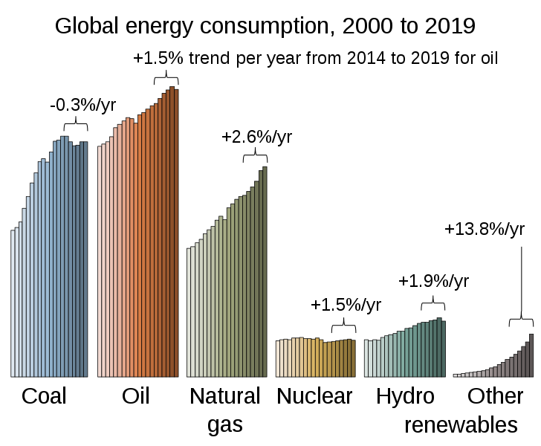https://folk.universitetetioslo.no/roberan/GCB2020.shtml

