2020105695 김희성

Exercise1

|  |  |
| --- | --- |
|  |  |

Exercise2

|  |  |
| --- | --- |
|  |  |

Exercise3.

|  |  |
| --- | --- |
|  |  |

|  |  |
| --- | --- |
|  |  |

Exercise4

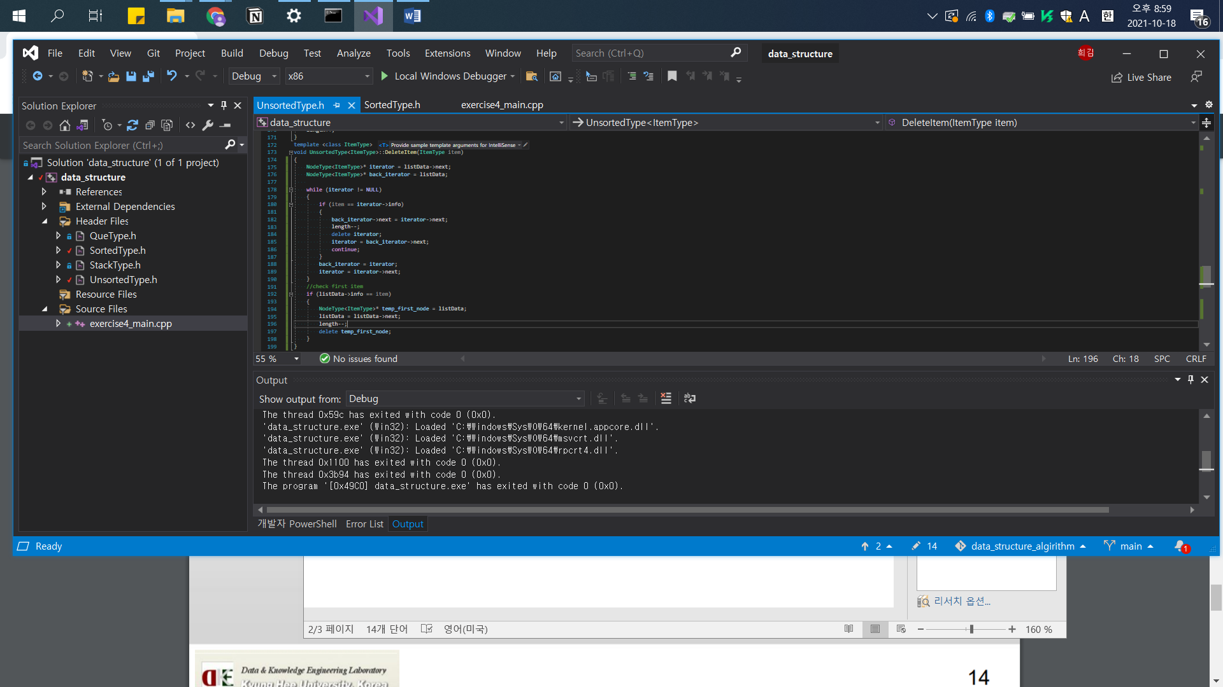

동일한 값을 가질 경우 모두 없애고

Exercise 5

