DB Ass1

Q1
select station_id,english_name,chinese_name,district from stations
where english_name like'%East%'
or english_name like'%South%'
or english_name like'%West%'
or english_name like'%North%'
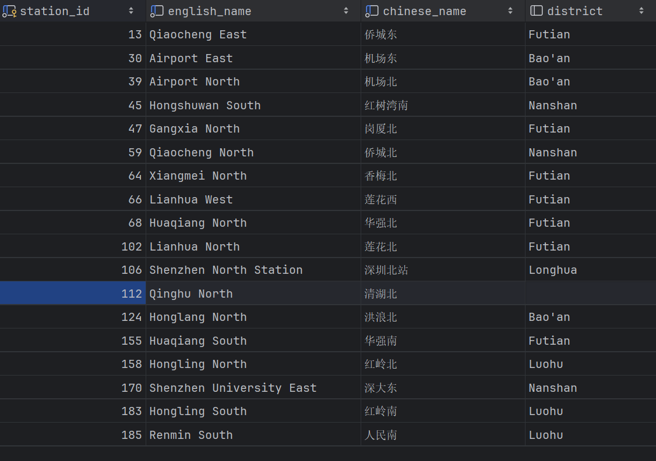

Q2
select district,
round(cast(max(latitude) - min(latitude) as numeric)*111,0) as 南北跨度km
from stations
where latitude is not null
group by district;

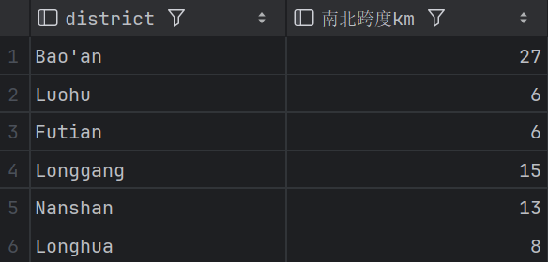

Q3
select 'Station ' || station_id || ' ' || english_name || '('|| chinese_name || ') in '
||district
from stations
where station_id between 2 and 10
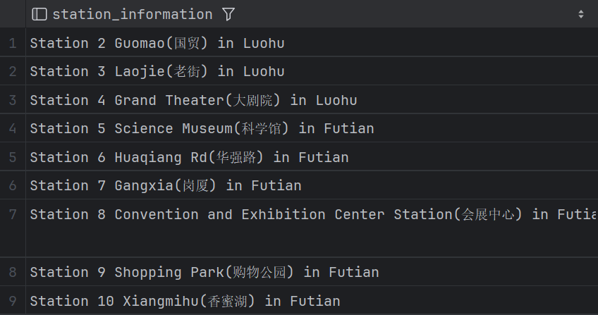

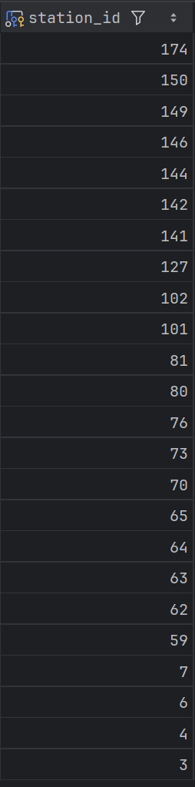
Q4
select DISTINCT station_id
from bus_lines
where bus_line = '103'
or bus_line = '104'
order by station_id DESC;

Q5
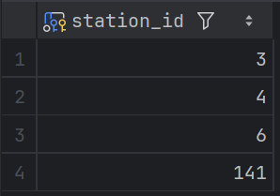
select station_id
from bus_lines b1
join bus_lines b2 using(station_id)
where b1.bus_line = '103'
and b2.bus_line = '104'
order by station_id;

Q6
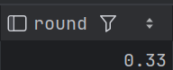
select round(1.0*count(num1034.station_id) / count(num103.station_id),2)
from
(select DISTINCT station_id from bus_lines where bus_line = '103') as num103
left join
(select DISTINCT station_id from bus_lines where bus_line = '104') as num1034
using (station_id);

Q7
select bus_line,count(station_id) as cnt
from bus_lines
group by bus_line
having count(station_id) >= 10
order by cnt DESC;
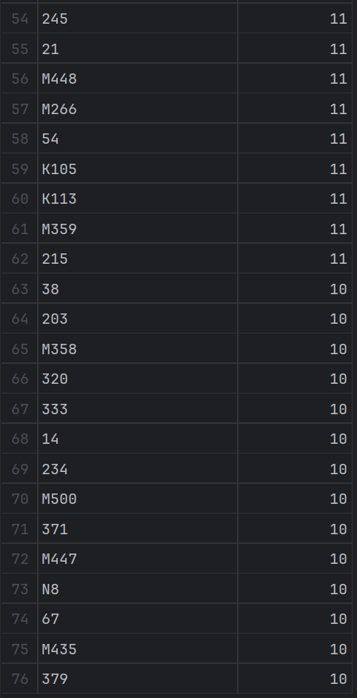
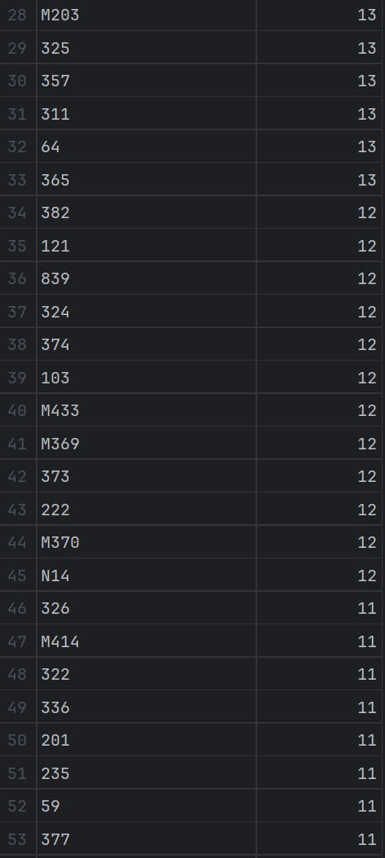
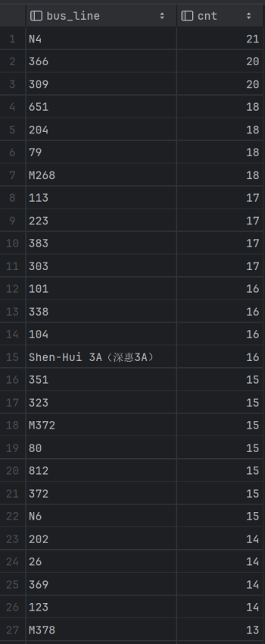

Q8
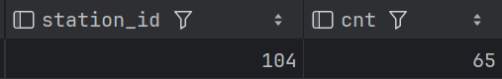
select station_id,count(bus_line) as cnt
from bus_lines
group by station_id
having count(bus_line) = (
select max(cnt)
from(
select count(bus_line) as cnt
from bus_lines
group by station_id
)as t
);

Q9
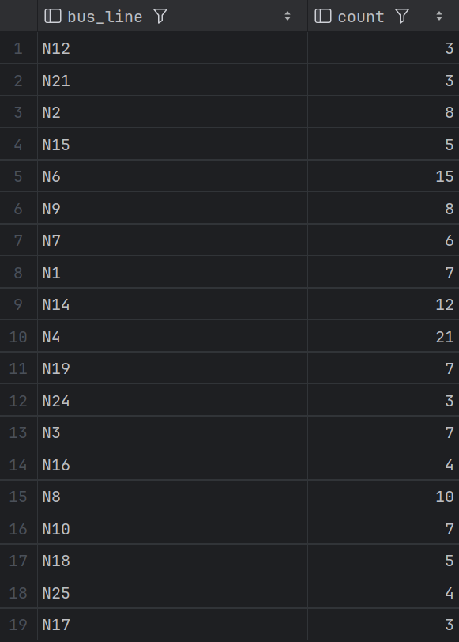
select bus_line, count(station_id) as count
from bus_lines
where bus_line like 'N%'
and (
bus_line like '%0'
or bus_line like '%1'
or bus_line like '%2'
or bus_line like '%3'
or bus_line like '%4'
or bus_line like '%5'
or bus_line like '%6'
or bus_line like '%7'
or bus_line like '%8'
or bus_line like '%9'
)
group by bus_line
order by count;

Q10
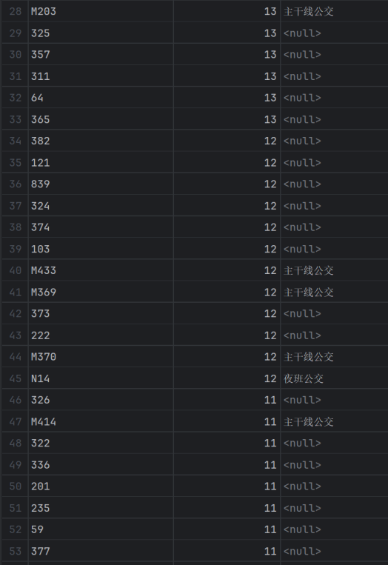
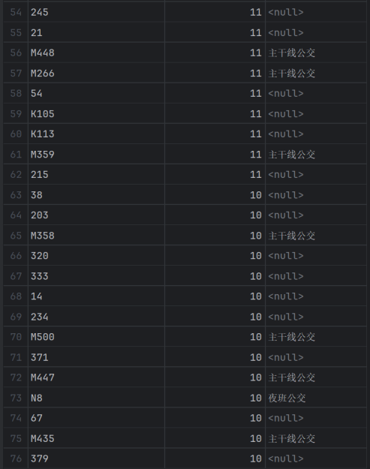
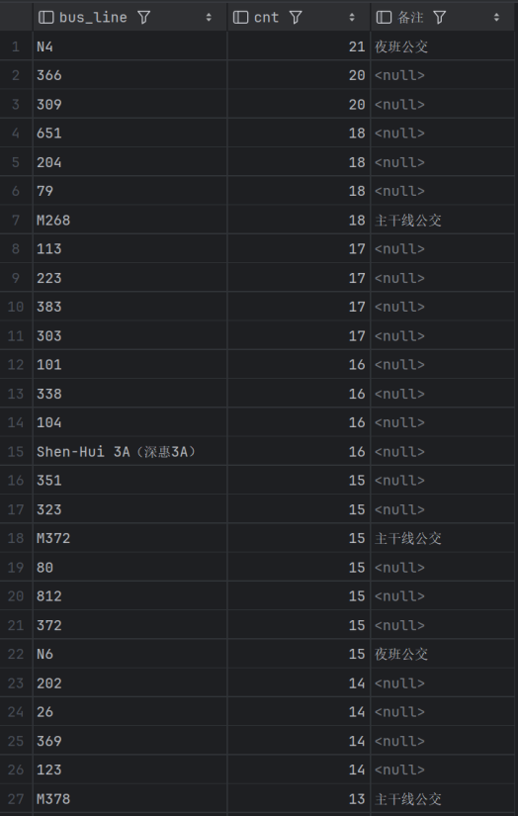
select bus_line,count(station_id) as cnt,
case
when
bus_line like 'N%'
and (
bus_line like '%0'
or bus_line like '%1'
or bus_line like '%2'
or bus_line like '%3'
or bus_line like '%4'
or bus_line like '%5'
or bus_line like '%6'
or bus_line like '%7'
or bus_line like '%8'
or bus_line like '%9'
) then '夜班公交'
when
bus_line like 'M%'
and (
bus_line like '%0'
or bus_line like '%1'
or bus_line like '%2'
or bus_line like '%3'
or bus_line like '%4'
or bus_line like '%5'
or bus_line like '%6'
or bus_line like '%7'
or bus_line like '%8'
or bus_line like '%9'
) then '主干线公交'
else null
end as 备注
from bus_lines
group by bus_line
having count(station_id) >= 10
order by cnt DESC;

