Ass2
Q1
SELECT line_id,
Chinese_name
FROM (SELECT DISTINCT ld.line_id,
s.chinese_name AS Chinese_name,
ld.station_id
FROM line_detail ld
JOIN stations s ON ld.station_id = s.station_id::integer
JOIN bus_lines bl ON ld.station_id = bl.station_id
WHERE bl.bus_line = '2') AS subquery
ORDER BY line_id ASC,
station_id ASC;
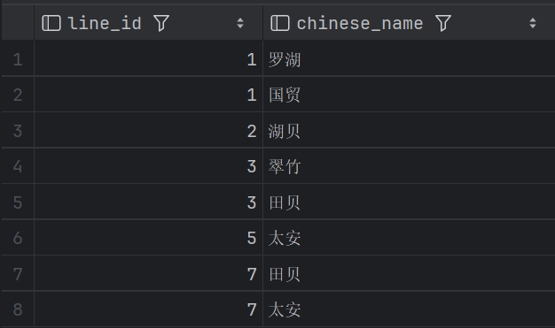

Q2
with max_count as (select count(*) as max_count
from line_detail
group by line_id
order by count(*) DESC
limit 1)
select distinct on (ld.line_id) ld.line_id,
st.chinese_name as chinese_name
from line_detail ld
join stations st on ld.station_id = st.station_id
where ld.line_id in (select line_id
from line_detail
group by line_id
having count(*) = (select max_count from max_count))
order by ld.line_id, ld.num;
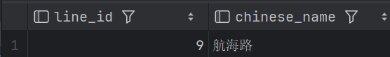

Q3
select station_id,
chinese_name
from stations
where station_id in (select station_id
from line_detail
where line_id = 1)
and station_id in (select station_id
from line_detail
where line_id = 5)
and station_id not in (select station_id
from line_detail
where line_id = 2)
order by station_id;
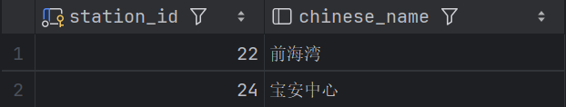

Q4
select distinct on (ld1.line_id , ld2.line_id , station_id) s.station_id,
s.chinese_name,
ld1.line_id as line_id,
ld2.line_id as line_id
from line_detail ld1
inner join line_detail ld2 on ld1.station_id = ld2.station_id
left join stations s on ld1.station_id = s.station_id
where ld1.line_id > ld2.line_id
order by ld1.line_id DESC, ld2.line_id DESC, station_id;
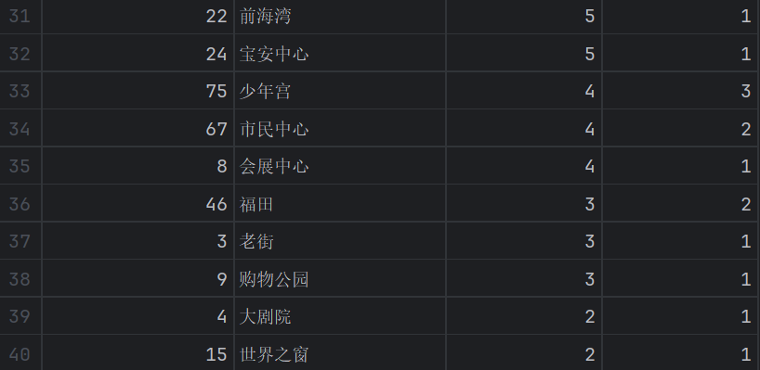
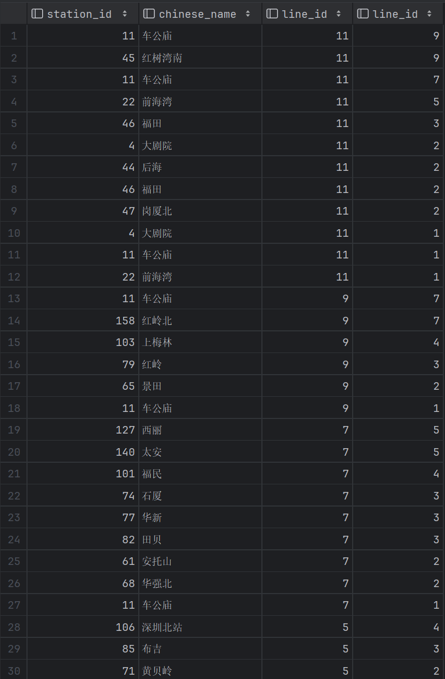

Q5

WITH ranked_stations AS (SELECT ld.line_id,
ld.station_id,
ld.num,
s.chinese_name,
l.line_color,
cn.hex,
FIRST_VALUE(s.chinese_name)
over(PARTITION BY ld.line_id ORDER BY ld.num) as start_name,
FIRST_VALUE(s.chinese_name)
over (PARTITION BY ld.line_id ORDER BY ld.num DESC) as terminal_name
from line_detail ld
left join stations s ON ld.station_id = s.station_id
left join lines l ON ld.line_id = l.line_id
left join color_names cn ON cn.name = l.line_color)
select distinct start_name as start,
terminal_name as terminal,
line_id,
line_color,
hex
from ranked_stations
order by line_id;

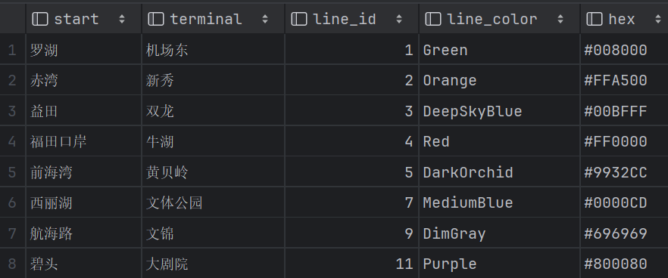

Q6
with warmcolor_lines as (select distinct ld.line_id,
l.line_color,
cn.hex
from line_detail ld
left join lines l on (ld.line_id = l.line_id)
left join color_names cn on (cn.name = l.line_color)
WHERE SUBSTRING(cn.hex FROM 6 FOR 2) < '80')
select wl.line_id
from warmcolor_lines wl
left join line_detail ld on (wl.line_id = ld.line_id)
left join stations s on (ld.station_id = s.station_id)
where s.latitude is NOT NULL
group by wl.line_id
order by (MAX(s.latitude) - MIN(s.latitude)) DESC
LIMIT 1;
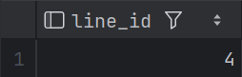

Q7
with first_words as (select split_part(english_name, ' ', 1) as first_word,
count(*) as count
from stations
where english_name is not NULL
group by first_word)
select first_word as prefix, count
from first_words
order by count DESC
limit 1;

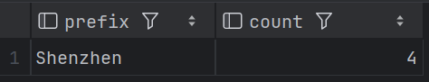

Q8
select distinct station_id
from connections
where connection like '%MTR%'
or connection like '%Railway%'
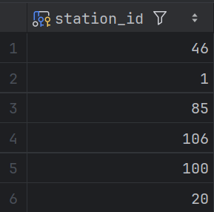

Q9
select distinct s.station_id,
s.chinese_name,
ld1.line_id as ld1id,
ld2.line_id as ld2id
from line_detail ld1
inner join line_detail ld2 on(ld1.station_id = ld2.station_id)
left join stations s on (ld1.station_id = s.station_id)
where ld1.line_id < ld2.line_id
and (ld1.line_id = 1 or ld1.line_id = 5 or ld1.line_id = 11)
and (ld2.line_id = 1 or ld2.line_id = 5 or ld2.line_id = 11)
order by station_id;
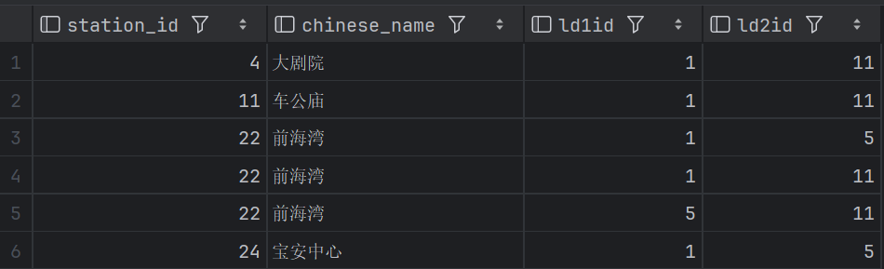

Q10
select opening as year,
'line ' || line_id || ' opened' as event
from lines
where opening is NOT NULL
and opening between 2008 and 2021
union all
select latest_extension as year,
'line ' || line_id || ' extended' as event
from lines
where latest_extension is NOT NULL
and latest_extension between 2008 and 2021
order by year
