**Deva-Bul**



**Eren VURAL – 120709027**

**Muğla Sıtkı Koçman University**

**Department of Computer Engineering**

**Senior Design Project**

**Instructor: Tuğba SÜZEK, PhD**

**30.05.2017**

**Deva-Bul**

**Bitbucket Link:** <https://bitbucket.org/ErenVural/seniorproject>

**Github Link:** <https://github.com/erenvural/DevaBul>

**PresentationLink:** <https://drive.google.com/open?id=0B9Dj0er568KWclFlUUIweG05bzg>

**Sql Schema:** <https://drive.google.com/file/d/0B9Dj0er568KWSGZKeWU0MDhJRmc/view>

Eren VURAL

Department of Computer Engineering

Muğla Sıtkı Koçman University

30.05.2017

**Summary**

My project is a mobile application that patients to exchange information about their diseases. It can also be called a social media environment for patients. Nowadays, patients tend to talk about health issues to other patients who have the same condition. In this project, aims to help the patients who are too shy to communicate with doctors and researching non-medical/homeopathic solutions.

In this report contains information about description of project, tools in project, status of project and similar information.

**Table of Contents**

1. Introduction 4

1.1. Who Can Use This Program? 4

2. Market Analysis 4

3. Tools & Resources 5

3.1. Programming Languages 5

3.2. Database 5

3.3. Website 5

3.4. Additional Programs 5

3.5. APIs 5

4. Roadmap of Web Operations 6

4.1. Status Pictures of Web Host 6

5. Roadmap of Google APIs Operations 8

6. GUI Pictures 8

7. Future Plan 10

8. Conclusion 10

9. References 10

# **1. Introduction**

Deva-Bul is a mobile application for patients to exchange information about their diseases in Turkish Language. The application will provide map benefits. Users can find their location and addresses of health institutions (Hospitals, Pharmacies etc.).

The application will be like social media for patients. Each user will be directed to specific diseases he/she wants to receive information. They can follow other users and will be able to ask questions in disease-dedicated forums.

The goal of the project is help the patients who are too shy to communicate with doctors but need social support for their diseases. The project also aims help the patients find non-medical/homeopathic solutions that already worked to some other patient.

## **1.1. Who Can Use This Program?**

All patients who have access to mobile phone can anonymously use this program. The project can be considered could be especially useful for patients who have chronic and venereal diseases. For diseases examples;

**Chronic:** Hypertension, Diabetes, Asthma, Bronchitis etc.

**Venereal:** AIDS, Syphilis, Gonorrhea etc.

# **2. Market Analysis**

There is a website like my application in the market. It is **Patients Like Me** [https://www.patientslikeme.com and IOS application]. My project has finding location feature and searching health institutions on the map of Turkey differently from Patients Like me. Other hand, language of my project will be Turkish. My application was made for Google Play Store but **Patients Like Me** is in IOS platform.

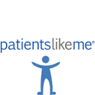

# **3. Tools & Resources**

Operating system of my application is Android.

## **3.1. Programming Languages**

* Java: Using in Android coding
* PHP: Helper files to Registration and Login operations with database on host written in PHP

## **3.2. Database**

* MySQL: Database on 000webhost.com
* phpMyAdmin: Management database on web host

## **3.3. Website**

* 000webhost, https://www.000webhost.com: Web Host Provider

## **3.4. Additional Programs**

* Gradle: Build System
* FileZilla: FTP (File Transfer Protocol) Program
* Genymotion: Android Emulator
* Android Studio: Integrated Development Environment

## **3.5. APIs**

* Google Maps: Using in find location operations
* Google Places: Using in find institutions
* Android Volley: REST API

# **4. Roadmap of Web Operations**

The steps of insert and read data from the database on the web host are shown in Figure 1.

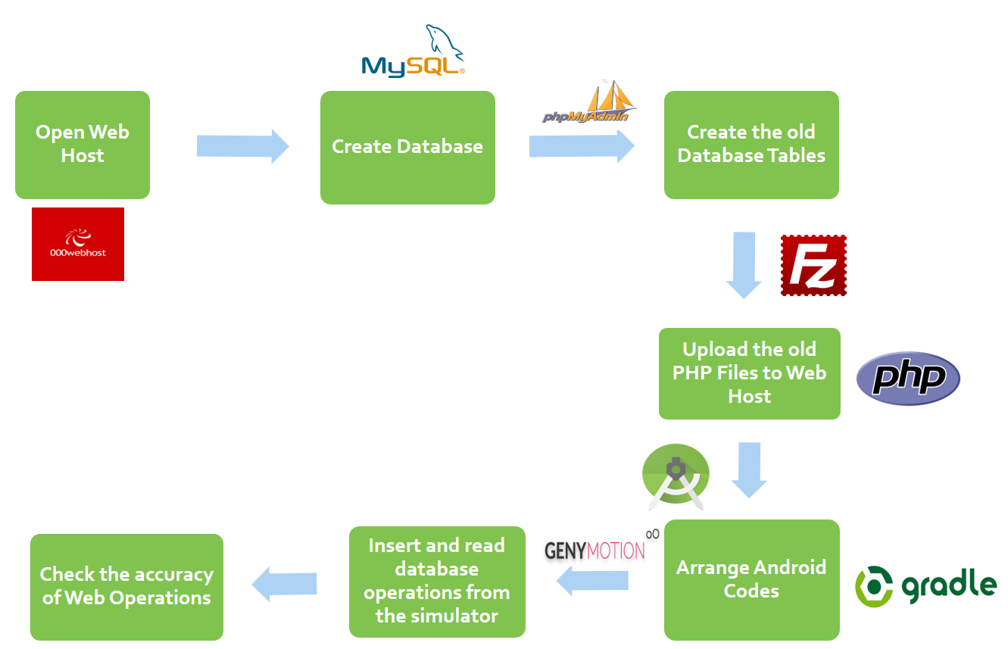

**Figure 1.** Step-by-step Web Operations

## **4.1. Status Pictures of Web Host**

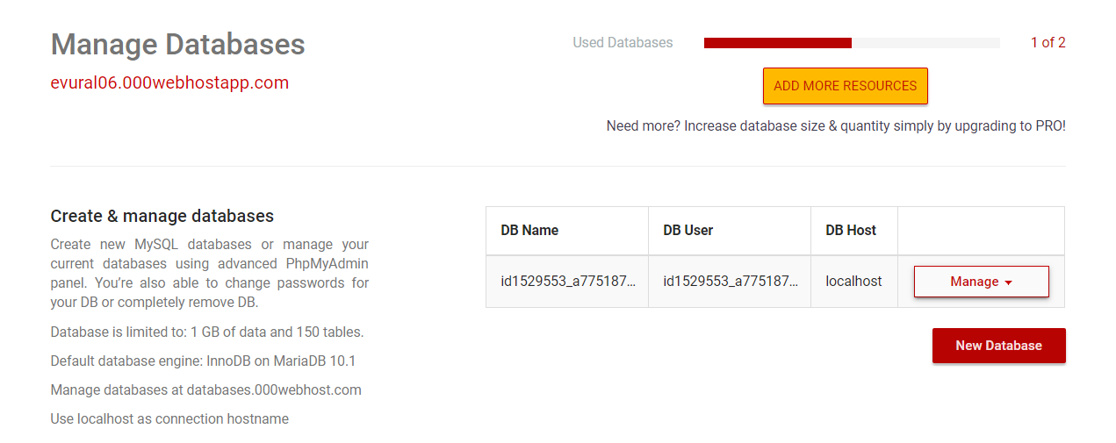

**Figure 2**. Database Management Section of My Host (Create & Manage Operations)

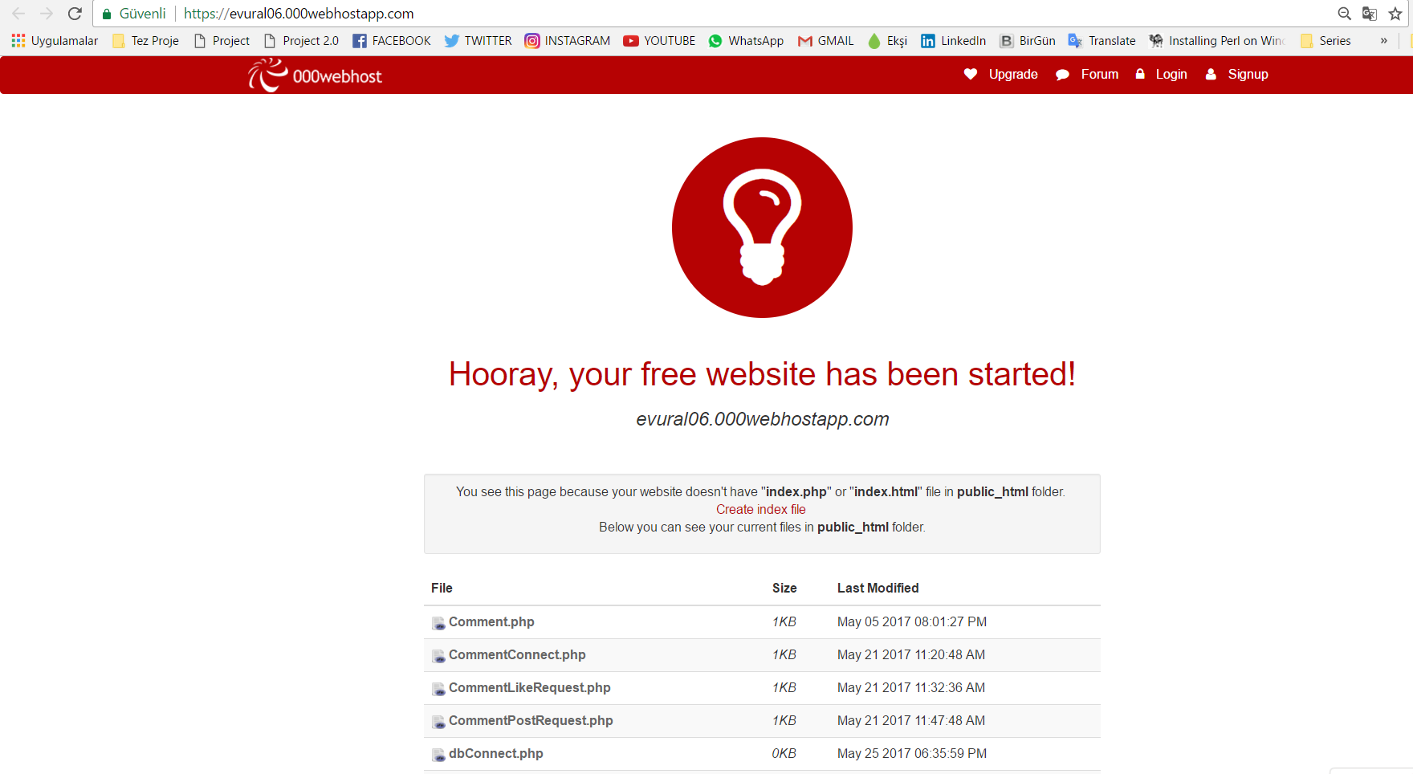

**Figure 3.** My Domain Website (PHP files on host are visible)

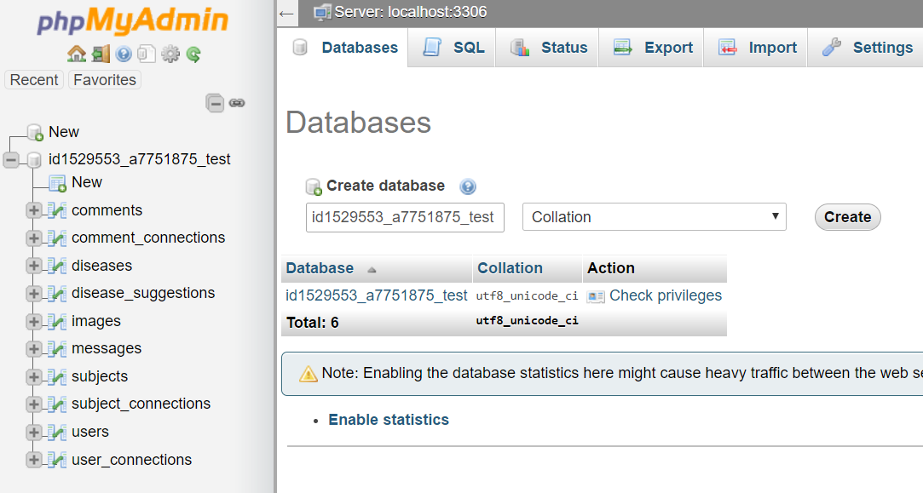

**Figure 4.** phpMyAdmin Page of My Host

# **5. Roadmap of Google APIs Operations**

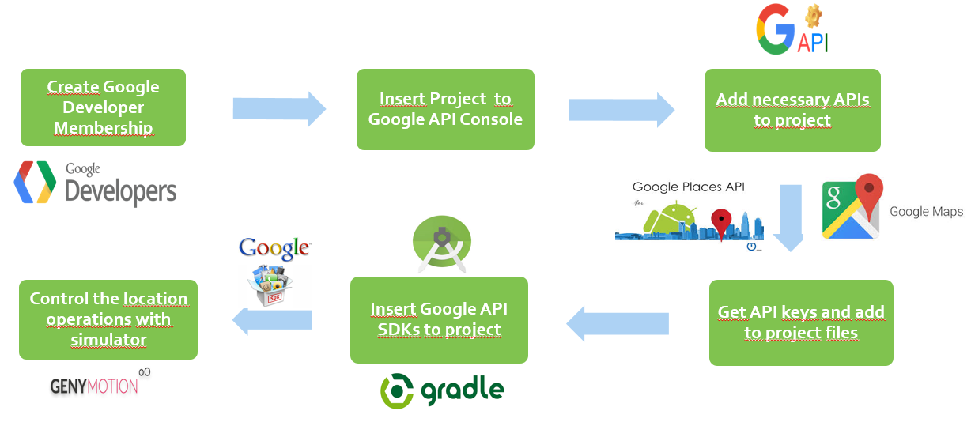

**Figure 5.** Step-by-step Google API Operation

# **6. GUI Pictures**

The UIs of Android Activities are shown in below pictures in order of.

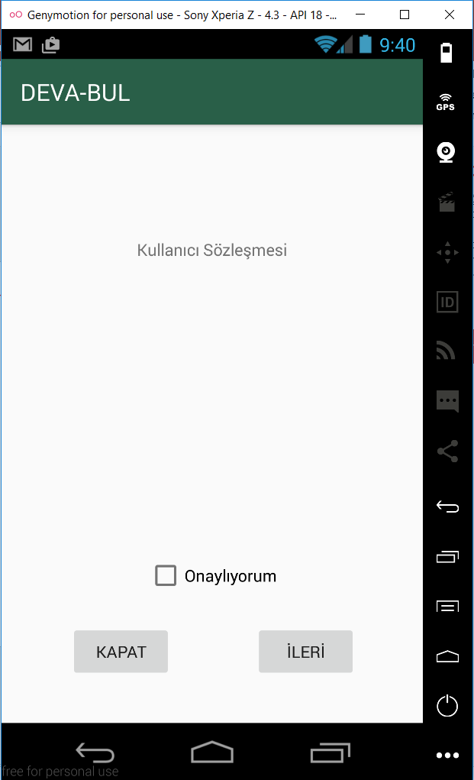 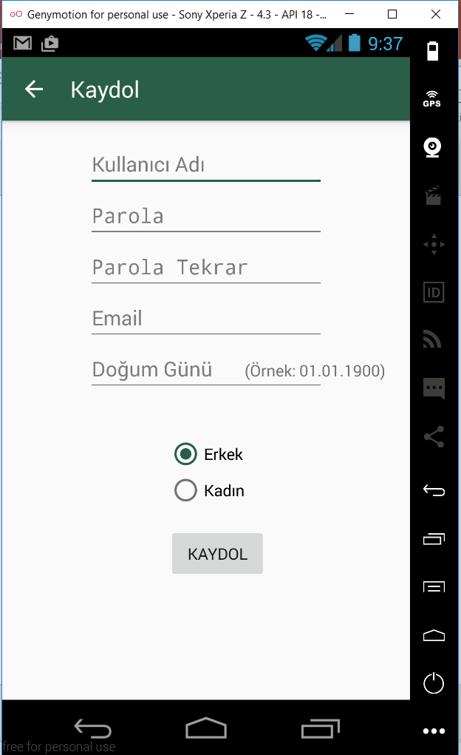 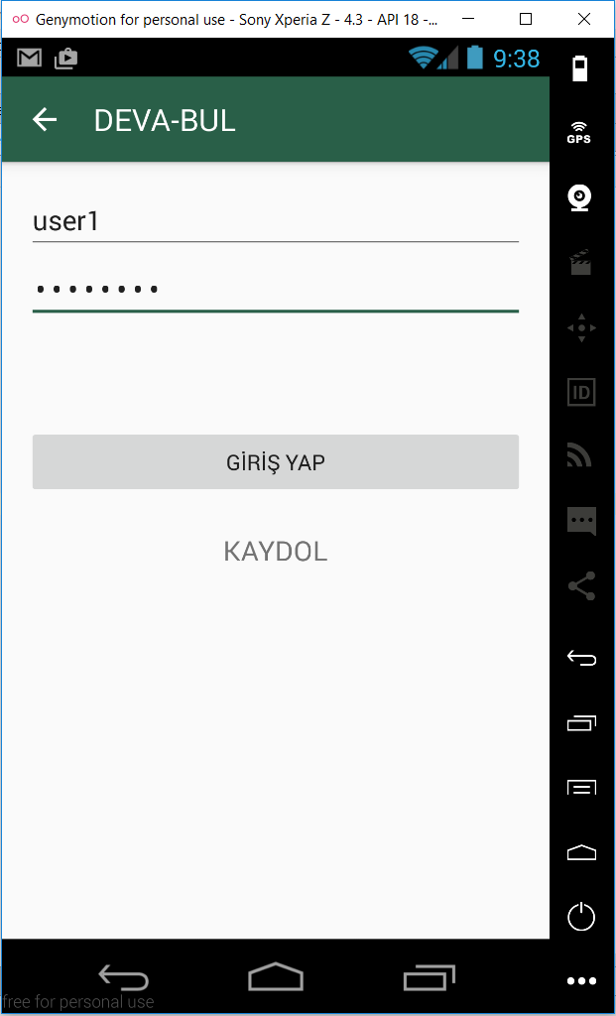 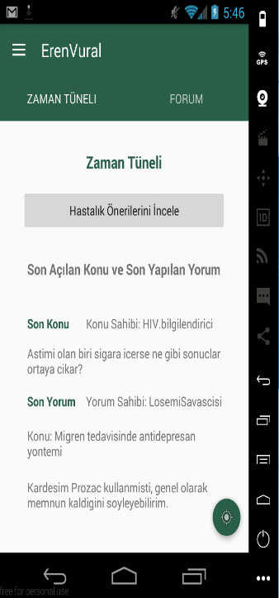

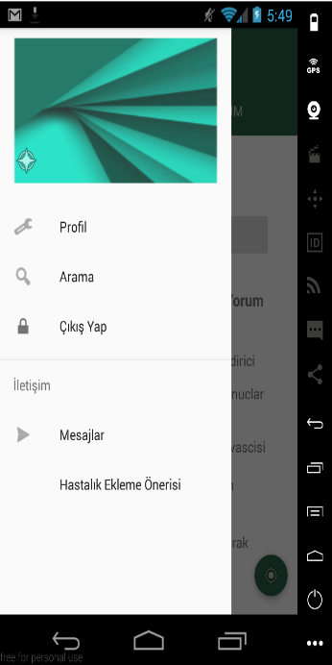 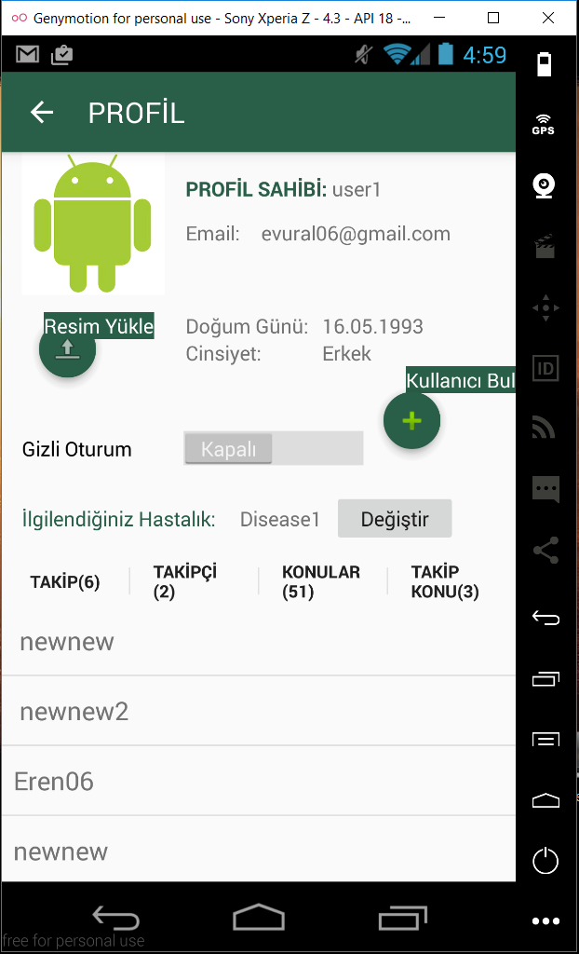 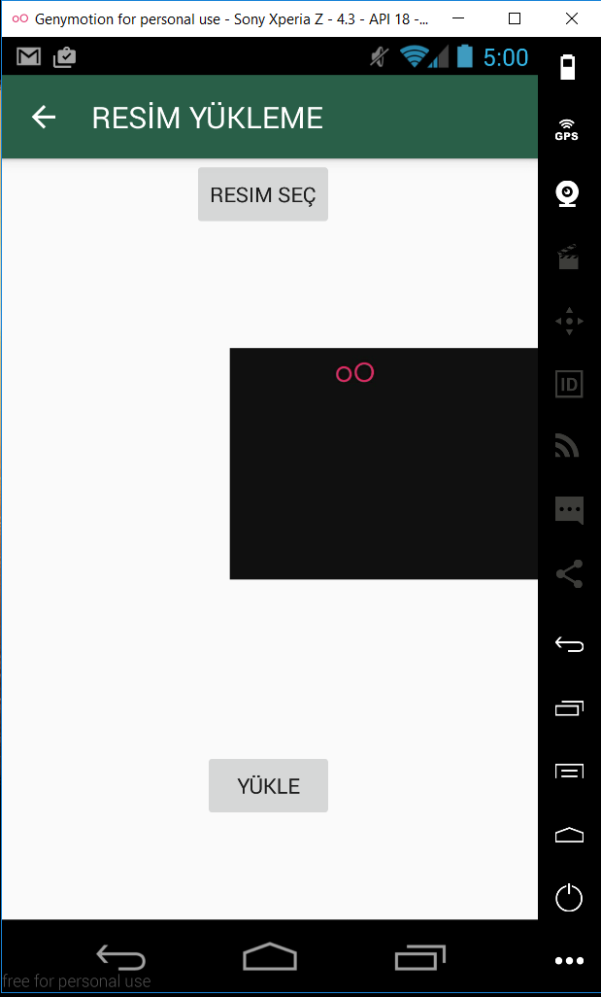 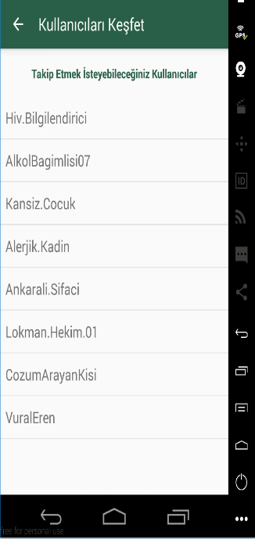

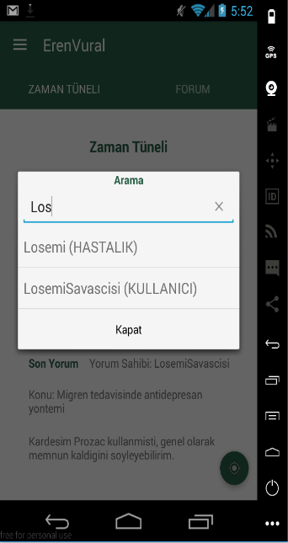 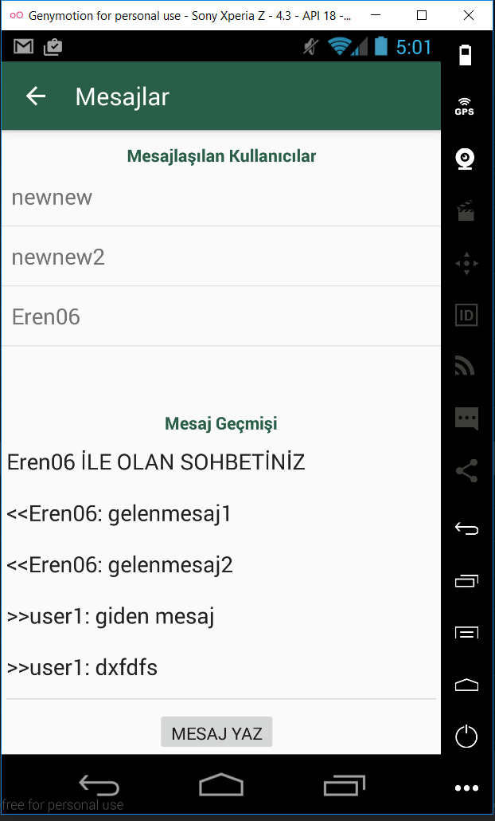 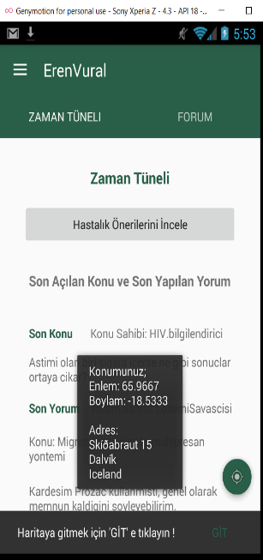 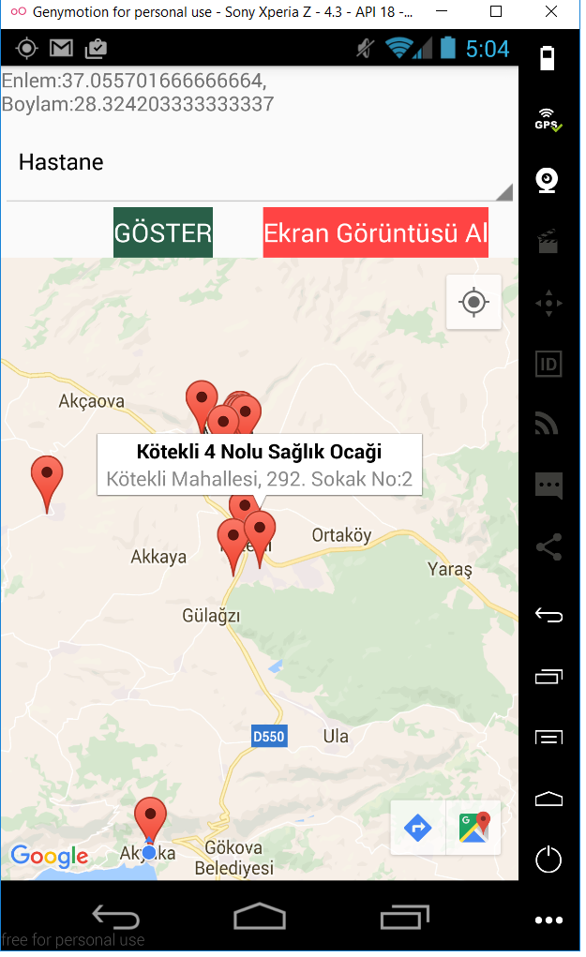

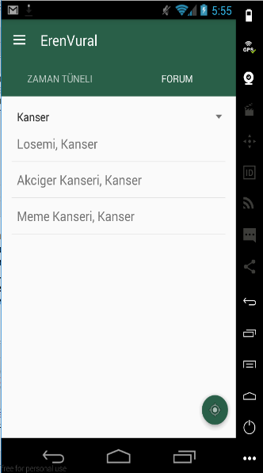 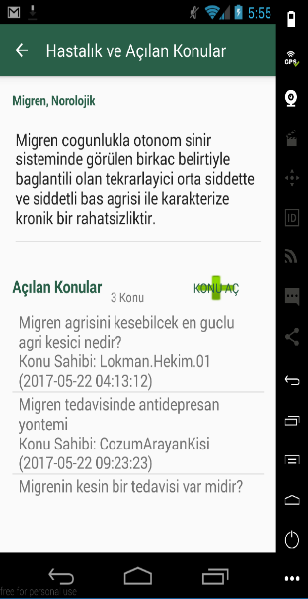 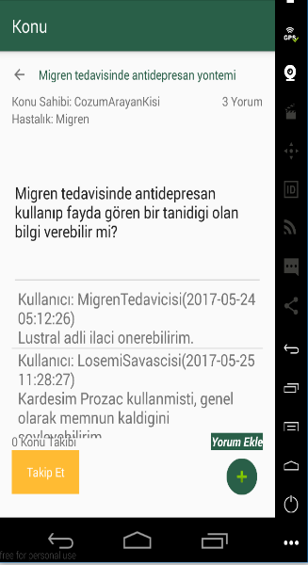 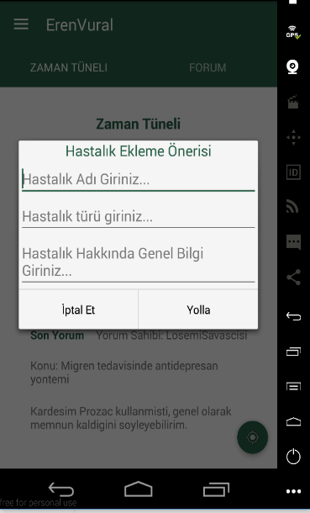

## **7. Future Plan**

* Voice control support for the elderly people
* Filtering for health institutions for example show only brain hospitals
* Information on pharmacies open at night

# **8. Conclusion**

In conclusion, people are spending a lot of time with mobile phones so they are interested in searching information from the internet by phone. Patients are curious about disease-related experiences. Patients can reach alternative non-medical/homeopathic solutions without contacting the doctor thanks to a mobile application.

They also can take advantage of location operations. They can quickly identify the locations of health care facilities according to their illness. Another useful aspect of the application is privacy. Patients who are ashamed of the situation, they can easily ask questions anonymously.

# **9. References**

My references are shown below;

* Developer Android [https://developer.android.com/guide/]
* 000webhost [https://www.000webhost.com/forum/c/tutorials]
* Stack Overflow [http://stackoverflow.com/documentation]
* PHP Server-side Scripting Language [http://php.net/docs.php]
* MySQL [https://dev.mysql.com/doc/]
* phpMyAdmin [https://www.phpmyadmin.net/docs/]
* FileZilla FTP Program [https://wiki.filezilla-project.org/Documentation]
* Genymotion Android Emulator [https://docs.genymotion.com/]