SERVER SIDE MODULE

Contents
- MODULE_SERVER_SIDE.docx
- MODULE_SERVER_SIDE.pdf
- MODULE_SERVER_SIDE_MEDIA.zip

Introduction
Our company “TechMart Solutions” appoints you as a Web Developer to build a web-based product management application using React as the frontend and Laravel 12 REST API as the backend. The application allows authenticated users to manage product data through features such as creating, viewing, up dating, and deleting products (CRUD).
User authentication is handled using Laravel Sanctum, ensuring that only authorized users can access and manage the data securely. The system stores all data in a MySQL database consisting of multiple related tables, including users, categories, products, and transactions. This application is designed to help users efficiently manage product information in a simple, secure, and scalable web application.

Description of Projects
There are 2 phases in this module. In the first phase, you will make the RESTFul API using Laravel Frameworks according to the provided documentation. In the second phase, you should build a frontend with the Interactive Maps using one of the provided Javascript Frameworks (React/Vue) and the data must come from the created RESTFul API.

You can find the provided media files to support your work:
- Postman collection and environment
- Template GUI (to build frontend UI)
- database.sql (a database with structures)

Phase 1 : Database Preparation and Model Creation
In this phase, you are required to prepare the database structure based on the provided ERD (Entity Relationship Diagram).
- Set up the database configuration in the .env file.
- Carefully analyze the entities, attributes, primary keys, foreign keys, and relationships shown in the ERD.
- Generate Laravel models corresponding to each entity in the ERD.
- Run migration, ensure all tables are successfully created without errors.

Entity Relationship Diagram

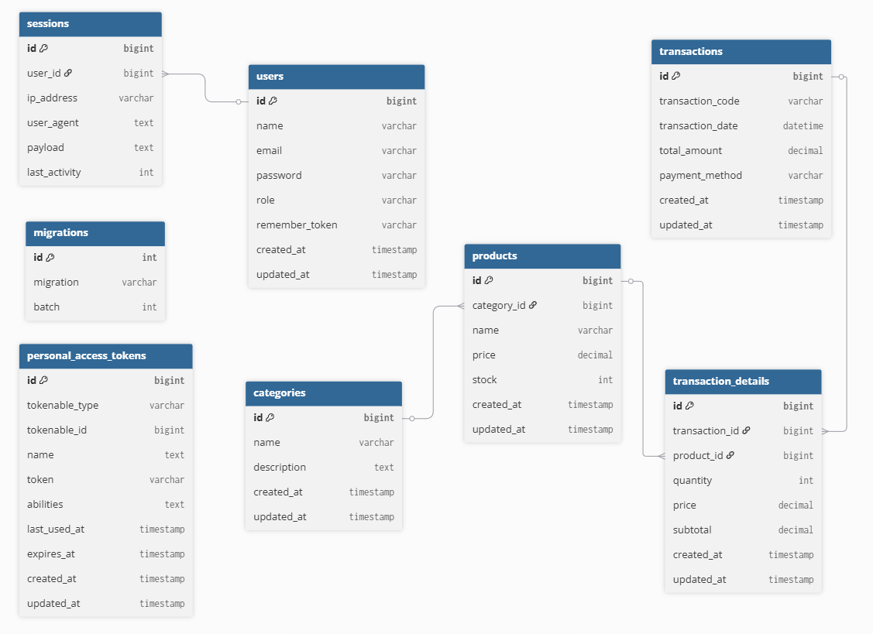

Phase 2 : RESTful API
In this phase, you should build a RESTful API using the Laravel framework according to the documentation below.
You are required to insert predefined user data into the database using Laravel Seeder:
Name | Email | Password
User 1 | user1@techmart.id | password1
User 2 | user2@techmart.id | password2
User 3 | user3@techmart.id | password3

Authentication
You should create Login and Logout endpoints. The accessToken must be generated by sanctum and will be placed in the request headers Authorization Bearer.

Login
Endpoint | : | [DOMAIN]/api/login
Description | : | For user to log in the system
Method | : | POST
Request | : | Body (JSON):  {  "email": "user1@techmart.id",  "password": "password1"  }
Validation | : | email:  - required  - valid email address  password:  - required  - min 5 chars
Response | : | If success:  Headers:  - Response status: 200  Body (JSON):  {  "success": true,  "message": "Login success",  "user": {  "name": "User 1",  "email": "user1@webtech.id",  "accessToken": "1|QnHFgF0C7ml2LkbDG5QDn34qvJoYGdpxoXy63Poi"  }  }  If invalid field:  Headers:  - Response status: 422  Body (JSON):  {  "success": false,  "message": "Invalid field",  "errors": {  "email": [  "The email must be a valid email address."  ],  "password": [  "The password field is required."  ]  }  }  If failed:  Headers:  - Response status: 401  Body (JSON):  {  "success": false,  "message": "Email or password incorrect"  }

Logout
Endpoint | : | [DOMAIN]/api/logout
Description | : | For user to log out the system
Method | : | POST
Request | : | Headers:  - Authorization: “Bearer <accessToken>”
Response | : | If success:  Headers:  - Response status: 200  Body (JSON):  {  "success": true,  "message": "Logout success"  }  If invalid token:  Headers:  - Response status: 401  Body (JSON):  {  "success": false,  "message": "Unauthenticated."  }

Categories
In this task, participants are required to develop a RESTful API for managing Categories data following the standard CRUD (Create, Read, Update, Delete) operations.

Create a Category
Endpoint | : | [DOMAIN]/api/categories
Description | : | For user to create new category
Method | : | POST
Request | : | Headers:  - Authorization: “Bearer <accessToken>”
Validation | : | name:  - required  description:  - nullabe
Response | : | If success:  Headers:  - Response status: 200  Body (JSON):  {  "success": true,  "message": "Create form success",  "data": {  "id": 1,  "name": "Elektronik",  "description": "Produk elektronik seperti HP dan Laptop"  }  }  If invalid field:  Headers:  - Response status: 422  Body (JSON):  {  "success": false,  "message": "Invalid field",  "errors": {  "name": [  "The name field is required."  ]  }  }  If invalid token:  Headers:  - Response status: 401  Body (JSON)  {  "success": false,  "message": "Unauthenticated."  }

Get all Categories
Endpoint | : | [DOMAIN]/api/categories
Description | : | For users to get all of their created categories
Method | : | GET
Request | : | Headers:  - Authorization: “Bearer <accessToken>”
Response | : | If success:  Headers:  - Response status: 200  Body (JSON):  {  "success": true,  "message": "List of categories",  "data": [  {  "id": 1,  "name": "Elektronik",  "description": "Produk elektronik seperti HP dan Laptop",  "created_at": "2026-02-11T10:00:00.000000Z",  "updated_at": "2026-02-11T10:00:00.000000Z"  },  {  "id": 2,  "name": "Makanan",  "description": "Produk makanan dan minuman",  "created_at": "2026-02-11T10:00:00.000000Z",  "updated_at": "2026-02-11T10:00:00.000000Z"  }  ]  }  If invalid token:  Headers:  - Response status: 401  Body (JSON):  {  "success": false,  "message": "Unauthenticated."  }

Get Category by ID
Endpoint | : | [DOMAIN]/api/categories/<id>
Description | : | For users to get category by ID
Method | : | GET
Request | : | Headers:  Authorization: “Bearer <accessToken>”
Response | : | If success:  Headers:  - Response status: 200  Body (JSON):  {  "success": true,  "message": "Get category by ID",  "data": [  {  "id": 1,  "name": "Elektronik",  "description": "Produk elektronik seperti HP dan Laptop",  "created_at": "2026-02-11T10:00:00.000000Z",  "updated_at": "2026-02-11T10:00:00.000000Z"  }  ]  }  If not found:  Headers:  - Response status: 404  Body (JSON):  {  "success": false,  "message": "Product not found",  }  If invalid token:  Headers:  - Response status: 401  Body (JSON):  {  "success": false,  "message": "Unauthenticated."  }

Update Category
Endpoint | : | [DOMAIN]/api/categories/<id>
Description | : | For users to update category
Method | : | PATCH
Request | : | Headers:  Authorization: “Bearer <accessToken>”
Response | : | If success:  Headers:  - Response status: 200  Body (JSON):  {  "success": true,  "message": "Category updated successfully",  "data": {  "id": 1,  "name": "Updated Electronics",  "description": "Updated electronic products category",  "created_at": "2026-02-10T10:00:00.000000Z",  "updated_at": "2026-02-11T08:30:00.000000Z"  }  }  If not found:  Headers:  - Response status: 404  Body (JSON):  {  "success": false,  "message": "Category not found",  }  If invalid token:  Headers:  - Response status: 401  Body (JSON):  {  "success": false,  "message": "Unauthenticated."  }

Delete Category
Endpoint | : | [DOMAIN]/api/categories/<id>
Description | : | For users to delete category
Method | : | DELETE
Request | : | Headers:  Authorization: “Bearer <accessToken>”
Response | : | If success:  Headers:  - Response status: 200  Body (JSON):  {  "success": true,  "message": "Category deleted successfully"  }  If not found:  Headers:  - Response status: 404  Body (JSON):  {  "success": false,  "message": "Category not found",  }  If invalid token:  Headers:  - Response status: 401  Body (JSON):  {  "success": false,  "message": "Unauthenticated."  }

Products
In this task, participants are required to develop a RESTful API for managing Products data following the standard CRUD (Create, Read, Update, Delete) operations.
Method | Endpoint | Auth | Description
GET | [DOMAIN]/api/products | Yes | Get all products
GET | [DOMAIN]/api/products/{id} | Yes | Get a specific product
POST | [DOMAIN]/api/products | Yes | Create a new product
PATCH | [DOMAIN]/api/products/{id} | Yes | Update product
DELETE | [DOMAIN]/api/products/{id} | Yes | Delete a product

The JSON response format must follow the same structure as the Category API. Example: List of Products (GET /api/products)
Endpoint | : | [DOMAIN]/api/products
Description | : | For users to get all of their created products
Method | : | GET
Request | : | Headers:  - Authorization: “Bearer <accessToken>”
Response | : | If success:  Headers:  - Response status: 200  Body (JSON):  {  "success": true,  "message": "List of products",  "data": [  {  "id": 1,  "name": "Laptop Asus ROG",  "description": "Laptop gaming 16GB RAM",  "price": "15000000.00",  "stock": 5,  "category": {  "id": 1,  "name": "Elektronik"  }  },  {  "id": 3,  "name": "Snack Kentang",  "description": "Snack rasa original 100gr",  "price": "10000.00",  "stock": 100,  "category": {  "id": 2,  "name": "Makanan"  }  }  ]  }  If invalid token:  Headers:  - Response status: 401  Body (JSON):  {  "success": false,  "message": "Unauthenticated."  }

Transactions
In this task, participants are required to develop a RESTful API for managing Transactions data following the standard CRUD (Create, Read, Update, Delete) operations.
Method | Endpoint | Auth | Description
GET | [DOMAIN]/api/transactions | Yes | Get all transactions
GET | [DOMAIN]/api/transactions/{id} | Yes | Get a specific transactions
POST | [DOMAIN]/api/transactions | Yes | Create a new transactions
PATCH | [DOMAIN]/api/transactions/{id} | Yes | Update transactions
DELETE | [DOMAIN]/api/transactions/{id} | Yes | Delete a transactions

The JSON response format must follow the same structure as the Category API.
Example: List of Products (GET /api/transactions)
Endpoint | : | [DOMAIN]/api/transactions
Description | : | For users to get all of their created transactions
Method | : | GET
Request | : | Headers:  - Authorization: “Bearer <accessToken>”
Response | : | If success:  Headers:  - Response status: 200  Body (JSON):  {  "success": true,  "message": "List of transactions",  "data": [  {  "id": 1,  "transaction_code": "TRX-20260211-001",  "transaction_date": "2026-02-11 10:15:00",  "total_amount": "15020000.00",  "payment_method": "Cash"  },  {  "id": 2,  "transaction_code": "TRX-20260211-002",  "transaction_date": "2026-02-11 11:00:00",  "total_amount": "170000.00",  "payment_method": "Transfer"  }  ]  }  If invalid token:  Headers:  - Response status: 401  Body (JSON):  {  "success": false,  "message": "Unauthenticated."  }

Phase 2 : Front-end Development
In this part, you should build a front-end application using one of the provided frameworks (vue js or react js). You can use the provided template gui on the media files to build the front-end ui.
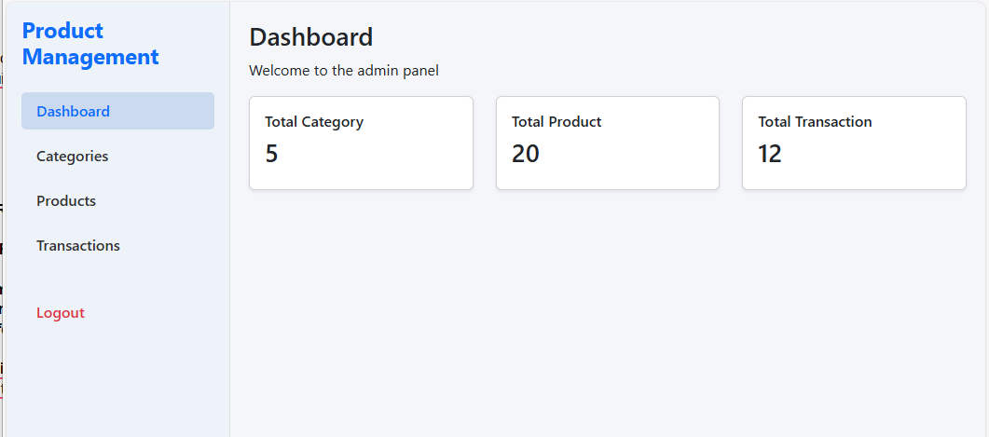

Instructions
- Save your REST Api in the directory called “SERVER_MODULE/backend” and save it in the repository folder.
- Save your front-end app in the directory called “SERVER_MODULE/frontend” and save it in the repository folder.
- When developing the Frontend, you can use/consume the provided REST API.
- You should build the frontend app to production mode and save the production files in the “SERVER_MODULE/frontend/build” folder before you push it to the github repository.
- Make sure the “/build” folder isn't written on the .gitgnore file.
- You should commit and push your changes to the github repository at least every 30 minutes.

Scoring Rubric
Phase | Parts | Score
Back-end | Database | 4
 | Authentication | 3
 | Category | 3
 | Product | 3
 | Transaction | 3
 | Back-end Code Quality | 4
Front-end | Authentication Implementation | 3
 | Category Management (CRUD UI) | 3
 | Product Management (CRUD UI) | 4
 | Transaction Management | 3
 | User Interface & User Experience (UI/UX) | 3
 | Frontend Code Quality | 4
Total |  | 40

