**New Changes**

1. Convert type further detail to multiple selection. All the multiple selection should be added in the setting and on page load dropdown should be loaded.  
   On selecting Laminectomy or any other option should load last saved data. Its currently working but will be changed when type further detail convert to multiseleced.  
   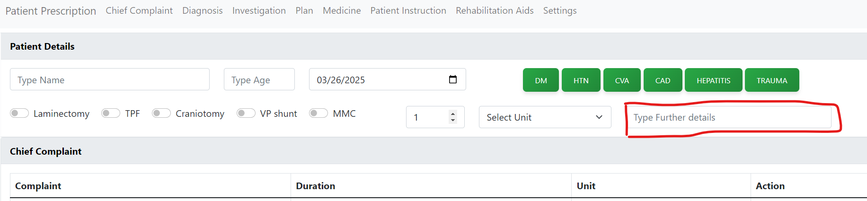  
     
   Same changes should be done for investigation More Details.  
   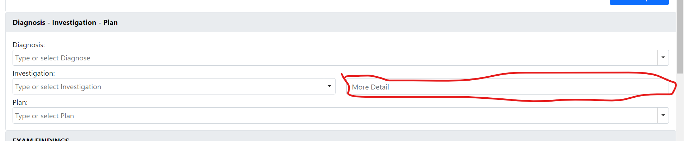
2. Need to change Date format to dd/mm/yyyy all over the application.
3. Move Exam Finding right after Patient Detail. The new order will be like  
   1. Patient Details  
   2. EXAM FINDINGS  
   3. Diagnosis - Investigation – Plan  
   4. Chief Complaint  
   5. Medicine  
   6. Rehabilitation Aids  
   7. Patient Instructions
4. Add default follow up duration in setting. Should be same as   
   Default Complaint Duration & Default Complaint Unit. 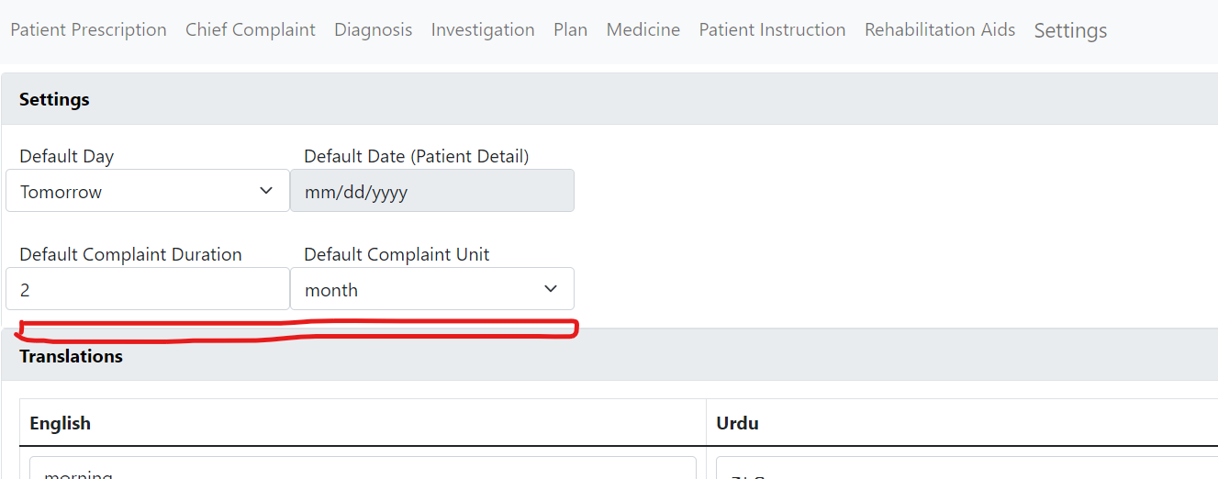  
   In follow up case it will be  
   Default Follow up Duration & Default Follow up Unit. And they will be shown before print button and should be editable too.  
   A screenshot of a computer

   AI-generated content may be incorrect.
5. Implement history for patient. (Need discussion)
6. Add these two New Dropdowns in EXAM FINDINGS.  
   FABER (Negative(Default),Positive)  
   Sphincter (INTACT(Default),,LOST)
7. Power UL and LL not showing correctly in the print. Should be shown like this  
   
8. Add Continue option in medicine duration as well  
   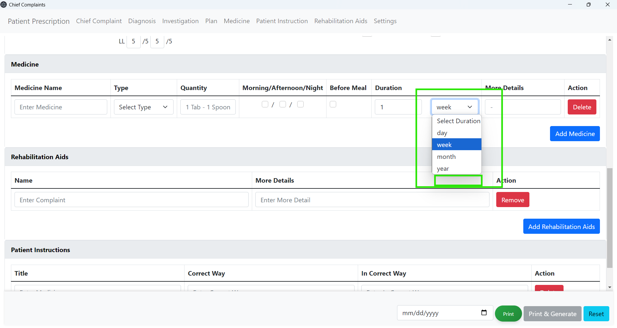
9. Remove Before Meal from overall application.
10. Move Rehab ad to the top in print.
11. More details should be shown under medicine name in the print.
12. If same medicine added in multiple time then it will shown one time but detail should be shown row by row.
13. If no Morning/Afternoon/Night selected then only more detail should be shown in the print.
14. If Type ING selected the need to show one more dropdown after Type that will contain two option (IV,IM).  
    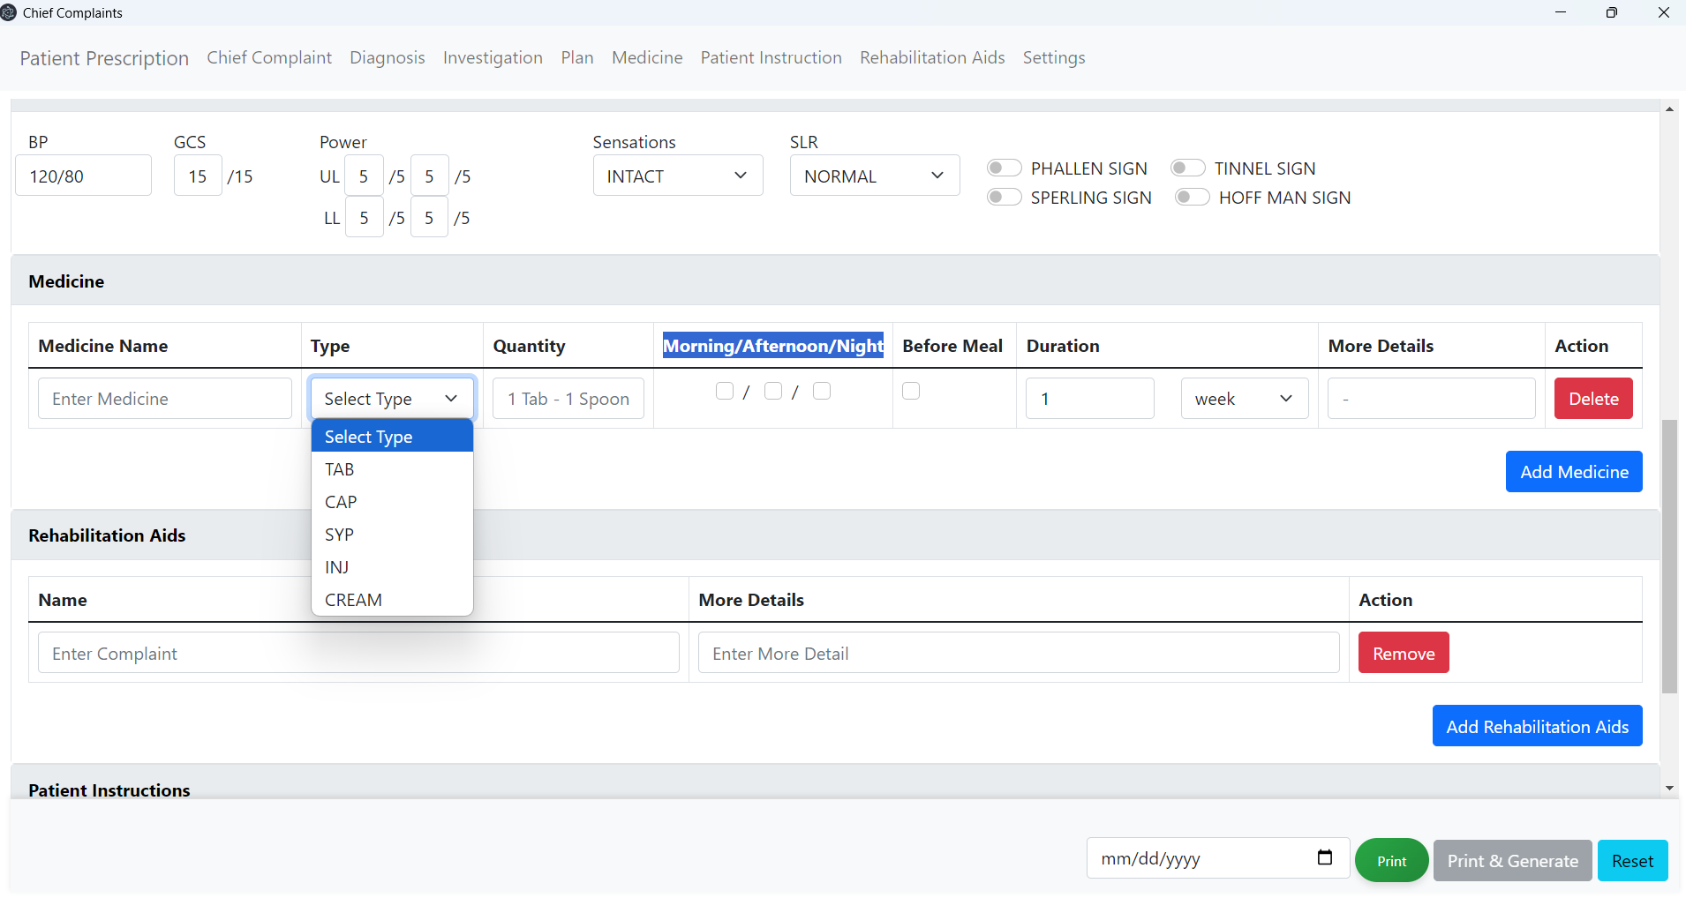
15. Add more options in medicine details.  
    DROPS  
    GEL  
    OINT  
    LOTION
16. Need to add print button   
    1. after investigation   
    2. after medicine type if type INJ selected   
    these buttons will be used to print data on thermal printer only.
17. On pressing Ctrl+P prescription should be print automatically and if Ctrl+I pressed only the investigation and INJ type medicine will be print on themal printer.
18. Add printable field while adding investigation and medicine. And they will not be shown in Ctrl+P print page.  
    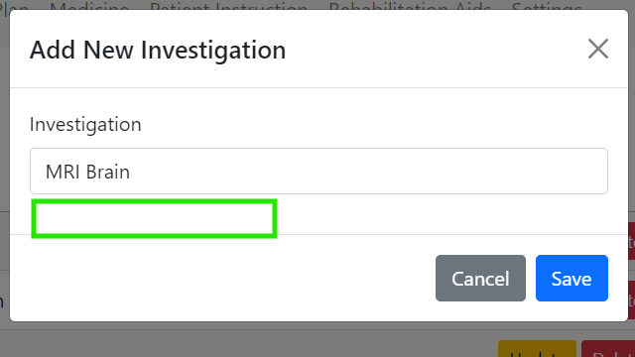  
      
    A screenshot of a computer

    AI-generated content may be incorrect.
19. Remove Correct way and incorrect way from overall application. And convert them with single Details fields.  
    A screenshot of a computer

    AI-generated content may be incorrect.
20. Need to attach Complaint, Investigation, Plan and Rehabilitation Aids with diagnoses just like we attached medicine and Patient Instructions  
    A screenshot of a computer

    AI-generated content may be incorrect.