Name – Muzahid Hussain
Emp_id – 90119769
LEVEL 1 SOLUTION
1. The two file-system problems are data redundancy and data inconsistency. The same customer address is stored in multiple places, so when the customer changes their address in only one file, different departments can have different versions of the same customer's data.
A database stores the customer address in a controlled, shared location so different departments can use the same data. Updates can therefore be made centrally, reducing duplication and preventing inconsistent copies.

2. a) Concurrency control :- Two ATMs could update the same account balance at the same time and produce an incorrect balance.
b) Transaction management :- During a transfer, money could be debited from one account but not credited to the other.
c) Data integrity constraints :- Invalid data, such as an account linked to a non-existent customer or a negative transaction amount, could enter the system.

3.
Formal relational term | Everyday term | ICICI Bank example
Relation | Table | customer table
Tuple | Row / record | One customer's record
Attribute | Column / field | customer_id
Degree | Number of columns | Number of columns in customer
Cardinality | Number of rows | Number of customers in customer

4. a) customer.customer_id – Primary Key
b) account.account_number – Candidate Key
c) account.customer_id – Foreign Key
d) account.balance - None
e) employee.manager_id – Foreign Key
f) branch.ifsc_code – None

5. a) A customer checks a balance on the ICICI mobile app. - OLTP
b) The risk team calculates non-performing loans by branch for the quarter. - OLAP
c) An ATM dispenses 10,000 rupees. - OLTP
d) A regulator asks for the total value of transactions above 200,000 in the last financial year. - OLAP
e) A teller opens a new savings account. - OLTP
f) Marketing finds the top 100 customers by average monthly balance. – OLAP

6. Running a quarterly regulatory report directly against the core banking Oracle database has several technical problems:
- Performance impact: A large analytical query can consume CPU, memory and I/O needed by real-time banking transactions.
- Concurrency: Reporting workloads running at the same time as operational transactions can increase contention and slow down customer-facing operations.
- Workload separation: OLTP and analytical workloads have different access patterns and should not compete for the same production resources.
Instead, I would offer a separate reporting/analytical system or replica/data warehouse populated from the operational database. This provides fresher data without putting the core banking workload at unnecessary risk.

7.
ACID property | Failure it prevents
Atomicity | d. Money is debited but never credited
Consistency | c. An account exists for a customer who does not
Isolation | b. Two ATMs both pay out against the same balance
Durability | a. A committed transfer disappears after a power cut

8. The write-ahead log (WAL) is written to disk before the actual data page so that the database has a durable record of the change before modifying the data page.
If the order were reversed and the server crashed after changing the data page but before recording the WAL entry, PostgreSQL might not have enough information to recover the change correctly. WAL therefore supports crash recovery and durability.

9. SELECT * FROM customer creates a dependency on the table's physical structure and therefore breaks logical data independence at the application level.
If the bank later adds a pan_number column, the query will start returning an additional column. Code that assumes a fixed number or order of columns may therefore break or behave incorrectly.

10. Oracle: Suitable for core banking/enterprise OLTP workloads where strong transaction management, reliability and enterprise database capabilities are required.
PostgreSQL: Suitable for applications and services requiring a powerful open-source relational database with strong SQL and transaction support.
MySQL: Suitable for applications where a widely used relational database with straightforward deployment and read-heavy workloads is appropriate.
Redis: Suitable for very fast in-memory use cases such as caching, temporary data, counters and session-related data.
LEVEL 2 SOLUTION

11. SELECT current_database() AS database_name,
current_user AS current_user,
inet_server_port() AS server_port;
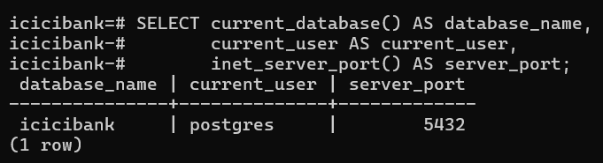

12. SELECT column_name, data_type, is_nullable
FROM information_schema.columns
WHERE table_schema = 'public'
AND table_name = 'loan'
ORDER BY ordinal_position;
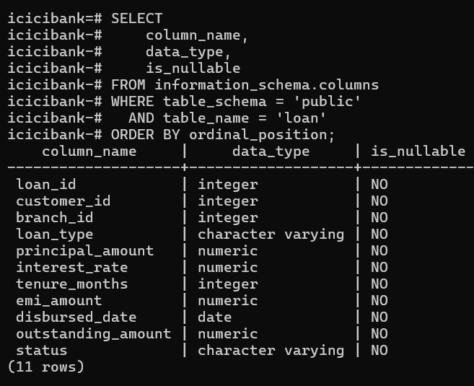

SELECT COUNT(*) AS column_count
FROM information_schema.columns
WHERE table_schema = 'public'
AND table_name = 'loan';
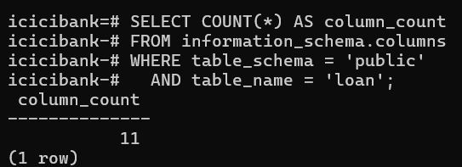

Number of columns in loan = 11
Degree of the loan relation = 11
13. SELECT 'account' AS table_name, COUNT(*) AS row_count FROM account
UNION ALL SELECT 'account_txn', COUNT(*) FROM account_txn
UNION ALL SELECT 'beneficiary', COUNT(*) FROM beneficiary
UNION ALL SELECT 'branch', COUNT(*) FROM branch
UNION ALL SELECT 'card', COUNT(*) FROM card
UNION ALL SELECT 'customer', COUNT(*) FROM customer
UNION ALL SELECT 'employee', COUNT(*) FROM employee
UNION ALL SELECT 'loan', COUNT(*) FROM loan
UNION ALL SELECT 'loan_payment', COUNT(*) FROM loan_payment
ORDER BY table_name;
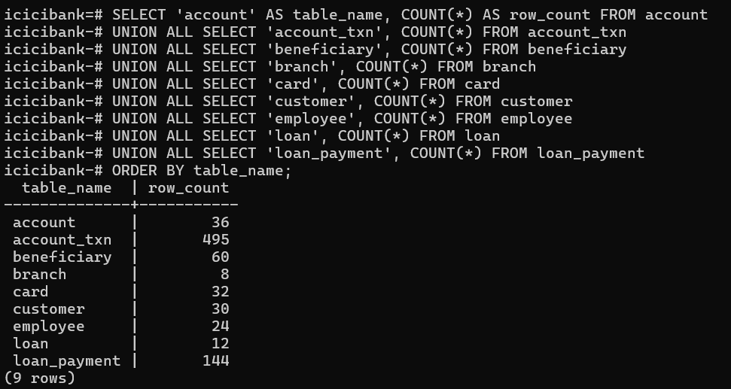

14. SELECT tc.table_name AS child_table, kcu.column_name AS child_column,
ccu.table_name AS parent_table, ccu.column_name AS parent_column
FROM information_schema.table_constraints tc
JOIN information_schema.key_column_usage kcu ON tc.constraint_name = kcu.constraint_name
JOIN information_schema.constraint_column_usage ccu ON ccu.constraint_name = tc.constraint_name
WHERE tc.constraint_type = 'FOREIGN KEY' ORDER BY tc.table_name, kcu.column_name;
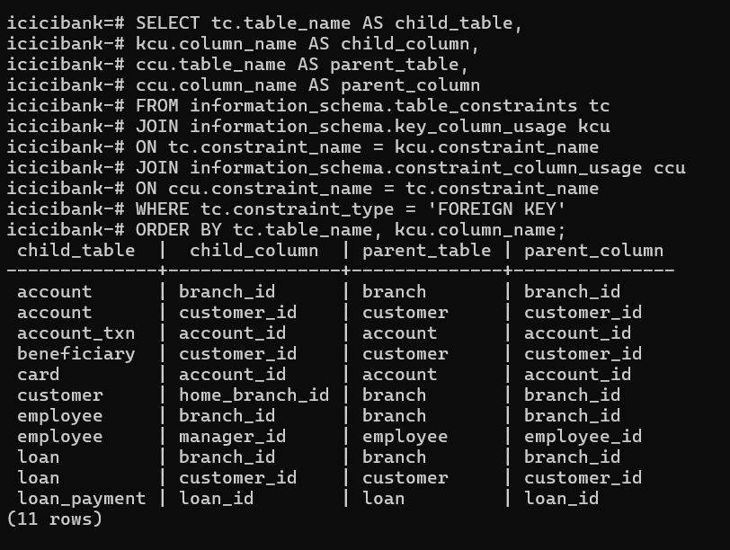
The employee table has a self-referencing foreign key, where manager_id refers to another employee’s employee_id
It represents the employee–manager hierarchy, showing which employee reports to which manager within the bank.
15. SELECT relname AS table_name,pg_size_pretty(pg_total_relation_size(relid)) AS total_size
FROM pg_catalog.pg_statio_user_tablesORDER BY pg_total_relation_size(relid) DESC LIMIT 3;
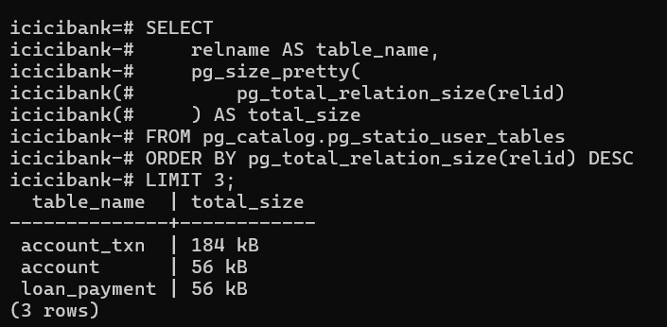
account_txn records individual account transactions. A single account can have many transactions, so transaction records accumulate much faster than relatively static entities such as customers, branches or accounts.
16. INSERT INTO customer
(customer_id, first_name, last_name, date_of_birth, email, phone,
city, kyc_status, risk_rating, customer_since, home_branch_id)
VALUES
(1032, 'Latha', 'Krishnan', DATE '1985-09-23', 'latha.krishnan@example.com',
'9845099887', 'Chennai', 'VERIFIED', 'MEDIUM', DATE '2026-03-01', 5);
INSERT INTO account
(account_id, account_number, customer_id, branch_id, account_type,
balance, currency, status, opened_date, interest_rate)
VALUES
(9047, 'ICIC0000009047', 1032, 5, 'CURRENT',
500000.00, 'INR', 'ACTIVE', DATE '2026-03-01', 0.00);
SELECT c.customer_id, c.first_name, c.last_name, a.account_number,
a.account_type, a.balance
FROM customer c JOIN account a ON a.customer_id = c.customer_id
WHERE c.customer_id = 1032;
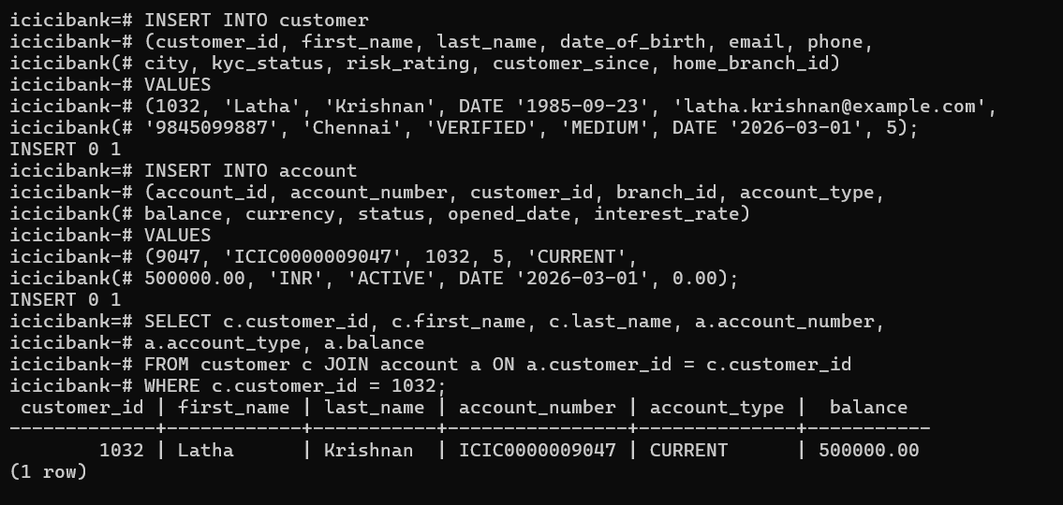

17. UPDATE account SET balance = balance + 75000 WHERE account_id = 9047;
UPDATE account SET balance = balance - 20000 WHERE account_id = 9047;
SELECT account_number, balance FROM account WHERE account_id = 9047;
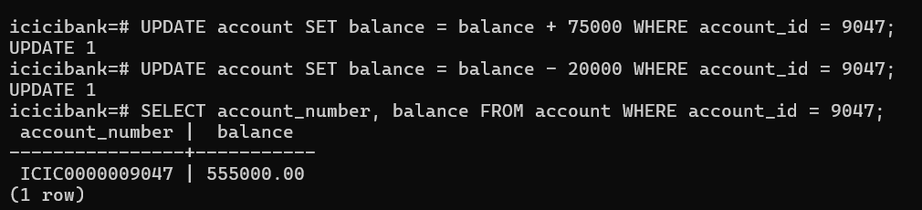

18. DELETE FROM customer WHERE customer_id = 1032;

DELETE FROM account WHERE account_id = 9047;
DELETE FROM customer WHERE customer_id = 1032;
SELECT (SELECT COUNT(*) FROM customer) AS customers,
(SELECT COUNT(*) FROM account) AS accounts;
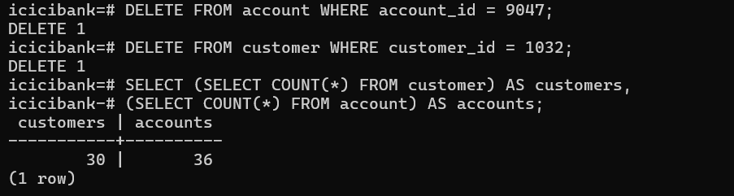
19.
1. An account whose account_type is FIXED.
INSERT INTO account
(account_id, account_number, customer_id, branch_id, account_type,
balance, currency, status, opened_date, interest_rate)
VALUES (9099, 'ICIC0000009099', 1001, 1, 'FIXED', 1000, 'INR', 'ACTIVE',DATE '2026-03-01', 0);
2. A transaction whose amount is -5000.
INSERT INTO account_txn
(txn_id, account_id, txn_date, txn_type, amount, channel, narration, status, reference_no)
VALUES (999998, 9001, TIMESTAMP '2026-03-01 10:00:00', 'DEBIT', -5000,
'ATM', 'test', 'SUCCESS', 'REF999998');
3. A customer whose kyc_status is IN_PROGRESS.
INSERT INTO customer
(customer_id, first_name, last_name, date_of_birth, email, phone,
city, kyc_status, risk_rating, customer_since, home_branch_id)
VALUES (1033, 'Test', 'User', DATE '1990-01-01', 'test.user@example.com',
'9800000000', 'Pune', 'IN_PROGRESS', 'LOW', DATE '2026-03-01', 7);

20. BEGIN;
UPDATE account SET balance = balance - 5000 WHERE account_id = 9002;
SELECT account_id, balance FROM account WHERE account_id = 9002;
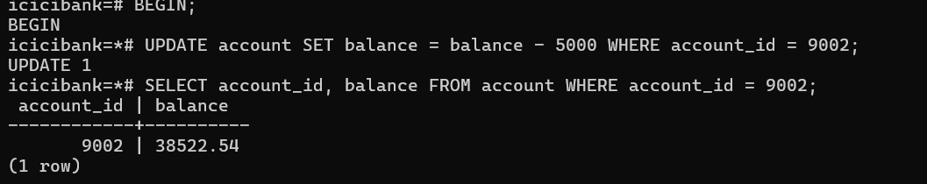
SELECT account_id, balance FROM account WHERE account_id = 9002;
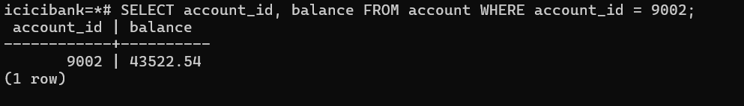
ROLLBACK;
21. SELECT account_id, balance FROM account WHERE account_id IN (9004, 9010);
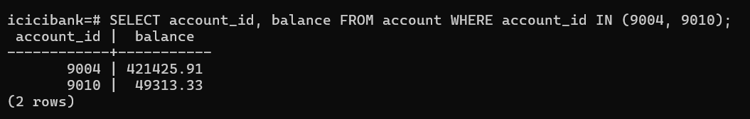
BEGIN;
UPDATE account SET balance = balance - 12000 WHERE account_id = 9004;
UPDATE account SET balance = balance + 12000 WHERE account_id = 9010;
SELECT account_id, balance FROM account WHERE account_id IN (9004, 9010);
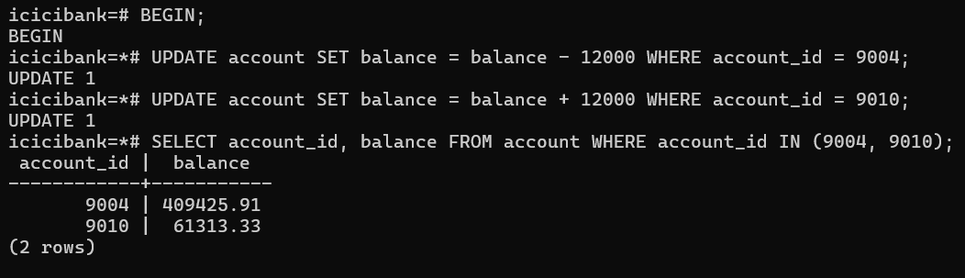
ROLLBACK;
SELECT account_id, balance FROM account WHERE account_id IN (9004, 9010);
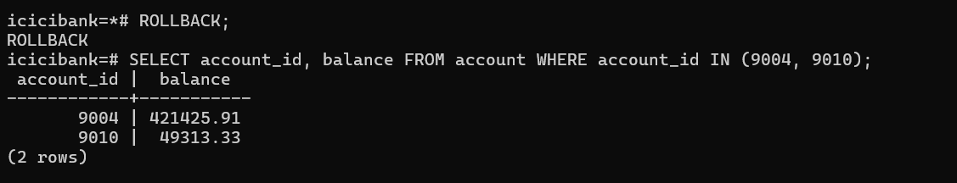
22. SHOW shared_buffers;
SHOW work_mem;
SHOW wal_level;
SHOW fsync;
