PROJECT REPORT: DIGITAL LOCK SYSTEM
Smart Access Control with Environmental Automation and Intrusion Detection

Course: Digital Logic Design (DLD)
By: Muzamil Ahmed Bhayo
Department: Artificial Intelligence

1. Executive Summary & Project Context
In modern residential and commercial architectures, smart security and building automation are increasingly interlinked. This project presents the design and logic simulation of an integrated Digital Lock System. The system combines secure access control using sequential and combinational logic circuits with environmental controls (lighting and climate automation) and a multi-tiered safety alarm network. Built primarily using core digital elements including XNOR comparators, JK flip-flops, and elementary logic gates, this system provides a robust blueprint for an autonomous, tamper-resistant property access controller.

2. Operational Scenario & System Specifications
The system operates according to a highly specific state-driven and conditional framework, simulating real-world security behavior. The operational details are categorized into three main distinct subsystems:

2.1 Access Control Subsystem
• Binary PIN Authentication: To unlock the door and enter the room, the user must input a 5-digit binary PIN code. This input is matched against a pre-stored 5-bit reference key.
• Status Indicators: Entering the correct code immediately unlocks the door and activates a 'CORRECT' visual indicator. If an incorrect code is entered, an 'Incorrect' visual indicator is illuminated.
• Sequential Retry Counter: The system tracks consecutive failed attempts using a synchronous digital counter. If an incorrect PIN is entered 3 times sequentially, an intrusion alarm is triggered and the property owner is alerted. Entering a correct PIN before reaching the 3-try threshold resets the counter instantly to zero.

2.2 Environmental Automation Subsystem
• Occupancy-Based Lighting: An integrated motion detector monitors the room's interior. Upon successful entry (door unlocked), if any movement is detected, a 'Light Bulb' is automatically switched on.
• Climate Control (AC) Regulation: Concurrently with motion detection, the system queries an internal temperature sensor. If the ambient room temperature is registered as high, an 'Air Conditioner (AC)' unit is activated to cool down the space.

2.3 Perimeter Intrusion Subsystem
• Anti-Tamper / Tailgating Guard: A critical secondary security loop runs constantly. If the door lock remains unchecked or locked, but the internal motion detector senses movement inside the room (implying an intruder entered through a window or tailgated), the primary audible 'Alarm' is instantly triggered and a notification is dispatched to the owner.
Design Constraint Highlights:
1. All PIN validation is strictly performed in the binary domain using a 5-bit parallel interface.
2. The system state is state-dependent, resetting security parameters gracefully upon authentic access.
3. Perimeter breach overrides standard environmental checking logic to prioritize threat containment.

3. Engineering Problem Breakdown & Design Strategy
To implement this comprehensive automation matrix, the design process was sub-divided into five distinct, modular steps, enabling isolated verification of each circuit before full-scale system integration:
▪ Step 1: Password/PIN-Checking Core: Develop a 5-bit parallel magnitude comparator that contrasts the active user input bits with the pre-stored key bits and generates a high output only upon a flawless match.
▪ Step 2: Sequential Failure Tracker: Construct a digital counter capable of counting from 0 up to 3 (binary 11). This module handles edge-triggered clock pulses generated by incorrect inputs and features an asynchronous master reset link.
▪ Step 3: Multi-Input Alarm Controller: Synthesize combinational logic to actuate an alarm based on two independent hazard vectors: three sequential authentication failures or an anomalous internal motion detection signature.
▪ Step 4: Conditional Actuator Interface: Design logical interlocking paths for the environmental appliances (Light and AC) so that they respond exclusively when valid occupancy is established under specific environmental thresholds.
▪ Step 5: Full System Synthesis: Merge the independent modules into a cohesive, synchronized schematic, routing inter-module signals accurately to avoid racing conditions or feedback loops.

4. Logic Gate Implementation & Implementation Methodology
Each functional requirement maps to specific digital components and standard Boolean logic functions, as detailed below:

4.1 5-Digit PIN Comparison (Step 1)
Bit-wise equivalence checking is achieved using Exclusive-NOR (XNOR) logic gates. An XNOR gate outputs a logic high (1) if and only if its two inputs are identical. Let the input bits be P0-P4 and the stored reference bits be S0-S4. The equivalence for each bit position i is given by:
E_i = P_i ⊙ S_i (for i = 0 to 4)
The outputs of all five XNOR gates are fed into a single 5-input AND gate (U16). The output of this AND gate represents a perfect PIN match (VALID = 1). If even a single bit deviates, the AND gate outputs a logic low (VALID = 0).

4.2 Failure Counter & Sequential Control (Step 2)
The failure counter must record up to three invalid attempts. This is implemented using a 2-bit synchronous counter constructed with two JK Flip-Flops (U21 and U22). A 2-Hz clock signal provides a steady periodic pulse, gated by the PIN-checking status. When an incorrect code is submitted, a clock pulse shifts the counter state forward (00 -> 01 -> 10 -> 11). A 7-segment Hexadecimal Decoder (DCD_HEX) is attached to the flip-flop outputs to provide a real-time visual display of the failed attempts count. If a correct PIN is provided, the VALID signal triggers the asynchronous RESET pins on both flip-flops, instantly flashing the counter back to 0.

4.3 Integrated Alarm Logic (Step 3)
The audible alarm and owner alert signal (X3) are driven by a composite combinational network. The alarm triggers under two conditions: either the counter reaches its terminal state of 3 (binary 11, indicating Q1 and Q0 are both high) OR an intrusion is detected (motion present when the door is not validated). The simplified Boolean expression is:
Alarm (X3) = (Q_1 • Q_0) + (VALID' • Motion)

4.4 Environmental Actuator Activation (Step 4)
The Light Bulb (X4) and Air Conditioner (X5) are driven conditionally by standard AND gates to preserve energy and ensure operational safety. The activation formulas are defined as follows:
Light Bulb (X4) = VALID • Motion
Air Conditioner (X5) = VALID • Motion • Temperature_High

5. Bill of Materials & Component List
The complete digital circuit schematic requires the following list of discrete logic components, integrated circuits, and visualization probes:
Component Identifier | Quantity | Description / IC Equivalent | Functional Role in Circuit
XNOR_2 | 5 | 2-Input Exclusive-NOR Gate | Performs parallel bit-wise matching between user input and pre-stored PIN digits.
AND_5 | 1 | 5-Input Standard AND Gate | Aggregates bit matches; yields high output only when all 5 bits are fully synchronized.
AND_2 / AND_3 | 6 | 2-Input & 3-Input AND Gates | Handles conditional environmental triggering and sequential clock gating circuits.
NOT | 4 | Standard Logic Inverter | Generates active-low signals for the incorrect PIN indicators and control logic lines.
JK_FF | 2 | Edge-Triggered JK Flip-Flop | Serves as the basic memory units to assemble the 2-bit failed attempts counter.
Prob_Light | 5 | Visual Output Probe Lights | Provides user feedback (CORRECT [X1], Incorrect [X2], Alarm [X4], Light [X4], AC [X5]).
DCD_HEX | 1 | 7-Segment Hexadecimal Decoder | Provides a real-time digital numeric display of the current incorrect tries counter.

6. Circuit Simulation & Operational Verification
The digital logic schematic was modeled and rigorously tested under various potential scenario vectors. Below are the functional analyses of the primary states with integrated circuit simulations.

6.1 Scenario A: Authenticated Access & Environmental Activation
When the 5-digit user input perfectly matches the pre-saved pattern, the 5-input AND gate (U16) goes HIGH. This triggers the following events:
1. The 'CORRECT' indicator (X1) illuminates immediately, indicating a successful door unlock state.
2. The high signal acts on the asynchronous reset lines of the JK Flip-Flops, resetting the failure count to 0.
3. If the internal motion sensor is activated (switched to 1), the interior 'Light Bulb' (X4) turns on. If the temperature sensor is concurrently toggled high, the 'Air Conditioner' (X5) activates instantly.
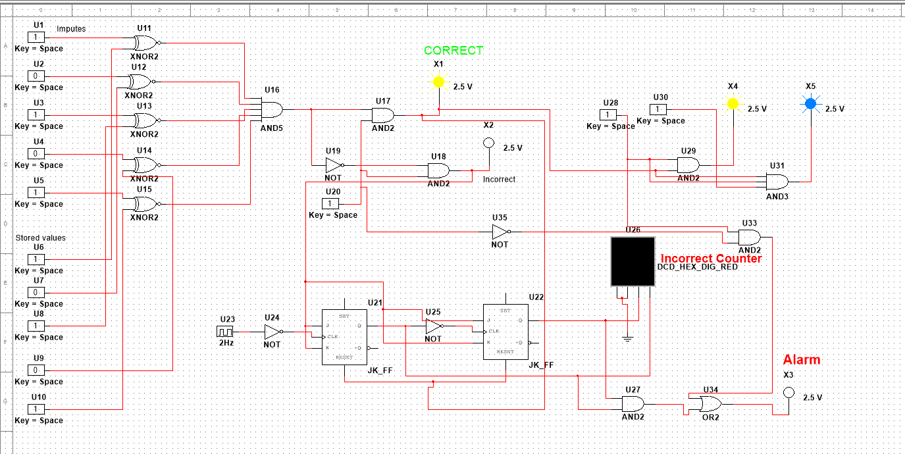
Figure 1: Simulation Schematic for Correct PIN & Active Actuators

6.2 Scenario B: Authentication Failure & Threat Containment
When a mismatched PIN is entered, the validation chain goes LOW. This prompts the 'Incorrect' probe (X2) to glow blue. Furthermore, entering an incorrect key 3 times sequentially routes clock pulses to the counter, raising the state to '3' on the 7-segment display. This triggers the perimeter alarm network:
1. The 'Alarm' indicator (X3) turns bright orange/red, signaling an active lock-out state and owner notification.
2. Environmental appliances (Light and AC) are entirely disabled or locked out, as the validation line remains low, isolating the room's electrical infrastructure.
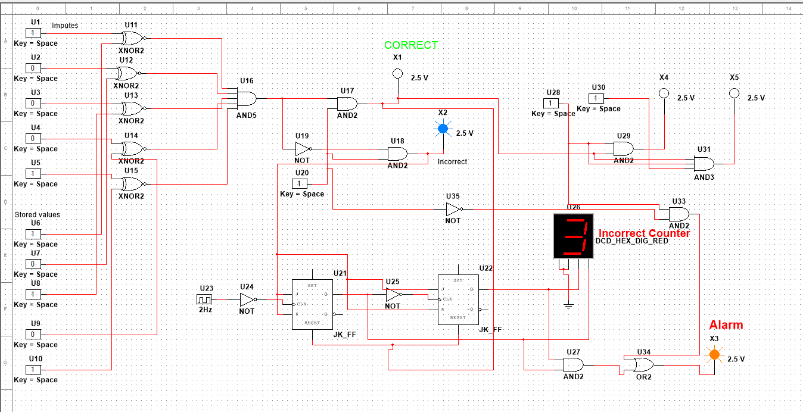
Figure 2: Simulation Schematic for Incorrect PIN Attempts Counter & Main Alarm Triggered

7. Conclusion & Future Recommendations
The Digital Lock System project successfully demonstrates how foundational combinational and sequential digital building blocks can solve multi-variable real-world engineering issues. By isolating logic paths for authorization, numerical tracking, and climate interlocking, the design maintains solid fault isolation. Future revisions could enhance this system by incorporating non-volatile EEPROM memory for dynamic PIN updating, implementing an automatic cool-down period after a lockout event, and integrating a serial communication interface (such as SPI or I2C) to relay granular system data to an overarching IoT micro-controller framework.

