**Library Management System**

**Flow of program:**

After registeration If registered

If not registered

The End

**Database connection provider:**

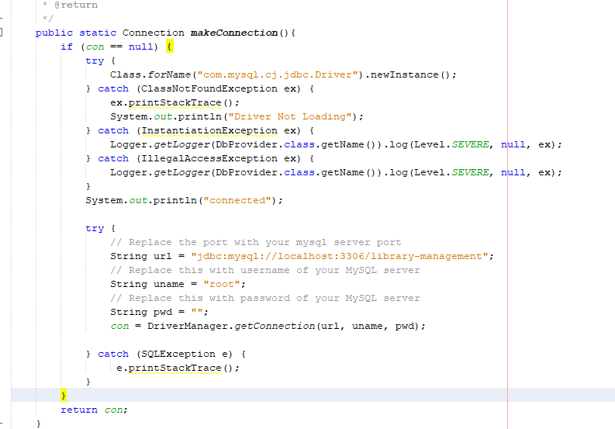

Db provider class is designed in a way so we could get the same database connection reference at any time throughout the system. It uses the Singleton Design pattern.

**Book class:**

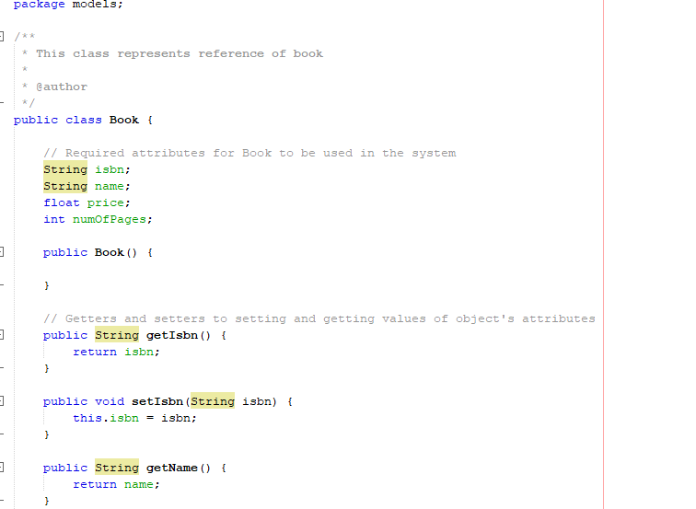

This model class is designed to refer a book with object with required attributes.

**Reader class:**

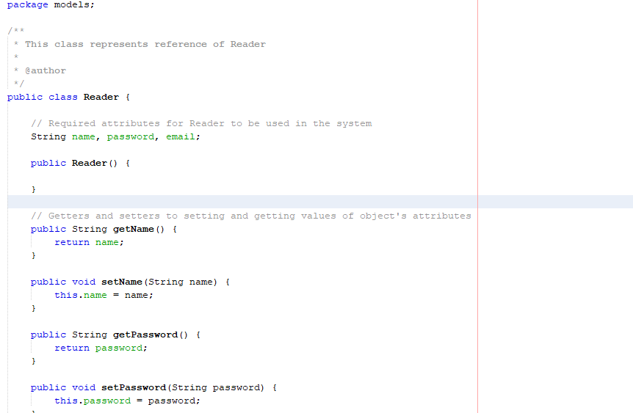

**Login Form:**

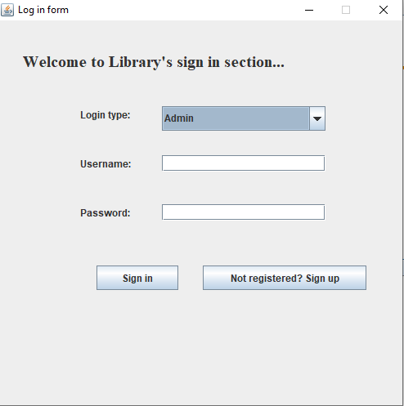

**Sign Up form:**

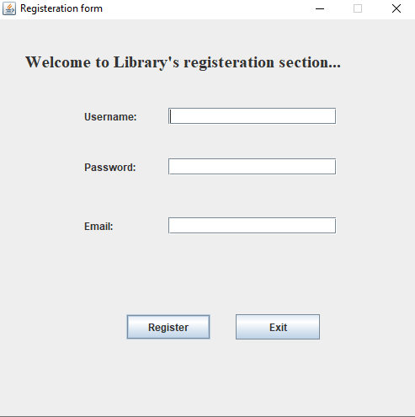

**Admin Dashboard:**

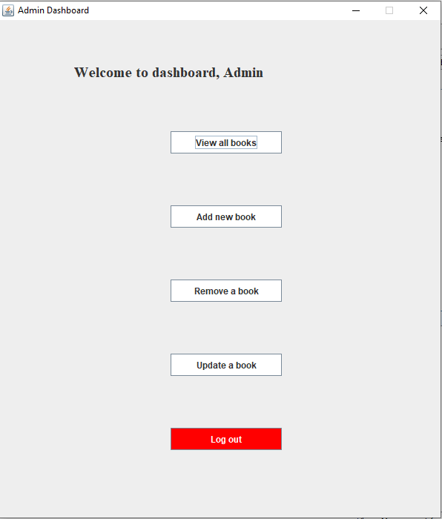

**Readers Dashboard:**

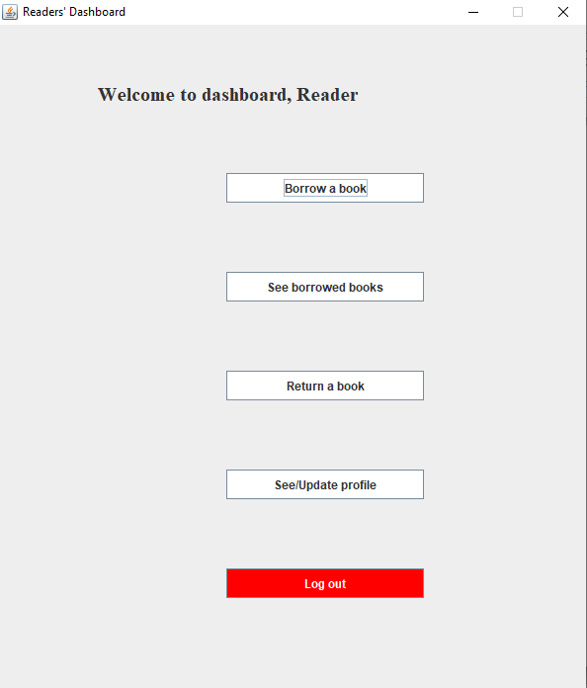

**Borrow a book:**

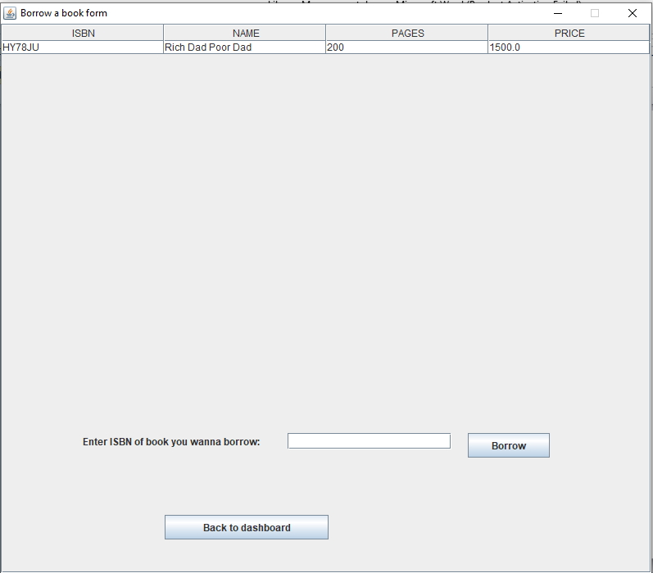

**See borrowed books:**

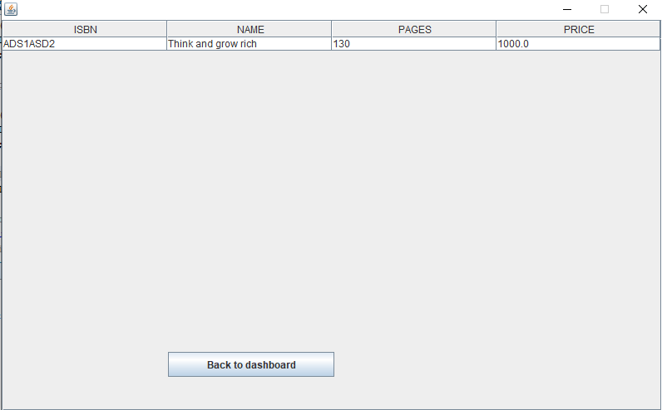

**Return a book:**

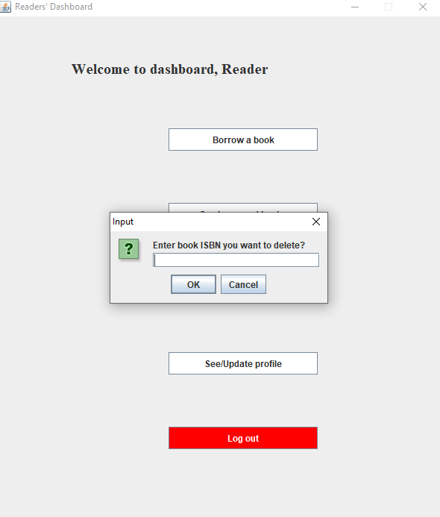

**See/Update profile:**

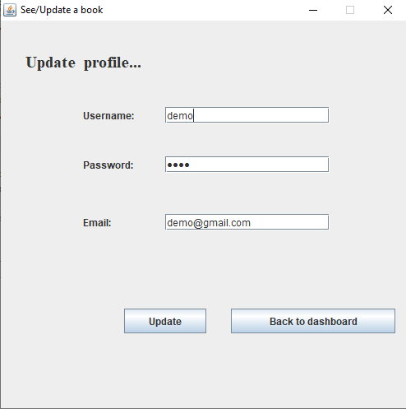

**View all books as ADMIN:**

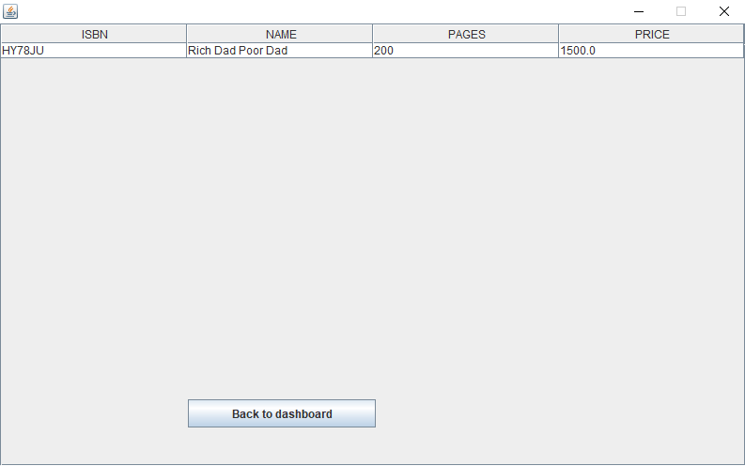

**Add new book as ADMIN:**

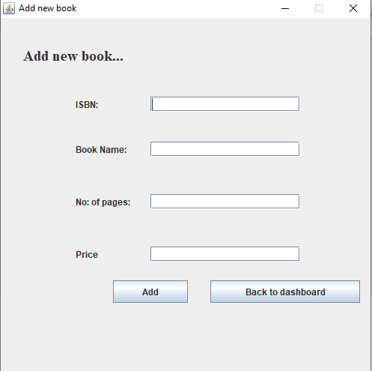

**Update a book as ADMIN:**

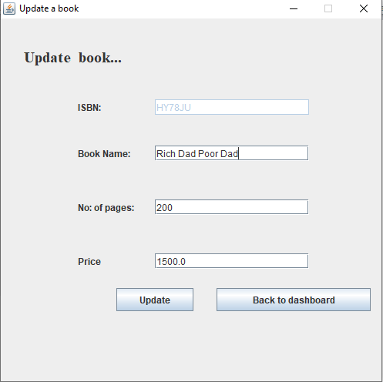

**Remove a book as ADMIN:**

