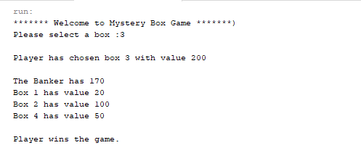

In above picture player chooses box 3 which has 200 in it, so according to calculation player have more amount than banker so , Player wins the game.

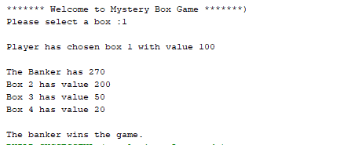

In above picture player chooses box 1 which has 100 in it, so according to calculation player have less amount than banker so , The banker wins the game.



In above picture player enters 6 so according to instruction given if player enters any numbers greater than 4 he will be awarded with box 4 which has 20 in it, so according to calculation player have less amount than banker so , The banker wins the game.

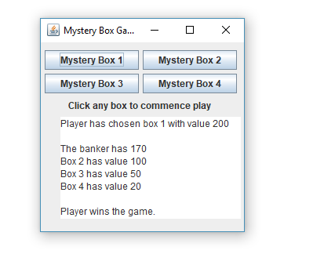

In above picture player clicks box 1 which has 200 in it, so according to calculation player have more amount than banker so , The player wins the game.

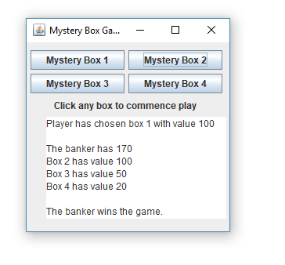

In above picture player clicks box 2 which has 100 in it, so according to calculation player have less amount than banker so , The banker wins the game.

**Note: As you can notice in both CLI and GUI based modes every box has different values and every time game runs again all boxes are awarder with different values.**