Image processing system with real time Camera image acquisition

Introduction

The goal of this specification is to describe a system which will perform multiple image processing techniques in a switchable manner where a user would be able to control which frame undergoes which particular processing. The start would be from two types of processing edge detection and blurring and afterwards will be expanded to more processing techniques.

The platform to execute such an image processing system would be Zynq7000 and board chosen is CoraZ7.

System Block Diagram
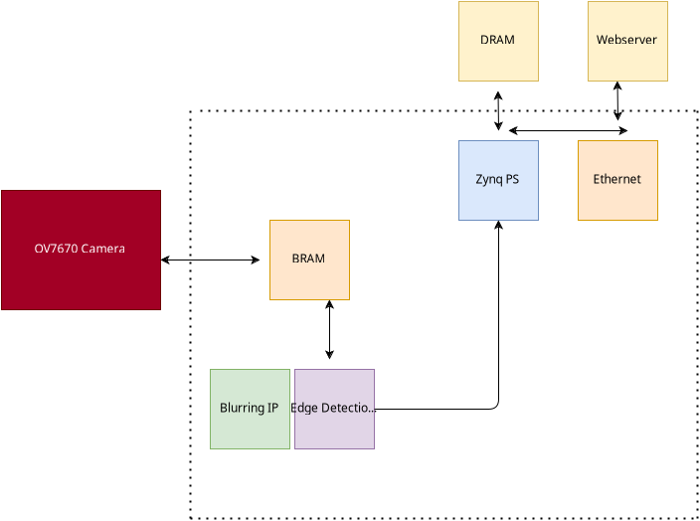

Design Methodology
The Design will consist of several IP blocks including from Xilinx and custom ones. The camera output will be fed to the Block Ram inside the FPGA where BRAM will store the pixels and lines of the frame temporarily. The temporary buffering inside the BRAM will prevent loss of image data, The lines of the frame will be read from the BRAM and streamed to the edge detection IP. Edge detection IP will perform edge detection of the full frame and store the frame in the DRAM on the CoraZ7 board and subsequently streamed to the monitor via PMOD VGA connection.

OV7670
The ov7670 camera produces 16 bits of RGB565 pixel data which needs to be converted to grayscale and then processed further. Each byte is generated per Pixel clock PCLK. After 2 PCLKs one RGB565 is generated.

The timing signals HSYNC VSYNC must also be handled in parallel to 8 bit pixel data from OV7670 since camera output comes in 2 bytes HSYNC and VSYNC indicate a valid line and frame of the image

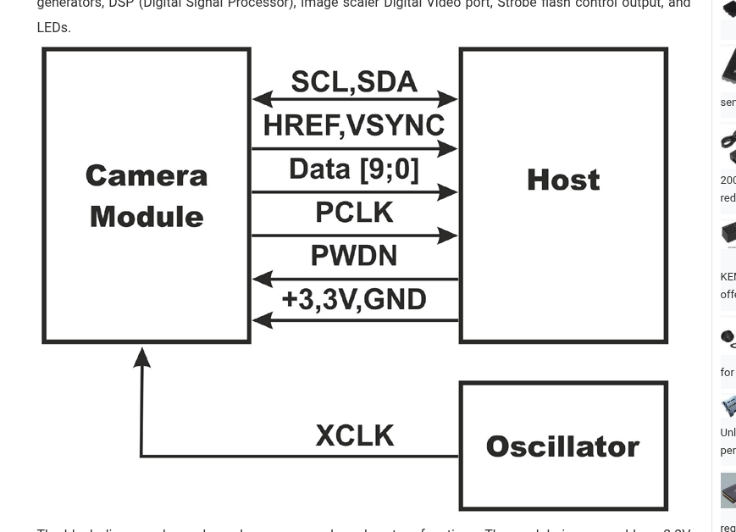
The

The camera must be supplied external XCLK potentially coming from Coraz7 for it to generate correct image data with pixel clock (PCLK)

SCCB interface
The OV7670 has several registers inside which can be configured via SCCB/I2C interface, In order to configure the camera to produce RGB data, Register COM7 must be programmed with correct value
The Zynq PS has I2C controller which will be used to configure camera registers, I2C pins of OV7670 can be directly connected to MIO pins connected to Zynq PS

Image Acquistion and GrayScale Conversion

Generate pixel_valid signal:
pixel_valid = (VSYNC == 0) && (HSYNC == 1) && (byte_pair_ready == 1)
(means frame active, line active, and full pixel data assembled)
- Address counter:
Increment by 1 only when pixel_valid is high (write enable active)
Reset to 0 on VSYNC falling edge (start of frame)

