7. Modify the employee class to have the PostProcessor implemented and demonstrate the postprocessor concept.

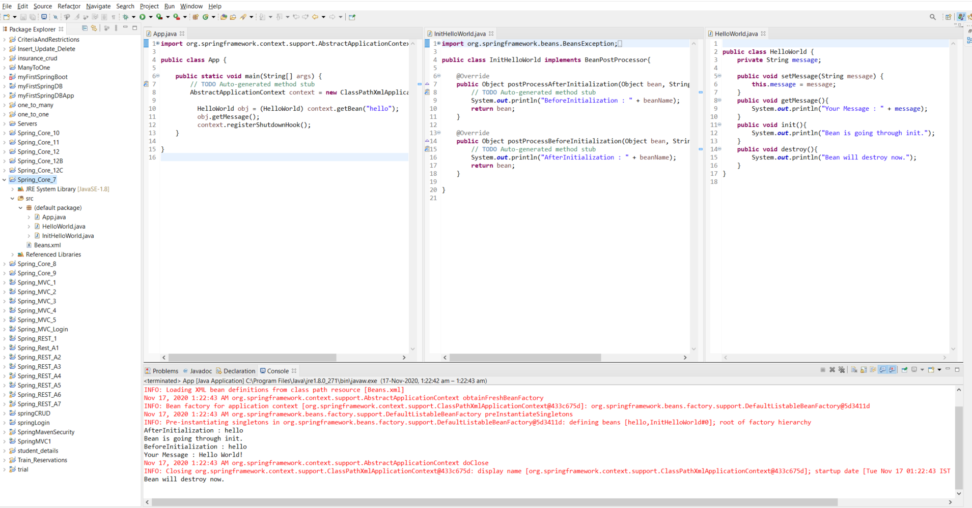

8. Inheritance : Define a car class with the attributes. Define BMW car and Mercedez car with the attributes. Let both cars BMW and Mercedez have a function display_Features(). This function will display the features of the car. Let the car be the base class for both BMW and Mercedez. Car class has basic attributes of the car like name, cost. basic_features (String). Create all the objects of the class and initialize them the data. Obtain the base class data and display in the derived class.

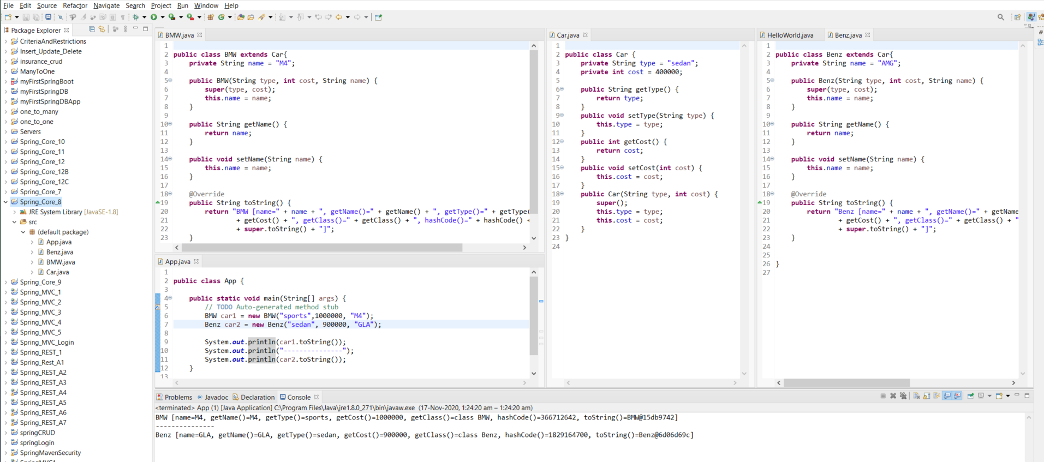

9. Create two classes named System and Processor with appropriate attributes. Processor object is injected using Setter method of Dependency Injection. Have a display() to display complete parameters of the system along with the Processor details.

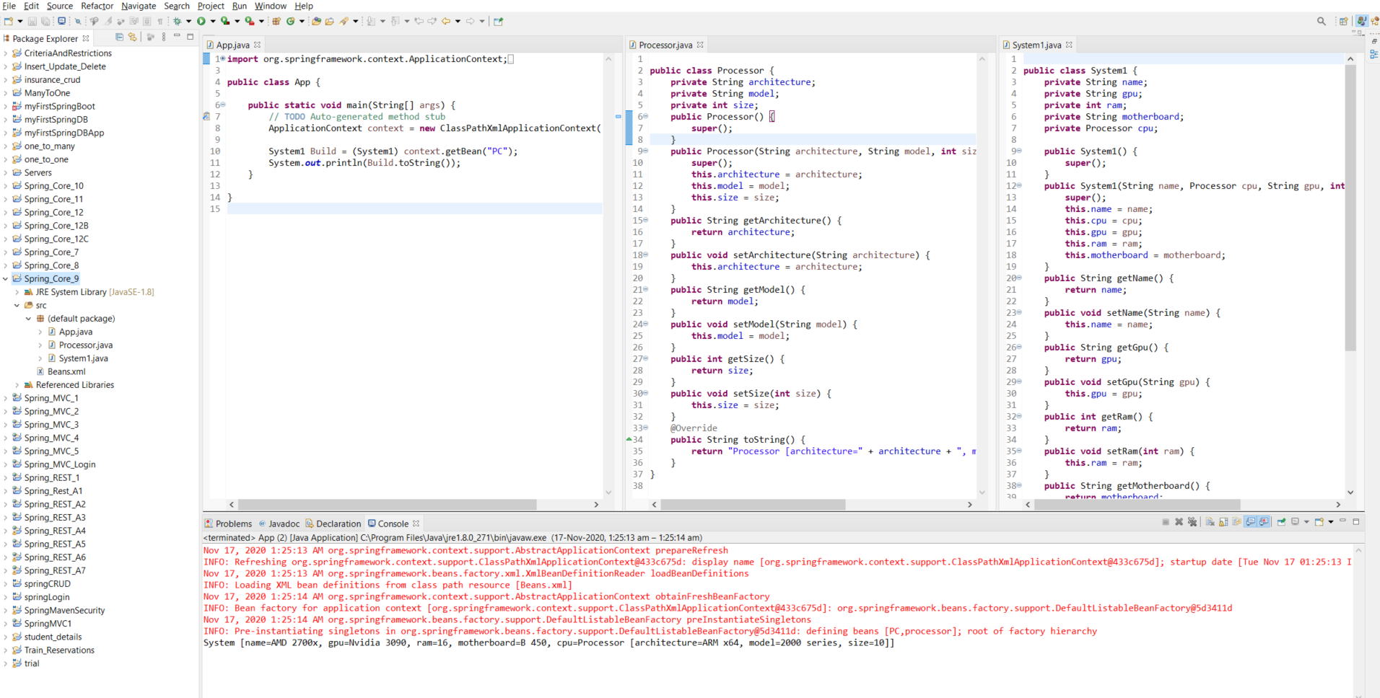

10. Modify the above program for Depedency Injection constructor based and see the output.

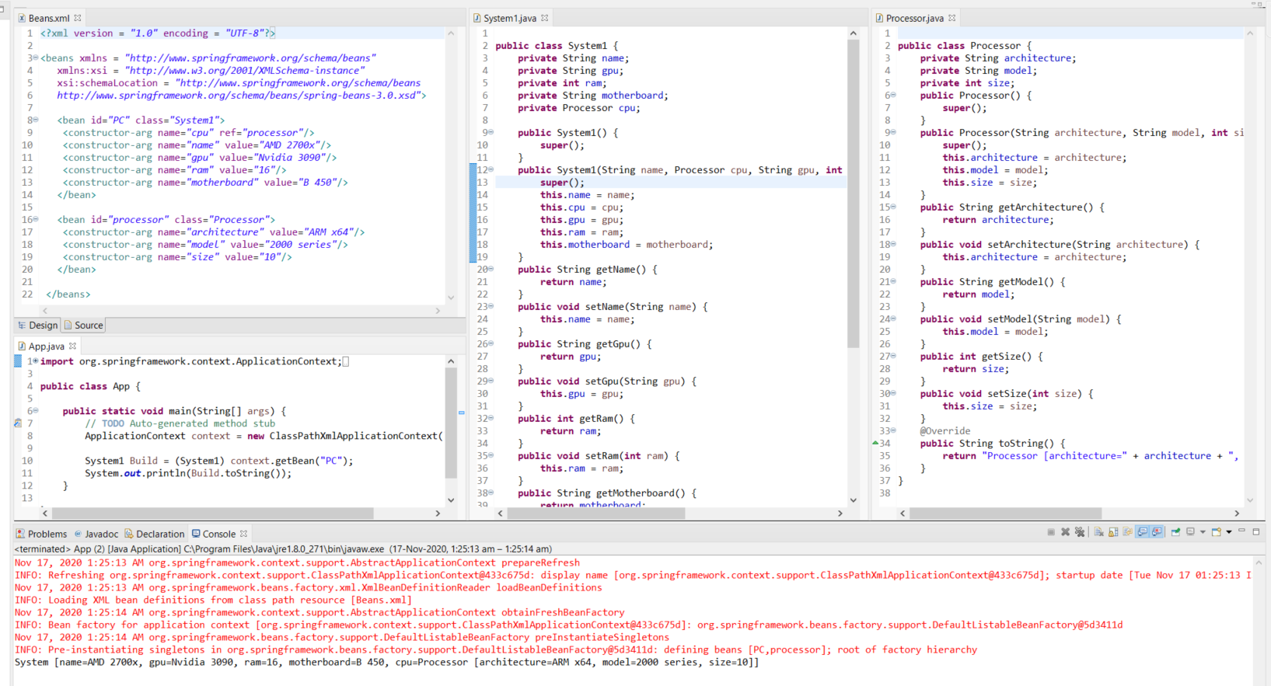

11. Modify the above program using @Autowired and see the output.

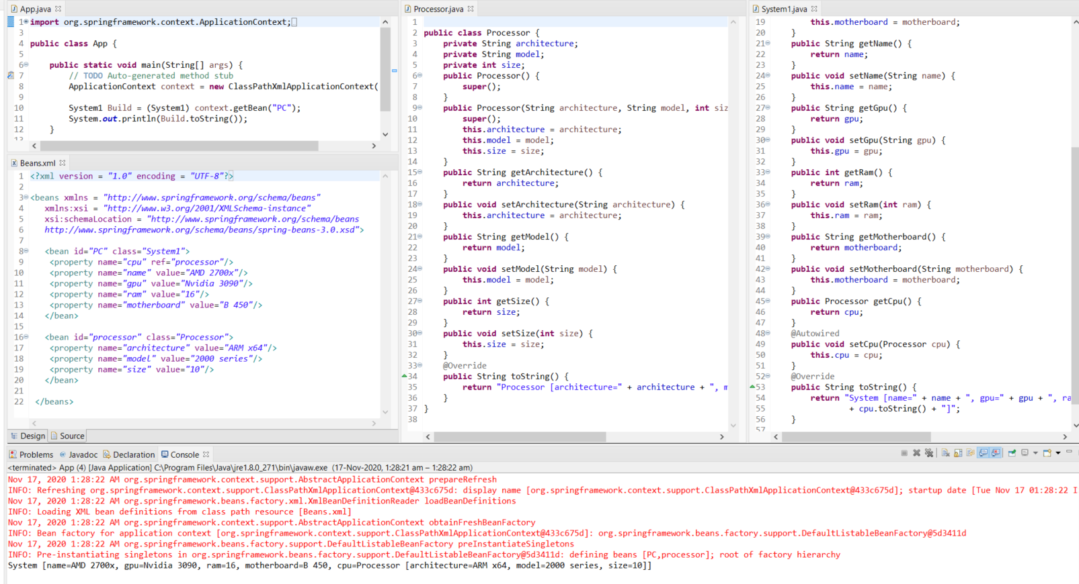

13. Demonstrate AOP using advices.

AfterAdvice:

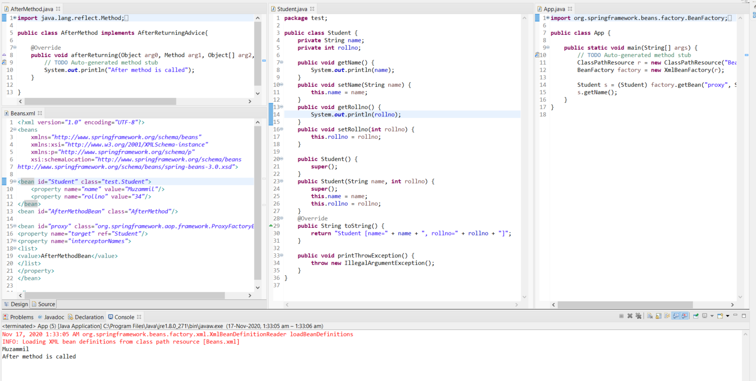

Around:

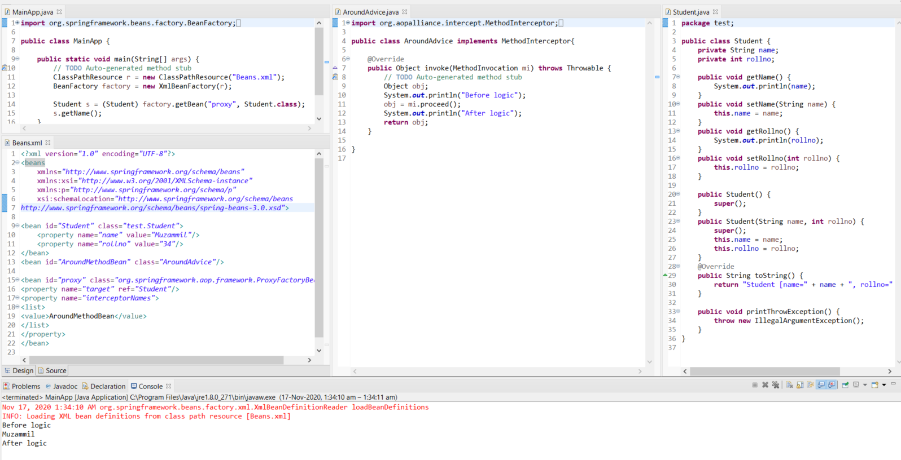

Throw Exception:

