Building an Airflow ETL Pipeline
MLOps Assignment 3
Name: Muzammil Aleem Student ID: 23L-0673
GitHub link:

Objective
I created a daily ETL pipeline using Airflow and Astro CLI. It gets EUR exchange rates for USD, GBP and JPY from the Frankfurter API and saves the transformed data in MongoDB.

Project setup
I initialized the project using astro dev init and started it using astro dev start.
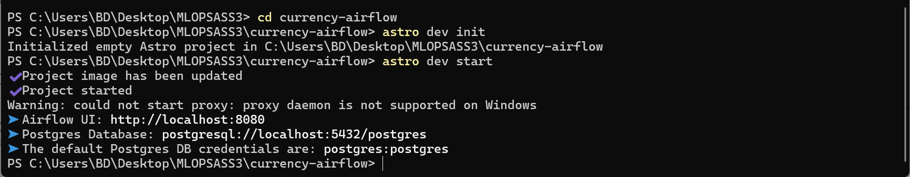
Figure 1. Starting the Astro project.
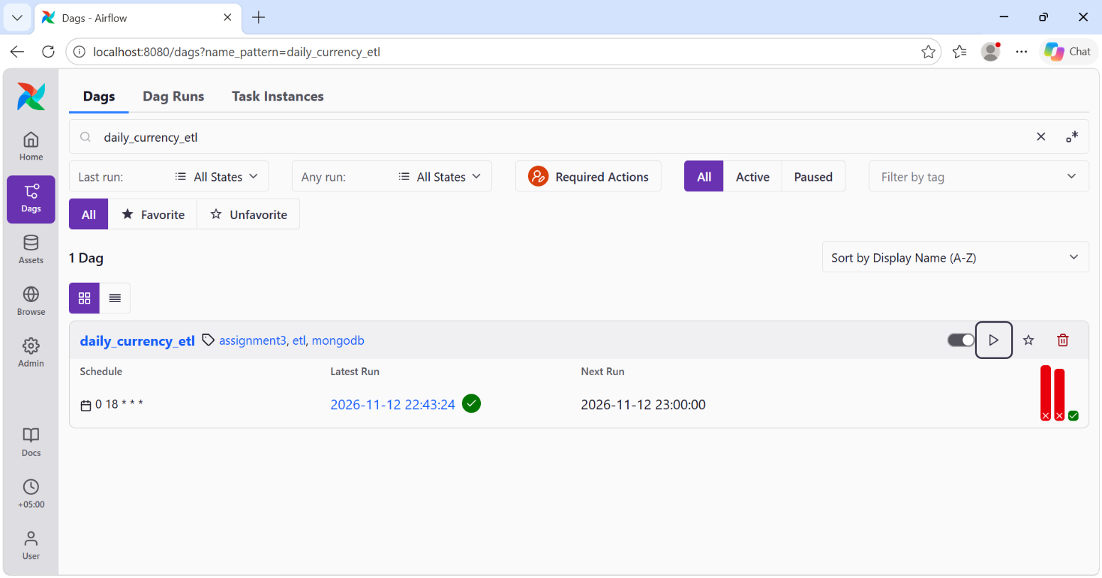
Figure 2. The currency DAG in Airflow.

Successful DAG run
The DAG has three tasks: extract_currency_rates, transform_exchange_rates and load_to_mongodb. All three tasks completed successfully.
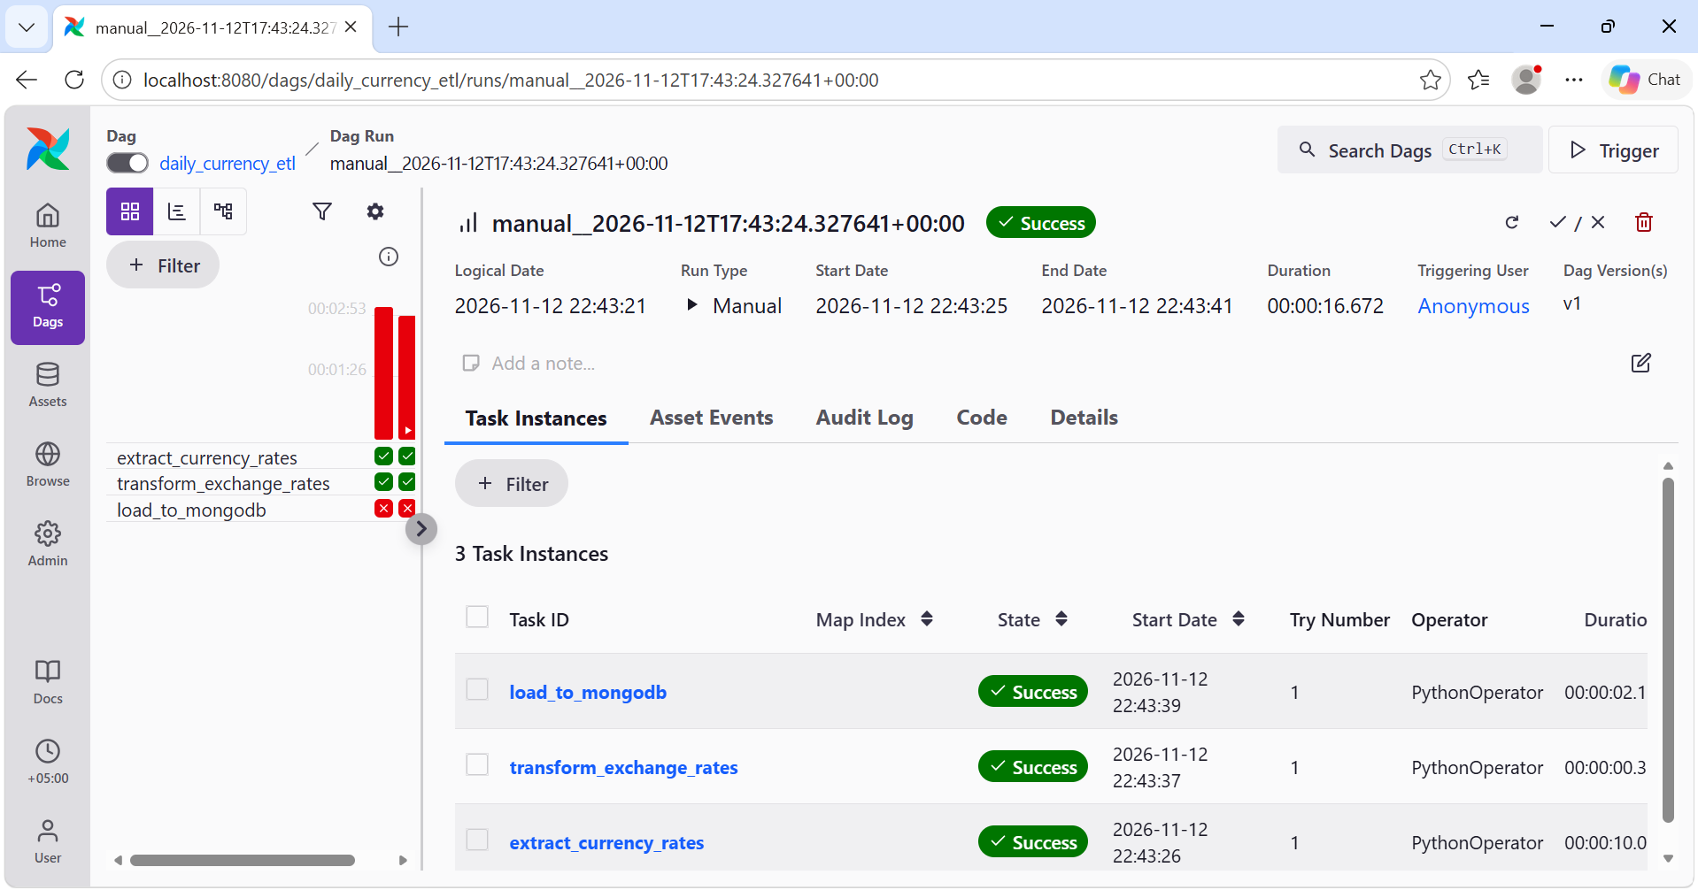
Figure 3. All three tasks succeeded.
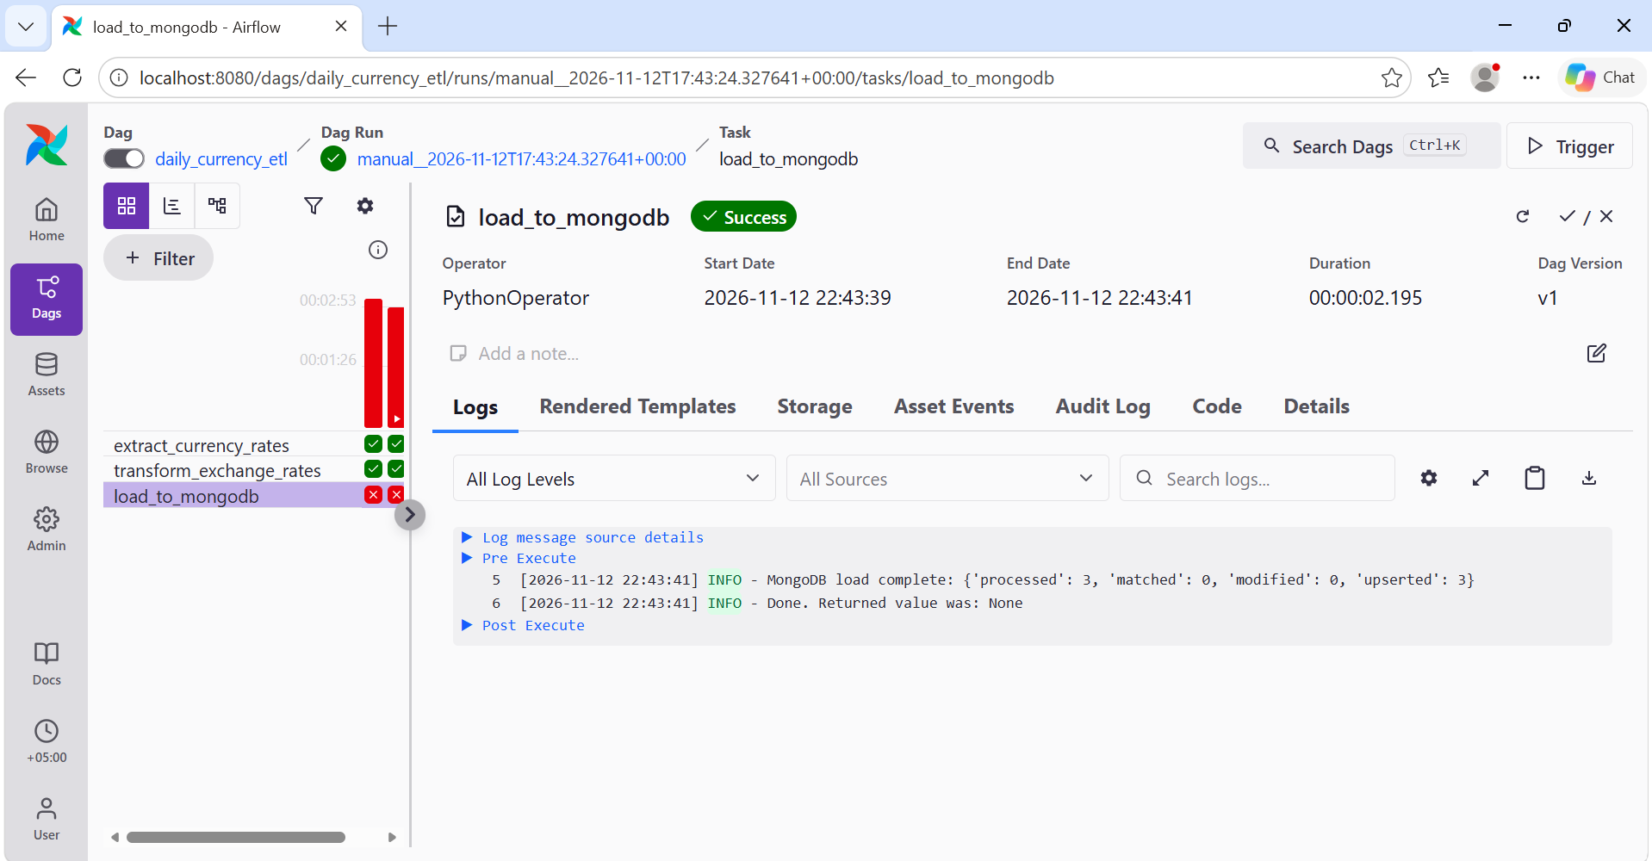
Figure 4. The load log shows 3 processed records and 3 upserts.

Extract task
This task fetches the exchange rates from Frankfurter. It passes the response to the next task using the named XCom raw_exchange_rates.
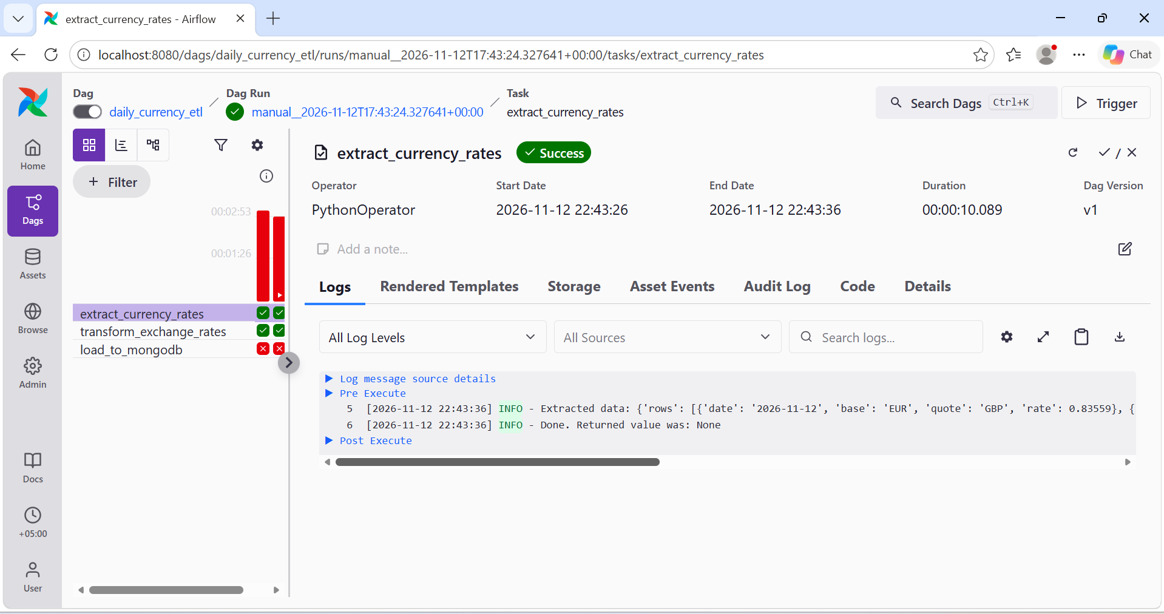
Figure 5. Extract task output.
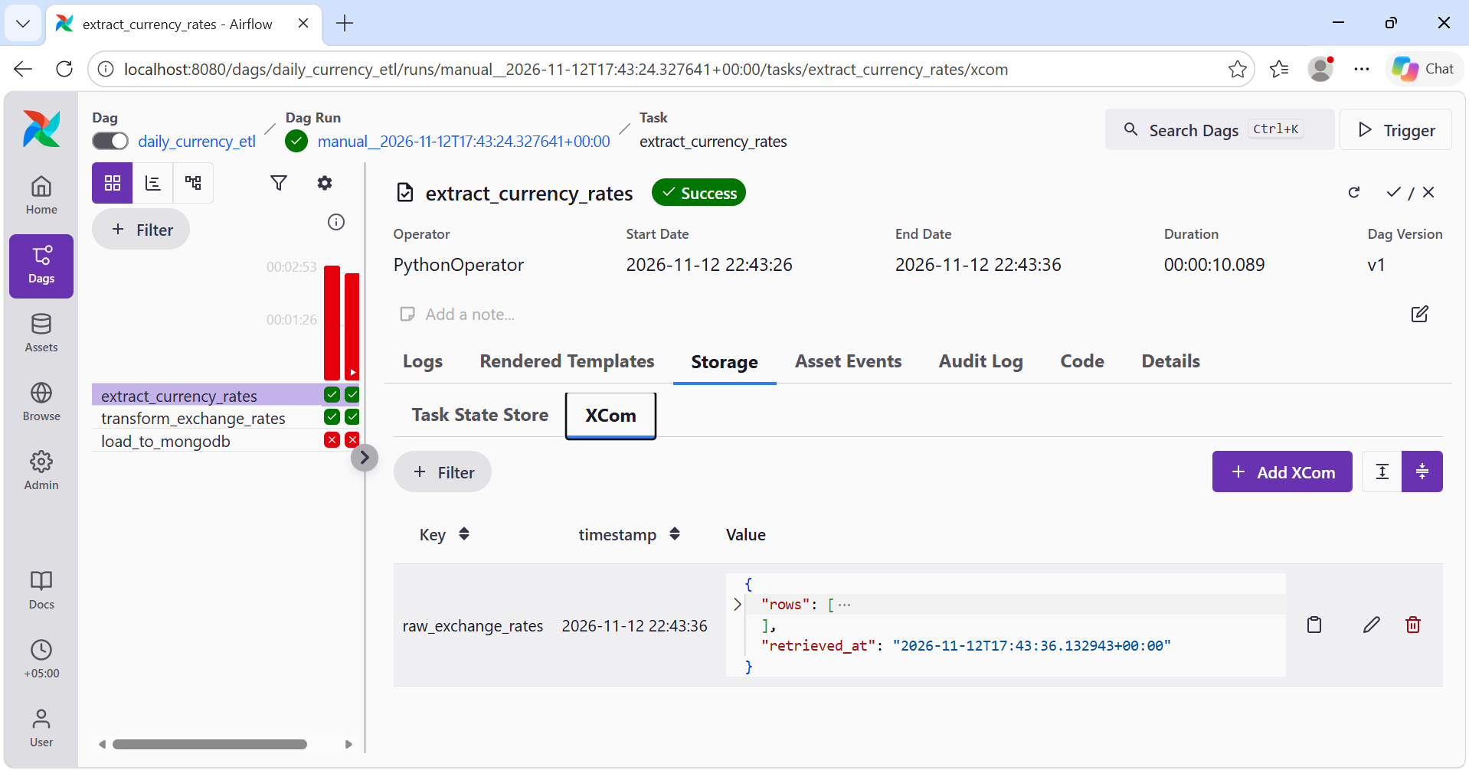
Figure 6. The raw_exchange_rates XCom.

Transform task
This task checks the rates and changes the field names to match the required format. It adds the source and retrieval time, then saves the result in transformed_exchange_rates.
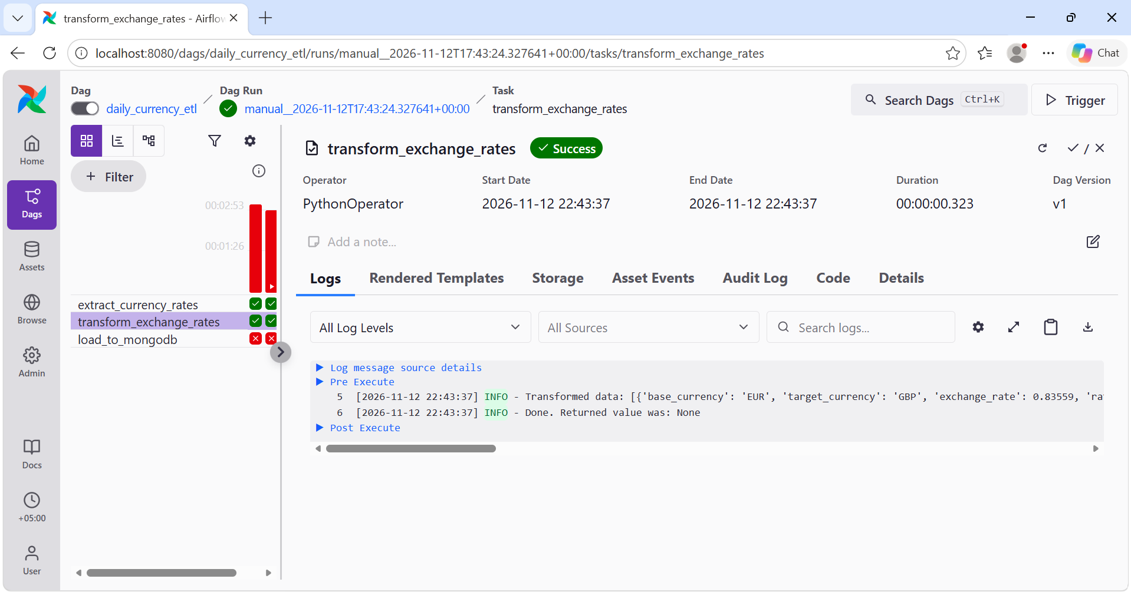
Figure 7. Transform task output.
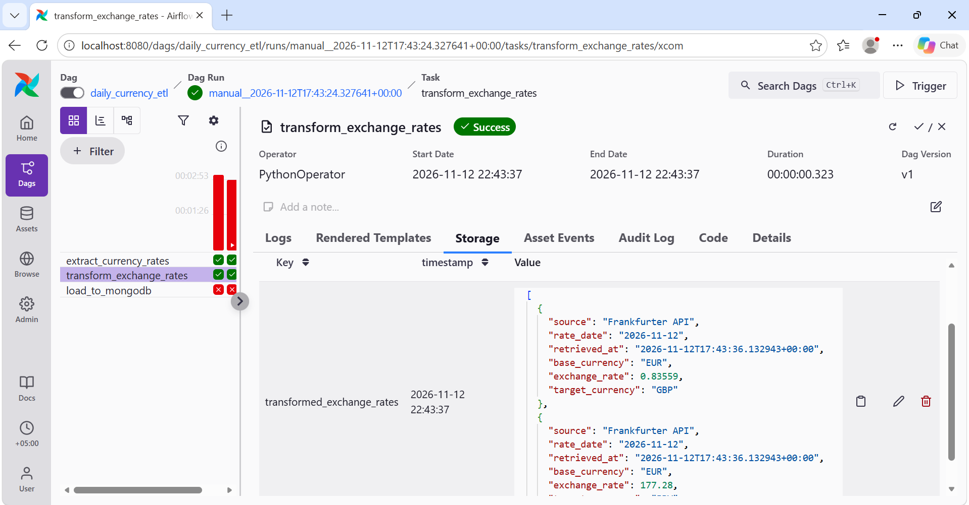
Figure 8. Transformed data with the required fields.

Named XComs and loading
The transformed records contain base_currency, target_currency, exchange_rate, rate_date, source and retrieved_at. The load task saves them in currency_etl.exchange_rates. A unique index and upserts help avoid duplicate daily records.
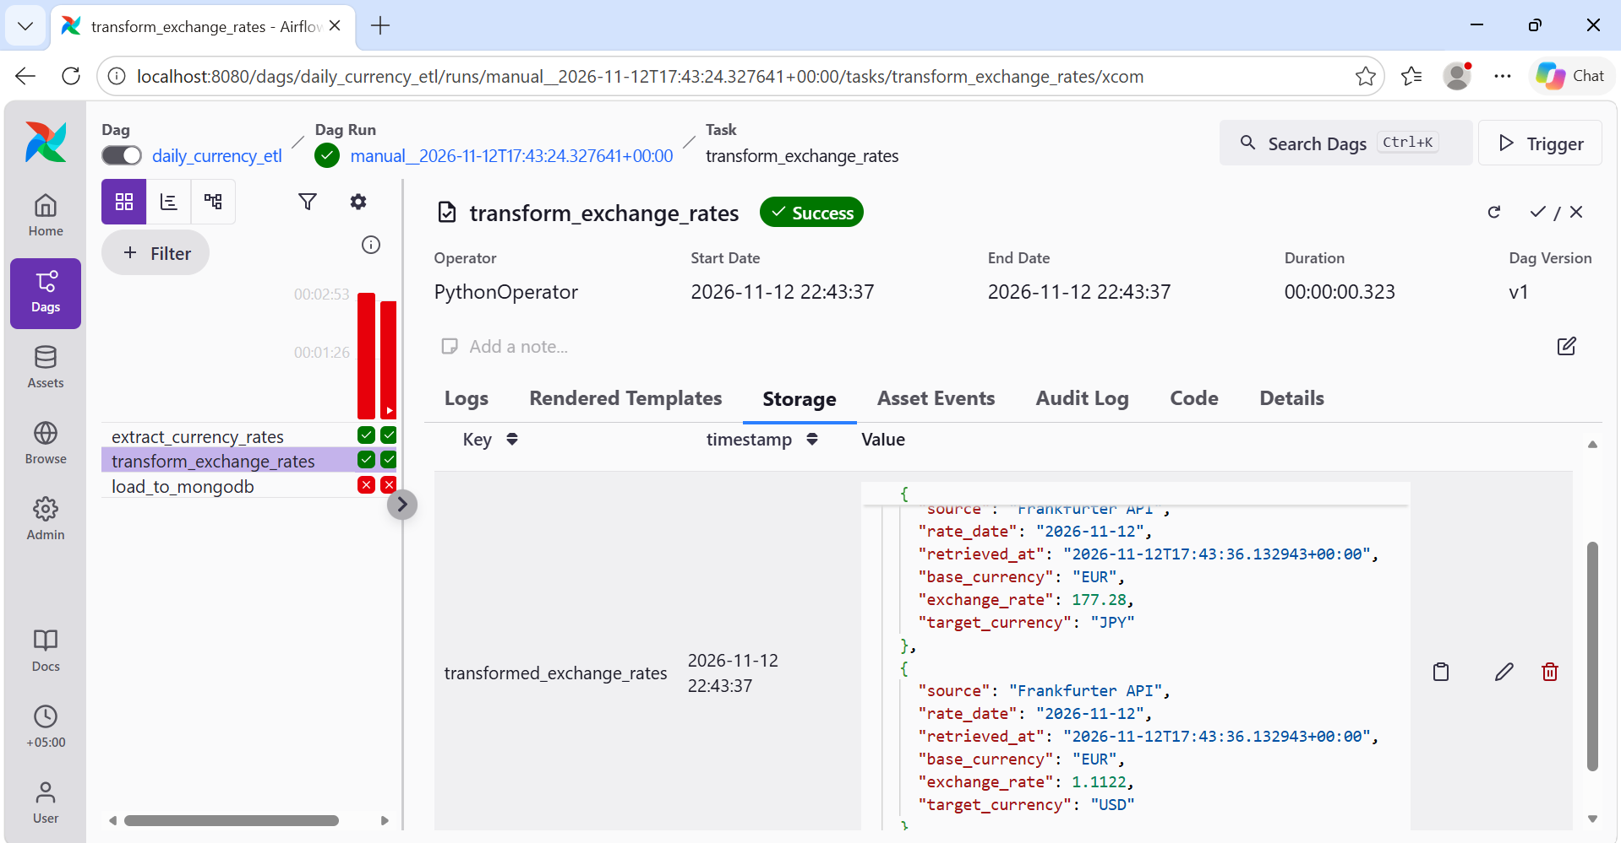
Figure 9. JPY and USD records in transformed_exchange_rates.
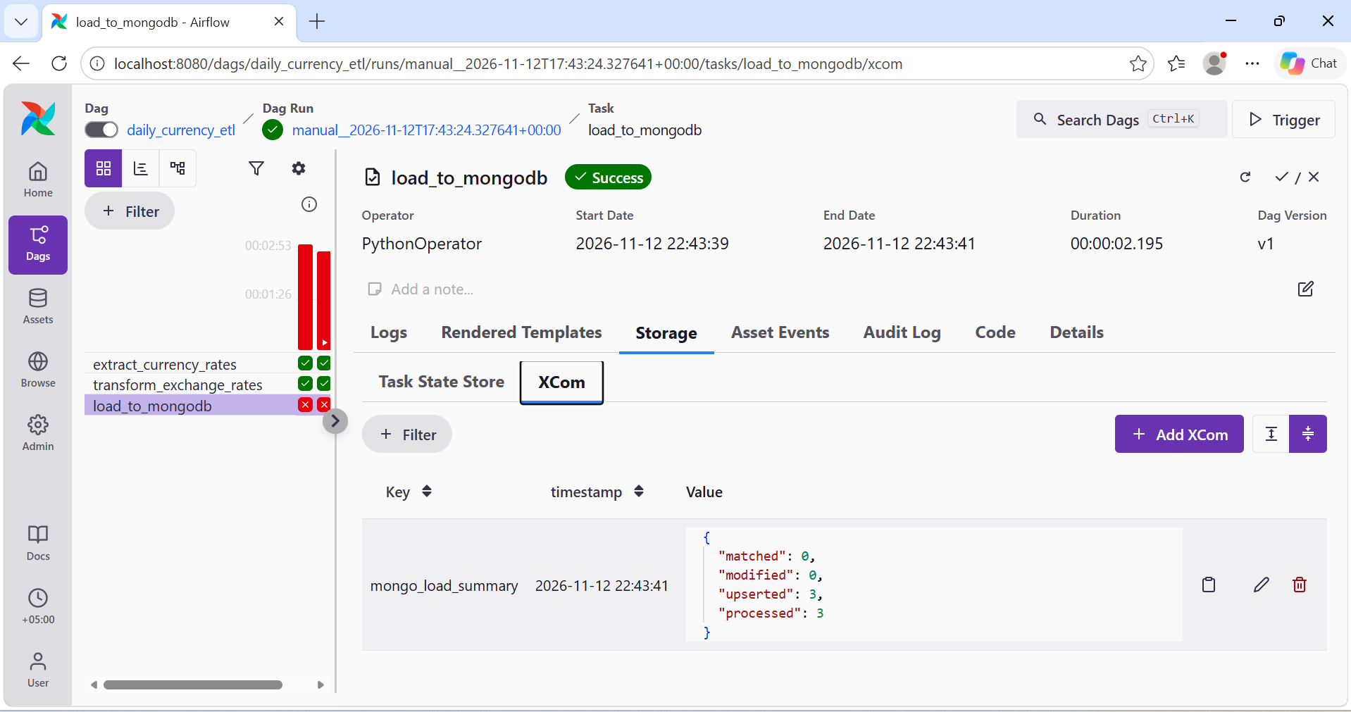
Figure 10. The mongo_load_summary XCom confirms 3 records were inserted.

MongoDB results
I used Mongo Express to check the saved data. The collection contains three records dated 12 November 2026: GBP 0.83559, JPY 177.28 and USD 1.1122 per EUR.
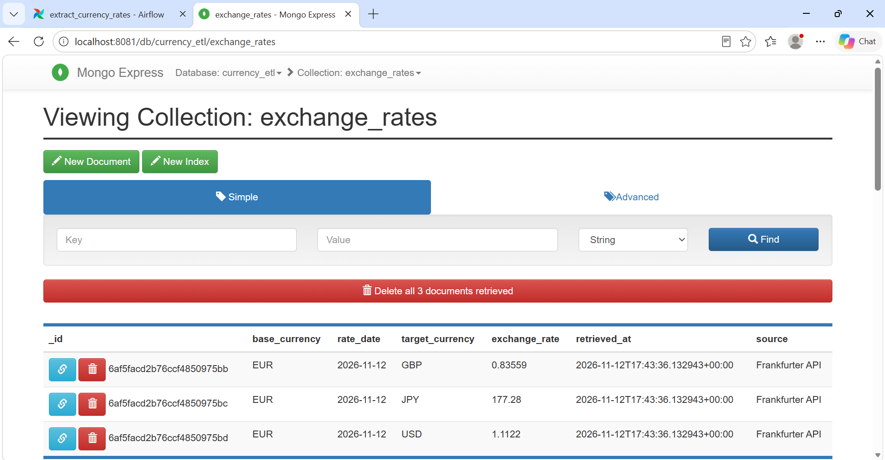
Figure 11. The three saved exchange rate records.
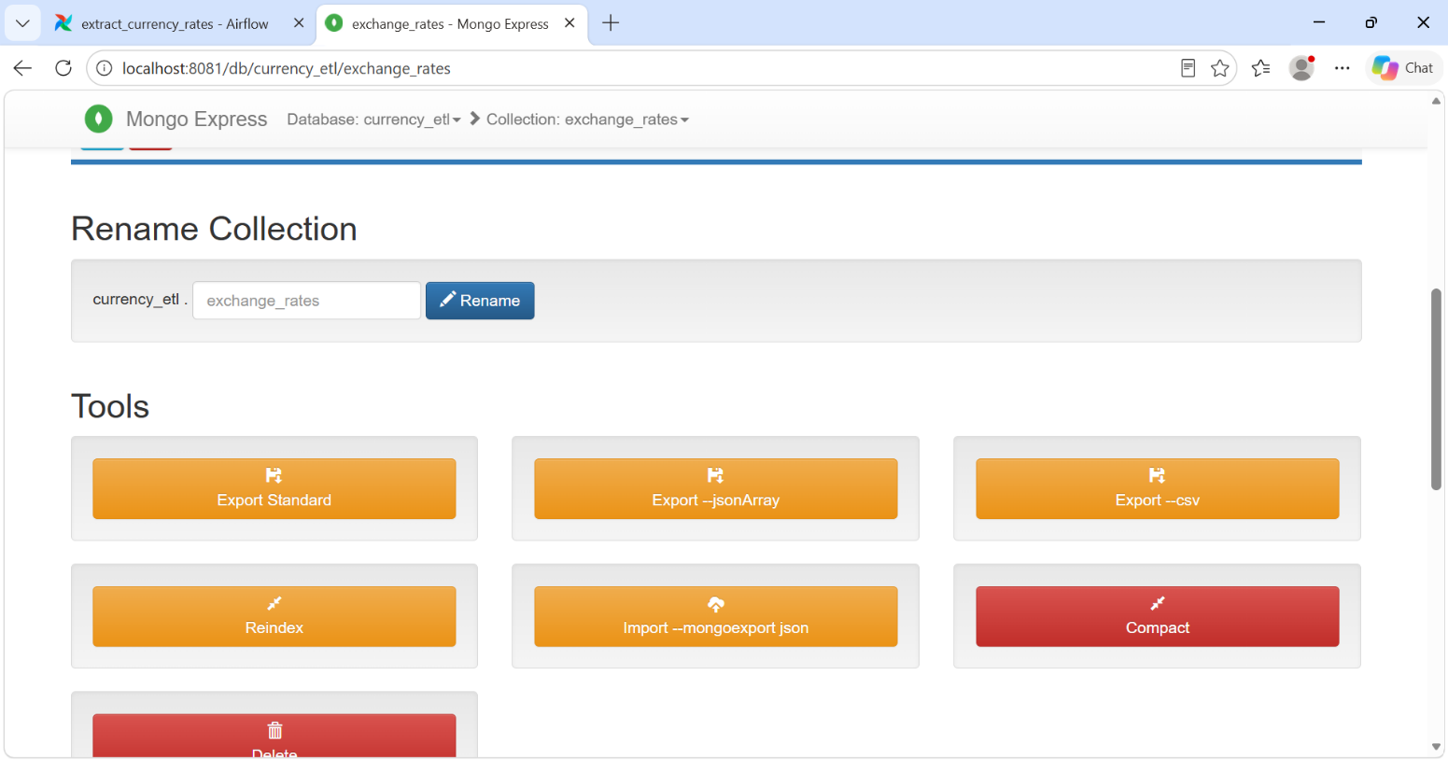
Figure 12. Mongo Express collection tools.

Conclusion
The pipeline successfully fetched, transformed and loaded the currency rates. MongoDB and Airflow share the airflow Docker network, and a named volume stores the database files. The DAG is configured to run daily at 18:00 UTC.

