Q1:



CODE:

public class PatternQ01

{ public static void main(String args[])

{ for(int i=1;i<=3;i++)

{ for(int j=1;j<=5;j++)

{ System.out.print("\* ");

}

System.out.println();

}

}

}

Q2:



CODE :

public class PatternQ2{

public static void main(String args[])

{ for(int i=1;i<=3;i++)

{ for(int j=1;j<=5;j++)

{

if(i==1 || i==3 || j==1 || j==5)

System.out.print("\* ");

else

System.out.print(" ");

}

System.out.println();

}

}

}

Q3:

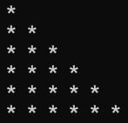

CODE :

public class PatternQ6{

public static void main(String args[])

{ for(int i=1;i<=6;i++)

{ for(int j=1;j<=6;j++)

{ if(i>=j)

System.out.print("\* ");

}

System.out.println();

}

}

}

Q4

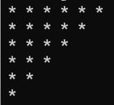

CODE :

public class PatternQ4

{

public static void main(String args[])

{

for(int i=6;i>=1;i--)

{

for(int j=1;j<=6;j++)

{

if(i>=j)

{

System.out.print("\* ");

}

}

System.out.println();

}

}

}

Q5:

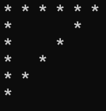

CODE:

class PatternQ5{

public static void main(String args[])

{ for(int i=6;i>=1;i--)

{ for(int j=1 ;j<=6;j++)

{ if(i==6 || j==1 || j==i)

System.out.print("\* ");

else

System.out.print(" ");

}

System.out.println();

}

}

}

Q6:



CODE :

public class PatternQ06{

public static void main(String args[])

{

for(int i=1;i<=6;i++)

{ boolean f=true;

for(int j=1;j<=11;j++)

{

if(j>=7-i && j<=5+i && f)

{System.out.print("\* ");

f=false;

}

else

{System.out.print(" ");f=true;}

}

System.out.println();

}

}

}

Q7



CODE :

public class PatternQ07{

public static void main(String args[])

{

for(int i=1;i<=6;i++)

{ boolean f=true;

for(int j=1;j<=11;j++)

{

if(j>=i && j<=12-i && f)

{System.out.print("\* ");f=false;}

else

{System.out.print(" ");f=true;}

}

System.out.println();

}

}

}

Q 08;

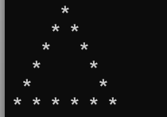

CODE:

public class PatternQ08{

public static void main(String args[])

{

for(int i=1;i<=6;i++)

{

boolean f=true;

for(int j=1;j<=11;j++)

{

if(j==7-i || j==5+i || i==6&&j>=1 && f)

{System.out.print("\*");f=false;}

else

{System.out.print(" ");f=true;}

}

System.out.println();

}

}

}

Q 09:

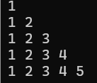

Code :

public class PatternQ09

{

public static void main(String args[])

{

for(int i=1;i<=5;i++)

{

for(int j=1;j<=5;j++)

{

if(j<=i)

{

System.out.print(j+" ");

}

}

System.out.println();

}

}

}

Q 10

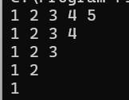

CODE :

public class PatternQ10

{

public static void main(String args[])

{

for(int i=5;i>=1;i--)

{

for(int j=1;j<=5;j++)

{

if(j<=i)

{

System.out.print(j+" ");

}

}

System.out.println();

}

}

}

Q 11

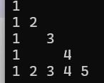

CODE :

public class PatternQ11{

public static void main(String args[])

{

for(int i=1;i<=5;i++)

{

for(int j=1;j<=5;j++)

{

if(j==1 || i==j || i==5)

System.out.print(j+" ");

else

System.out.print(" ");

}

System.out.println();

}

}

}

Q 12

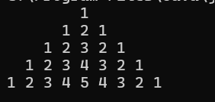

CODE :

public class PatternQ12

{

public static void main(String args[])

{

for(int i=1;i<=5;i++)

{

int counter=0;

for(int j=1;j<=9;j++)

{

if(j>=6-i && j<=4+i)

{ if(j<=5)

System.out.print((++counter)+" ");

else

System.out.print((--counter)+" ");

}

else

System.out.print(" ");

}

System.out.println();

}

}

}

Q 13

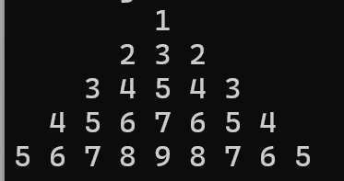

CODE :

public class PatternQ12

{

public static void main(String args[])

{

int counter=0;

for(int i=1;i<=5;i++)

{

for(int j=1;j<=9;j++)

{

if(j>=6-i && j<=4+i)

{ if(j<=5)

System.out.print((++counter)+" ");

else

System.out.print((--counter)+" ");

}

else

System.out.print(" ");

}

System.out.println();

}

}

}

Q 14

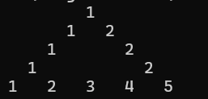

CODE :

public class PatternQ14

{

public static void main(String args[])

{

for(int i=1;i<=5;i++)

{ int counter=0;

boolean f=true;

for(int j=1;j<=9;j++)

{

if(j>=6-i && j<=4+i && f){

if(i==5 || j==6-i || j==4+i )

{System.out.print((++counter)+" ");f=false;}

else

{System.out.print(" ");}

}

else

{System.out.print(" ");f=true;}

}

System.out.println();

}

}

}

Q 15

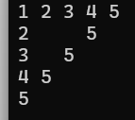

CODE :

public class PatternQ15

{

public static void main(String args[])

{ int k=0;

for(int i=5;i>=1;i--)

{ int counter=k;

for(int j=1;j<=5;j++)

{ ++counter;

if(i>=j)

{

if(i==5 || j==1 || j==i)

System.out.print(counter+" ");

else

System.out.print(" ");

}

}

++k;

System.out.println();

}

}

}

Q 16

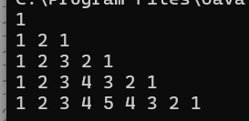

CODE :

public class PatternQ16

{

public static void main(String args[])

{ int k=1;

for(int i=1;i<=5;i++)

{ int counter=0;

for(int j=1;j<=9;j++)

{

if(k>=j)

{

if(i>=j)

System.out.print(++counter+" ");

else

System.out.print(--counter+" ");

}

}

k+=2;

System.out.println();

}

}

}

Q 17

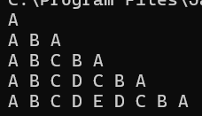

CODE :

public class PatternQ17

{

public static void main(String args[])

{ int k=1;

for(int i=1;i<=5;i++)

{ int counter=64;

for(int j=1;j<=9;j++)

{

if(k>=j)

{

if(i>=j)

System.out.print((char)++counter+" ");

else

System.out.print((char)--counter+" ");

}

}

k+=2;

System.out.println();

}

}

}

Q 18

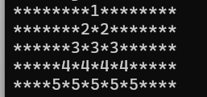

CODE :

public class PatternQ18

{

public static void main(String args[])

{

for(int i=1;i<=5;i++)

{ boolean f=true;

for(int j=1;j<=17;j++)

{

if( j>=10-i && j<=8+i && f)

{System.out.print(i);f=false;}

else{

System.out.print("\*");

f=true;

}

}

System.out.println();

}

}

}

Q 19

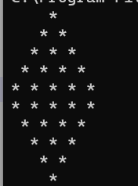

CODE :

public class PatternQ19

{

public static void main(String args[])

{

for(int i=1;i<=5;i++)

{ boolean f=true;

for(int j=1;j<=9;j++)

{

if(j>=6-i && j<=4+i && f)

{

System.out.print("\*");

f=false;

}

else

{

System.out.print(" ");

f=true;

}

}

System.out.println();

}

for(int i=5;i>=1;i--)

{ boolean f=true;

for(int j=1;j<=9;j++)

{

if(j>=6-i && j<=4+i && f)

{

System.out.print("\*");

f=false;

}

else

{

System.out.print(" ");

f=true;

}

}

System.out.println();

}

}

}

Q 20

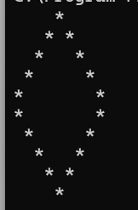

CODE :

public class PatternQ20

{

public static void main(String args[])

{

for(int i=1;i<=5;i++)

{

for(int j=1;j<=9;j++)

{

if(j>=6-i && j<=4+i)

{

if(j==6-i || j==4+i)

{

System.out.print("\*");

}

else

System.out.print(" ");

}

else

{

System.out.print(" ");

}

}

System.out.println();

}

for(int i=5;i>=1;i--)

{

for(int j=1;j<=9;j++)

{

if(j>=6-i && j<=4+i)

{

if(j==6-i || j==4+i)

{

System.out.print("\*");

}

else

System.out.print(" ");

}

else

{

System.out.print(" ");

}

}

System.out.println();

}

}

}

Q 21

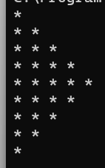

CODE :

public class PatternQ21 {

public static void main(String args[]) {

int k = 2;

for (int i = 1; i <= 9; i++)

{

for (int j = 1; j <= 5; j++)

{

if (i <= 5)

{

if (j <= i)

{

System.out.print("\* ");

}

}

else

{

if (j <= 10 - i)

{

System.out.print("\* ");

}

}

}

System.out.println();

}

}

}

Q 22

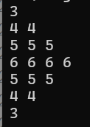

CODE :

public class PatternQ22

{

public static void main(String args[])

{ int counter=3;

for(int i=1;i<=7;i++)

{

for(int j=1;j<=4;j++)

{

if(i<=4)

{

if(j<=i)

{

System.out.print(counter+" ");

}

}

else if(i>4)

{

if(j<=8-i)

System.out.print(counter+" ");

}

}

if(i<4)

counter++;

else

counter--;

System.out.println();

}

}

}

Q 23

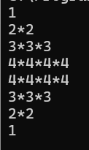

CODE :

public class PatternQ23

{

public static void main(String args[])

{ int k=1;

int count=1;

for(int i=1;i<=8;i++)

{

for(int j=1;j<=7;j++)

{

if(i<=4)

{

if(j<=k)

{

if(j%2==1)

System.out.print(count);

else

System.out.print("\*");

}

}

if(i>4)

{

if(j<=k)

{

if(j<=k)

{

if(j%2==1)

System.out.print(count);

else

System.out.print("\*");

}

}

}

}

if(i<=4)

{ k=k+2;

++count;

}

if(i>=4)

{ k=k-2;

--count;

}

System.out.println();

}

}

}

Q 24

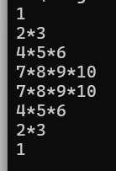

CODE :

public class PatternQ24

{

public static void main(String args[])

{ int k=1;

int count=1;

int q=8;

for(int i=1;i<=8;i++)

{

for(int j=1;j<=7;j++)

{

if(i<=4)

{

if(j<=k)

{

if(j%2==1)

{ System.out.print(count);++count;}

else

System.out.print("\*");

}

}

if(i>4)

{

if(j<=k)

{

if(j<=k)

{

if(j%2==1)

{System.out.print(count);++count;}

else

System.out.print("\*");

}

}

}

}

if(i==4)

count=7;

if(i<4)

{ k=k+2;

}

if(i>4)

{ k=k-2;

q=q/2;

count=q;

}

System.out.println();

}

}

}

Q 25:

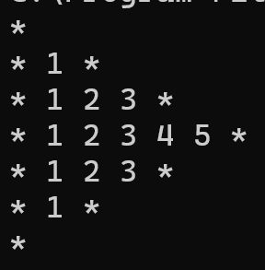

CODE :

public class PatternQ25

{

public static void main(String args[])

{

int k=1,kk=5;

int R=1,RR=5;

for(int i=1;i<=4;i++)

{ int count1=0;

for(int j=1;j<=7;j++)

{

if(j<=k)

{

if(j==1||j==R)

{ System.out.print("\* ");

}

else

System.out.print(++count1+" ");

}

}

R=R+2;

k=k+2;

System.out.println();

}

for(int i=3;i>=1;i--)

{ int count2=0;

for(int j=1;j<=7;j++)

{

if(j<=kk)

{

if(j==1||j==RR)

System.out.print("\* ");

else

System.out.print(++count2+" ");

}

}

RR=RR-2;

kk=kk-2;

System.out.println();

}

}

}

Q 26

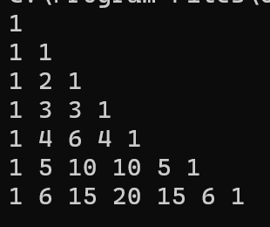

CODE :

public class PatternQ26

{

public static void main(String args[])

{

for(int i=0;i<7;i++)

{ int number=1;

for(int j=0;j<=i;j++)

{

System.out.print(number+" ");

number=number\*(i-j)/(j+1);

}

System.out.println();

}

}

}

Q 27

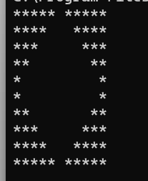

CODE :

public class PatterQ27

{

public static void main(String args[])

{

for(int i=1;i<=5;i++)

{

for(int j=1;j<=11;j++)

{

if(j>=7-i && j<=5+i)

{

System.out.print(" ");

}

else

{

System.out.print("\*");

}

}

System.out.println();

}

for(int i=5;i>=1;i--)

{

for(int j=1;j<=11;j++)

{

if(j>=7-i && j<=5+i)

{

System.out.print(" ");

}

else

{

System.out.print("\*");

}

}

System.out.println();

}

}

}

Q 28

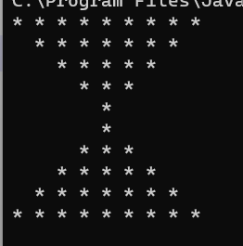

CODE :

public class PatternQ29

{

public static void main(String args[])

{

for(int i=1;i<=5;i++)

{

for(int j=1;j<=10;j++)

{

if(j>=i && j<=10-i)

System.out.print("\* ");

else

System.out.print(" ");

}

System.out.println();

}

for(int i=5;i>=1;i--)

{

for(int j=1;j<=10;j++)

{

if(j>=i && j<=10-i)

System.out.print("\* ");

else

System.out.print(" ");

}

System.out.println();

}

}

}

Q 29

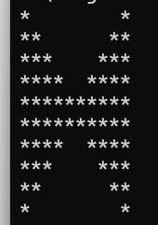

CODE :

public class PatternQ30

{

public static void main(String args[])

{

for(int i=1;i<=5;i++)

{

for(int j=1;j<=10;j++)

{

if(j>=1+i && j<=10-i)

System.out.print(" ");

else

System.out.print("\*");

}

System.out.println();

}

for(int i=5;i>=1;i--)

{

for(int j=1;j<=10;j++)

{

if(j>=1+i && j<=10-i)

System.out.print(" ");

else

System.out.print("\*");

}

System.out.println();

}

}

}

Q 30

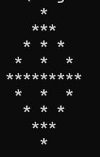

Code :

public class PatternQ31

{

public static void main(String args[])

{

for(int i=1;i<=5;i++)

{

for(int j=1;j<=9;j++)

{

if(i==5 || j==5 || j==6-i || j==4+i)

System.out.print("\*");

else

System.out.print(" ");

}

System.out.println();

}

for(int i=4;i>=1;i--)

{

for(int j=1;j<=9;j++)

{

if(i==5 || j==5 || j==6-i || j==4+i)

System.out.print("\*");

else

System.out.print(" ");

}

System.out.println();

}

}

}

Q 31

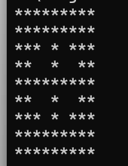

CODE :

public class PatternQ31

{

public static void main(String args[])

{

for(int i=1;i<=5;i++)

{

for(int j=1;j<=9;j++)

{

if(i==5 || j==5 || j<=6-i || j>=4+i)

System.out.print("\*");

else

System.out.print(" ");

}

System.out.println();

}

for(int i=4;i>=1;i--)

{

for(int j=1;j<=9;j++)

{

if(i==5 || j==5 || j<=6-i || j>=4+i)

System.out.print("\*");

else

System.out.print(" ");

}

System.out.println();

}

}

}

Q 32

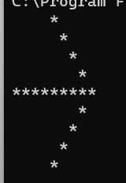

Code :

public class PatternQ32

{

public static void main(String args[])

{

for(int i=1;i<=5;i++)

{

for(int j=1;j<=9;j++)

{

if(i==5 || j==4+i)

System.out.print("\*");

else

System.out.print(" ");

}

System.out.println();

}

for(int i=4;i>=1;i--)

{

for(int j=1;j<=9;j++)

{

if(j==4+i)

System.out.print("\*");

else

System.out.print(" ");

}

System.out.println();

}

}

}

Q 33

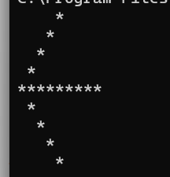

Code :

public class PatternQ33

{

public static void main(String args[])

{

for(int i=1;i<=5;i++)

{

for(int j=1;j<=9;j++)

{

if(i==5 || j==6-i)

System.out.print("\*");

else

System.out.print(" ");

}

System.out.println();

}

for(int i=4;i>=1;i--)

{

for(int j=1;j<=9;j++)

{

if(j==6-i)

System.out.print("\*");

else

System.out.print(" ");

}

System.out.println();

}

}

}

Q 34

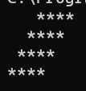

Code :

public class PatternQ34

{

public static void main(String args[])

{

for(int i=1;i<=4;i++)

{

for(int j=1;j<=7;j++)

{

if(j>=5-i && j<=8-i)

System.out.print("\*");

else

System.out.print(" ");

}

System.out.println();

}

}

}

Q 35

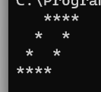

Code :

public class PatternQ35

{

public static void main(String args[])

{

for(int i=1;i<=4;i++)

{

for(int j=1;j<=7;j++)

{

if(j>=5-i && j<=8-i)

{

if(i==1 || i==4 || i==2&&j==3 || i==3&&j==2 || i==2&&j==6 || i==3&&j==5)

{

System.out.print("\*");

}

else

System.out.print(" ");

}

else

System.out.print(" ");

}

System.out.println();

}

}

}

Q 36

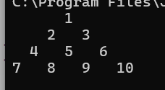

Code :

public class Pattern36

{

public static void main(String args[])

{

int count=0;

for(int i=1;i<=4;i++)

{ boolean f=true;

for(int j=1;j<=7;j++)

{

if(j>=5-i && j<=3+i && f)

{System.out.print(++count+" ");f=false;}

else

{System.out.print(" ");f=true;}

}

System.out.println();

}

}

}

Q 37

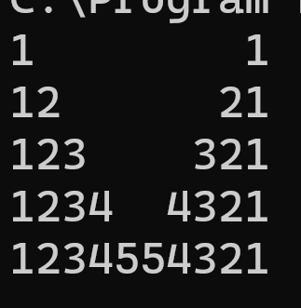

Code :

public class PatternQ37

{

public static void main(String args[])

{

for(int i=1;i<=5;i++)

{ int count=0;

for(int j=1;j<=10;j++)

{

if(j>=i+1 && j<=10-i)

{

System.out.print(" ");

}

else

{

if(j<=5)

System.out.print(++count);

else

System.out.print(count--);

}

}

System.out.println();

}

}

}

Q 38

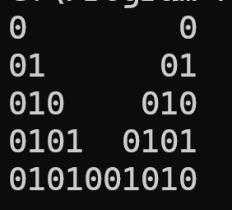

Code :

public class PatternQ37

{

public static void main(String args[])

{

for(int i=1;i<=5;i++)

{ int count=0;

for(int j=1;j<=10;j++)

{

if(j>=i+1 && j<=10-i)

{

System.out.print(" ");

}

else

{

if(j<=5){

if(j%2==1)

System.out.print("0");

else

System.out.print("1");

}

else{

if((j+i)%2==1)

System.out.print("0");

else

System.out.print("1");}

}

}

System.out.println();

}

}

}

Q 39

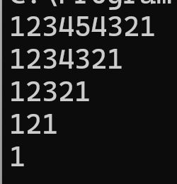

CODE :

public class PatternQ39

{

public static void main(String args[])

{

int k=9;

int Q=4;

for(int i=1;i<=5;i++)

{ int count=1;

for(int j=1;j<=9;j++)

{

if(j>=1 && j<=k)

{

if(j<=Q)

System.out.print(count++);

else

System.out.print(count--);

}

else

System.out.print(" ");

}

--Q;

k=k-2;

System.out.println();

}

}

}

Q 40

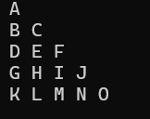

Code :

public class PatternQ40

{

public static void main(String args[])

{

int count=65;

for(int i=1;i<=5;i++)

{

for(int j=1;j<=i;j++)

{

System.out.print(((char)count++)+" ");

}

System.out.println();

}

}

}

Q 41

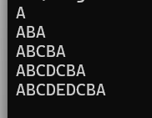

Code :

public class PatternQ41

{

public static void main(String args[])

{

int k=1;

for(int i=1;i<=5;i++)

{

int count=64;

for(int j=1;j<=9;j++)

{

if(j<=k)

{

if(j<=i)

System.out.print((char)++count);

else

System.out.print((char)--count);

}

}

k=k+2;

System.out.println();

}

}

}

Q 42

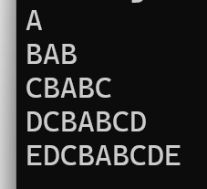

Code :

public class PatternQ42

{

public static void main(String args[])

{

int Q=66;

int k=1;

int count=Q;

for(int i=1;i<=5;i++)

{

count=Q;

for(int j=1;j<=9;j++)

{

if(j<=k)

{

if(j<=i)

System.out.print((char)--count);

else

System.out.print((char)++count);

}

}

++Q;

k=k+2;

System.out.println();

}

}

}