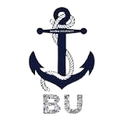

Bahria University, Lahore Campus

Department of Computer Science

Course: Computer Vision (BSCS-8th)

Instructor: Dr. Iram Noreen
Submitted by :
Muzammil Amjad 03-134212-080
Asad Ali 03-134202-013
Nazar Ali 03-134221-033

Halal Food Identifier

Abstract
This project presents an AI-driven Halal Food Identifier that combines computer vision, barcode recognition, and machine learning techniques to automate halal certification verification and ingredient classification. Leveraging YOLOv8 for real-time halal logo detection, pyzbar for barcode decoding, pytesseract for ingredient Optical Character Recognition (OCR), and a trained Linear SVC classifier achieving 97% accuracy for halal and haram ingredient labeling, the system offers a multi-faceted verification approach through an interactive Streamlit web interface. The model achieves a high mean Average Precision (mAP) of 93.9%, demonstrating reliable logo localization and classification across diverse product images. Integration with Open Food Facts API and a local E-code database strengthens ingredient validation and product lookup, providing an effective solution for halal compliance verification.
Keywords:
Halal Food Identification, Deep Learning, YOLOv8, Image Recognition, Computer Vision, E-code Verification, Dataset Preprocessing, Model Evaluation, Ultralytics Framework, Artificial Intelligence, Food Authentication, CNN-based Detection, Halal Certification Logos, OCR

Introduction
With an expanding global halal food market, consumers face challenges verifying the halal status of products due to inconsistent labeling and lack of centralized verification tools. Traditional systems mostly rely on static ingredient databases or manual inspections, which hinder scalability and automation. Modern advancements in computer vision and deep learning, particularly the YOLOv8 object detection architecture, provide opportunities for fast, precise halal logo recognition. Combined with barcode scanning and ingredient classification pipelines, a comprehensive halal verification system can better serve consumers' needs. This project aims to bridge gaps in existing methods by integrating real-time logo detection, barcode-based product information retrieval, and ingredient classification into a unified, user-friendly web application.
The Performance signifies that YOLOv8 is a robust and reliable architecture for the visual recognition of halal logos, greatly enhancing automation and scalability in halal verification systems. The model's capability to operate efficiently on real-time images makes it an ideal choice for mobile applications and integrated verification platforms.

Related Work
Previous research and applications in halal verification have primarily focused on text-based ingredient analysis and limited computer vision approaches for logo detection. Existing apps like Halal Check and E-Code Verifier rely on static databases without real-time API integration or machine learning automation. Attempts at OCR-based ingredient identification and traditional image classification lack robustness, failing to combine image, barcode, and textual data modalities effectively. The use of YOLOv8 architecture, noted for its speed and accuracy in object detection tasks, represents an advancement over older models in halal logo recognition. Moreover, integrating open product databases like Open Food Facts API enhances product detail accessibility and verification coverage.

Development Method

The development process involved dataset collection, model training, system integration, and interface design:

Data Collection: Gathered 5307 images across 11 halal logo classes from Roboflow.

Model Training: Trained the YOLOv8 model using PyTorch via Ultralytics, achieving a validation mAP 0.5 of 93.9%. Training included data augmentation and cross-validation for robustness.

Ingredient Classifier: Built a text classification model using linear SVC with a labeled ingredient dataset, exported as a .pkl file for deployment.

Barcode Decoding: Implemented with pyzbar and OpenCV for region localization.

System Integration: Combined models and APIs into a Streamlit application with a tabbed interface supporting image scanning, OCR extraction, and manual input.

Evaluation: Conducted performance tests and debugging to ensure seamless processing and user experience.

Dataset and Experimental Results
The dataset included 5307 total images across 11 Halal logo categories. The Dataset YOLOv8 validation results are summarized below:
Sno | Classes | Train | Test
0 | MalaysiaHalal | 883 | 234
1 | ThailandHalal | 345 | 44
2 | ChinaHalal | 311 | 92
3 | EuropeHalal | 595 | 16
4 | IndiaHalal | 480 | 26
5 | IndonesiaHalal | 356 | 55
6 | KoreanHalal | 334 | 46
7 | SingaporeHalal | 603 | 13
8 | SwitzerlandHalal | 571 | 13
9 | Unverifiedhalal | 459 | 129
10 | VietnamHalal | 370 | 37
 |  | 5,307 | 705

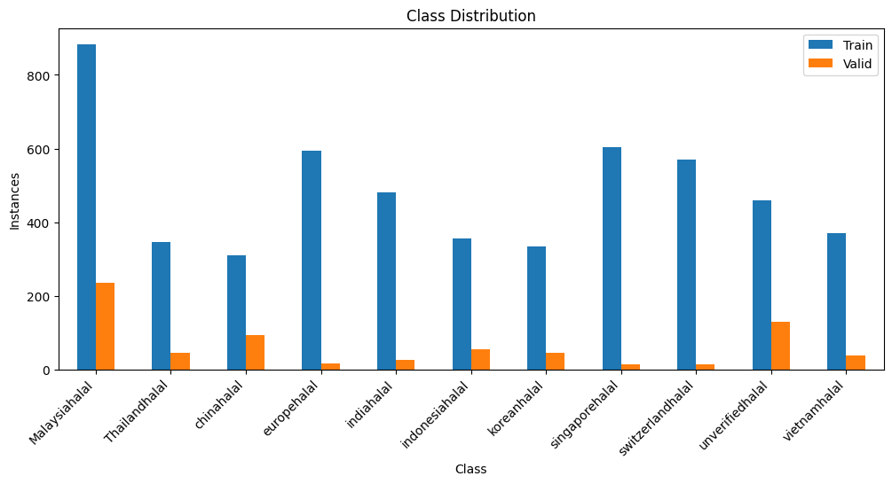

Overall mAP@0.5: 0.94 Train
mAP@0.5:0.94: 0.7353 Validation
The Ingredients Dataset is trained with Linear SVC using TF-IDF vectorization. Linear SVC is chosen because it is efficient and effective for high-dimensional sparse data, such as text features derived from ingredient lists. TF-IDF vectorization is used to transform textual ingredient data into numerical feature vectors, capturing the importance of each term while reducing the influence of common words.
Data counts:
Halal: 291,920
Haram: 236,172
Total = 291,920 + 236,172 = 528,092 entries.
Accuracy: 0.97, Recall: 0.98, Precision: 0.98, F1-Score: 0.98

Results and Discussion
The system successfully integrated cutting-edge deep learning tools and APIs into a cohesive halal verification platform. The YOLOv8-based logo detector provided high-accuracy real-time localization. Barcode decoding and API lookup extended product data retrieval complementary to logo detection. OCR and ML classification enabled robust ingredient analysis even in the absence of visible logos or barcode data. The Streamlit interface delivered an intuitive user experience with color-coded verdicts and annotated visuals. Known constraints include dependence on image quality for OCR, slight limitations in barcode detection integration, and English-only OCR support. Future work may address these through multilingual datasets, alternative OCR engines, and additional caching or offline capabilities.
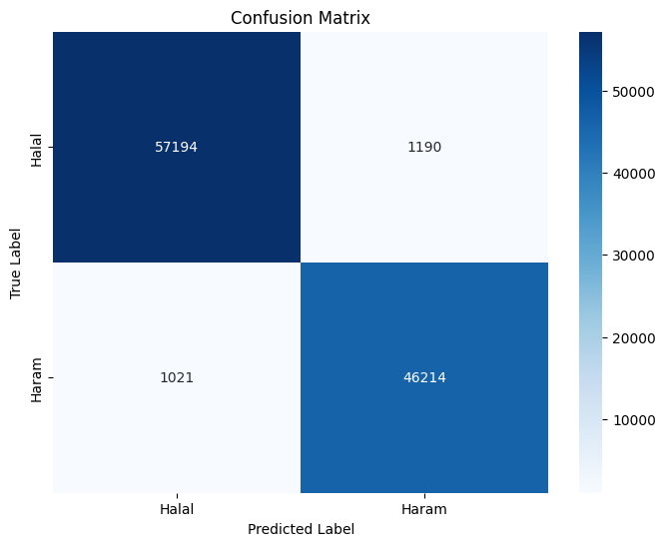

Conclusion
This project delivers a comprehensive Halal Logo & Barcode Detection System combining YOLOv8 object detection, barcode decoding, OCR, and machine learning to automate halal certification verification efficiently. High detection accuracy and integrated verification layers ensure trustworthy halal status determination. The modular design and interactive UI make it accessible for end users across platforms. The success of this system demonstrates the potential of AI and computer vision to enhance religious compliance verification processes, providing a scalable and user-friendly solution for consumers worldwide.

Appendix
GitHub/Colab Link: https://github.com/Asad-10x/halal_food_classifier

