**Task#64 Freezing Billing Requirements**

School’s inputs:

1. Fees settings

Fee Type:

1. Yearly Fees
2. Admission Fees with Term Fees(3 terms)
3. Admission Fees with monthly Fees (10 months Jun - Mar)

Fee particulars and amount for all classes from LKG to XII standards:

1. Admission Fees – Rs. Xxxx

Enter particulars like

Book

Note books

Uniform and belt

Tuition

Shoes

Computer

Bus

Hostel

Smart class

Extra curricular

Abacus

and give them option “add field” and “edit field” so that they can do themselves.

1. Enter the Term fee amount
2. Enter the Yearly fee amount
3. Monthly fee amount
4. Preparing Database for student in Excel with following fields
5. SI No
6. Roll No
7. Admission No
8. Name
9. Father’s Name
10. Father’s Income
11. Father’s Occupation
12. Mother’s Name
13. Mother’s Occupation
14. Mother’s Income
15. Guardian’s Name (if applicable)
16. DOB
17. Class
18. Sec
19. Address
20. emis no
21. Aadhar No
22. Caste
23. Religion
24. Date of joining
25. Previous School
26. Sibling’s Roll No

Or

We can include an option of “add information or student database” adding all details in our tool.

Associate Requirements in fees collection and billing module:

Following reports are needed in this module with downloading pdf and excel options

1. Fees collection Report

Start Date: End Date: Generate Reset

|  |  |  |  |  |  |  |  |  |
| --- | --- | --- | --- | --- | --- | --- | --- | --- |
| SI No | Roll No | Name | Payment Date | Receipt No | Fee Type | Class | Sec | Amount |
|  | Total | | | | | | |  |

1. Fees Outstanding Report (Class wise & Overall)

Fee Type: Class: Over all outstanding

|  |  |  |  |  |  |  |  |  |
| --- | --- | --- | --- | --- | --- | --- | --- | --- |
| SI No | Roll No | Name | Total Amount | Parent Contact | Address | Class | Sec | Outstanding amount |
|  | Total | | | | | | |  |

1. Fees payment Receipt

Student Name: or Roll No: or Date of Payment or Fee type:

Reprint

Pages 1 to 3 are discussed enough and front end designs were enclosed in previous tasks.

Here we start with page 4

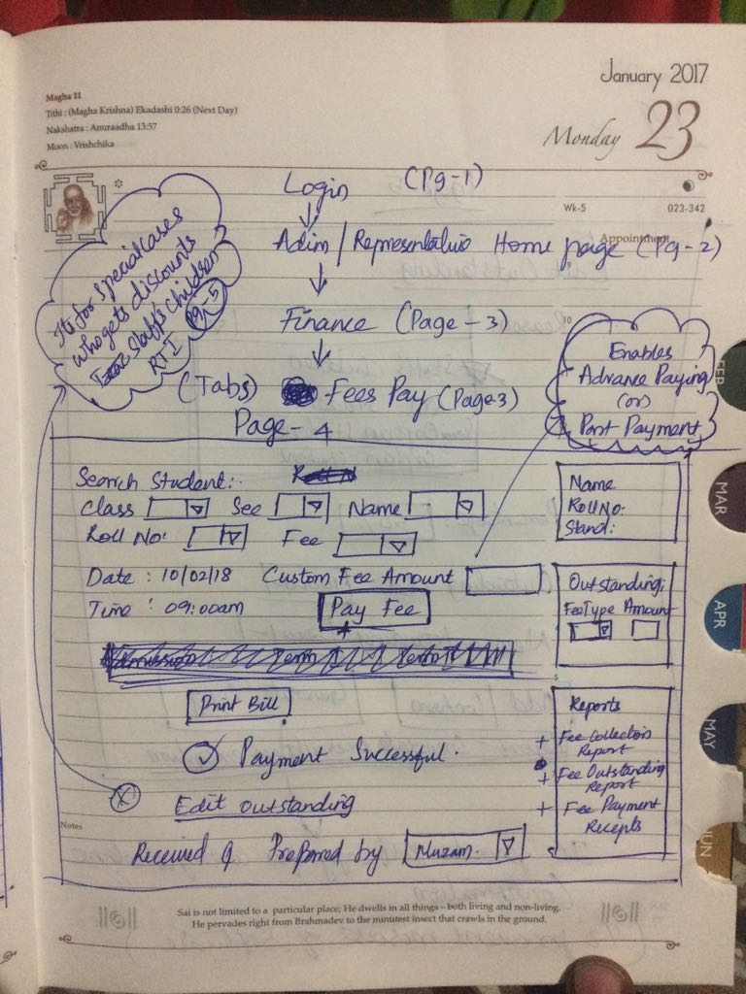

Page – 5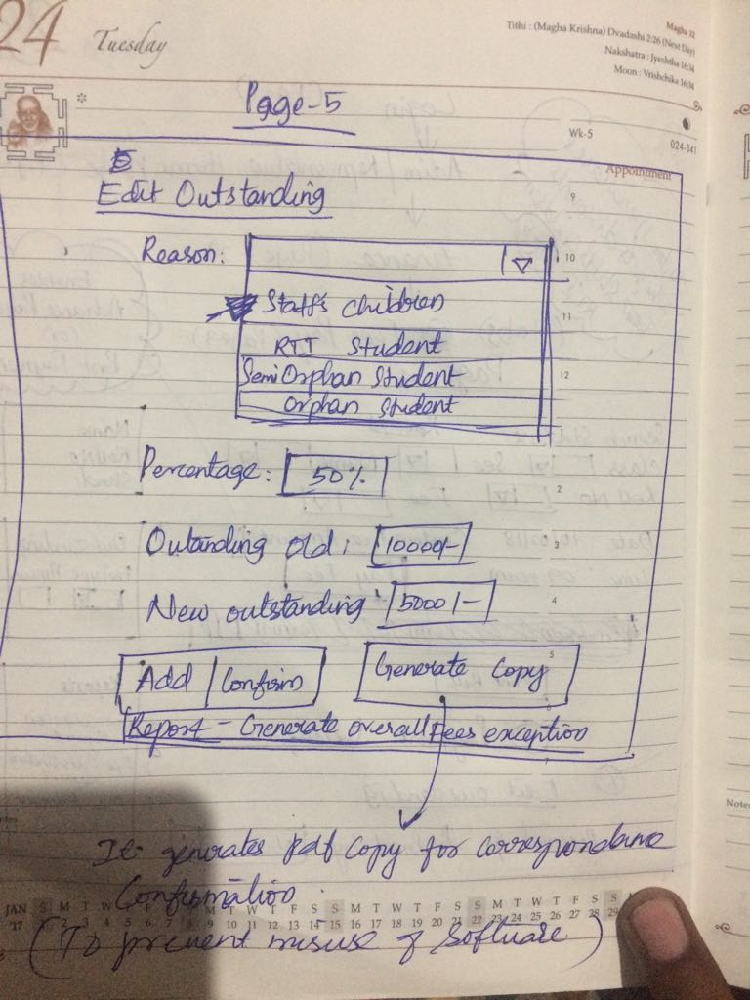

Pages 6 to 8 are discussed in top of this document are nothing, but fetching reports in different forms.

