Solar Device Advance
An ESP32-based DIY solar/UPS controller designed to add solar management, power monitoring, automatic source switching, and configurable control functions to a Car Inverter Or conventional UPS.

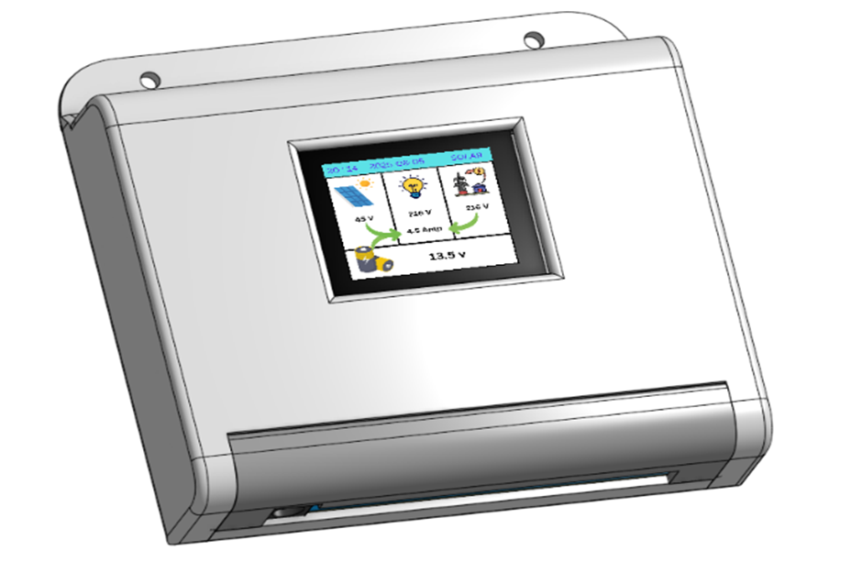

⚠️ Safety Warning: This project can involve battery currents, inverter output, and potentially lethal AC mains voltage. Do not work on energized circuits. Use appropriate fuses, isolation, protection, wiring, relay ratings, and enclosure clearances.

Video link：
Will be uploaded soon.

Project Support & Sponsors
The development of Solar Device Advance was made possible with support from OSHWLab, EasyEDA, and JLCPCB.
We sincerely thank these organizations for providing complimentary PCBs and electronic components used during the development and testing of this project.
OSHWLab
EasyEDA
JLCPCB
Thank you to OSHWLab, EasyEDA, and JLCPCB for supporting DIY and open-source hardware development.

Introduction
This Solar Device enables the user to built your own Solar System using a car inverter & charge controller OR to convert conventional UPS into Solar inverter.
Existing small/household UPS units provide battery-backed AC output but typically do not accept solar input or intelligently prioritise solar energy. Retrofitting these UPS units with a dedicated controller converts them to hybrid solar inverters at a fraction of the cost of buying a commercial solar inverter.
Parameter | Description
Controller | ESP32
Display | 1.8" TFT
Current sensing | ACS712
Power sources | Solar / Grid / Battery
Inverter | Conventional UPS / Car inverter
Solar charging | External charge controller
Source switching | Relay-based
User interface | TFT + keypad
Connectivity | Wi-Fi / Bluetooth
Firmware | ESP32
Project type | DIY / Open Source

Project function
The controller integrates power monitoring, Solar charge regulation, automatic transfer switching (between grid, battery, and solar). It monitors PV voltage, battery voltage, Output/load current, and grid status; then makes intelligent switching.
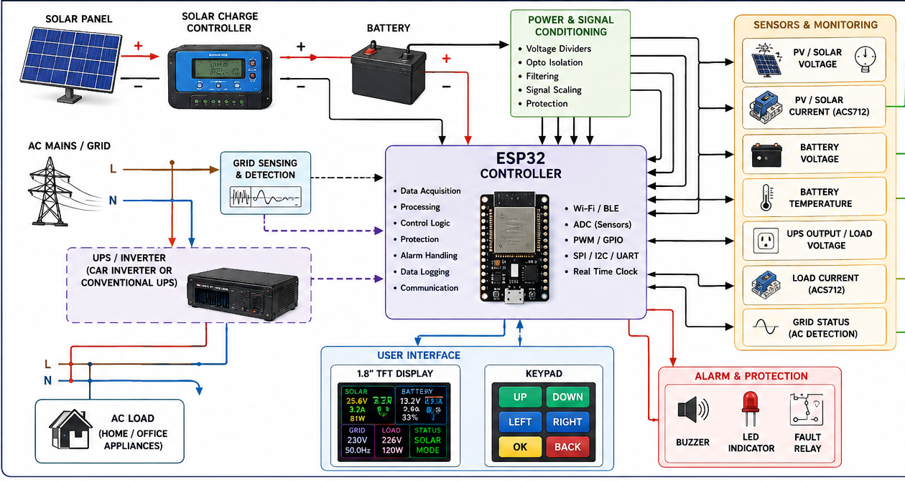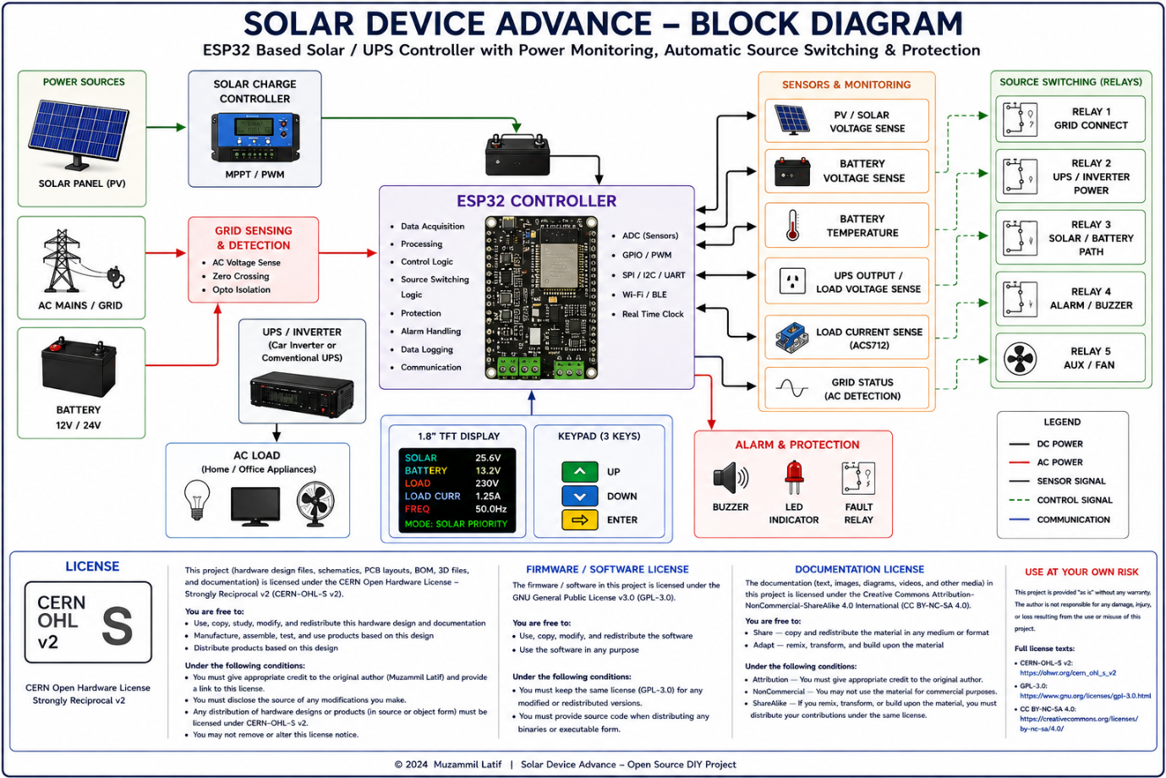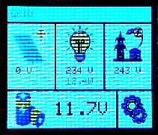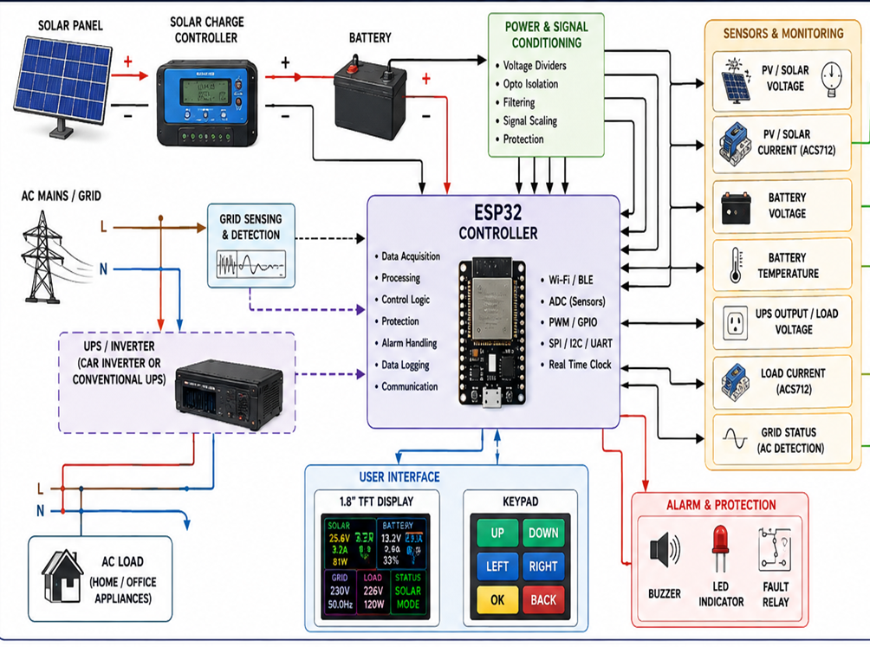

User Interface
The Device provides a menu-based interface for system monitoring and configuration.

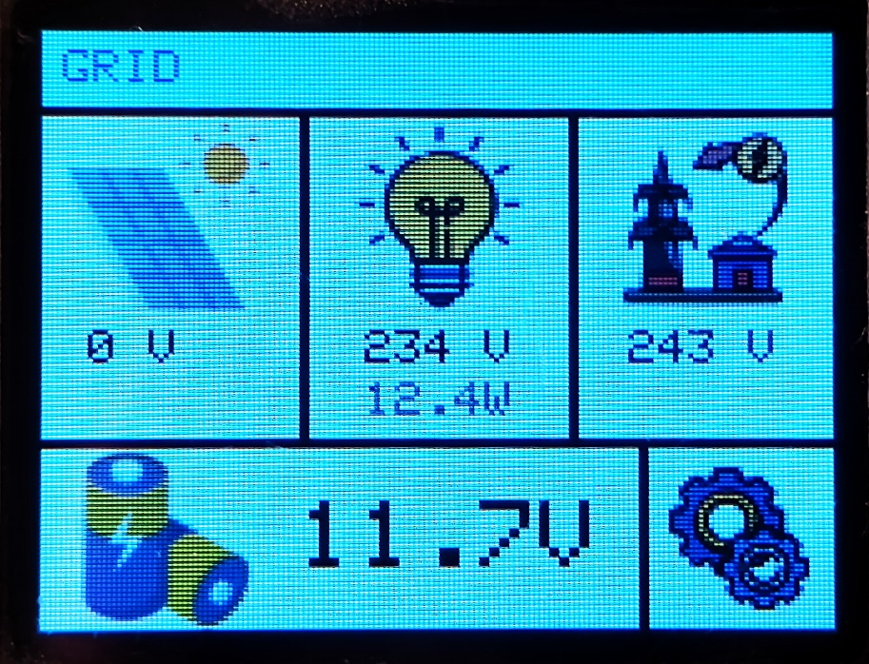
3
1
2
4
5

6

- Working mode: Running on Grid or Battery
- Solar Status
- Load Status
- Grid Status
- Battery Status
- Settings

Hardware description

Main Board

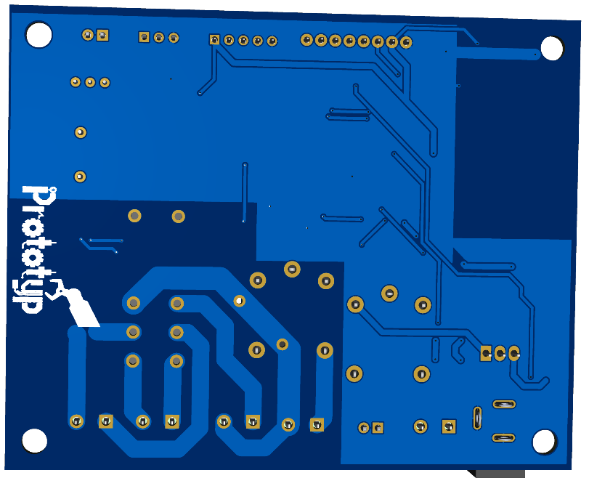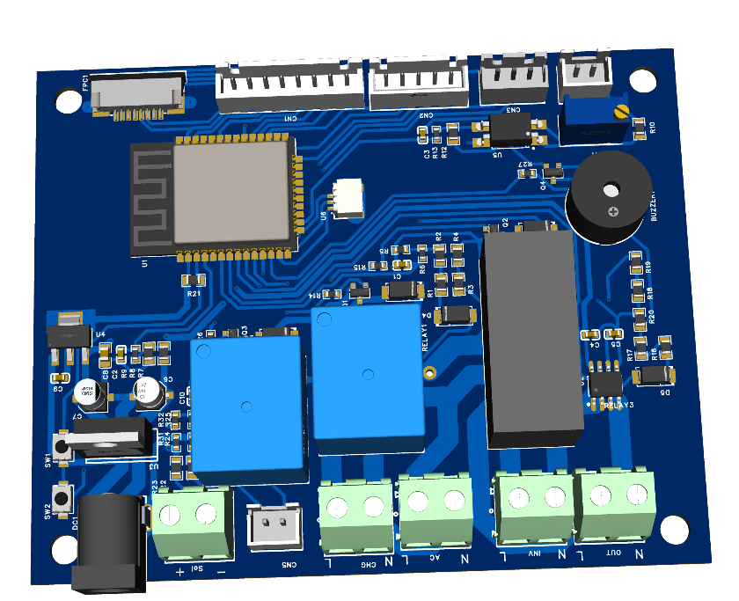

MicroController
The main controller is based on an ESP32.
The ESP32 handles:
- System-state monitoring
- Relay control
- Display control
- Keypad input
- Settings
- Fault handling
- Operating logic
- Communication functions
The ESP32 also provides Wi-Fi and Bluetooth/BLE hardware for possible future expansion and remote monitoring functions.

Power Monitoring
The controller monitors the electrical parameters.
These include the system's relevant:
- Solar/PV voltage
- Battery voltage
- AC/grid status
- UPS output/load condition
- Output Current measurements
The actual measurement circuits, scaling networks, sensor connections, and protection components are shown in the project schematic.

Current Measurement
Current measurement is performed using ACS712 current sensors.
The measured current is read by the ESP32 ADC and processed by the firmware.
Current measurements are used for system monitoring and control functions implemented in the System.
Sensor calibration is required to obtain accurate measurements.

Battery Monitoring
The controller monitors battery voltage.
Battery measurements can be used by the device to determine battery operating conditions and activate the configured battery protection behavior.
The actual battery limits and settings should be configured according to the battery type and the connected UPS/inverter system.

Grid Detection
The controller monitors the grid/AC input through the dedicated detection circuit.
The controller uses the grid status as one of the inputs for automatic operating-state decisions.

Solar Monitoring
Solar/PV conditions are monitored by the controller through the implemented voltage sensing circuits.
The controller uses these measurements to determine the available solar condition and display the relevant information to the user.
The controller can work with an external solar charge controller as part of the overall system.

Relay Control
Relay outputs are controlled by the ESP32 through the relay-driver circuitry implemented on the PCB.
Relay 1 for AC charging
Relay 2 for Inverter control
Relay 3 for Load Shifting
The relay contacts must be rated appropriately for the connected voltage, current, load type, and inrush current.

Refer to the schematic for the exact circuit implementation.

Display
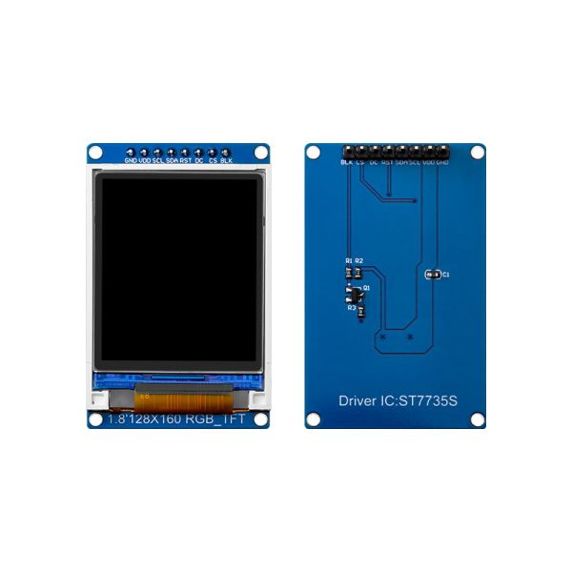
A 1.8-inch TFT display provides the main user interface.
The display is used to show system information such as:
- Operating status
- Solar parameters
- Battery parameters
- Load/current information
- Grid status
- System state
- Settings

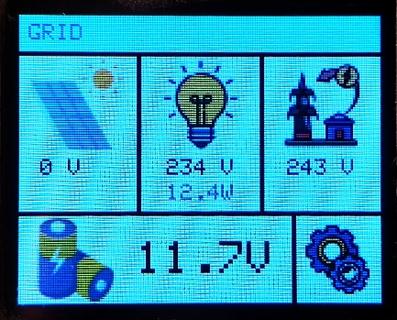 | 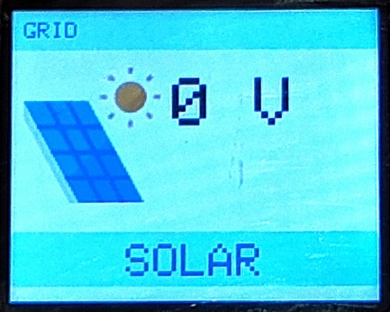 | 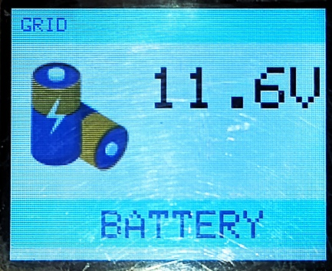
Home Screen | Solar UI | Battery UI

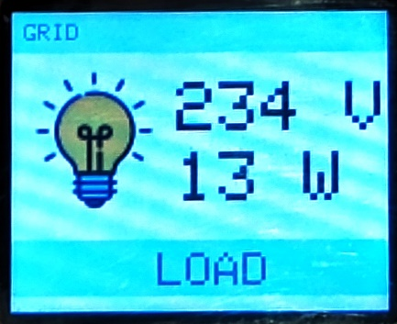 | 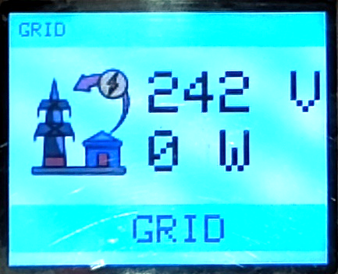 | 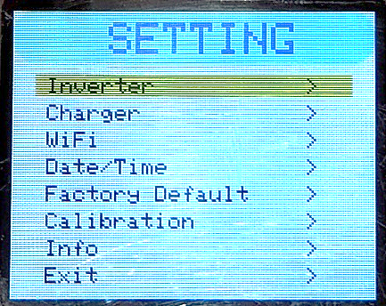
Load UI | Grid UI | Setting UI

Keypad
A dedicated keypad is provided for navigation and configuration.
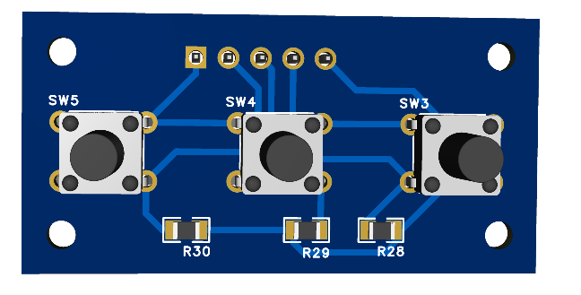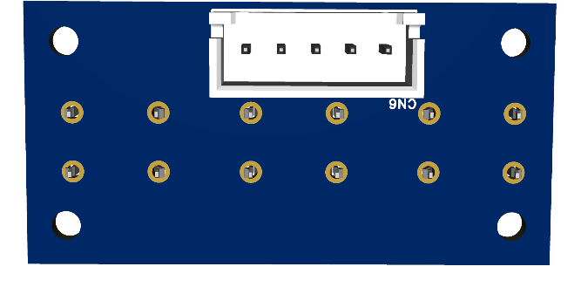
The keypad allows the user to:
- Navigate through menus
- Change settings
- Select operating options
- Confirm selections
- Return to previous menus
- Access monitoring pages

Key functions
Key | Function
Key 1 | UP
Key 2 | DOWN
Key 3 | ENTER

Settings
The device provides configurable parameters through the keypad and TFT interface.
The available settings depend on the current firmware version.
Examples include:
- Operating mode
- Battery thresholds
- Solar-related thresholds
- Switching parameters
- Protection limits
- Display settings

Firmware
The controller firmware is written on ArduinoIDE for the ESP32.
The latest firmware is available in the GitHub repository.

GitHub
Solar Device Advance – GitHub Repository
Complete process to upload the firmware is described in the document:
How to upload the firmware

Enclosure

Casing
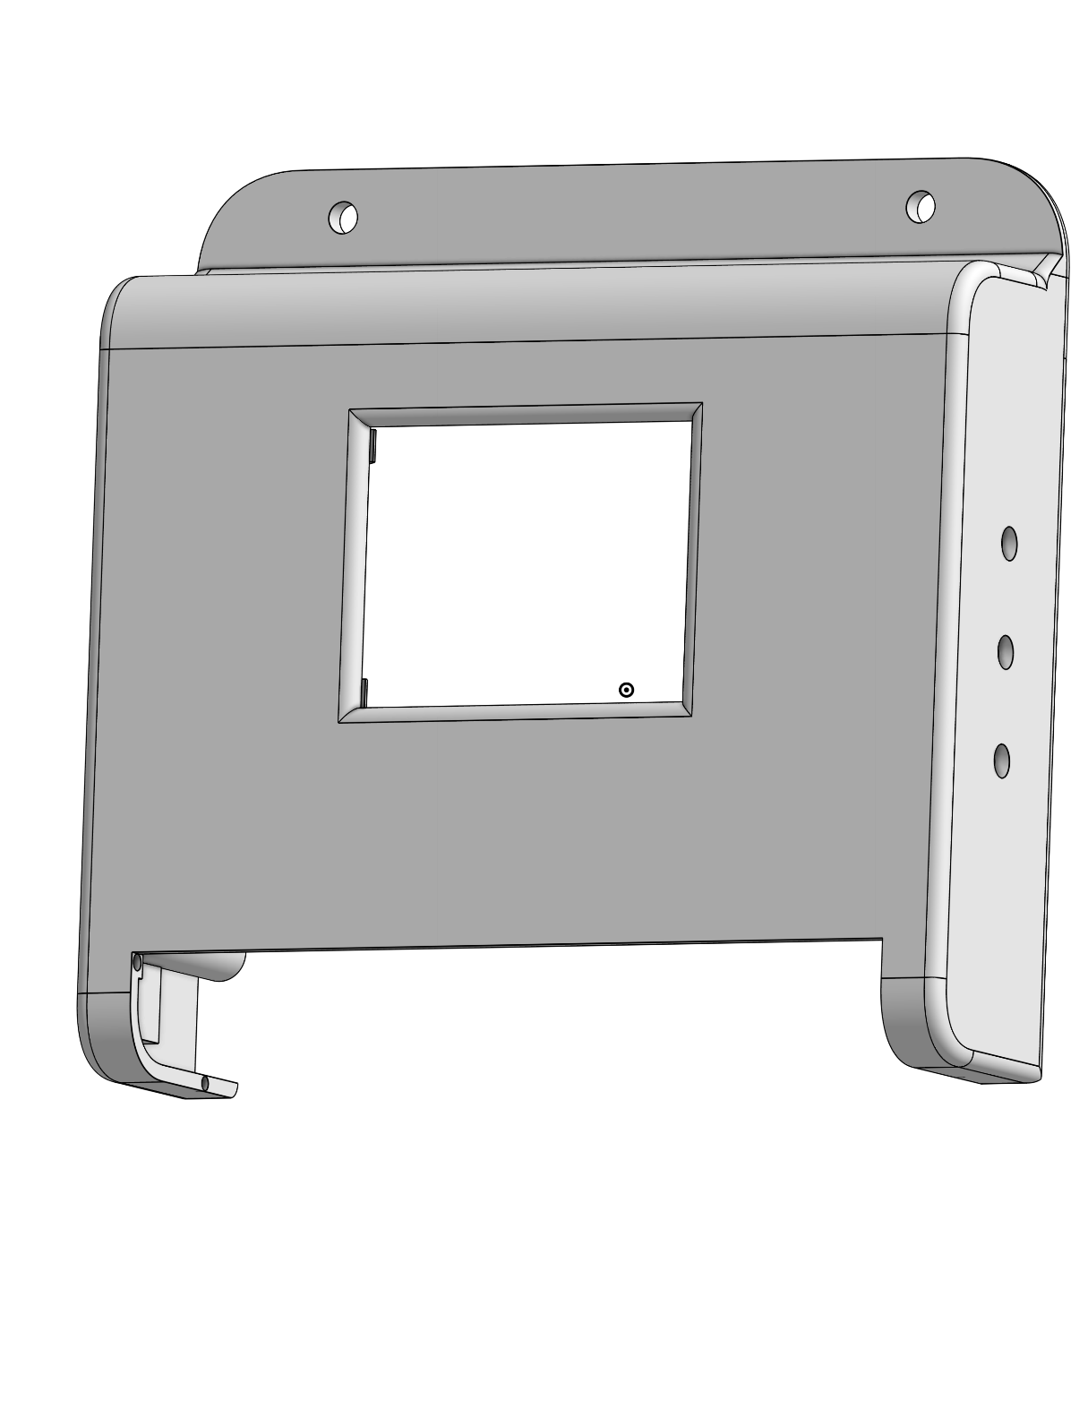

Back plate
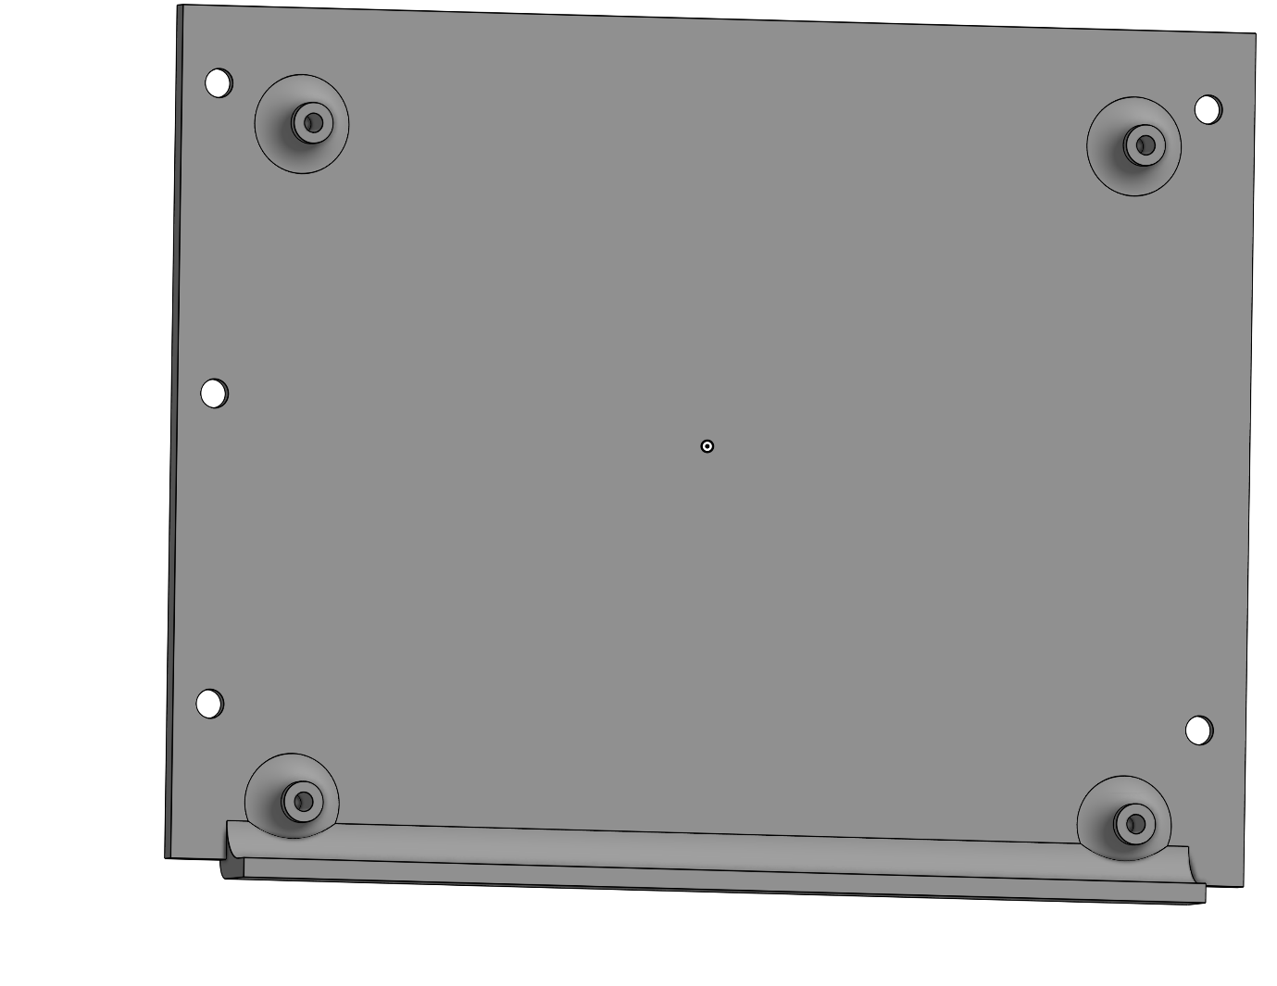

Connection cover

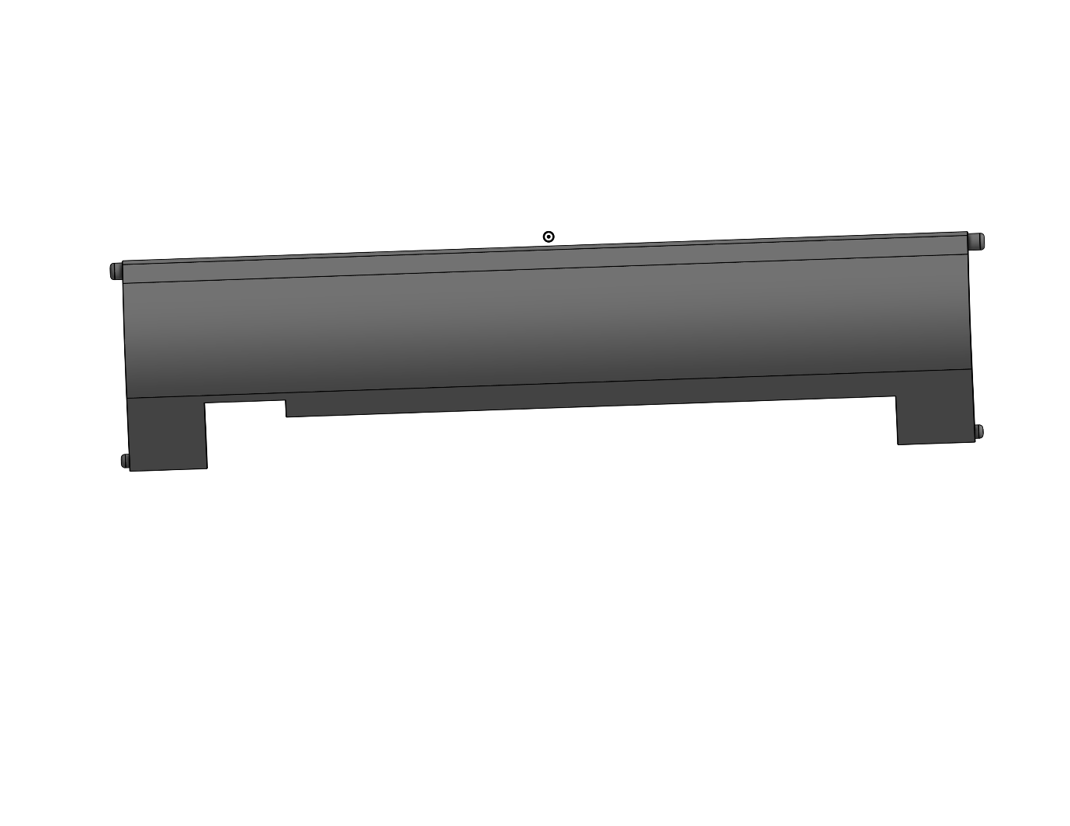

Assembling

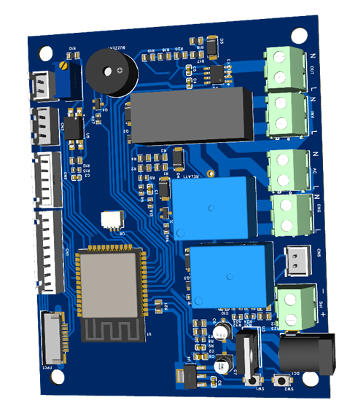
Reserve
Firmware upload
Reserve
To Keypad
To LCD
Connect 1.8” TFT LCD to CN1 connector of the mainboard and keypad to the CN2 connector of the mainboard as mentioned in the figure.

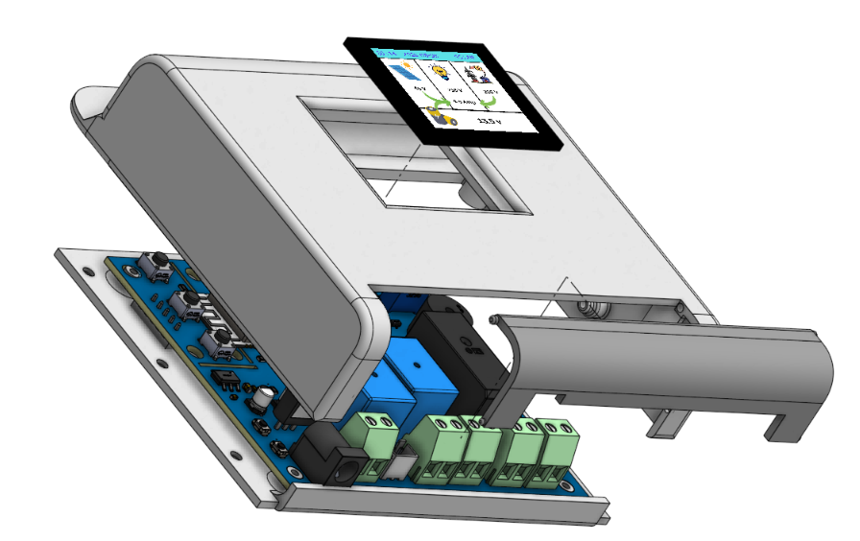

Finished product display
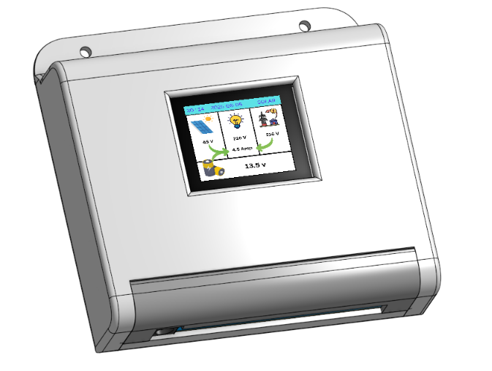

Calibrations
The measurement channels should be calibrated before normal operation.
Calibration may be required for:
- PV voltage
- Battery voltage
- Current sensors
- Grid Voltage
- Other analog measurement channels

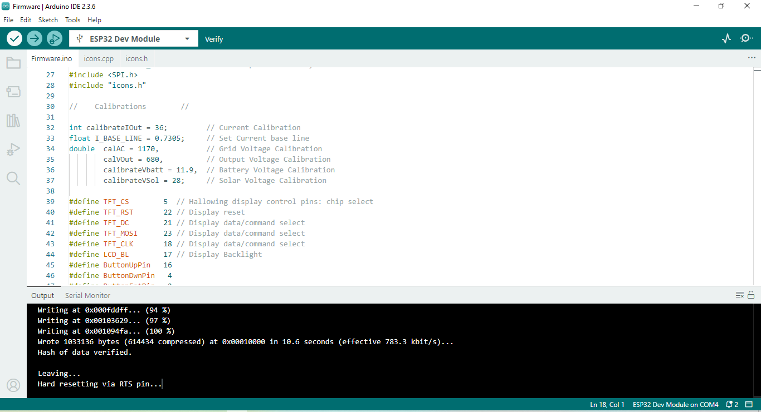

Use a calibrated multimeter or suitable reference instrument when performing calibration.
The calibration procedure and values should correspond to the actual hardware and firmware version.

Troubleshooting
Problem | Possible Cause
TFT does not start | Wiring, power, SPI configuration, or firmware
Keypad not responding | Wiring or GPIO configuration
Voltage reading incorrect | Calibration or voltage-divider configuration
Current reading incorrect | ACS712 offset/calibration
Relay does not operate | Driver, GPIO, relay supply, or wiring
Grid status incorrect | Grid detection circuit or configuration
ESP32 resets | Power supply, noise, or wiring
Incorrect source switching | Firmware settings or sensing conditions
For detailed troubleshooting, compare the measured hardware signals with the schematic and configuration.

Limitations
This project is designed to work with the hardware configuration documented in the repository.
Performance and measurement accuracy depend on:
- Sensor accuracy
- Component tolerances
- PCB design
- Calibration
- Power supply quality
- UPS/inverter characteristics
- Relay/contact ratings
- Installation and wiring

Future Development
Possible future improvements include:
- Wi-Fi monitoring
- Web dashboard
- Mobile monitoring
- Energy logging
- Remote notifications
- OTA firmware updates
- Data logging
- Additional operating modes
- Improved measurement accuracy
- Additional battery-management functions

Disclaimer
This project is provided “as is” for educational, experimental, and DIY purposes.
The system may involve high battery currents, solar DC voltage, inverter output, and potentially lethal AC mains voltage. Incorrect wiring, component selection, firmware configuration, or installation can result in electric shock, fire, equipment damage, battery damage, or other hazards.
The author assumes no responsibility for injury, death, equipment damage, fire, property damage, or any other loss resulting from the construction, modification, installation, or use of this project.
Do not work on energized circuits.
If you are not experienced with mains-voltage or high-current electrical systems, seek assistance from a qualified professional.

Project Status
Status: Development / Testing
The hardware and firmware are under continuous development. Features, circuit designs, firmware behavior, and documentation may change between versions.

