Using the earnings CSV as a base, prepare a new data file with employees’ office locations. Make sure there are 5-6 distinct locations that are shared between employees.
Create a Glue job that aggregates the data based on the office location to calculate average salaries and raise percentages for these locations.

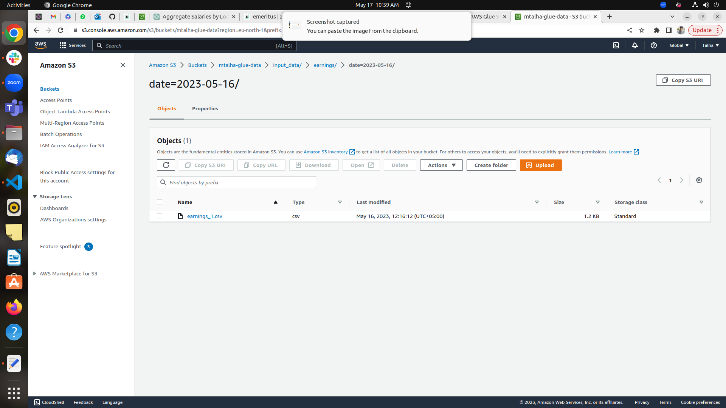
Uploading data into S3 bucket

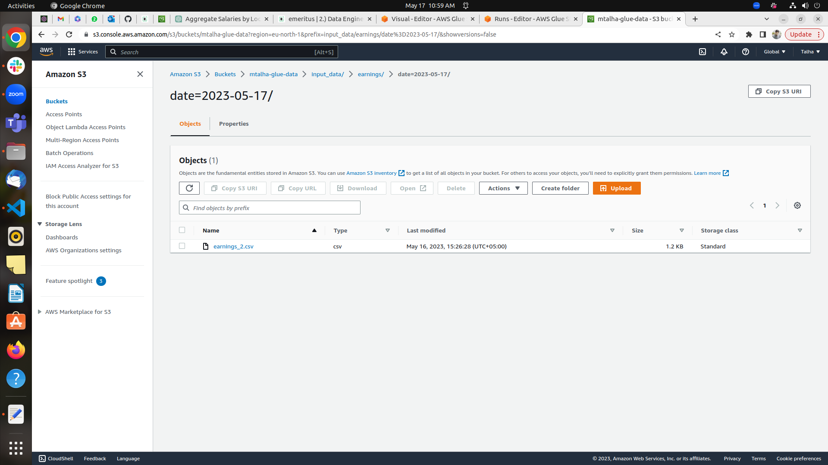
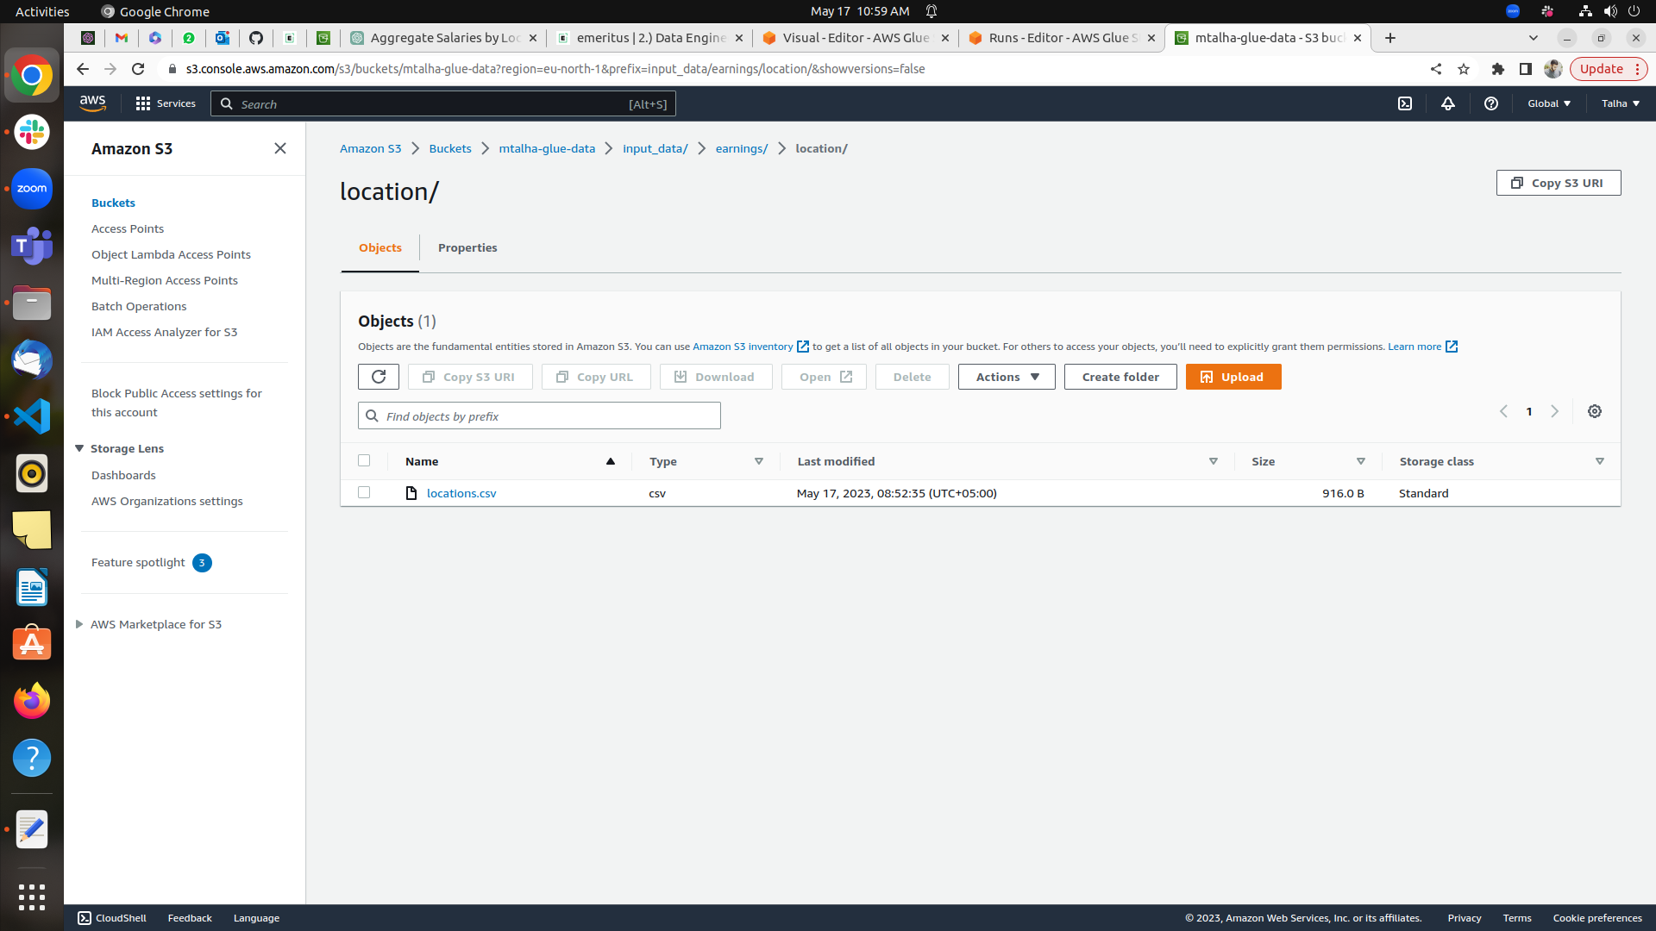
Created Crawler
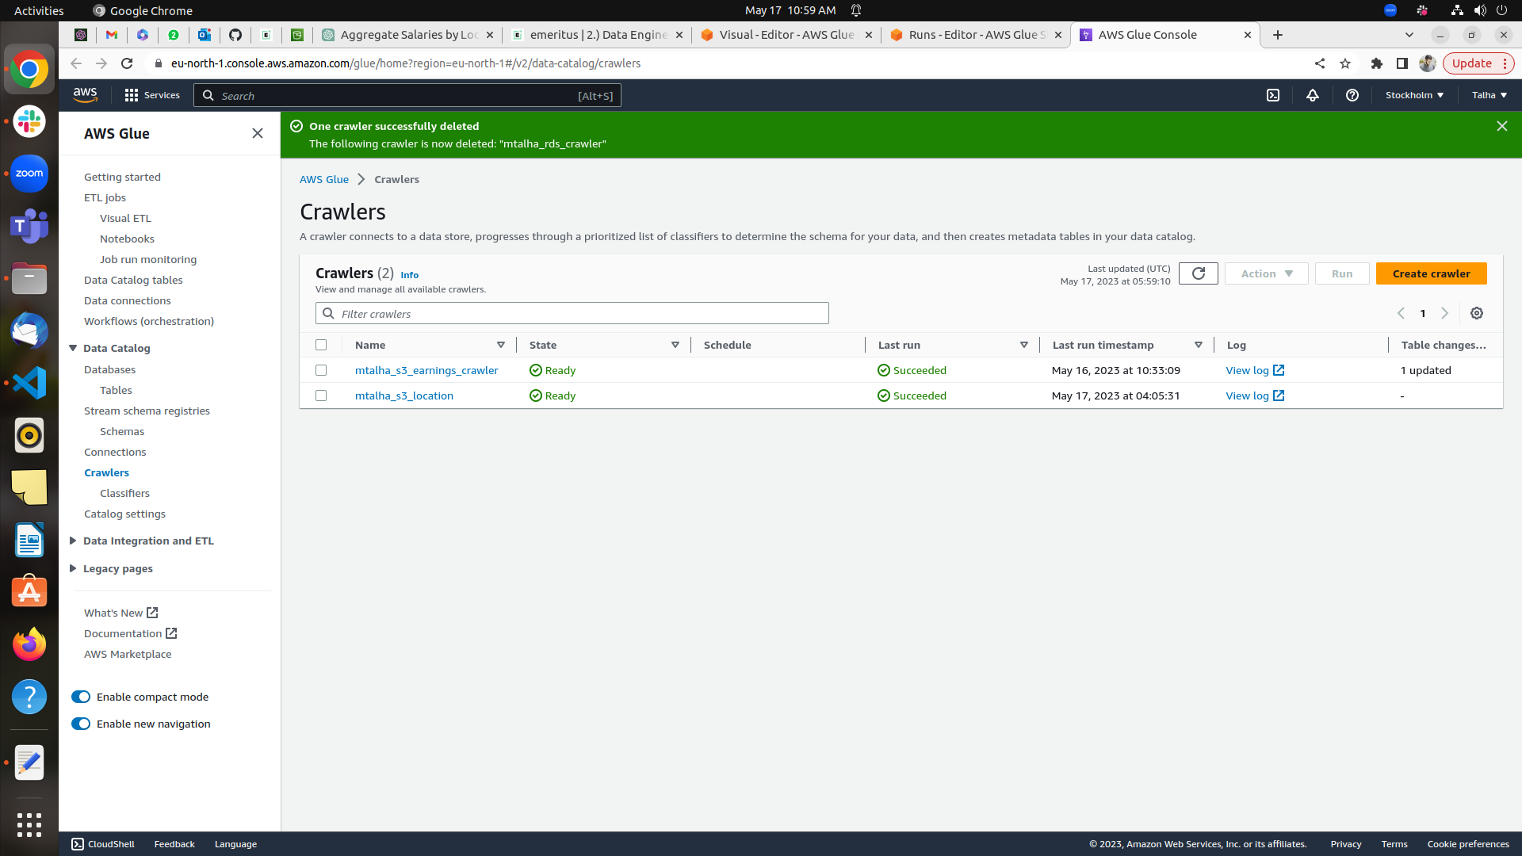
Created Glue Job
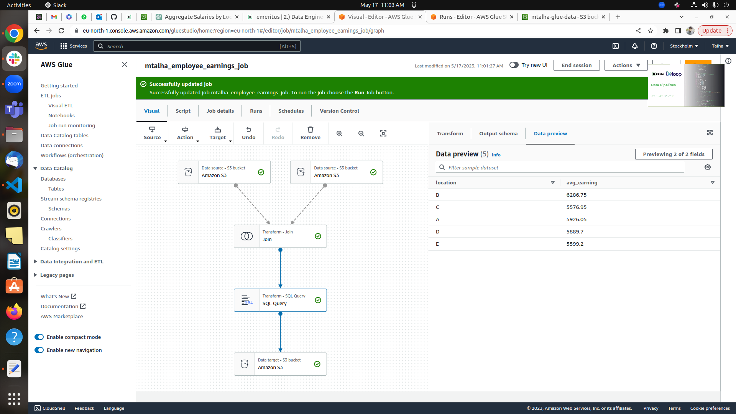

Running the job

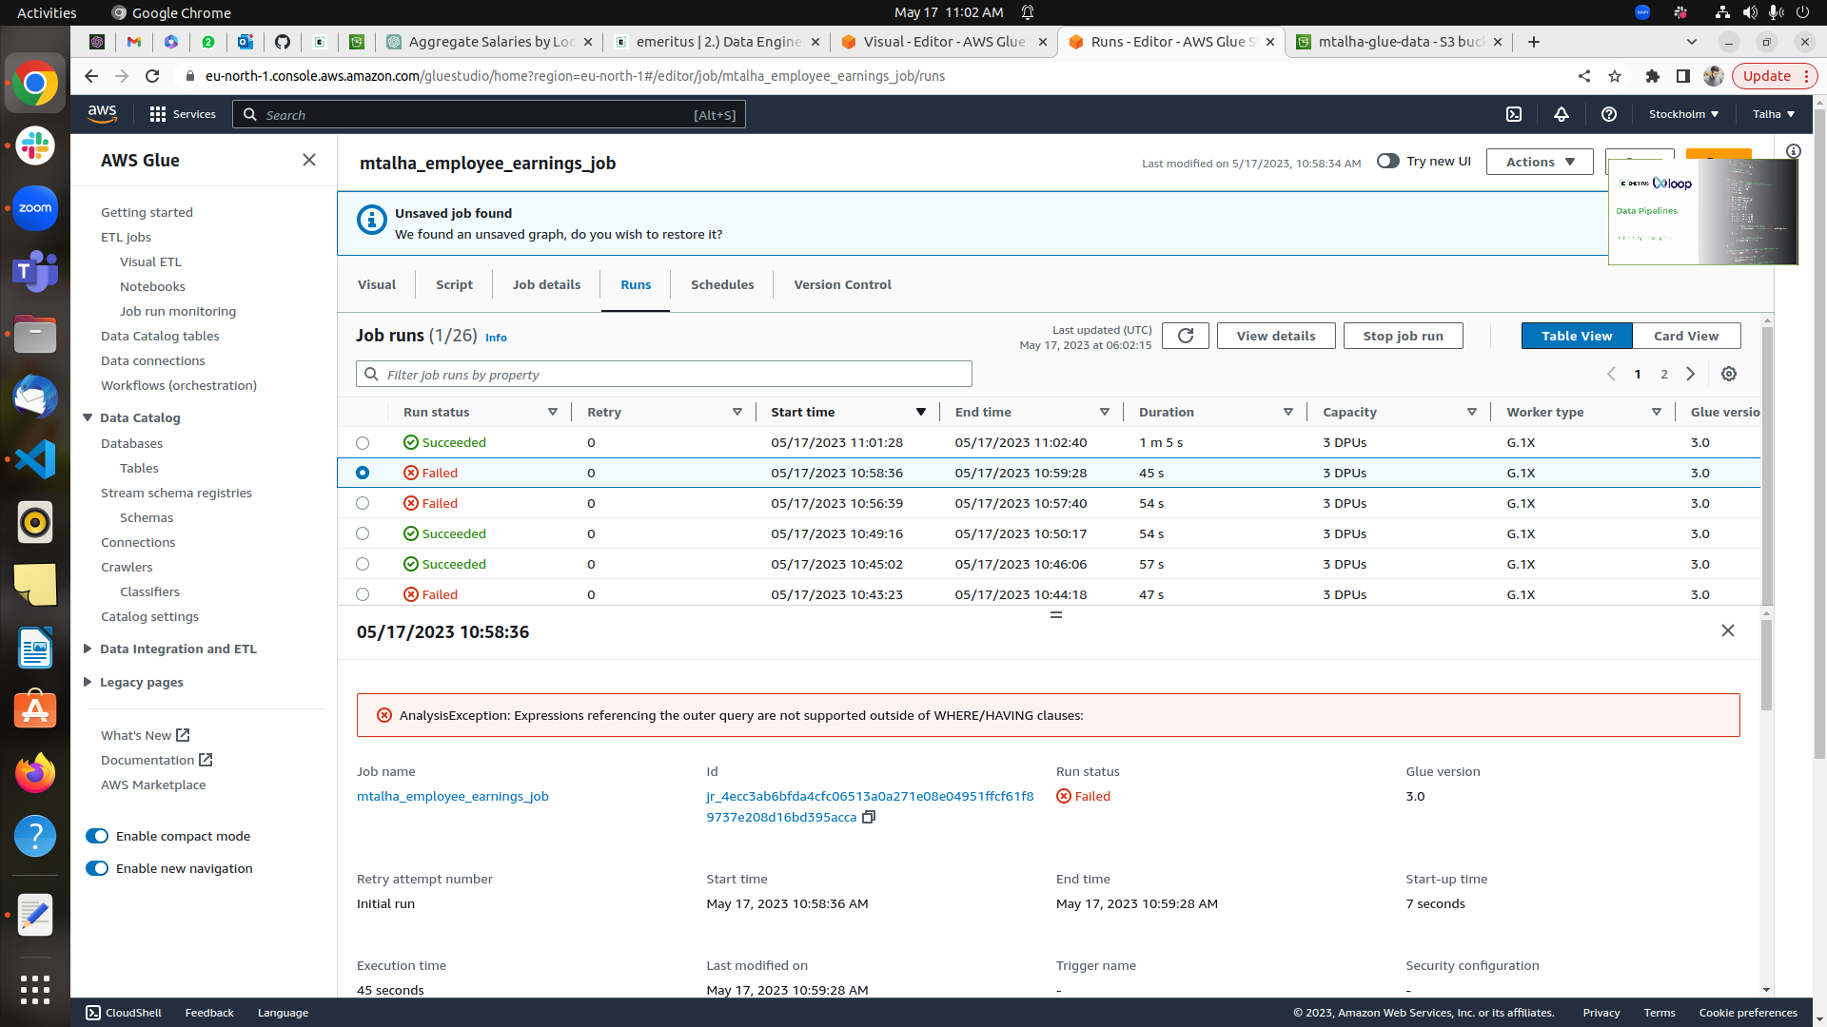

Sql Query & query output showing the result Avg salary based on the location
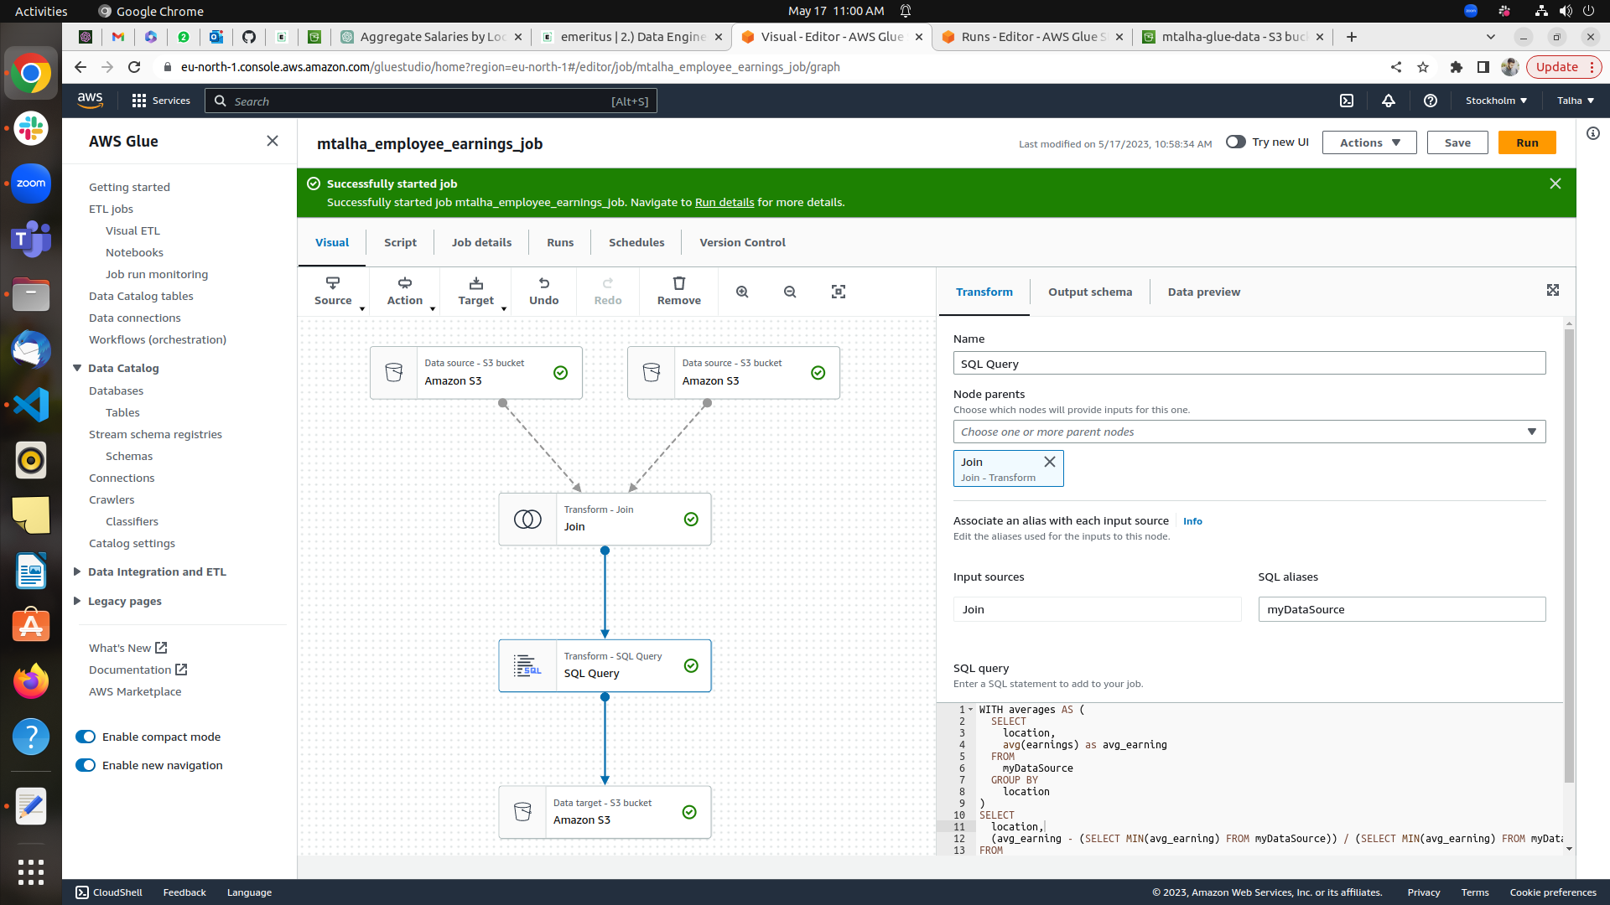

Query output showing the result raise percentage based on the location

Saving the data
