
F/SOP/FYDP 02/01/00

Department of Computer and Information Systems Engineering

Title

CS-406 Computer Engineering Project

Proposal for the Final Year Design Project

“Smart Asset Tracking and Predictive Maintenance System for Emirates Flight
Catering”

Domain |  | Domain 1 |  |  | Domain 2 |  | Domain 3 |  | Domain 4 |  | Domain 5 |  |  | Domain
 |  |  |  |  |  |  |  |  |  |  |  |  |  | 6
 |  | Internet of Things |  |  | Cloud | Data Analytics |  |  | AI and
 |  | (IoT) |  |  | Computing |  | and Machine |  | Predictive |  | ERP
 |  |  |  |  |  |  | Learning |  | Models | Integration
 | 1. Nature of Project [Tick all that applicable]
 | ☒ New Project OR |  | ☐ Extension of Existing Project |  |  |  |  | ☒ Industrial Collaboration |  |  |  |  | ☐ Funded
 | ☐ Other Department Collaboration |  |  |  |  |  |  | ☐ Other Academic Institution
 |  |  |  |  |  |  |  | Collaboration
 | (If yes) Department |  | Name |  |  |  |  | (If yes) Institution Name

- Brief Outline (Problem Identification and Significance)

Emirates Flight Catering faces challenges in managing and maintaining its fleet of catering vehicles. These vehicles are responsible for delivering food to aircraft and must be operational at all times to ensure seamless airport operations. Current manual methods of tracking vehicle usage and scheduling maintenance are prone to inefficiencies and unplanned downtime, leading to operational delays.

The Smart Asset Tracking and Predictive Maintenance System addresses these issues by using IoT sensors to collect real-time telemetry data from vehicles. This data will be processed by an AI-driven system to predict potential maintenance needs before breakdowns occur, ensuring operational efficiency. Additionally, the system will integrate with Emirates Flight Catering's ERP system to automate maintenance work orders, further streamlining fleet management and reducing downtime.

  - Objectives

- Real-Time Asset Tracking: Implement a system for real-time monitoring of vehicle locations, speed, fuel consumption, and operational status using IoT sensors.

- Predictive Maintenance: Develop machine learning models to predict when a vehicle will require maintenance, reducing unexpected breakdowns and improving uptime.

- ERP Integration: Automatically generate maintenance service work orders based on predictive maintenance data, integrating with the existing ERP system to ensure seamless operations.

- Data Analytics: Provide analytics and reports on vehicle performance, usage patterns, and maintenance history, empowering the operations team to make informed decisions.

F/SOP/FYDP 02/01/00

  - Alerts and Notifications: Implement alert systems to notify relevant personnel of potential issues or maintenance needs in real-time.

    - AI-Powered Insights: Leverage AI to provide insights and recommendations for optimizing vehicle usage, reducing costs, and improving efficiency.

- Scope

The system is designed to optimize vehicle management and maintenance for Emirates Flight Catering by using IoT, predictive AI models, and ERP integration. The solution will involve:

- Installing IoT sensors on all vehicles to monitor real-time operational data.
- Developing a backend to process and store data securely in the cloud.

- Implementing predictive algorithms to forecast maintenance needs and reduce unexpected vehicle breakdowns.

- Creating a user-friendly interface for tracking vehicle performance, generating alerts, and viewing historical data.

Integrating with the ERP system to automate maintenance scheduling and work order creation.

  - Proposed Methodology

- Requirements Gathering and System Design:

  - Collaborate with Ephlux to define the telemetry data (e.g., engine health, fuel efficiency) and integration with Fly Emirates' ERP system for maintenance work orders.
Outcome: Detailed project plan and integration flow with Ephlux.
- IoT Sensor and Telemetry Data Collection:

  - Install OBD-II readers and additional sensors with to collect real-time data from the vehicles.
Outcome: Real-time telemetry data from vehicles.
- Data Transmission and Cloud Integration:

  - Work with Ephlux to set up cloud platforms and communication protocols for data transmission.
Outcome: Reliable telemetry data pipeline.
- Real-Time Monitoring and Alerts:

  - Build dashboards and alert systems for vehicle performance metrics. Outcome: Real-time insights.
- Predictive Maintenance Model:

  - Develop machine learning models for predictive maintenance. Outcome: Predictive models that reduce vehicle downtime.
- ERP System Integration and Automation:

  - Integrate predictive alerts with Fly Emirates' ERP system, automating maintenance workflows.
Outcome: Automatic work order generation.

F/SOP/FYDP 02/01/00
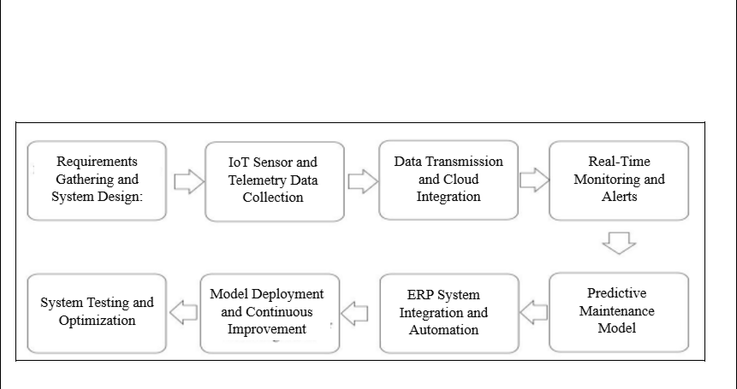

7. Model Deployment and Continuous Improvement:

- Deploy and refine predictive models based on real-time data.
Outcome: Continuous improvement of models, reducing vehicle downtime.

- Resources Involved Tools:
  - Swift Platform

  - Swift Team

  - IoT/vehicle sensors

7. Description of Industrial Support (If any)

Ephlux has provided us with valuable insights to understand the problem and develop a tailored solution for Emirates Flight Catering. They will provide access to their Swift platform, which will be used to implement the system, manage telemetry data, run predictive models, and integrate with the RP system. Their expertise and platform will be critical in ensuring the successful development and deployment of the solution.

8. SDGs (If Applicable)
☐ No Poverty | ☐ Zero Hunger
☐ Good Health and Well-Being | ☐Quality Education
☐ Gender Equality | ☐ Clean water and Sanitation
☐ Affordable and Clean Energy | ☒ Decent Work and Economic growth
☒ Industry, Innovations and Infrastructure | ☐ Reduced Inequalities
☒ Sustainable Cities and Communities | ☐ Responsible Consumption and Production
☐ Climate action | ☐ Life Below Water
☐ Life on Land | ☐ Peace, Justice and Strong Institutions
☐ Partnerships

 |  |  |  |  |  |  |  | F/SOP/FYDP 02/01/00
8. Gantt Chart
Year |  |  |  |  | 2024 to 2025
Months | Aug’ 24 | Sep’ 24 | Oct’24 | Nov’24 | Dec’24 | Jan’25 | Feb’25 | Mar’25 | Apr’25
Proposal
Preparation | ✓
Requirement
Analysis and |  | ✓
Understanding |  |  | ✓
Needs
IoT Sensor
Selection and |  |  |  | ✓
Procurement
IoT Sensor
Installation and |  |  |  |  | ✓
Telemetry Data
Collection

Cloud
Infrastructure |  |  |  |  |  | ✓
Setup and Initial
Data
Transmission
Testing.
Predictive
Maintenance |  |  |  |  |  |  | ✓
Model
Development
ERP System
Integration and |  |  |  |  |  |  |  | ✓
Model
Deployment and
Refinement
System Testing
and Optimization |  |  |  |  |  |  |  |  | ✓

F/SOP/FYDP 02/01/00

  - Details of Project Team

- Students

No. | Name | Seat No. | Signature (s)
1 | Syed Wahaj Raza Zaidi | CS21-055
2 | Farrukh Niaz | CS-21-064
3 | Huzaifa Naseer Khan | CS-21-067
4 | Muzammil Raza Rizvi | CS21-089

- Supervisors / Advisors
 | Name | Designation & | Address & Contact | Signature(s)
 | Name | Department | Address & Contact | Signature(s)
Supervisor | Dr. Shahab Tahzeeb | Assistant Professor
Supervisor | Dr. Shahab Tahzeeb | at CIS Department | stahzeeb@neduet.edu.pk
Co-Supervisor
(If any)
Industrial Advisor
(If any)

F/SOP/FYDP 02/01/00

For Office Use Only

Project Serial No.:

Dated:

Signature

Convener Steering Committee

Signature

FYP Coordinator

- Proposal Approved

- Not Approved

- Returned for Clarification / Modification

Comments:
(if any)

(Signature of Chairperson)

Date:

