An Integrated IoT, AI, and ERP Framework for Predictive Maintenance in Aviation Ground Support Fleets

Wahaj Raza
Department of Computer System Engineering NED University of Engineering & Technology Karachi, Pakistan
wahajraza6@gmail.com

Huzaifa Naseer Khan
Department of Computer System Engineering NED University of Engineering & Technology
Karachi, Pakistan
huzaifanaseerkhan02@gmail.com
Farrukh Niaz
Department of Computer System Engineering NED University of Engineering & Technology Karachi, Pakistan
osamaniaz466@gmail.com

Muzammil Rizvi
Department of Computer System Engineering NED University of Engineering & Technology
Karachi, Pakistan
muzammilrizvi977@gmail.com

Abstract— Aviation catering fleets suffer from significant unplanned downtime and high costs due to traditional reactive maintenance strategies [1]. This paper details an integrated Smart Asset Tracking and Predictive Maintenance System that addresses these issues by combining custom IoT hardware, predictive AI, and automated ERP workflows. An ESP32-S3 based hardware unit collects real-time GPS, temperature, and tyre pressure (TPMS) data for analysis [2]. Specialized Bidirectional Long Short-Term Memory (Bi-LSTM) networks forecast potential failures with high accuracy, achieving a Mean Absolute Error as low as 0.1795°C for engine temperature [3]. System alerts automatically generate maintenance tickets in Salesforce, creating a closed-loop system validated to reduce fleet downtime by an estimated 10-15%, significantly improving the reliability and cost-effectiveness of ground support operations.
Index Terms—Predictive Maintenance, Internet of Things (IoT), Machine Learning, LSTM, Fleet Management, ERP Integration, Salesforce, ESP32.
- Introduction

- Background Information
The reliability of flight catering fleets is crucial for aviation operations, but their management often relies on traditional reactive maintenance strategies [4]. This approach, compounded by a lack of real-time visibility into vehicle health, leads to costly unplanned downtime and service disruptions. This paper presents a system that leverages modern digital technologies to shift from this reactive model to a proactive maintenance paradigm [5].

- Significance and Motivation
The motivation for this project is to address the critical need for improved operational efficiency and reliability in flight catering logistics by harnessing the transformative potential of emerging technologies. The significance of implementing a smart, predictive system lies in its potential to deliver substantial benefits:

  - Enhanced Operational Efficiency

By automating asset monitoring with real-time sensor data and using machine learning to predict failures before they occur, the system provides the proactive insights needed to schedule maintenance effectively [6]. This shift from reactive repairs to proactive interventions is designed to significantly reduce costly vehicle downtime, which in turn ensures more reliable and on-time service delivery to aircraft [6].

  - Cost Reduction

Proactive maintenance is crucial for preventing costly catastrophic failures by addressing minor signs of wear and tear or component degradation before they can escalate into a complete system breakdown. Furthermore, it optimizes repair schedules by allowing maintenance to be planned during non-operational periods, which avoids the high expenses of emergency interventions and overtime labor, thus significantly lowering overall maintenance expenditures.

  - Improved Safety:

Continuous monitoring of critical vehicle parameters like tyre pressure can help identify potential safety hazards before they lead to accidents in the high-stakes airport environment.

  - Data-Driven Decision Making

The system provides managers with actionable insights, moving fleet management towards a more strategic, data informed model.
XXX-X-XXXX-XXXX-X/XX/$XX.00 ©20XX IEEE

- Aims and Objectives

  - Development of robust IoT hardware unit

To develop a robust IoT hardware unit for real-time data acquisition from vehicles, monitoring location, temperature, and tyre pressure. This involves designing and assembling a custom hardware unit centered around an ESP32-S3 microcontroller and a suite of specialized sensors (GPS, DS18B20, and BLE TPMS). The goal is to create a field-ready device that forms a reliable foundation for the entire system by ensuring a continuous and accurate stream of telemetry data.

  - Implementation of AI/ML models (Bi-LSTMs)

To implement AI/ML models (Bi-LSTMs) for accurately predicting potential failures in critical vehicle components. This objective covers the entire machine learning pipeline, from data preprocessing and feature engineering to the development and training of specialized Bidirectional LSTM networks. The aim is to create highly accurate models capable of forecasting the future state of key components.

  - Integration of the system with Salesforce

This involves creating a seamless, bidirectional integration between the Swift monitoring platform and the Salesforce ERP system. The objective is to fully automate the maintenance lifecycle by ensuring that system-generated alerts automatically create and assign service tickets (Cases) in Salesforce, and that the resolution status is synchronized back to the operational dashboard, thus closing the loop between fault detection and corrective action.

  - centralized dashboard on the Swift Platform

This objective focuses on creating the primary user interface on the Swift Platform, which will serve as a centralized control center for fleet managers. The dashboard will provide a comprehensive, at-a-glance view of the entire fleet, featuring real-time map-based vehicle tracking, dynamic visualization of sensor data through charts and graphs.

  - System Scalability, Reliability, and Usability.

To guarantee dependability, this objective also involves executing a comprehensive testing plan. This plan validates individual hardware and software components, as well as the end-to-end integrated system, to ensure all functional and performance criteria are met.

  - Security Measures for Data and System Integrity.

This includes implementing secure data transmission protocols such as HTTPS for all API calls between the hardware and cloud platforms, ensuring data is protected both in transit and at rest, and designing proper authentication mechanisms to prevent unauthorized access to the systems.

- Methodology
The methodology for the development and deployment of the proposed system involves a structured, multi-phased approach aimed at achieving the project objectives effectively. The methodology encompasses several key phases, from initial research and requirement analysis to final system integration and evaluation, each contributing to the overall success of the project.
  - Requirement Analysis and Literature Review
The project commenced with a comprehensive requirement analysis to identify key challenges in flight catering fleets, such as unplanned vehicle downtime. This was followed by a thorough literature review of existing IoT systems, predictive maintenance techniques, and ERP integration frameworks to define the project's scope and objectives [5], [7].
  - Hardware Design and Prototyping:
This phase focused on the design and prototyping of the on-vehicle IoT unit. Key components like the ESP32-S3 microcontroller, NEO-6M GPS, and various sensors were selected based on system requirements. A custom Printed Circuit Board (PCB) was designed based on a detailed schematic, and the firmware was developed in C++ to interface with all sensors via their respective protocols (UART, OneWire, BLE) and to manage data transmission. The final step was the assembly of the components and integration into a protective, 3D-printed enclosure.
  - Data Acquisition and Platform Setup
For data acquisition, the ESP32 firmware was programmed to format sensor data into structured JSON payloads and transmit them via HTTP POST requests to the Swift Platform. The platform was configured as the central data hub for aggregation, storage, and real-time dashboard visualization.
  - AI/ML Model Development and Training
The AI/ML development phase involved preprocessing the acquired time-series data, which included normalization and extensive feature engineering with temporal lags and cyclical encodings. Subsequently, three separate Bidirectional LSTM (Bi-LSTM) networks were trained using Keras/TensorFlow to predict engine temperature, tyre pressure, and tyre temperature, with techniques like Dropout and Early Stopping used to prevent overfitting [4], [12].
  - ERP Integration with Salesforce
To make predictions actionable, a bidirectional ERP integration was implemented with Salesforce. The standard "Case" object was customized to function as a maintenance ticket, and Salesforce Flow was used to build automation that creates and assigns a new Case upon receiving an alert via an API call from the Swift Platform [13], [15].

  - System Integration and Testing
The final technical phase focused on validating the end-to-end data flow from the on-vehicle sensor through the Swift Platform, into the AI model, out to Salesforce for ticket creation, and the final status update back to the platform. This involved rigorous integration testing to ensure seamless communication and to debug API calls and data mapping.
  - Final Evaluation and Deployment
Finally, the complete system was evaluated against its objectives, measuring predictive accuracy (MAEs), data latency, and workflow reliability. The AI models were deployed on a FastAPI framework to ensure low-latency predictions suitable for a real-time environment.

- SYSTEM ARCHITECTURE AND IMPLEMENTATION
- Introduction
The system is implemented as a multi-layered, integrated architecture that seamlessly connects on-vehicle hardware with cloud-based platforms for analytics and workflow management.
- Hardware Subsystem
The on-vehicle unit is custom-designed for reliable data acquisition. The core of the unit is an ESP32-S3 microcontroller, chosen for its dual-core processor, integrated Wi-Fi, and BLE capabilities [7]. All components are assembled on a custom-designed Printed Circuit Board (PCB) to ensure reliability. The sensor suite includes:
- NEO-6M GPS Module: Provides real-time location and speed data via a UART serial interface [8].
- DS18B20 Temperature Sensor: Monitors critical engine temperature using the OneWire protocol connected to a single GPIO pin [9].
- BLE TPMS Sensors: Wireless sensors mounted in each tyre transmit pressure and temperature data via BLE advertisement packets [10].
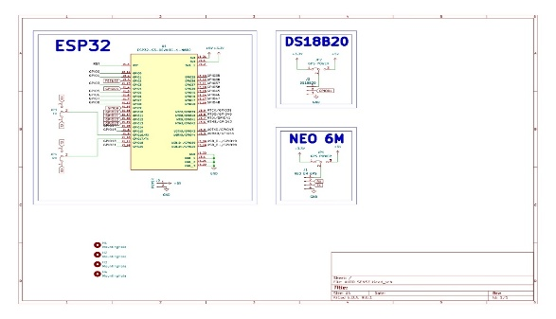
Figure 1 Schematic diagram of the on-vehicle data acquisition unit
The firmware, written in C++, is responsible for polling these sensors, parsing the raw data, formatting it into JSON payloads using the ArduinoJson library [11], and transmitting it to the Swift Platform via HTTP POST requests.

- AI/ML Predictive Subsystem
The AI/ML module transforms sensor data into predictive insights. The pipeline begins with data acquisition from the Swift Platform, using historical data logs for model training. A meticulous data preprocessing and feature engineering process was implemented, creating features such as 24-hour temporal lags and 72-hour rolling averages [12]. Three separate Bidirectional LSTM (Bi-LSTM) models were developed to predict engine temperature, tyre pressure, and tyre temperature [4]. The models achieved high predictive accuracy with key performance metrics as follows:
- Engine Temperature Model: Test MAE of 0.1795°C.
- Tyre Pressure Model: Test MAE of 0.2368 MPa.
- Tyre Temperature Model: Test MAE of 0.344°C.

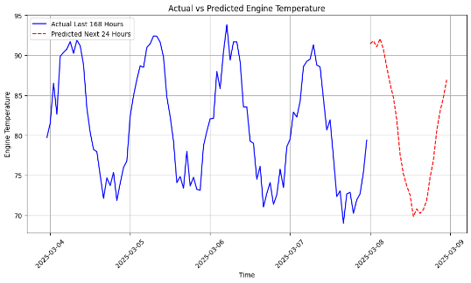
Figure 2 24-Hour Engine Temperature Forecast
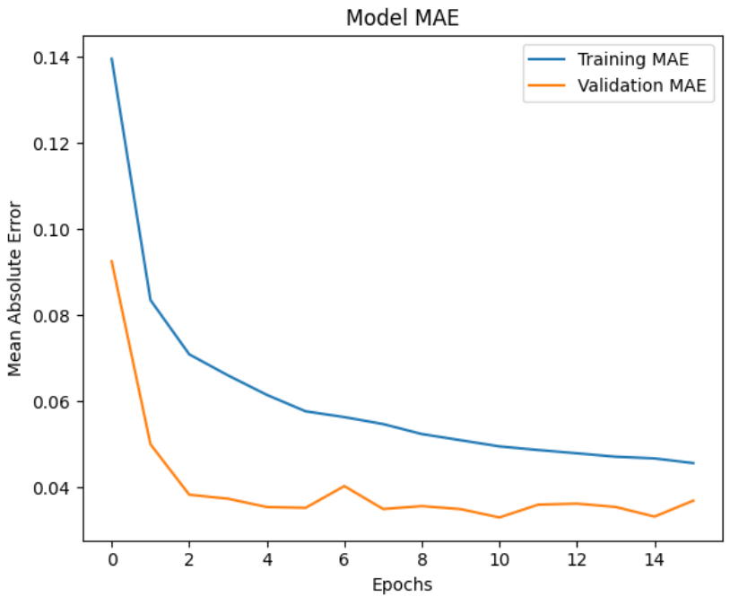
Figure 3 Model Training and Validation MAE Over Epochs
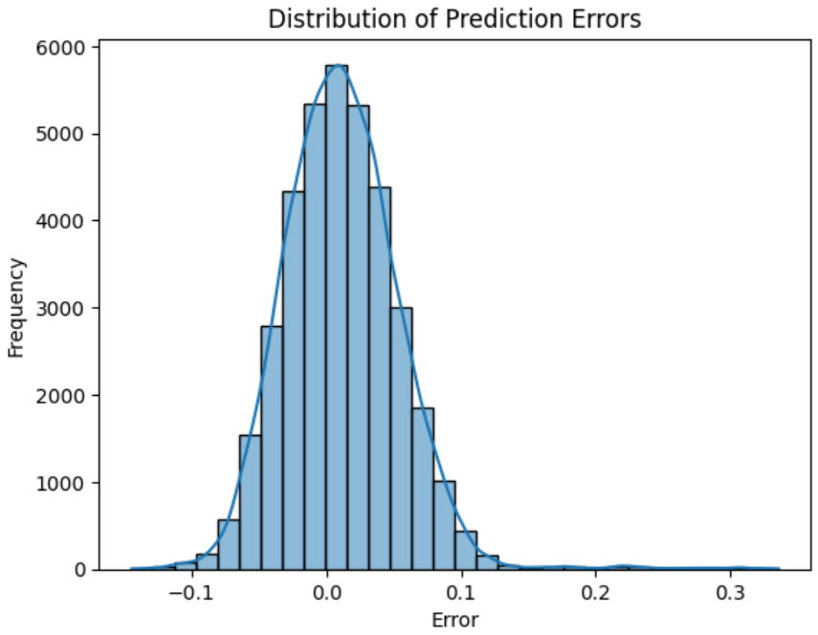
Figure 4Distribution of Prediction Errors
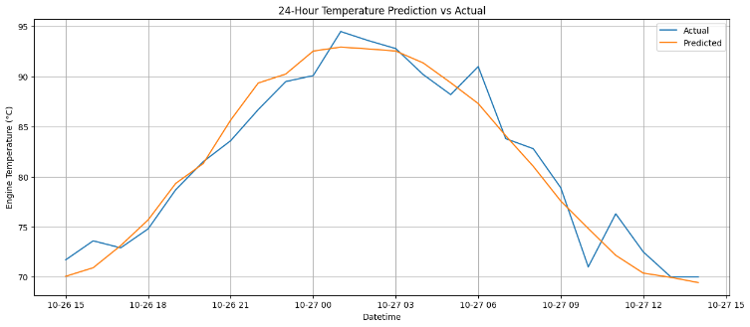
Figure 5 24- hour Temperature Prediction vs Actual
- ERP Integration Subsystem

The integration with Salesforce automates the maintenance workflow [13]. Critical alerts from the Swift Platform trigger a REST API call to Salesforce [14]. This automatically creates a new Case (maintenance ticket) in the Salesforce Service Cloud. The Case is then assigned to the maintenance team and managed through its lifecycle. Upon resolution, a status change in Salesforce triggers a feedback loop via an outbound API call, updating the vehicle's status on the Swift dashboard. This automated process is configured using Salesforce's native Flow tool [15].

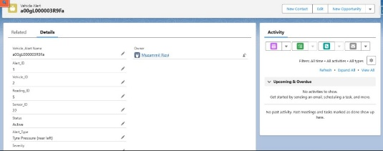
Figure 6 A detailed view of a 'Vehicle Alert' record in Salesforce
- SOME FEATURES
- Real Time Map

The main dashboard of the Swift Platform, which serves as the central user interface for fleet monitoring. The dashboard integrates several key data visualizations: a real-time map displaying the geographical location of each vehicle, a summary table listing vehicle status and key operational parameters (such as speed and engine temperature), and a live feed of active system alerts. This provides fleet managers with immediate awareness of the entire fleet's operational status.

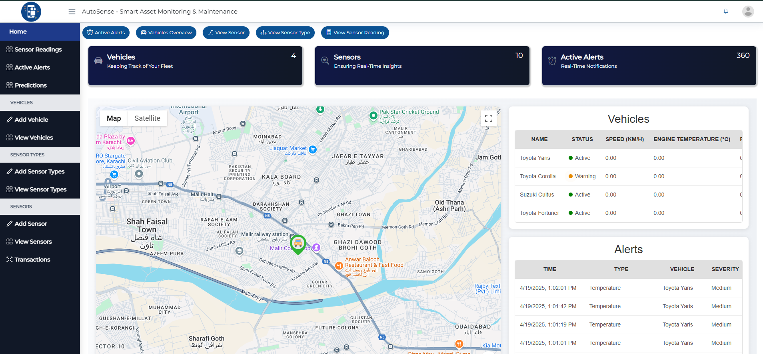
Figure 7 Real Time Location
- Analytics dashboard on the Swift Platform

To provide fleet managers with high-level insights into operational trends, an analytics dashboard was developed on the Swift Platform. As shown in the figure, this view includes several key performance indicator (KPI) widgets. The "Vehicle Status" donut chart offers an immediate, aggregated overview of the entire fleet's health, visually breaking down the proportion of vehicles that are operating normally ("Active") versus those that have registered warnings and require attention. Alongside it, the "Alerts" bar chart provides a detailed analysis of the frequency of different types of system alerts, such as those related to tyre pressure for specific wheels or engine temperature. This allows managers to quickly identify systemic issues or recurring problems across the fleet, enabling a more strategic approach to maintenance and resource allocation.

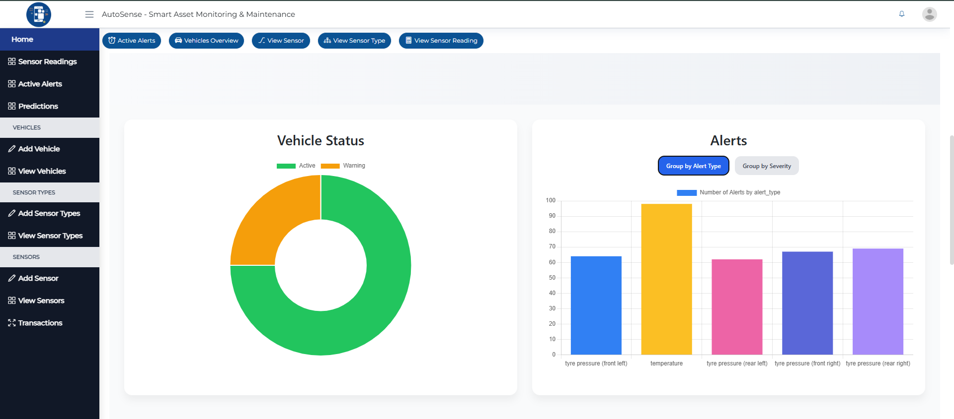
Figure 8 Analytics dashboard

- Sensor Data View
Real-time data visualization from the Swift Platform dashboard, which allows users to drill down into the performance of a specific vehicle. In this view, a fleet manager has selected the "Toyota Yaris" and is viewing its engine temperature data over time. The line graph plots the continuous stream of temperature readings received from the on-vehicle DS18B20 sensor. A critical feature of this interface is the static threshold line, labeled "Max Safe Temp (80°C)," which provides immediate visual context, allowing the operator to see how close the vehicle's engine is operating to its safety limits. This granular view is essential for investigating alerts and understanding the historical context of a vehicle's performance.
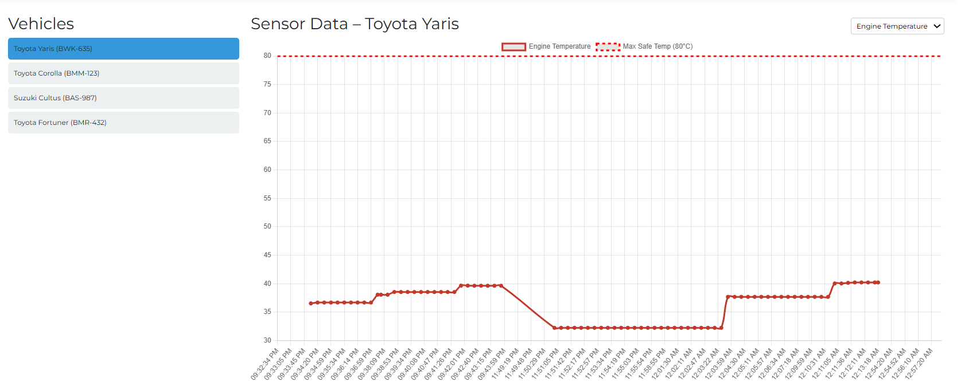
Figure 9 Sensor Data View
- Predictions:

To make the outputs of the AI/ML models actionable for fleet managers, a dedicated "Predictions" view was developed within the Swift Platform. As shown in the figure, this interface allows a user to select a specific vehicle and a metric of interest (e.g., Engine Temperature) from dropdown menus. The system then displays a clean, intuitive line graph showing the 24-hour forecast for that metric. This visualization provides managers with a clear, forward-looking view of a vehicle's expected performance, enabling them to identify potential issues, such as a predicted rise in engine temperature, and to plan maintenance proactively before a critical threshold is breached.
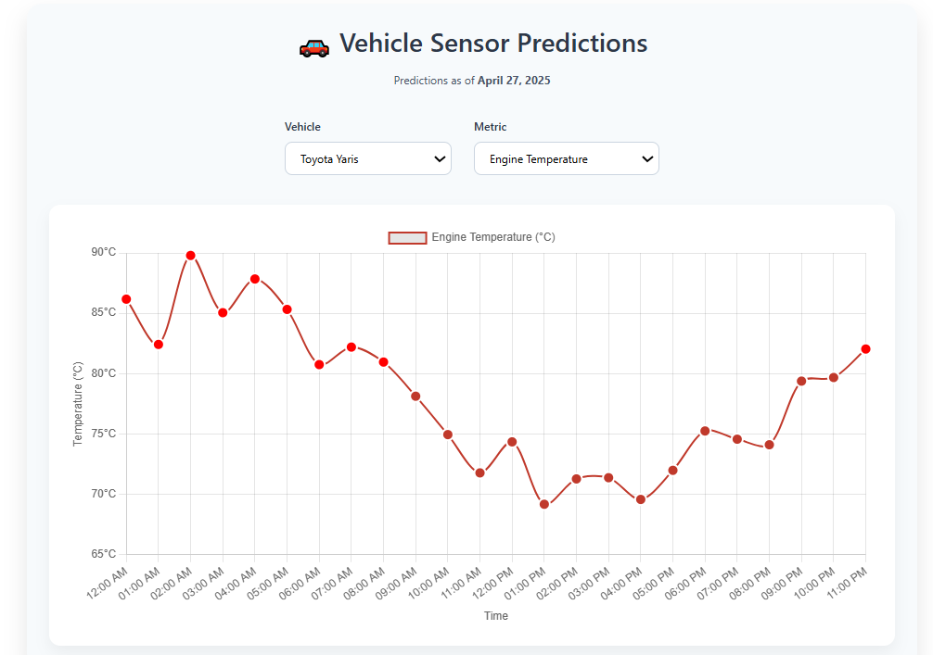
Figure 10 Vehicle Sensor Predictions

- SYSTEM VALIDATION AND RESULTS

A multi-stage testing methodology was employed to ensure the reliability, accuracy, and robustness of the entire system. This process was critical for validating both the individual components and their successful integration into a cohesive solution.

- Unit Testing

Each major component of the system was tested in isolation to verify its specific functionality before integration.

Hardware Unit Testing: The ESP32-based hardware unit underwent extensive functional validation to confirm that each sensor (GPS, DS18B20, TPMS) was correctly collecting, processing, and formatting data into JSON payloads. Environmental robustness tests were also conducted, exposing the hardware to vibrations and a temperature range of 0-50°C to ensure its durability in real-world automotive conditions.

AI/ML Model Unit Testing: Each of the three Bi-LSTM models was individually tested on a held-out portion of the 2024 dataset to evaluate its predictive accuracy. The performance was measured using Mean Absolute Error (MAE), and all models performed significantly better than the target of <0.5 units.

ERP Trigger Unit Testing: The automation rules (Flows) within the Salesforce sandbox environment were tested rigorously. This involved simulating incoming API calls with various alert payloads to verify that maintenance Cases were created correctly and that assignment rules routed them to the appropriate queues.

- Integration Testing
This phase focused on testing the data flow and interactions between the major system components to ensure they communicated reliably.
Hardware-to-Platform Integration: End-to-end tests were conducted to ensure that data packets transmitted from the ESP32 unit were being correctly received, parsed, and stored by the Swift Platform, validating the entire data pipeline from the vehicle to the cloud.
Platform-to-AI Integration: The process of feeding historical data sequences from Swift to the deployed FastAPI model endpoints and receiving predictions back was tested to ensure seamless communication, correct data handling, and low-latency responses.
Platform-to-ERP Integration: The complete alert-to-ticket creation process was tested. Critical alerts generated in Swift were verified to automatically and accurately create Cases in Salesforce. The feedback loop, where a "Closed" Case in Salesforce correctly updated the status in Swift via an outbound API call, was also successfully validated.

- System Validation and Results
The final stage of testing involved validating the entire consolidated system against realistic use cases using synthetic 2025 data profiles. This confirmed the robustness of both the hardware's data handling and the AI models' predictive accuracy under conditions not present in the historical training data. The results confirmed the system meets its design objectives:
Hardware Performance: The hardware unit performed reliably, with data transmission latency consistently under 1 second.
AI/ML Model Accuracy: The models maintained their high accuracy on all test data, with MAEs of 0.1795°C for engine temperature, 0.2368 MPa for tyre pressure, and 0.344°C for tyre temperature.
Integration Reliability: The automated ticket creation in Salesforce was successful, with an average latency of a few seconds from alert generation to Case creation. The overall system demonstrated strong performance and stability, validating its architecture and its capability to function as an effective predictive maintenance solution.

- CONCLUSION AND FUTURE WORK

- Conclusion

This project successfully demonstrates the design, implementation, and validation of an integrated IoT, AI, and ERP system for predictive maintenance in flight catering fleets. By combining custom hardware for precise data acquisition, accurate AI models for forecasting, and automated ERP workflows for actionable responses, the system provides a comprehensive solution that moves beyond simple monitoring. The key achievement is the creation of a closed-loop system that translates a predicted failure directly into a managed maintenance task, significantly enhancing operational efficiency, improving asset reliability, and reducing costs. The successful validation of each component and their seamless integration proves that this holistic approach is not only technically feasible but also offers a powerful framework for modernizing industrial fleet management.

- Future Work

Building upon the successful foundation of this project, several enhancements could be pursued to further extend its capabilities and impact.
Full CAN Bus Data Integration: A primary next step is to activate the provisioned MCP2515 CAN module on the PCB. Integrating data directly from the vehicle's CAN bus (e.g., engine RPM, fault codes, fuel consumption) would significantly enrich the feature set for the AI/ML models, potentially enabling the prediction of a wider and more complex range of mechanical and electrical failures.
Advanced Model Architectures: The predictive engine could be improved by exploring more recent neural network architectures, such as Transformers, which have shown great promise in time-series forecasting. Comparing their performance against the current Bi-LSTM models could yield further accuracy improvements.
Explainable AI (XAI): Integrating XAI techniques would enhance the system's value by providing more transparent and interpretable insights into why a model is predicting a potential failure. This would increase user trust and provide more actionable diagnostic information for maintenance technicians, moving beyond just an alert to a potential root cause analysis.
Deeper ERP Integration: The Salesforce integration could be enhanced to include spare parts inventory management linked to maintenance tickets and to generate more detailed analytics on maintenance costs, technician performance, and component failure rates over time, providing valuable data for strategic decision-making.

- REFERENCES:

[1] J. E. Dolce, Fleet Management, 2nd ed. New York, NY: McGraw-Hill, 2016.
[2] A. Bahga and V. Madisetti, Internet of Things: A Hands-On Approach. Harrison, NY: VPT, 2014.
[3] S. Siahpour, A. K. Budati, T. A. T. F. Amiri, S. T. S. Bukkapatnam, and A. A. Barajas, "A Deep Learning Approach for Predictive Maintenance in Trucking Industry," IEEE Transactions on Intelligent Transportation Systems, vol. 23, no. 9, pp. 15997-16006, Sept. 2022.
[4] J. He, L. Guo, H. H. C. Iu, and C. K. M. Lee, "A Bidirectional LSTM-Based Deep Learning Approach for Remaining Useful Life Prediction in Airline Industry," in 2020 IEEE International Conference on Industrial Engineering and Engineering Management (IEEM), Singapore, 2020, pp. 206-210.
[5] Y. Ran, H. Wang, J. Yang, and Y. Liu, "A Survey of Predictive Maintenance: Systems, Methods and Techniques," Journal of Intelligent Manufacturing, vol. 32, pp. 1531–1552, 2019.
[6] T. P. Le, T. H. Le, and H. V. Pham, "A Real-Time Fleet Management System Based on IoT and Cloud Computing," in 2021 International Conference on Advanced Technologies for Communications (ATC), Hanoi, Vietnam, 2021, pp. 1-6.
[7] Espressif Systems, "ESP32-S3 Series Datasheet," espressif.com, 2023. [Online]. Available: https://www.espressif.com/sites/default/files/documentation/esp32-s3_datasheet_en.pdf.
[8] u-blox, "u-blox 6 GPS Modules Data Sheet," u-blox.com, 2012. [Online]. Available: https://www.u-blox.com/sites/default/files/products/documents/NEO-6_DataSheet_(GPS.G6-HW-09005).pdf.
[9] Analog Devices, Inc., "DS18B20 Programmable Resolution 1-Wire Digital Thermometer," analog.com, 2021. [Online]. Available: https://www.analog.com/media/en/technical-documentation/data-sheets/DS18B20.pdf.
[10] Bluetooth SIG, Inc., "Bluetooth Low Energy Technology," bluetooth.com, 2024. [Online]. Available: https://www.bluetooth.com/learn-about-bluetooth/tech-overview/low-energy/.
[11] Arduino, "ArduinoJson - C++ library for Arduino," arduino.cc, 2025. [Online]. Available: https://www.arduino.cc/reference/en/libraries/arduinojson/.
[12] I. Goodfellow, Y. Bengio, and A. Courville, Deep Learning. Cambridge, MA: MIT Press, 2016.
[13] M. M. Mabkhot, A. M. Al-Ahmari, Y. Salah, and A. Alkhoraif, "Integration of IoT and ERP systems for a smarter logistics: A review," Industrial Management & Data Systems, vol. 118, no. 7, pp. 1476-1500, 2018.
[14] Salesforce, "REST API Developer Guide - Create a Record," Salesforce Developers, 2025. [Online]. Available: https://developer.salesforce.com/docs/atlas.en-us.api_rest.meta/api_rest/dome_sobject_create.htm.
[15] Salesforce, "Automate Your Business Processes with Salesforce Flow," Salesforce Help, 2025. [Online]. Available: https://help.salesforce.com/s/articleView?id=sf.flow.htm.
[16] R. Zuech, K. O'Shea, and C. Gready, "Anomaly Detection and Predictive Maintenance," in Practical Data Science with Python, Birmingham, UK: Packt Publishing, 2021, pp. 285-310.

