**Step 1**: Open Google Chrome on your computer.

**Step 2:** Once Chrome is open, access the Chrome menu by clicking on the three dots located at the top right corner of the browser window.

* From the dropdown menu, select "More tools" and then click on "Extensions."
* At the top right corner of the Extensions page, toggle the Developer Mode switch to "On." This enables advanced options for extensions.

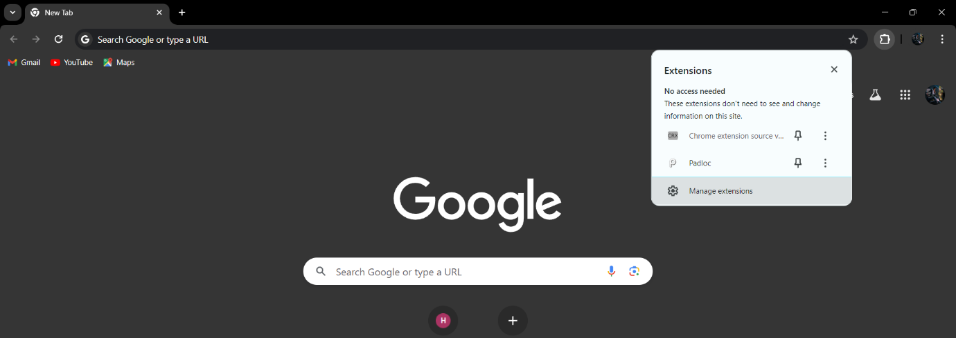

**Step 3:** After enabling Developer Mode, you'll see additional options appear.

* Click on the "Load unpacked" button.
* In the file explorer window that opens, navigate to the folder where you cloned or extracted the AIML phishing domain detection tool repository.
* Go to fronted folder and Select the folder containing the extension files and click "Select Folder" to load the extension.

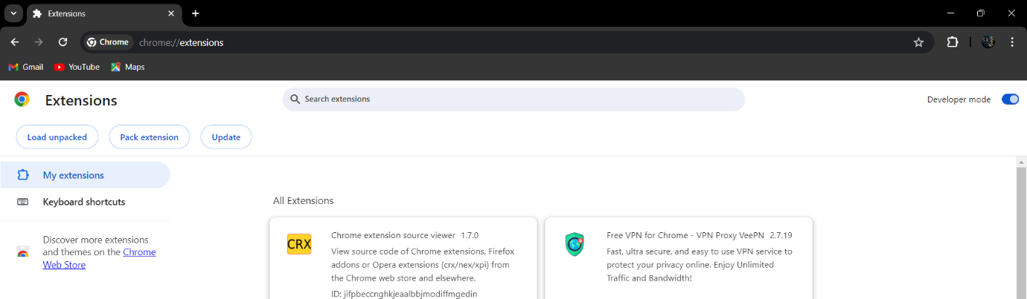

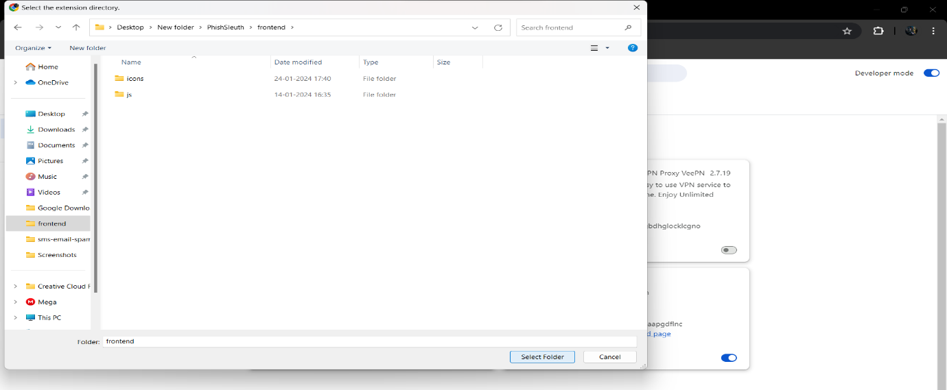

**Step 4:** Once the extension is loaded, you should see its icon appear in the Chrome toolbar.

* You may need to pin the extension to the toolbar for easy access. Right-click on the extension icon and select "Pin" if necessary.

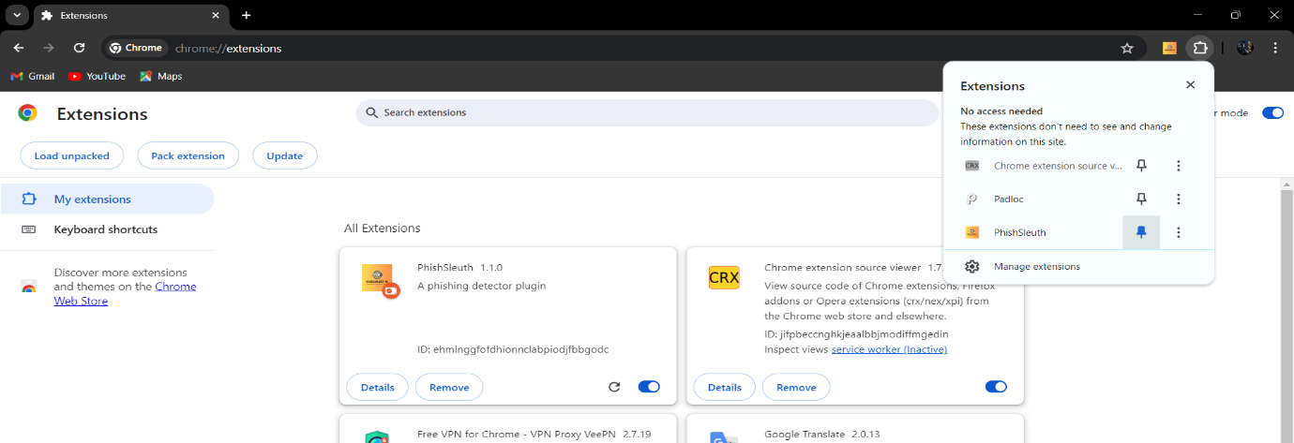

**Step 5:** Go to **PHISHALERT AI** folder and Install python-3.12.3 setup file.  
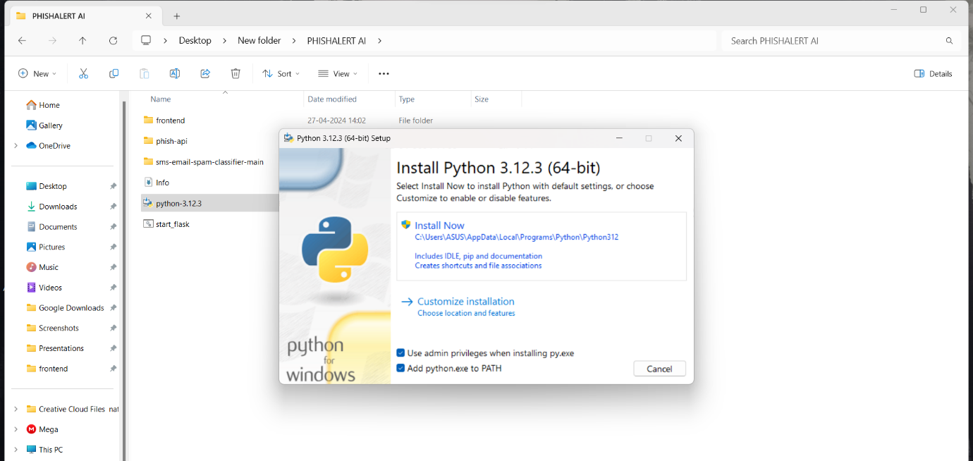

**Step 6:** After Installing Python go to the **Phish-api** folder and run **Install_package.bat** file.

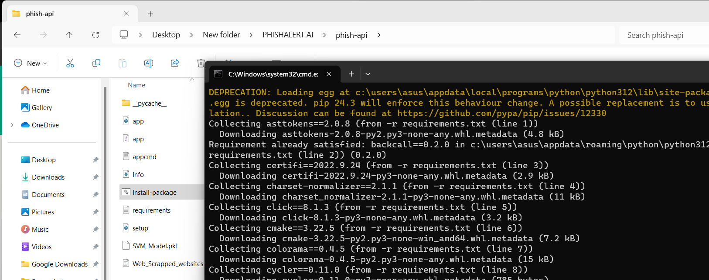

**Step 7:** After step 6 go to the **sms-email-spam-classifier-main** folder and run **Install_package.bat** file.

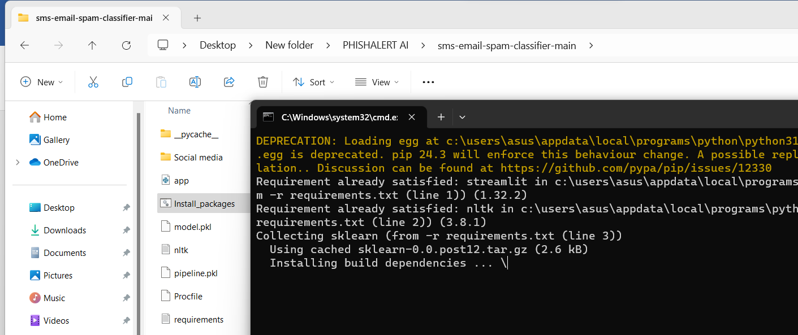

**Step 8:** After installation of package go to main folder and run **Start_flask.bat** file.

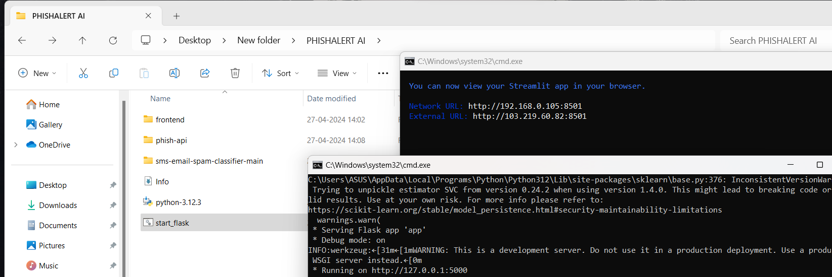

**Step 9:** Open your Brower and click on **PHISHALERT AI** extension and open any website and check the site is safe or no.

