Mesh Networking Chat Program
The ZigBee protocol, often implemented through XBee modules, is a popular way of communicating between low-power devices. However, most computers found in the home communicate using Wi-Fi.
This project demonstrates how the two protocols can be bridged, in the form of a chat program implemented in Python. This chat program allows the user to select a nickname, which is then propagated through the network, along with their IP or XBee address, and allows other users to send messages directly to them.
The demonstrator consists of a Raspberry Pi and two laptops which can communicate with each other via XBee modules or by Wi-Fi. They communicate via a Raspberry Pi which both acts as the Wi-Fi router, and bridges the Wi-Fi and XBee communications.
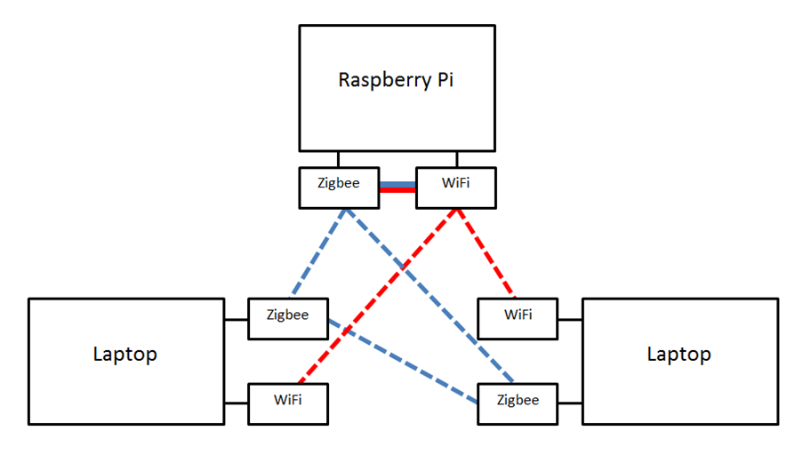
The XBee/Wi-Fi bridge in this case works transparently to the XBee and Wi-Fi clients. When it receives a nickname propagation on one interface, it sends it out with its own address on the other interface. When it receives a message for another nickname, it locates that nickname in its own records for the other interface, and passes the message across. In this way, other clients don't even have to know that the bridge exists.

