Restaurants management

Scrum Project ITC 315

USE CASE AND TEST CASE DIAGRAMS

**Admin**

**User stories:**

1. As an admin I want to be able to login to the system So, I can access the system
2. As an admin, I want to be able to access the waiters list so I can register waiters in the system
3. As an admin, I want to access waiter’s attendance so I can see who is present
4. As an admin I want to be able to access the menu So, I can add items to the menu

**Use Case Diagram:**

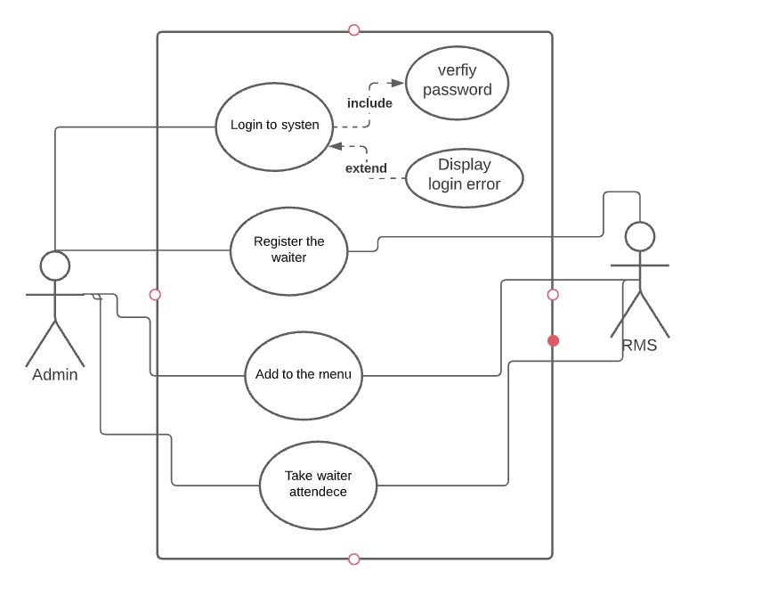

**Admin Test Case:**

|  |  |  |  |  |  |  |
| --- | --- | --- | --- | --- | --- | --- |
| **Test Case ID** | **Test Scenario** | **Test Steps** | **Test Data** | **Expected Results** | **Actual Results** | **Pass/Fail** |
| TU01 | Login into the system | Enter username  Enter Password  Click login | Username = Admin  Password=Admin | Admin should Login into an application | As Expected, | Pass |
| TU02 | Register the waiter | Enter ID  Enter full Name  Enter Phone  Enter Password | ID=1  Full name= Ahmad Farooq  Phone=3847589437  Password= 3345sd | Admin should register the waiter into the database | As Expected, | Pass |
| TU03 | Add to the menu | Enter Name  Enter the category  Enter the Price | Name= Palaaw  Category= Meal  Price=200af | Admin should add menu items into the menu table | As Expected, | pass |
| TU04 | Take waiter attendance | Enter ID  Enter full Name  Enter starting time  Enter leaving Time  Enter the date | ID= 1  Full name= Ahmad Farooq  starting time=6am  leaving Time=7pm  date= 4/17/2021 | Admin should add the attendance of the waiter into the attendance table | As Expected, | pass |

**User/Customer**

**User Stories:**

1. As a user I want to be able to sign in to the system So, I can access the system
2. As a user I want to be able to register a table

**Use case Diagram:**

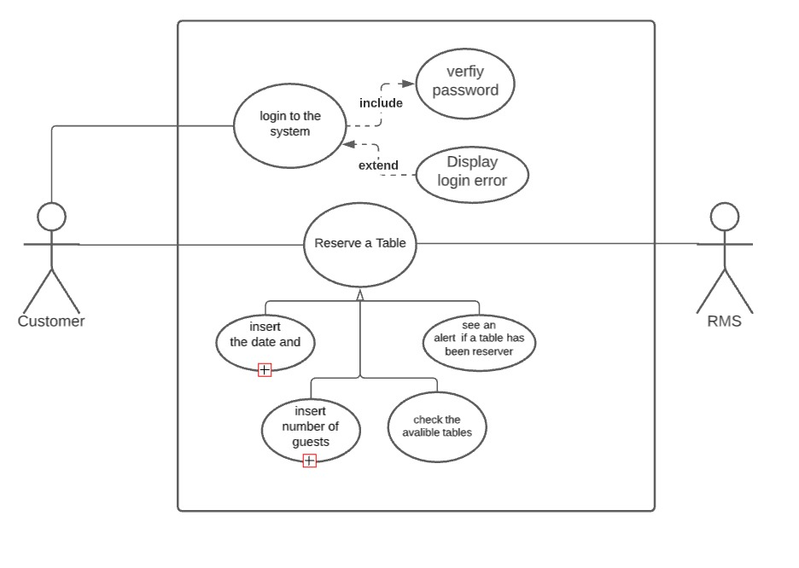

**Test Case:**

|  |  |  |  |  |  |  |
| --- | --- | --- | --- | --- | --- | --- |
| **Test Case ID** | **Test Scenario** | **Test Steps** | **Test Data** | **Expected Results** | **Actual Results** | **Pass/Fail** |

|  |  |  |  |  |  |  |
| --- | --- | --- | --- | --- | --- | --- |
| TU05 | Login into the system | Enter username  Enter Password  Click login | Username = Zaki  Password=4567 | user should Login into an application | As Expected, | Pass |
| TU07 | Reserve a table | Enter Name  Enter Guest number  Enter table number  Enter date | Name=Ahmad  Guest number=9  Table number= 5  Date=4/8/2021 | User should reserve a table | As Expected, | Pass |

**Waiter**

**User Stories:**

1. As a waiter, I want to be able to login to the system so I can access the system resources
2. As a waiter, I want to be able to check my attendance
3. As a waiter, I want to be able to see the table I am assigned to so I can serve the guests
4. As a waiter, I want to be able to access the menu So, I can see which dishes are available

**Use Case Diagram:**

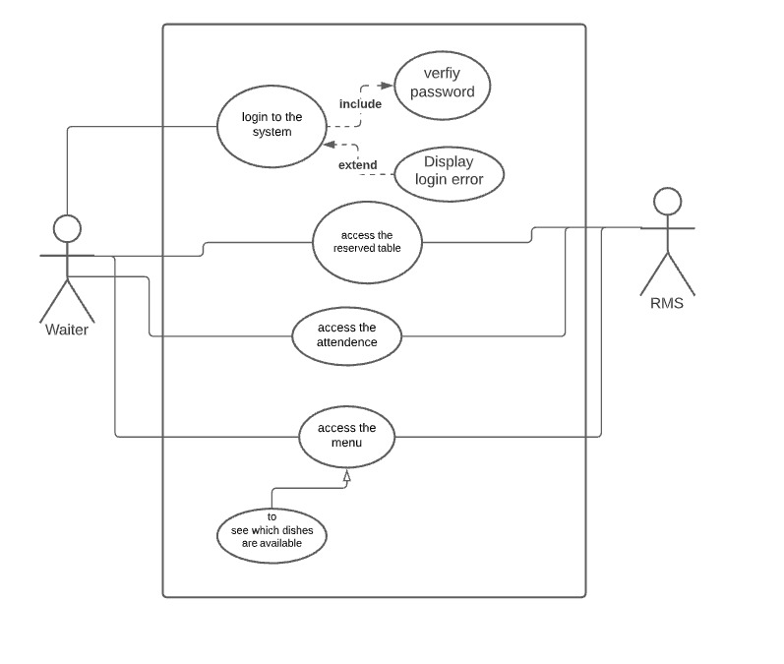

**Test Case:**

|  |  |  |  |  |  |  |
| --- | --- | --- | --- | --- | --- | --- |
| **Test Case ID** | **Test Scenario** | **Test Steps** | **Test Data** | **Expected Results** | **Actual Results** | **Pass/Fail** |

|  |  |  |  |  |  |  |
| --- | --- | --- | --- | --- | --- | --- |
| TU08 | Login into the system | Enter username  Enter Password  Click login | Username = Zaki Farooq  Password=3456 | waiter should Login into an application | As Expected, | Pass |
| TU09 | See the assigned tasks  (reserved table) | Enter ID  Enter Name  Enter status | ID=1  Name=Zaki Farooq  Status= work done | Waiter should see the assigned tasks | As Expected, | Pass |
| TU10 | See the attendance | Enter ID | ID=1 | Waiter should see the attendance | As Expected, | Pass |
| TU11 | See the menu | Click Picture  Click picture  Click picture | Picture=Meal  Picture= Drinks  Picture=Dessert | Waiter can view the meu items | As Expected, | Pass |