Game Design Document

Fill up the following document

1. Write the title of your project.

The Escape

1. What is the goal of the game?

To reach to the city

1. Write a brief story of your game.

A man was staying in a mansion outside the city in an abandoned place.one night a group of zombies attacked on his mansion.somehow he manage to escape from the mansion , he ran into the jungle ,after sometime he realised that the group of zombies was chasing him .he ran as fast as he could to escape from the group of zombies .in his path he found many obstacles eg:stone,bats,bushes etc.he also found some magical portion which could slow down the speed of the zombie.after somestime he reaches to the city in the morning and he had escaped from the zombie.

1. Which are the playing characters of this game?

* Playing characters are the ones who respond to the user based on the input from the user.
* Cars, monkeys, dinos, wizards, etc., are the playing characters in the game.

|  |  |  |
| --- | --- | --- |
| Number | Character Name | What can this character do? |
| 1 | Man/horse | Escape from the zombie |
| 2 |  |  |
| 3 |  |  |
| 4 |  |  |
| 5 |  |  |
| 6 |  |  |
| 7 |  |  |
| 8 |  |  |

1. Which are the Non-Playing Characters of this game?

* Non-Playing characters are the ones that don't have an action or behavior when the user interacts with the game.
* Hurdles, stones, bananas, coins, etc., are non-playing characters in the game.

|  |  |  |
| --- | --- | --- |
| Number | Character Name | What can this character do? |
| 1 | Stone |  |
| 2 | Zombie |  |
| 3 | bushes |  |
| 4 | Bats |  |
| 5 | Clouds |  |
| 6 | Magical portion |  |
| 7 | Moon |  |
| 8 |  |  |

Draw your imagination of this game. What does this game look like?

* Draw the game either on your computer or on paper.
* Add images of the game scenes to show each of the playing and non-playing characters at least once.

Images would be added 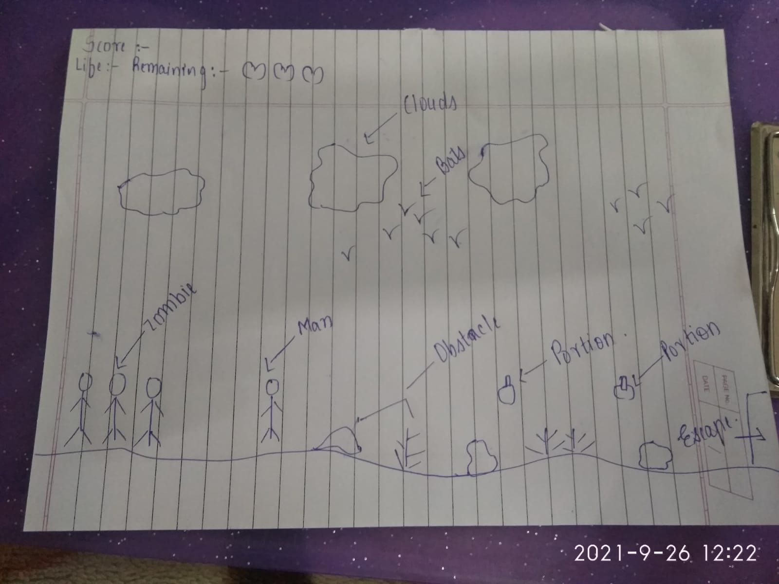

Rough sketch.

How do you plan to make your game engaging?

Will keep the difficulty level increasing.