SETU Approval Note
Company: SETU
Reviewer: Parvez Ashraf
Department: Procurement
Generated: 08 September 2026

Executive Summary
Total Findings: 2

Findings
Field | Value | Status
Pump P101 | 12 kW | Approved
Sensor S22 | Offline | Review

Status Distribution
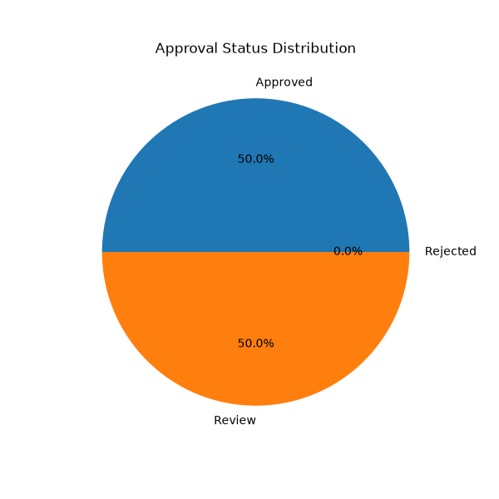

Recommendations
- Perform quarterly inspection
- Replace faulty sensors

Approval

________________________
Authorized Signatory

