SETU Approval Note
Company: SETU
Reviewer: Parvez
Department: Procurement
Generated: 08 September 2026

Executive Summary
Total Findings: 2

Findings
Field | Value | Status
pump p101 | 12kw | approved
sensor s22 | offline | review

Status Distribution
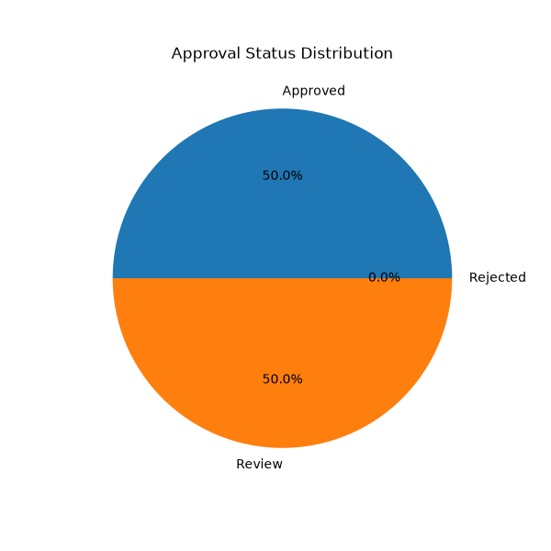

Recommendations
- me
- abdul
- muzz

Approval

________________________
Authorized Signatory

