SETU Approval Note
Company: SETU
Reviewer: Parvez Ashraf
Department: Procurement
Generated: 08 September 2026

Executive Summary
Total Findings: 5

Findings
Field | Value | Status
Pump P101 | 12kW | Approved
Sensor S22 | Offline | Review
Value V10 | Leakage Detected | Rejected
Motor M7 | Operational | Approved
Conveyor C3 | Requires Caliberation | Review

Status Distribution
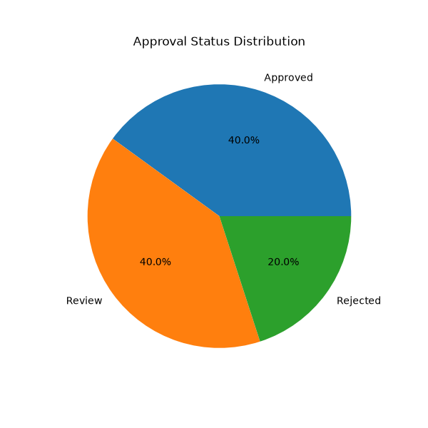

Recommendations
- Perform quaterly inspection

Approval

________________________
Authorized Signatory

