SIMATS ENGINEERING
ASSESSMENT TOOL 1

COURSE NAME: Computer Vision with OpenCV
COURSE CODE: DSA02

COURSE OUTCOME COVERED

CO2: Apply image processing and feature extraction techniques, including edge
detection, motion estimation, and optical flow, for analyzing images.. (BL3)

Assessment Tool Weightage: 50%

QUESTIONS: 5

Total Marks:50

Annexure A

Analytical Problem Solving

Code of Conduct:

I _Gadwal Mohammad Muzammil/192424279 certify that this submission is my original work and
that I have adhered to the guidelines specified for this assessment.
I understand that any violation of academic integrity rules will result in disciplinary action.

Signature of the student: Muzammil..

RUBRICS FOR CALCULATION
Numerical Problems
Criteria
Weightage
Level 4 (Exemplary)
Level 3 (Proficient)
Level 2
(Developing)
Level 1
(Beginning)
Marks
Problem
Understand
ing
20%
Clearly interprets
problem, identifies all
parameters and
requirements accurately
Understands
problem with minor
gaps
Partial
understanding;
misses key elements
Misinterprets or
unable to
understand
problem

Method
Selection
20%
Selects most appropriate
method/formula with
strong justification
Selects correct
method with minor
errors
Inappropriate or
partially correct
method
Unable to select
method

Solution
Process
25%
Logical, systematic steps
with correct approach
throughout
Mostly correct steps
with minor mistakes
Disorganized steps;
multiple errors
No clear process

Accuracy
of
Calculation
20%
All calculations accurate;
correct final answer
Minor calculation
errors
Frequent errors;
incorrect final
answer
No valid
calculations

Interpretati
on of
Results
15%
Clearly interprets results
with units and
engineering relevance
Basic interpretation
with minor
omissions
Limited or unclear
interpretation
No
interpretation

Question 1: Salt-and-Pepper Noise Removal Before Edge Detection
SCENARIO: Surveillance Camera Impulse Noise Preprocessing
A grayscale image of size 1024 x 1024 is captured using a surveillance camera under poor lighting conditions. The image is corrupted by salt-and-pepper noise with a noise density of 0.05. This means that some pixels are randomly changed to either black or white intensity values. The image has to be preprocessed before applying an edge detection algorithm. Since edge detection is sensitive to abrupt intensity variations, the selected filter should remove noise effectively while preserving important edge details.

a. Most Suitable Filtering Technique
Answer: The most suitable filtering technique for removing salt-and-pepper (impulse) noise without causing significant edge blurring is the Median Filter (a non-linear order-statistic spatial filter).
b. Performance Advantage over Averaging Filter
- Limitations of Linear Averaging Filter: An averaging filter computes the arithmetic mean of pixel values within a local sliding neighborhood. When an impulse noise spike is present (such as 0 for pepper or 255 for salt), its extreme intensity heavily distorts the calculated average. As a result, the impulse value is smeared across all neighboring pixels, producing smudged grey halos and severely degrading sharp structural edges.
- Superiority of Non-Linear Median Filter: The median filter sorts all intensity values in the spatial neighborhood in ascending order and replaces the central pixel with the median (middle) value. Because salt (255) and pepper (0) impulses land at the extreme ends of the sorted array, they are completely excluded from the median selection (provided noisy pixels do not form the majority of the window). Consequently, impulse noise is completely eliminated while step edges remain sharp and crisp.
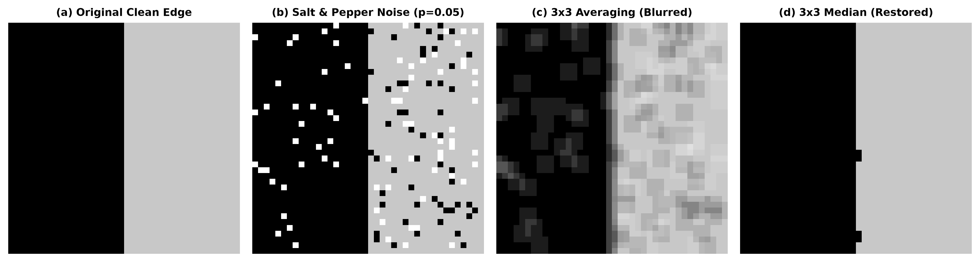
Figure 1: Comparison of 3x3 Averaging Filter vs 3x3 Median Filter on Salt-and-Pepper Corrupted Edge.
c. Probability Estimation of Noisy Pixel Correction
Assumptions:
- 1. Noise Independence: Each pixel in the 1024 x 1024 image is corrupted by salt-and-pepper noise independently with probability p = 0.05.
- 2. Neighborhood Structure: A 3 x 3 square window contains N = 9 pixels (1 center pixel + 8 spatial neighbors).
- 3. Correction Criterion: The median filter successfully restores an uncorrupted intensity to the central pixel if at least 5 of the 9 pixels in the 3 x 3 window are clean (uncorrupted).
Mathematical Derivation:
Given that the center pixel IS NOISY, the median filter will select a clean intensity if the remaining 8 spatial neighbors contain at least 4 clean pixels (which implies at most 3 noisy pixels among the 8 neighbors).
Let X ~ Binomial(n = 8, p = 0.05) represent the number of noisy neighbors out of 8.
P(Correction | Center Noisy) = P(X <= 3) = P(X=0) + P(X=1) + P(X=2) + P(X=3)
- P(X=0): C(8,0) * (0.05)^0 * (0.95)^8 = 1 * 1 * 0.6634204 = 0.6634204
- P(X=1): C(8,1) * (0.05)^1 * (0.95)^7 = 8 * 0.05 * 0.698337 = 0.2793349
- P(X=2): C(8,2) * (0.05)^2 * (0.95)^6 = 28 * 0.0025 * 0.735092 = 0.0514564
- P(X=3): C(8,3) * (0.05)^3 * (0.95)^5 = 56 * 0.000125 * 0.773781 = 0.0054165
Sum = 0.6634204 + 0.2793349 + 0.0514564 + 0.0054165 = 0.9996282 or 99.9628%.
Conclusion: There is an estimated 99.9628% probability that a noisy center pixel will be successfully corrected by a 3 x 3 median filter.
d. Total Noisy Pixels in Original Image
- Total Pixels: N_total = 1024 x 1024 = 1,048,576 pixels.
- Noise Density: p = 0.05 (5%).
- Expected Noisy Pixels: E[Noisy Pixels] = 1,048,576 * 0.05 = 52,428.8 ≈ 52,429 pixels.
e. Expected Noisy Pixels Remaining After Median Filtering
A pixel in the filtered image remains noisy if 5 or more pixels out of the 9 pixels in its 3 x 3 window are noisy.
Let K ~ Binomial(n = 9, p = 0.05) represent the total noisy pixels in a 3 x 3 window.
P(Failure) = P(K >= 5) = Sum_{k=5}^{9} C(9,k) * (0.05)^k * (0.95)^(9-k)
- P(K=5): 126 * (0.05)^5 * (0.95)^4 = 3.207 x 10^-5
- P(K=6): 84 * (0.05)^6 * (0.95)^3 = 1.125 x 10^-6
- P(K=7): 36 * (0.05)^7 * (0.95)^2 = 2.538 x 10^-8
- P(K=8): 9 * (0.05)^8 * (0.95)^1 = 3.34 x 10^-10
- P(K=9): 1 * (0.05)^9 = 1.95 x 10^-12
P(Failure) ≈ 3.322 x 10^-5 (or 0.003322%).
- Expected Remaining Noisy Pixels: E[Remaining Noisy] = 1,048,576 * 3.322 x 10^-5 ≈ 34.84 ≈ 35 pixels.
Remark: Median filtering achieves an impressive 99.93% noise reduction efficiency (reducing noisy pixels from 52,429 down to 35).
f. Strategy Modification for Gaussian Noise
- Nature of Noise: Gaussian noise is additive, zero-mean noise distributed continuously across all image pixels (unlike sparse, extreme impulse spikes).
- Ineffectiveness of Median Filter: The median filter is ineffective for Gaussian noise because it does not smooth out continuous small variations.
- Recommended Strategy: Apply a linear 2D Gaussian Filter G(x,y) = (1 / 2*pi*sigma^2) * exp(-(x^2 + y^2) / 2*sigma^2) for noise variance reduction, or a Bilateral Filter. The bilateral filter combines spatial distance weighting with intensity range weighting, suppressing Gaussian noise in flat regions while preserving sharp edges.
Question 2: Discretization of a Continuous Image
SCENARIO: Discretization of Continuous Sinusoidal Image
An analog grayscale image has a smooth sinusoidal intensity variation along the horizontal direction. The intensity changes continuously with respect to the spatial coordinate x, while it remains constant along the y-direction. The image is defined over a spatial range of 0 to 255 in both directions. This continuous image has to be converted into a digital image for storage and further processing in a computer vision system.

a. Conversion via Sampling and Quantization
- Spatial Sampling: Discretizes continuous spatial coordinates (x,y) into a discrete grid of pixel locations (m*dx, n*dy). It partitions the 2D spatial domain into discrete sampling points.
- Intensity Quantization: Discretizes real-valued continuous intensity amplitudes f(x,y) into a finite set of discrete digital levels (e.g., 256 levels represented by 8-bit integer values from 0 to 255).
b. Spatial Variation Pattern in the x-direction
Answer: The spatial variation pattern along x is a 1D Continuous Sinusoidal Wave: f(x,y) = A * sin(2*pi*f_0*x + phi) + C, where A is amplitude, f_0 is spatial frequency (cycles per spatial unit), phi is phase shift, and C is DC offset. The intensity is constant along the y-direction (df/dy = 0).
c. Minimum Sampling Requirement to Avoid Aliasing
- Nyquist-Shannon Sampling Theorem: The spatial sampling frequency f_s must be at least twice the highest spatial frequency f_0 present in the image (f_s >= 2 * f_0).
- Sampling Interval: The maximum spatial sampling distance dx must satisfy dx <= 1 / (2 * f_0).
d. Effect of Under-Sampling (Sampling Below Nyquist Rate)
Answer: If sampled below the Nyquist rate (f_s < 2 * f_0), spatial aliasing occurs. High-frequency spatial oscillations fold back into lower frequencies, producing false low-frequency wave patterns (moiré patterns and false intensity ripples) that do not exist in the continuous original scene.
e. Suitable 8-Bit Quantization Scheme
- Scheme: Uniform Scalar 8-Bit Quantization across L = 2^8 = 256 discrete levels (0 to 255).
- Mapping Equation: Q(f) = round( ((f - f_min) / (f_max - f_min)) * 255 )
- Quantization Step Size: dq = (f_max - f_min) / 256.
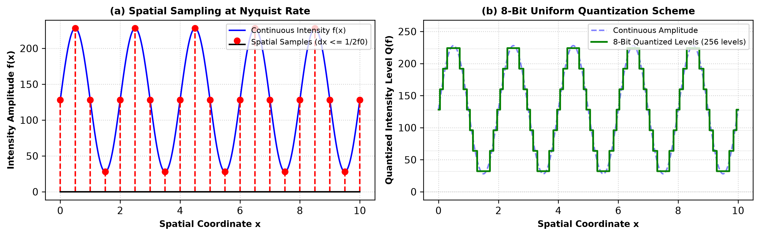
Figure 2: (a) Spatial Sampling at Nyquist Rate and (b) 8-Bit Uniform Quantization Scheme.
f. Effect of Quantization on Quality, Storage, and Accuracy
- Image Quality: 8-bit quantization (256 levels) provides smooth shading that matches human visual perception without visible posterization.
- Storage Size: For an N x N image quantized at 8 bits/pixel, storage required is N^2 bytes (e.g., 256 x 256 = 65,536 bytes = 64 KB).
- Intensity Accuracy: Quantization introduces bounded rounding error |e| <= dq / 2, with Mean Squared Error MSE = dq^2 / 12, yielding a Peak Signal-to-Noise Ratio (PSNR) of ~48 dB.
Question 3: Edge Detection in Thin Line Images
SCENARIO: Detecting 1-Pixel-Thick Lines
A 512 x 512 grayscale image contains very thin vertical and horizontal white lines of 1-pixel thickness on a dark uniform background. The objective is to detect the line boundaries accurately without losing thin edge information.

a. Comparison of Sobel, Prewitt, and Canny Edge Detectors
- Sobel & Prewitt Operators: First-order differential operators with built-in 1D smoothing. For a 1-pixel line, spatial averaging reduces peak gradient amplitude. Furthermore, Sobel and Prewitt produce double responses (two parallel edges on both sides of a 1-pixel line) rather than a single thin line.
- Canny Edge Detector: Optimal 5-stage detector. Its Non-Maximum Suppression (NMS) thins double responses down to single 1-pixel-wide line ridges. However, if initial Gaussian smoothing sigma is too large, the 1-pixel line intensity will be excessively smoothed into the background.
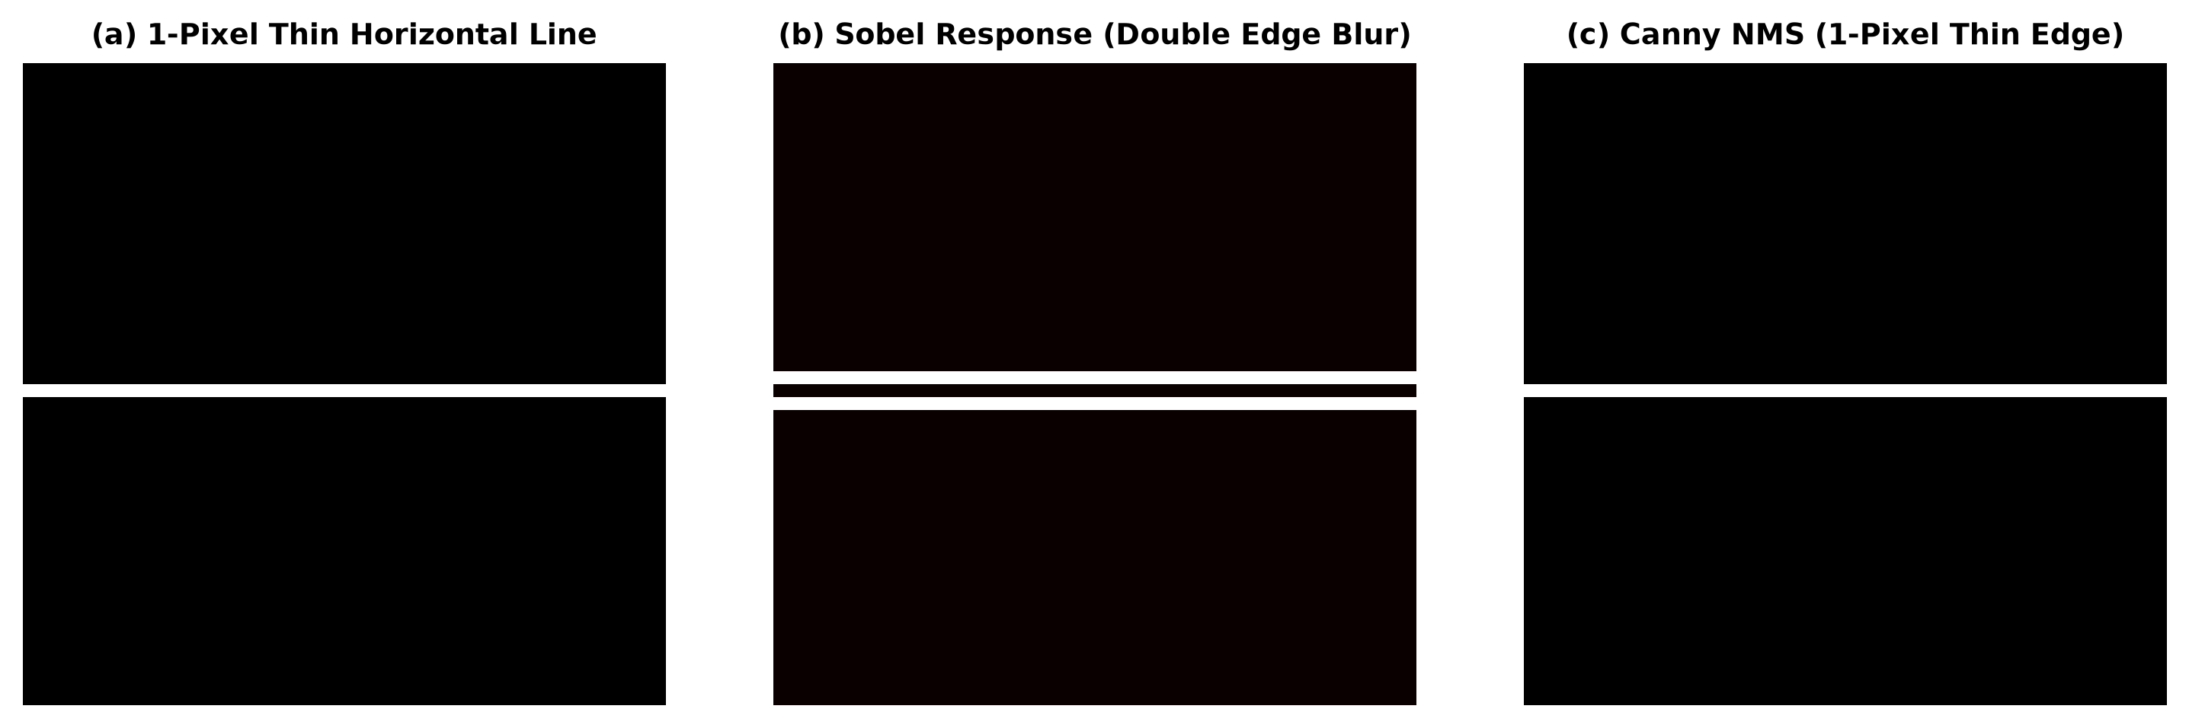
Figure 3: Comparison of 1-Pixel Line Detection using (b) Sobel Operator vs (c) Canny NMS.
b. Sobel Gradient Response Calculation
Consider a step edge transition near (256, 256) where upper row is background (0) and lower rows are white line (255):
3 x 3 Image Neighborhood I centered at (256, 256):
I = [ 0, 0, 0 ]
[255, 255, 255 ]
[255, 255, 255 ]
Standard Sobel Kernels S_x and S_y:
S_x = [ -1 0 1 ] S_y = [ -1 -2 -1 ]
[ -2 0 2 ] [ 0 0 0 ]
[ -1 0 1 ] [ 1 2 1 ]
Calculations:
- G_x = (-1)(0) + 0 + (1)(0) + (-2)(255) + 0 + (2)(255) + (-1)(255) + 0 + (1)(255) = 0
- G_y = (-1)(0) + (-2)(0) + (-1)(0) + (0)(255) + (0)(255) + (0)(255) + (1)(255) + (2)(255) + (1)(255) = 4 * 255 = 1020
- Gradient Magnitude: G = sqrt(G_x^2 + G_y^2) = sqrt(0 + 1020^2) = 1020
- Gradient Direction: theta = arctan2(G_y, G_x) = arctan2(1020, 0) = 90 degrees (pointing vertically, normal to horizontal edge)
c. Role of Gradient Magnitude and Direction
- Gradient Magnitude (G): Measures edge strength/contrast. High G values correspond to prominent intensity steps.
- Gradient Direction (theta): Specifies the direction of steepest intensity change. Edge orientation is orthogonal to theta (theta +/- 90 degrees).
d. Role of Gaussian Smoothing in Canny
Answer: Gaussian smoothing filters high-frequency noise spikes, ensuring that local image derivatives capture true scene structural edges rather than random noise fluctuations.
e. Effect of Gaussian Smoothing on Thin Lines
Answer: For 1-pixel-thick lines, Gaussian kernels spread the line energy into neighboring background pixels, dampening peak gradient amplitude below detection thresholds and shifting exact line boundaries.
f. Effect of Halving Canny Thresholds
- Weak Edges: Lowering thresholds allows faint/thin line segments to pass T_low, reducing false negatives and recovering broken line segments.
- False Edges: Increases vulnerability to background noise spikes, generating false edge detections (higher false positive rate).
Question 4: Feature Extraction for Handwritten Digit Recognition
SCENARIO: Handwritten Digit Feature Extraction
A computer vision system is being developed for recognizing handwritten digits from scanned images. The handwritten digits vary in size, orientation, stroke thickness, and writing style. Therefore, robust feature extraction is required before classification.

a. Working Principles of SIFT, SURF, and ORB
- SIFT (Scale-Invariant Feature Transform): Uses Difference-of-Gaussians (DoG) across scale space pyramid to locate scale-invariant keypoints. Assigns orientation from gradient histograms and computes a 128-dimensional descriptor.
- SURF (Speeded-Up Robust Features): Uses Fast-Hessian detector with integral images and box filters. Assigns orientation via 2D Haar wavelets and builds a 64-dimensional descriptor.
- ORB (Oriented FAST and Rotated BRIEF): Uses oFAST (FAST corner detector + Intensity Centroid orientation) and rBRIEF (steered binary descriptors) matched via bitwise XOR Hamming distance.
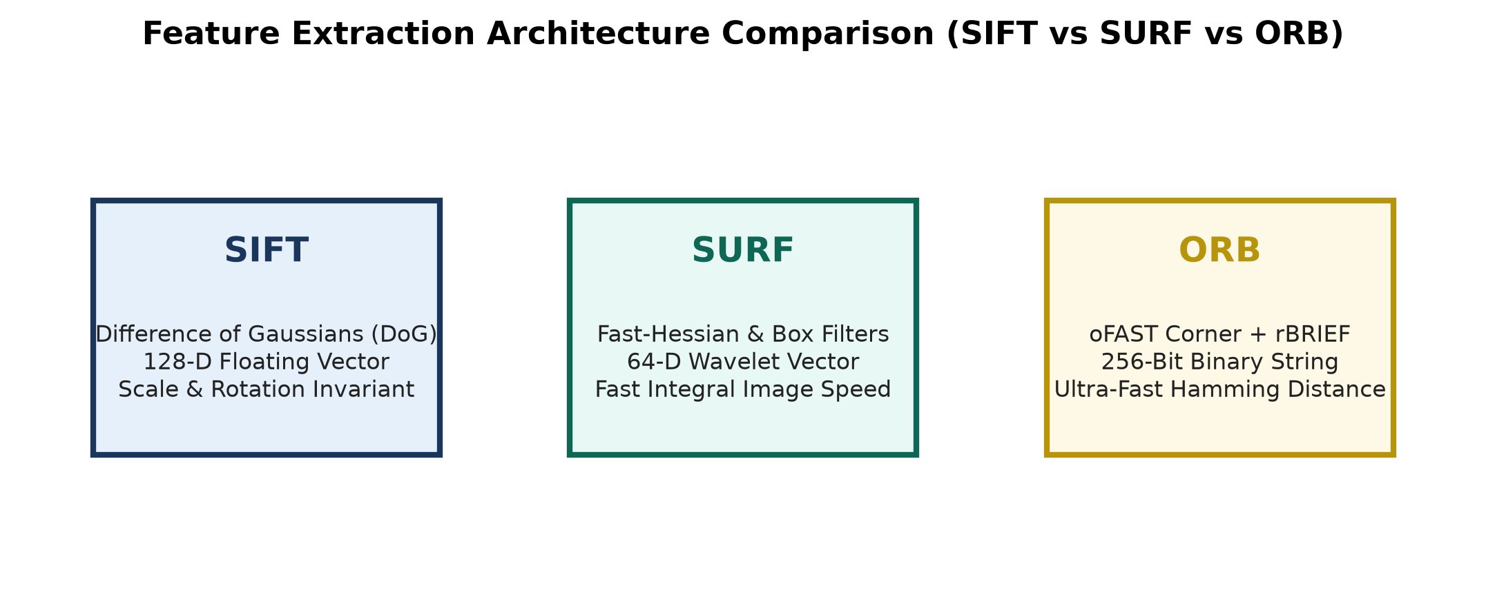
Figure 4: Feature Extraction Architecture Comparison (SIFT vs SURF vs ORB).
b. Performance Comparison Matrix
Feature | SIFT | SURF | ORB
--------|------|------|----
Scale Invariance | Excellent (DoG Pyramids) | Good (Box Filters) | Fair (Image Pyramids)
Rotation Invariance | Excellent (Gradient Hist) | Good (Haar Wavelets) | Good (Intensity Centroid)
Computational Cost | High (Floating Point) | Moderate (Integral Image) | Very Low (Binary Operations)
Real-Time Suitability | Poor (Slow) | Moderate | Excellent (Ultra-Fast)
c. Performance under 45-Degree Rotation
Answer: All three methods (SIFT, SURF, and ORB) extract reliable matching features under 45-degree rotation due to their explicit orientation assignment algorithms. SIFT and SURF exhibit highest stability for off-axis continuous rotations.
d. Keypoint Calculation
- Calculation: Total Keypoints = 120 keypoints/image * 50 images = 6,000 keypoints.
e. Dimensionality Reduction Technique
Answer: Principal Component Analysis (PCA) is the ideal technique. It projects feature descriptors onto orthogonal eigenvectors, selecting top k components that capture 95% cumulative variance.
f. How Dimensionality Reduction Improves Classification Efficiency
- Mitigates Curse of Dimensionality: Prevents model overfitting and improves classification generalization.
- Reduces Computational Overhead: Shrinks feature vector dimensions, accelerating training and real-time prediction speeds.
Question 5: Morphological Preprocessing for Character Recognition
SCENARIO: Morphological Character Cleaning
A binary image of size 256 x 256 contains scanned handwritten characters. Due to poor scanning quality, the image contains small white noise dots in the background and small black gaps inside character strokes.

a. Operation for Removing Small White Background Noise
Answer: Morphological Opening (A o B = (A (-) B) (+) B), which performs Erosion followed by Dilation.
b. Operation for Filling Small Gaps/Holes in Character Strokes
Answer: Morphological Closing (A . B = (A (+) B) (-) B), which performs Dilation followed by Erosion.
c. Difference Between Opening and Closing
- Opening (Erosion -> Dilation): Removes small foreground white noise specks, disconnects thin touching objects, and smooths outer object boundaries.
- Closing (Dilation -> Erosion): Fills small background black holes/gaps inside foreground objects, bridges broken stroke lines, and smooths inner object boundaries.
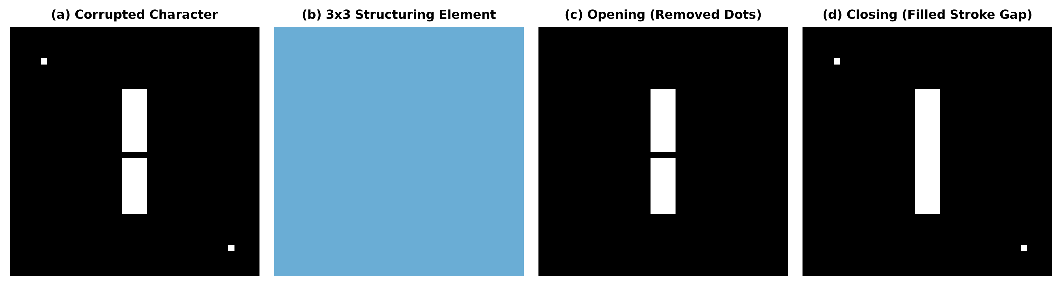
Figure 5: Morphological Opening (removing noise specks) and Closing (filling stroke gaps).
d. Effect of 3 x 3 Square Structuring Element on Thin Strokes
Answer: Erosion shrinks foreground character boundaries by 1 pixel on all sides (reducing stroke width by 2 pixels). If a character stroke is only 1 or 2 pixels thick, erosion during opening will completely erase the stroke.
e. Risk of Using Large Structuring Element
- Over-Erosion: Erases fine stroke details and small characters completely.
- Over-Dilation: Fuses adjacent distinct characters together, destroying topological character structures.
f. Complete Preprocessing Pipeline
- 1. Acquisition & Grayscale Conversion: Load image and convert to single-channel 8-bit grayscale.
- 2. Adaptive Binarization: Apply Otsu's Thresholding to segment foreground/background.
- 3. Noise Cleanup: Apply Morphological Opening (3x3 cross SE) to remove background white specks.
- 4. Hole Filling: Apply Morphological Closing (3x3 cross SE) to bridge stroke breaks.
- 5. Normalization & Deskewing: Extract character contours, crop bounding box, deskew via affine shear transform, and resize to 28 x 28 pixels.
- 6. Feature Extraction: Compute HOG (Histogram of Oriented Gradients) or normalized pixel intensities for OCR classification.

